Acoustic Guitar Anatomy and Cost Estimate

Description of Activity
In order to successfully estimate the cost of building an acoustic guitar, students must calculate the cost and quantity of the following components: soundbox or body back, sides, top, interior bracing and kerfing, soundhole rosette, neck, fretboard, tuning machines, fret wire, fretboard, nut, truss rod, fret dots, bridge, bridge pins, and strings. In doing so, students will learn basic business math computation; how to create and use an Excel spreadsheet with formulas; how to search and locate specific items online; how to compare/contrast the quality vs. cost of different options for purchasing one specific part over another; make final selection decisions for each part; and identify each component of the electric guitar anatomy.

Learning Objectives:

(List measureable objectives)
- Students will learn the names of the components that make up an acoustic guitar
- Students will build a spreadsheet as evidence of having researched prices for the components of an acoustic guitar, and determine a total cost
- Students will be able to discuss the various options they discovered and be able to provide an explanation for the choices they made, taking in to account factor such as quality, availability or cost.

Standards:

CCSS.Math.Content.HSN-Q.A.2 Define appropriate quantities for the purpose of descriptive
modeling.
CCSS.Math.Content.HSN-Q.A.3 Choose a level of accuracy appropriate to limitations on
measurement when reporting quantities

Materials Required:

N/A
Safety:

safetys:

N/A

Background:

Stringed instruments in the form-factor of what would recognize as a guitar trace back thousands of years throughout the Mediterranean to Persia. The modern steel string acoustic guitar can be traced to the 1930 introduction of the Martin OM model. With a large body, 25.4” scale length (slightly longer than their standard 24.9” scale length) this guitar was Martin’s first new release with X bracing intended to withstand the higher tension of steel strings that had been seen during the previous decade. Martin quickly adapted X bracing to the rest of their models for steel strings through the 1930’s.

An acoustic guitar body, or soundbox is an assembly made of a number of components. The ones we can see are the top, sides, and back. The sides are bent or formed in most cases using heat and steam. The top is designed to vibrate, which helps amplify the sound of the vibrating string. The rigid back and sides help bounce and project the sound out the sound hole of the top. To hold the back, sides, and top together, glue is used. Because the sides are very thin, kerfing is used to increase glue surface area. Kerfing is small strips of wood with thin saw cuts that go nearly through the stick. As a result, kerfing is very easily curved to follow the shape of the sides. The thin back and top could not withstand string tension, so interior bracing is used to add stiffness to the assembly. Commonly used materials in acoustic guitar construction is summarized in the table below. The use of these materials is a combination of tradition, aesthetic, woodworking properties, and tonal contribution to the instrument. That said, all manner of materials have been used to great effect in the fabrication of acoustic guitars.
Top: quartersawn spruce, cedar, redwood, mahogany, maple, koa
Back, sides, bridge: rosewood, ebony, mahogany, maple, cherry, walnut
Neck: quartersawnmahogany, maple, Spanish cedar
Fretboard: rosewood, ebony, ivory, maple
Kerfing: mahogany
Bracing: quarter sawn spruce or cedar
* quarter-sawn lumber is where the lumber has been cut from the log in such a way that the end grain lines in the board run perpendicular to the broad faces of the board. Orienting the grain in this manner yields a much stronger piece of wood, enabling the wood to withstand greater forces that might tend to bend the board.

Bracing inside the soundbox has been executed in a number of ways. Top bracing tends to be more elaborate, and much fuss over bracing is made by luthiers attempting to get the best possible tone from the guitar while still retaining sufficient stiffness to prevent the top from collapsing under the string tension. Martin has heavily influenced much of the acoustic guitar world with the very successful X bracing. Taylor introduced a line of guitars in 2019 called V class bracing, and a quick internet search will reveal many bracing patterns for the top. The back of the guitar is braced more simply, typically with four braces that run across the width of the back.

Bracing for Top of an Acoustic Guitar

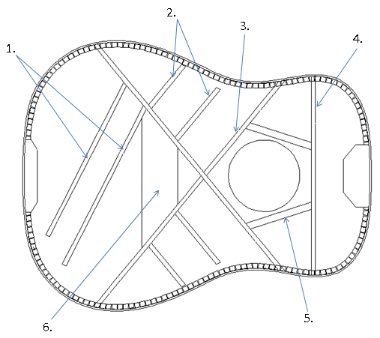

Acoustic Guitar Top X bracing components.
- Tone bars. These are often shaved or pared down to allow the top to vibrate, and alter the guitar’s resonance.
- Finger braces
- X brace
- Number One brace
- Sound hole reinforcement
- Bridge plate

Bracing for Back of an Acoustic Guitar

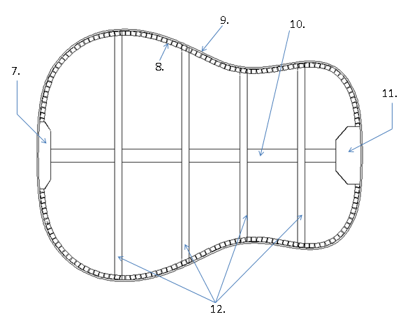

- End block or tail block. Holds the two bent sides together.
- Kerfing (lining if it is bent solid wood). Provides additional glung surface to join sides and top, sides and back.
- Side (or rim when glued to the end blocks)
- Center seam reinforcement or back graft. Ideally prepared so grain runs perpendicular to the back’s grain.
- Neck block. Holds the two bent sides together.
- Back braces or transverse braces.

Front of Guitar
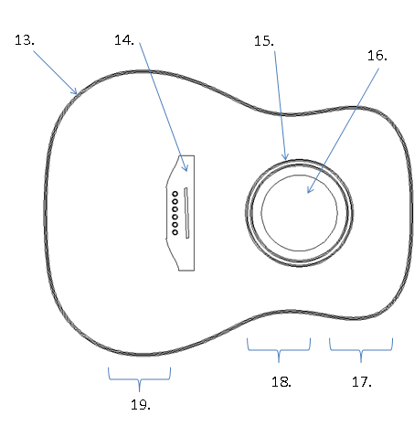
- Binding. Can be wood, celluloid material, ABS plastic, or vulcanized fiber. Binding helps protect the edge of the guitar, and serves a decorative purpose.
- Bridge. Typically the same species of wood as the fretboard and guitar sides, serves as anchor for the strings, and holds the bridge sadde.
- Rosette. Like binding, can be made from a variety of materials. It’s job is to reinforce around the sound hole, keep the top from splitting or cracking, and serves a decorative purpose.
- Sound hole
- Upper bout
- Waist
- Lower bout

Bridge detail

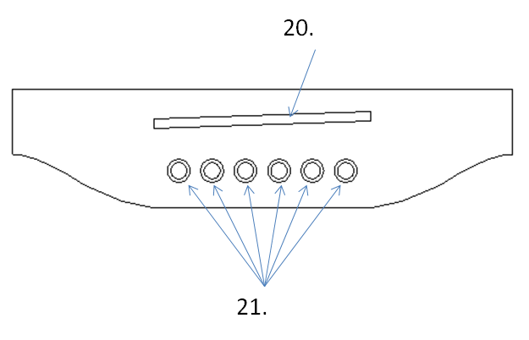

- Saddle slot. The string vibrates between the string nut and the saddle. Nut and saddle are made from bone, ivory, hard wood, plastic, or engineered polymers.
- Holes for bridge pins. Bridge pin holes are tapered as are the pins that are inserted into the holes. A bridge pin has a slot to clear the string. Friction holds the pin in place.

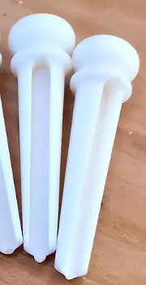
Bridge pin showing taper and slot
In traditional steel string guitar construction, the neck and soundbox are joined using what’s known as a dovetail joint. Dovetail joints are prepared with mating surfaces with a V-shape feature widest near the fretboard, and narrowing at the end of the neck heel. The neck component is created with an angle along its lengths such that the very end of the neck is wider than where the dovetail meets the end of the neck proper. The neck block has a corresponding pocket for the dovetail to slide into from above. The mating surfaces require a good deal of skill and patience to perfect with sharp chisels. This results in each neck and soundbox being custom fitted together. Once fitted, the neck and soundbox are glued together(!)
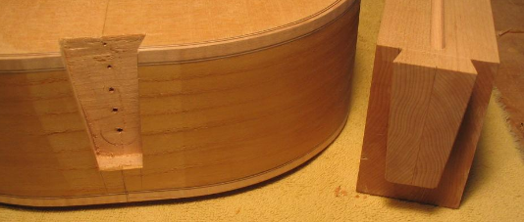
Illustration of dovetail joint

Other methods have been devised using a mortise and tenon joint and screws used to hold the two together. Our STEM Guitar Project kit will use a neck pocket much like on an electric guitar, including using screws to attach. As such, our neck won’t have the deep heel prominent on guitars assembled with a dovetail joint or mortise and tenon joint.

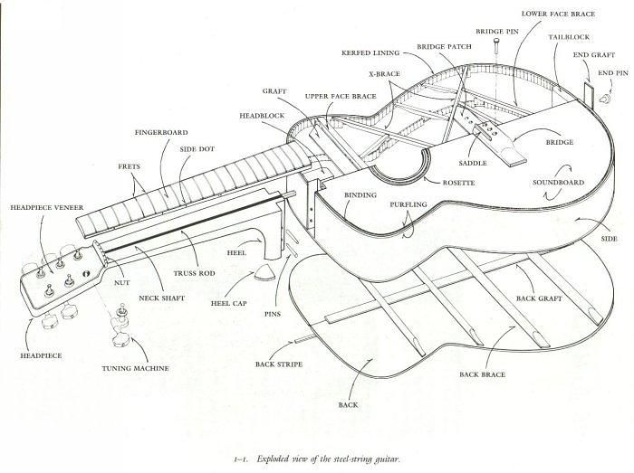

References:

https://breedlovemusic.com/soundstudio/vocabulary/

French, R. M. Technology of the Guitar Springer, 2012

Activity:

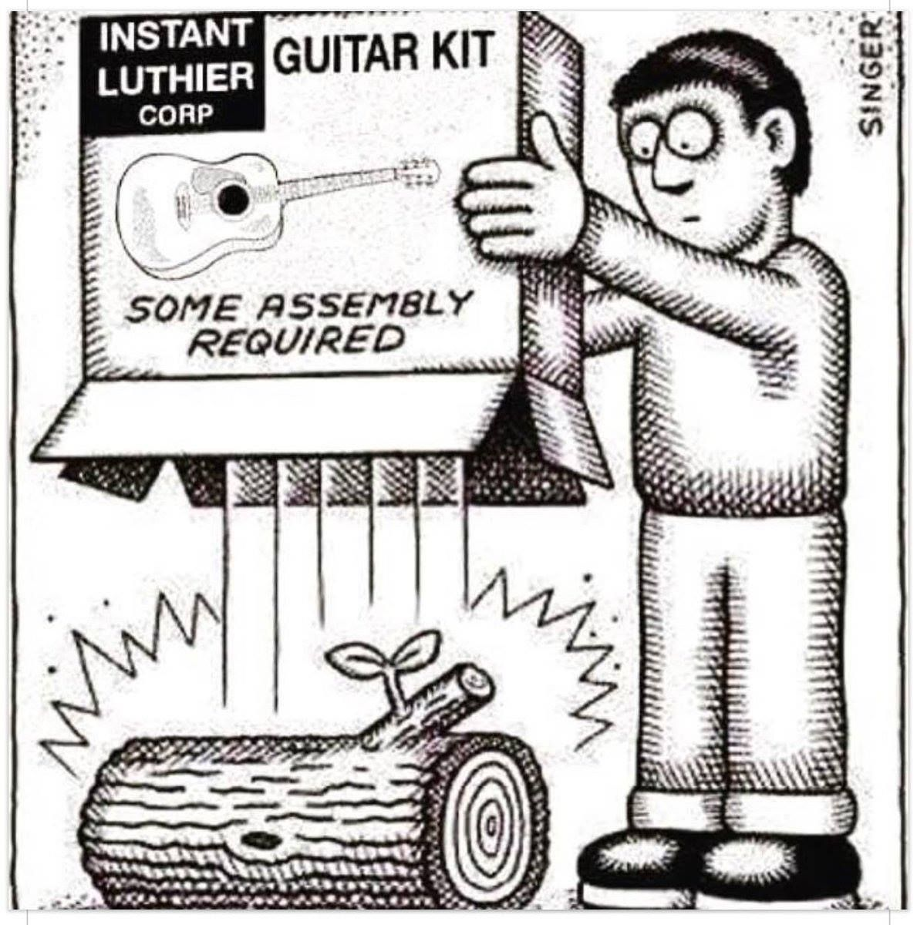

Step 1: Using the Acoustic Guitar Anatomy Diagrams on the previous pages, complete the Guitar Part Spreadsheet.
To find vendor, manufacturer, part number, and unit cost, use your web browser to search
for guitar components.
Recommended vendors include: Stewart-MacDonald - www.stewmac.com , Luthiers
Mercantile International - www.lmii.com and ALLPARTS - www.allparts.com

Step 2: Using Microsoft Excel, construct a spreadsheet that uses formulas to calculate the
total cost of the components necessary to build a guitar. Your calculations will include unit
cost and quantity to determine cost for each part, and a sum of part costs to determine the
total guitar kit cost.

Because of the high level of handwork that traditionally goes in to crafting an acoustic guitar, don’t be surprised if you are not able to find finished parts ready to install in the guitar. You may find instead sticks of wood or a block of wood sold to create the desired component(s).

Part#/  vendor | Website | Manufacturer  (if not vendor) | Qty | Unit Price | Ext Price
Side and back set (3-4 pieces of wood) |  |  | 1 | $ | $
Top
End block
Neck block
Kerfing
Soundhole rosette
Top bracing
Back bracing
Bridge
Neck
Fretboard
#8x2-1/2 drywall screw
Headplate veneer
Fretboard inlays
Fret Wire
Truss rod 14”-17”
Tuners 3R 3L
String nut and bridge saddle
Strings
Strap Buttons

TOTAL AMOUNT $__________________
Quiz – Acoustic Guitar Anatomy Name ___________________________

Label the parts of the guitar top bracing:

- _______ 2. _______ 3. _______ 4. ______ 5. ______ 6. ______

- Finger braces B. Bridge Plate C. Sound hole reinforcement
D. No. 1 brace E. X brace F. Tone Bars
Quiz – Acoustic Guitar Anatomy Name ___________________________

Label the parts of the guitar back bracing:

7.______ 8. ______ 9.______ 10._____ 11._____ 12_____

- Braces B. Neck block C. Kerfing D.Center seam reinforcement

E. Heel block F. Sides
Quiz – Acoustic Guitar Anatomy Name ___________________________

Label the parts of the guitar back bracing:

13. ______ 14.______ 15. ______ 16. ______

17. ______ 18. ______ 19. ______

- Waist B. Rosette C. Bridge D. Binding

E. Upper Bout F. Sound hole G. Lower Bout

Quiz – Acoustic Guitar Anatomy Name ___________________________

20. What holds the bridge pins into the bridge?
- Glue C. Tension
- Friction D. Gravity

21. What type of wood is NOT commonly used for a guitar top?
- Spruce C. Oak
- Cedar D. Mahogany

22. What type of wood is NOT commonly used for guitar back and sides?
- Ebony C. Rosewood
- Maple D. Spruce

23. What does the term “quarter-sawn” mean?
- The wood has been cut from the log so the end grain is perpendicular to the faces
- The wood has been cut from the log so the end grain is parallel to the faces
- The wood has been cut from the log so the end grain is at a 45 degree angle to the faces
- The wood has been cut from the log so the end grain is face

24. What does top bracing do in the acoustic guitar?
- Provides stiffness
- Allows the top to vibrate
- Both A&B
- A only

25. What does kerfing do for the acoustic guitar?
- Provides stiffness
- Provides more gluing surface for joining the sides to the top and back
- Allows the top to vibrate
- Protects the edges of the guitar

26. What does binding do for the acoustic guitar?
- Provides stiffness
- Provides more gluing surface for joining the sides to the top and back
- Allows the top to vibrate
- Protects the edges of the guitar

Answer Key:

1. F
2. A
3. E
4. D
5. C
6. B
7. E
8. C
9. F
10. D
11. B
12. A
13. D
14. C
15. B
16. F
17. E
18. A
19. G
20. B
21. C
22. D
23. A
24. C
25. B
26. D

Reviewing Faculty Cohort Members:

- Include at least two names and schools of reviewing faculty cohort members (refer to email list for faculty cohort member email addresses).

