MEASUREMENT OF STRING ACTION

Description of Activity
- Students will learn about guitar string action.
- Students will learn to use precision measurement tools (string action gauges or steel rules) to determine the amount of string action on their guitar.
- Students will compare their measuring results to values from a table to determine if their string action is considered low, medium, or high.
- Suitable for middle school through college.

Learning Objectives:

- Students will use string action gauges and/or steel rules to measure string action on their guitar.
- Students will convert fractional inch values to decimal values.
- Students will place their string action into a commonly accepted category.
- Students will determine the course of action necessary to change their string action.

Standards:
SME Competency Gap:
Manufacturing process control: Know and apply principles regarding control of process variability, measurement systems and tolerances, process reliability and maintainability, process interactions and continuous improvement.
CCSS.MATH.CONTENT.2.MD.A.1
Measure the length of an object by selecting and using appropriate tools such as rulers, yardsticks, meter sticks, and measuring tapes.
CCSS.MATH.CONTENT.5.NBT.A.1
Recognize that in a multi-digit number, a digit in one place represents 10 times as much as it represents in the place to its right and 1/10 of what it represents in the place to its left.

CCSS.MATH.CONTENT.5.NBT.A.2
Explain patterns in the number of zeros of the product when multiplying a number by powers of 10, and explain patterns in the placement of the decimal point when a decimal is multiplied or divided by a power of 10. Use whole-number exponents to denote powers of 10.

CCSS.MATH.CONTENT.5.NBT.A.3
Read, write, and compare decimals to thousandths.

CCSS.MATH.CONTENT.5.NBT.A.3.A
Read and write decimals to thousandths using base-ten numerals, number names, and expanded form, e.g., 347.392 = 3 × 100 + 4 × 10 + 7 × 1 + 3 × (1/10) + 9 × (1/100) + 2 × (1/1000).

CCSS.MATH.CONTENT.5.NBT.A.3.B
Compare two decimals to thousandths based on meanings of the digits in each place, using >, =, and < symbols to record the results of comparisons.

CCSS.MATH.CONTENT.5.NBT.A.4
Use place value understanding to round decimals to any place.

Materials Required:

- An in-tune acoustic guitar with neck relief set.

One of the following will be needed to complete the activity:

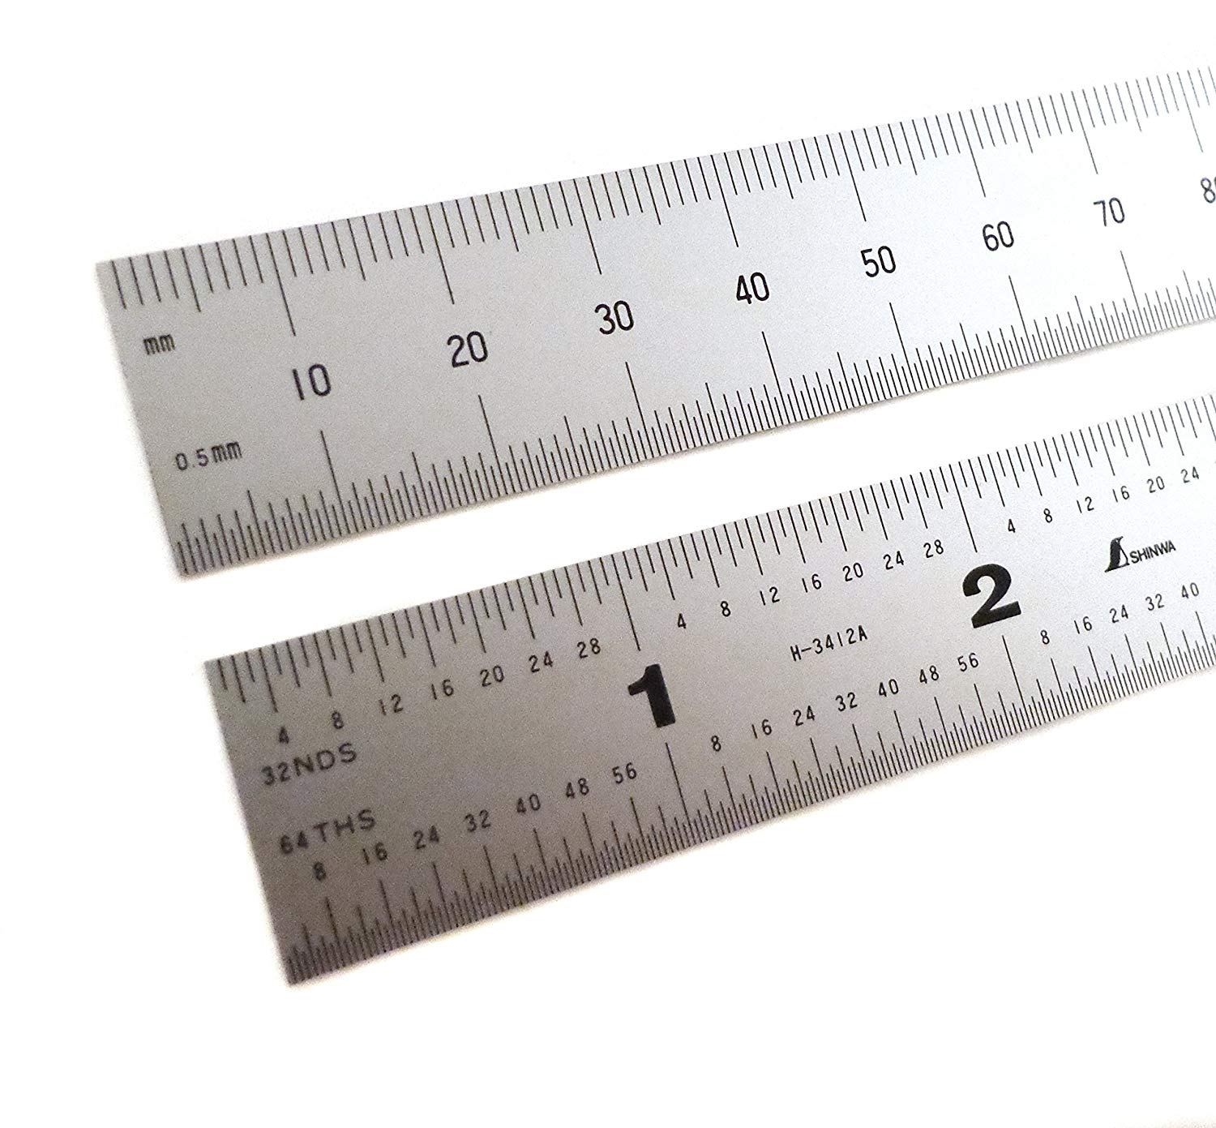
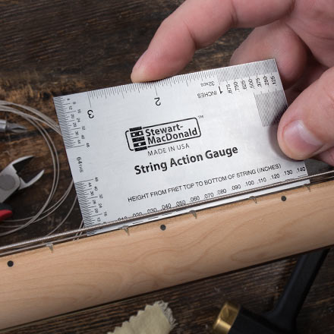
- String Action Gauge – metric or inch

- Machinist’s Steel Rule – metric or inch

Safety:

safetys:

- Safety glasses if removing or installing guitar strings

References:

- Stewmac String Action Gauge Video
- Stewmac String Action Gauge Instructions
- http://acousticguitar.com/video-instruction-series-7-lessons-on-diy-acoustic-guitar-maintenance/
- https://www.guitaranswerguy.com/guitar-action-good-string-height/
- https://www.liutaiomottola.com/formulae/action.htm

Activity:

String action is the distance between the top of a fret and the bottom of a string. The string action on your guitar will define the pressure and distance required for the string to make full contact with a fret. The string action of a guitar is ultimately a personal preference based on factors such as playing style, types of strings, and repertoire. However, there are ranges of string action that provide a consistent baseline from which to begin determining your personal preference. This activity will give you a chance to measure the string action on your guitar using various tools to determine your baseline string action range.

This activity presumes that you have already adjusted the truss rod to create the necessary string relief and have the strings under normal tuning tension. Go HERE for an overview of adjusting the truss rod (courtesy of acousticguitar.com).

When measuring string height, be sure to do it with the guitar in playing position. If you take measurements with the guitar setting on it back, gravity can distort the neck and strings, making your measurements less accurate.

The most important string action measurement is taken at the 12th fret (this is the midpoint of the string, also known as the octave). Sometimes action is checked at the 1st fret, too, if there is a problem with string buzzing or “it doesn’t feel right”. This activity will focus on action at the 12th fret.

Guitar techs will usually measure the string action of the low E and high E strings at the 12th fret. That is usually enough to determine the category of action (low, medium, high). For measuring practice purposes, you will measure action for each string. To make the measurement you can use a string action gauge or a machinist’s steel rule.

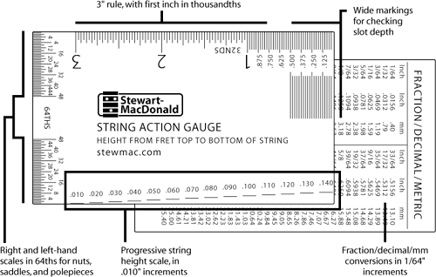
Here’s how to do it:

Inch String Action Gauge: The string height measurement scale is located at the bottom of the string action gauge. This is a precision measuring tool, so use care not to damage the edges.

With the guitar in playing position, hold the gauge behind the string to be measures as in the figure below. The string height markings are at increments of .010" (ten thousandths of an inch). When the top or bottom of the mark aligns with the bottom of the string, that’s the measurement of the string action.
The markings themselves are .005" thick, so referring to the top of a mark instead of the bottom adds .005" to the measurement. In this way the string height scale measures in .005" increments.

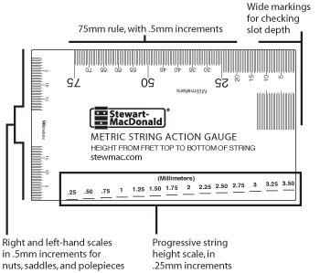
Metric String Action Gauge: The string height measurement scale is located at the bottom of the string action gauge. This is a precision measuring tool, so use care not to damage the edges.

With the guitar in playing position, hold the gauge behind the string to be measures as in the figure below. The string height markings are at increments of .25mm. When the top or bottom of a mark aligns with the bottom of the string, that’s the measurement of the string action.
The markings themselves are .1mm thick, so referring to the top of a mark instead of the bottom adds .1mm to the measurement. In this way the string height scale measures in .1mm increments.

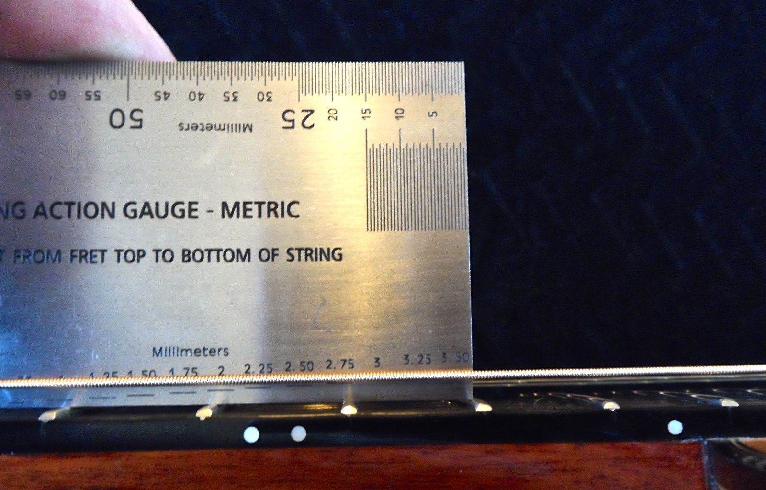

Machinist’s Steel Rule: Steel rules are available in many sizes, units, and graduations (divisions of a unit). For this activity, a 6” steel rule with 1/2mm graduations or 1/64” graduations is needed. The steel rule has machined and ground ends which allows accurate measurements from the end of the steel rule. Steel rules are precision measuring instruments. Don’t use your steel rule as a screwdriver or pry bar.

The following photo shows correct use of a steel rule to measure the string action at the 12th fret. The right side of the rule is graduated to 1/64” and the left side to 1/32”. In this example, you can see seven 1/64” lines below the bottom of the string. That means the space is 7/64th of an inch. So, 7 ÷ 64 = .1094”. You can also use the conversion chart shown below to see the decimal equivalent of the fractional value.

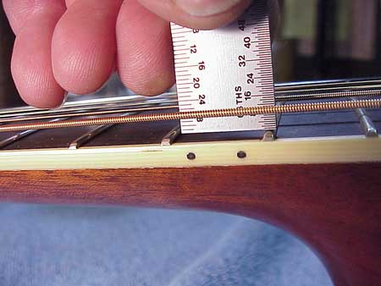
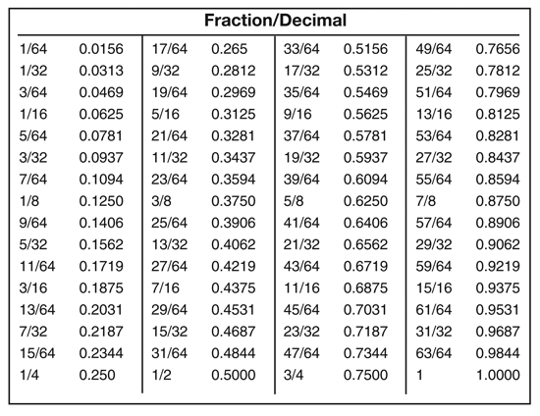

It’s a bit easier to use a metric steel rule because it is not necessary convert the fractional value to a decimal value. Metric steel rules are commonly graduated to .5mm. The photo below shows both metric and fractional inch steel rule gradations:

So now you get to try. Hold your guitar in playing position and use a steel rule or string action gauge to check the action height for all 6 strings. It’s best to be in a place with very good light so you can see the graduations on the scale. Be sure to check the action at 12th fret and record it in the table below:

String Action at the 12th Fret
Low E | A | D | G | B | High E

There is not an industry standard for string action ranges. You will find significant variances in what is considered low, medium, and high action among industry “authorities”. Classical nylon string acoustic guitars will typically have higher action than steel string acoustic guitars. Acoustic guitar action is a little different than electric guitar action because acoustic guitar strings have a bidder diameter and need more room to vibrate. The tables below represent an unofficial approximation of the ranges to use for this activity. Table values are given in metric and in inches in order to accommodate your measuring tool units.

String Height at the 12th Fret (Steel String Acoustic Guitar)
LOW ACTION | MEDIUM ACTION | HIGH ACTION
Low E: 2.0mm (0.079”)  High E: 1.5mm (0.059”) | Low E: 2.5mm (0.098”)  High E: 1.8mm (0.071”) | Low E: 3.8mm+ (0.149”)  High E: 3.2mm+ (0.126”)

String Height at the 12th Fret (Nylon String Acoustic Guitar)
LOW ACTION | MEDIUM ACTION | HIGH ACTION
Low E: 3.2mm (0.126”)  High E: 2.4mm (0.094”) | Low E: 3.9mm (0.154”)  High E: 3.2mm (0.126”) | Low E: 4.7mm (0.185”)  High E: 3.9mm (0.154”)

Does your action fall into the high, medium, or low range according to the chart above? _____________

Exchange guitars with a classmate and complete the string action check on a second guitar.

String Action at the 12th Fret (second guitar)
Low E | A | D | G | B | High E

How do you results compare to the original measurements? If the measurements don’t match, what might be causing a variation?

Now that you know your baseline string action, you can make changes if desired. Remember that string action is a personal preference for each player. Most guitar techs recommend a medium to low action while learning to play the guitar. It’s easier to play a low action guitar, but if your action is too low, there is a higher probability of getting string “buzz” across some frets. Once you develop hand strength and the dexterity to control the aggressiveness of your playing, you may want to raise the action.

You can find many YouTube videos and online guides for adjusting string action at the nut and the bridge. These processes require careful removal or addition of material to the nut and/or bridge saddle. This job is often better left to an expert guitar technician.

Quiz:

- Include at least 10 quiz questions with answer key. (Questions must be Multiple Choice, and/or Matching).

- Gravity can cause measurements to be less accurate?
- True b) False

- String action measurements are typically made at the __________ fret.
a) 1st b) 5th c) 12th d) 16th

- What is the string action in the following photo?
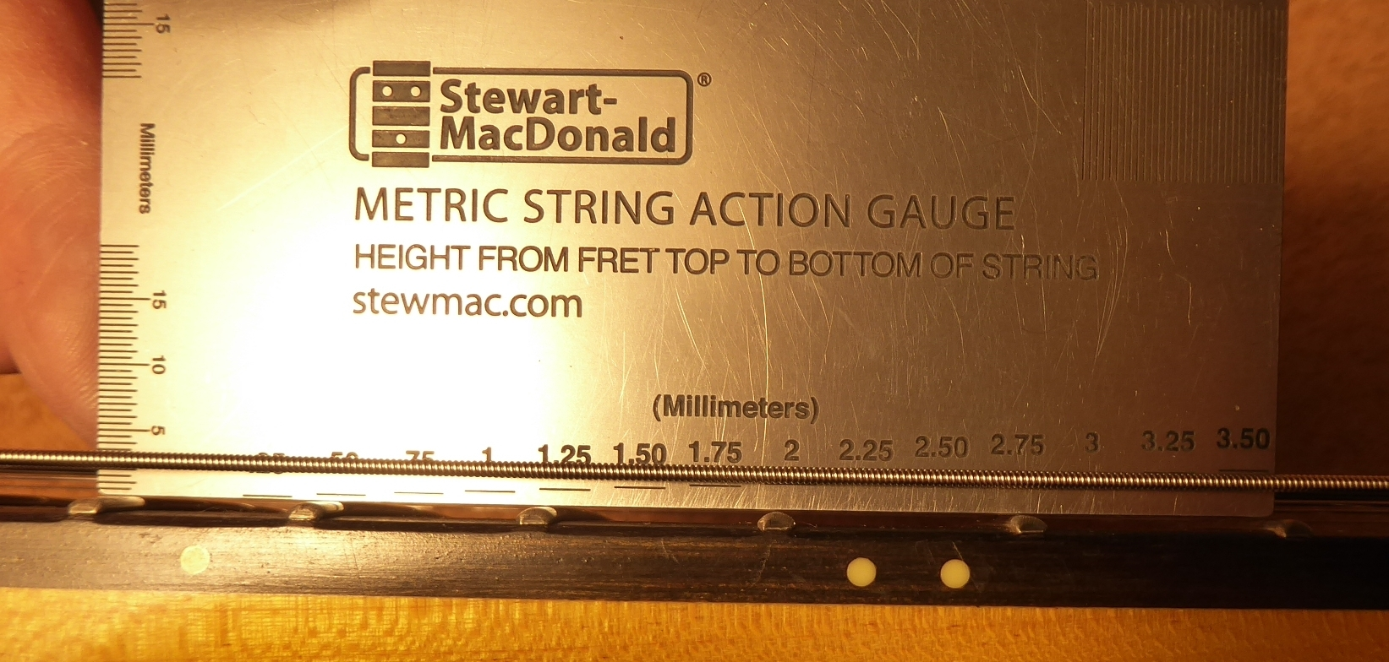
- 1.75” b) 1.75mm c) 2mm d) 2.75mm

- What is the action height for the following photo?
(note in this case the 1/64” graduations are on the left)
- .1443 b) .1562 c) .0781 d) .1550

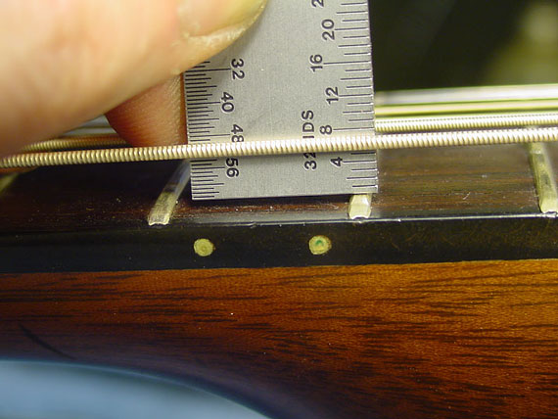

- On an inch string action gauge the graduations are:
- .025” b) .001” c) .010” d) .100”

- What’s the smallest increment that can be measured using a metric string action gauge?
- .1mm b) .025mm c) .01mm d) .25mm

- On a steel string acoustic guitar, the action would be considered ______________ if it measured 2.4mm on the low E string.
- Low b) Medium c) High

- On a steel string acoustic guitar, the action would be considered ______________ if it measured .127” on the high E string.
- Low b) Medium c) High

- What is the fractional equivalent of .125”?
- 1/4” b) 1/16” c) 1/32” d) 1/8”

- What is the decimal equivalent of 7/32”
- .2187” b) .1094” c) .2012” d) .1975

ANSWER KEY: 1. A 2. C 3. C 4. B 5. C 6. A 7. B 8. C 9. D 10. A

Reviewing Faculty Cohort Members:

- Include at least two names and schools of reviewing faculty cohort members (refer to email list for faculty cohort member email addresses).

