Modular Learning Activity

The Science and Art of Sharpening Edged Cutting Tools Used in the Construction of Acoustic Guitars

Name: Timothy J. Wilhelm, P.E.

School District: Kankakee Community College

E-mail address: tjwillyhelm@gmail.com

Date: 10/07/2018, First Draft Started; 02/21/2019, First Draft Completed; Latest Edits, 06/05/2019

Subject: The Science and Art of Sharpening Edged Cutting Tools Used in the Construction of Acoustic Guitars.

Topic: STEM/Science: Hardness; Force; Pressure. STEM/Technology: Sharpening Stone Types; Sharpening Stone Grits; Sharpening Jigs and Oils; Sharpening Technique; Care of Sharpening Stone; Strops; Polishing Compound; Stropping Technique; Testing a Sharpened Edge for Good Sharpness; Safety Hazards, Precautions, PPE, and First Aid Supplies Relevant to the Sharpening of Edged Cutting Tools.

1. Goals: The goals of this MLA are to guide the student to an understanding of the basic, physical-science concepts underlying the sharpening of edged cutting tools; to instruct the student in safe and proper sharpening technique, widely accepted as general practice and “good form;” and, to guide the student toward successful fulfilment of the “behavioral objectives.”

2. Student Learning Objectives:

Student will be able to (SWBAT)….

- Student will be able to explain, in simple terms, the concept of material hardness;
- Student will be able to explain, in simple terms, the related concepts of force and pressure;
- Student will be able to explain, in simple terms, how the concept of hardness relates to sharpening edged cutting tools;
- Student will be able to explain, in simple terms, how the concepts of hardness and pressure relate to the ability of an edged cutting tool to efficiently cut, shape, and sculpt wood;
- Student will be able to explain, in simple terms, the differences between common, sharpening-stone grits;
- Student will be able to explain, in simple terms, the basic steps and techniques involved in sharpening a common, beveled-edge chisel;
- Student will be able to list and explain the safety hazards associated with the sharpening of edged cutting tools;
- Student will be able to list and explain the safety precautions, PPE, and on-hand first aid supplies relevant to the sharpening of edged cutting tools;
- Student will be able to SAFELY demonstrate good, beginner-level technique in the sharpening of a beveled-edge chisel;
- Student will be able to SAFELY demonstrate the good sharpness of the freshly sharpened, beveled-edge chisel, using the paper cutting method explained and illustrated in this lesson.

3. Standards:

- International Technology & Engineering Educators' Association (ITEEA), Standards for Technological Literacy

  - Grades 9-12, Standard #12: Students will develop abilities to use and maintain technological products and systems
    - 12.N. Troubleshoot, analyze, and maintain systems to ensure safe and proper function and precision.
    - 12.O. Operate systems so that they function in the way they were designed

  - Standard #19: Students will develop an understanding of and be able to select and use manufacturing technologies.
    - 19.L. Servicing keeps products in good condition
    - 19.M. Materials have different qualities and may be classified as natural, synthetic, or mixed

- Common Core standards for grades 9-10, and 11-12, CCSS.ELA-LITERACY.RST.9-10.3, CCSS.ELA-LITERACY.RST.11-12.3

  - Follow precisely a complex multi-step procedure when carrying out experiments, taking measurements, or performing technical tasks, attending to special cases or exceptions defined in the text.

4. Sources:

- https://en.wikipedia.org/wiki/Hardness
- https://en.wikipedia.org/wiki/Force
- https://en.wikipedia.org/wiki/Pressure
- https://www.ncbi.nlm.nih.gov/pmc/articles/PMC4843621/
- http://multimedia.3m.com/mws/media/813249O/what-does-grit-mean-tech-talk.pdf
- https://sharprazorpalace.com/advanced-honing-topics/130720-american-standard-grit-chart-conversions-microns.html
- https://www.knifeplanet.net/best-sharpening-stones/
- https://prosharpeningsupplies.com/products/guide
- http://www.hocktools.com/tech-info/sharpen.html
- https://m.outdoorrevival.com/instant-articles/actually-sharpen-knife.html
- https://thekitchenprofessor.com/blog/a-guide-to-knife-edges
- http://www.tomonagura.com/honing/the-bevels-angle.html
- https://www.toolsforworkingwood.com/store/more/chiselguide.html
- https://www.stewmac.com/How-To/Trade_Secrets/Sharpen_your_chisels_so_they_cut_like_razors.html
- http://www.leevalley.com/us/shopping/instructions.aspx?p=41682
- https://www.iteea.org/File.aspx?id=67767&v=b26b7852

5. Materials: beveled-edge chisel; coarse, medium, and fine diamond sharpening stones suitable for the chisel being sharpened; sharpening oil; an appropriate chisel-sharpening jig (typically adjustable 25º to 30º); leather sharpening strop; green, chromium-oxide polishing compound; safety glasses; thin/light mechanic’s gloves; first aid kit suitable for treating cuts

6. Safety Concerns: Sharpening edged cutting tools involves removing metal filings and powder from the tool. Eye protection is recommended. Edged cutting tools possess the inherent hazard of potential cuts to fingers and hands. Light-weight mechanics gloves are recommended.

7. Activity:

Instructor Preparation:

For students lacking training and experience in sharpening edged cutting tools, this lesson should be useful for, when appropriately adapted, any grade level from jr. high school through college level. The instructor will need to judge how rigorous or intuitive to make the conceptual material; and, to what level of hands-on experience the students engage in.

Prior to instruction, sharpening demonstration, and students’ sharpening practice, of course, the instructor will need to gather all the needed tools and materials, especially safety and first-aid supplies. It’s also recommended the instructor practice the techniques described in this lesson, to a point of self-confident competence, prior to giving the lesson.

General Understanding, Basic Concepts, and Explanation of Terms:

Fabricating an acoustic guitar involves a fair amount of hand-tool work, including the use of hand-held chisels. When chisels are dull-edged, they require greater effort and applied force to engage the wood; and, tend to abruptly gouge out rough chucks of wood, often leaving behind a rough, gouge-pit or pocket. When chisels are sharp-edged, with relatively light force they easily engage the wood; and, tend to slice off clean wedges of wood, leaving behind a fairly smooth surface.

It should be understood, because dull chisels require more force to engage the wood and more effort to control the chisel, if the chisel abruptly gouges and releases a chunk of wood, there is a tendency for the chisel to suddenly and swiftly fly forward along the applied force vector resulting in a severe stabbing hazard. Because of this, dull chisels are much less safe than sharp chisels. This being the case, the ability to properly sharpen a hand chisel is essential within the scope of acoustic-guitar building skills.

The following terms are defined here in order to share their intended meanings within the context of this modular learning activity:

These basic, physical-science principles underlie the materials, procedures, and techniques used in hand-chisel sharpening; and, lend to understanding why sharp chisels are more effective and safer to use than dull chisels:

Hardness – For the purposes of this lesson, “hardness” refers to a mechanical property of materials. In this context, hardness is the ability of a given material to resist being deformed, fractured, sheared, or abraded by a different material, applying mechanical indentation or abrasion.

Force – For the purposes of this lesson, “force” refers to the magnitude and direction of a mechanical push on and through an edged cutting tool. In this context, the force is pushing the tool into a softer material intending to cut the softer material; or, into a harder material intending to abrade and sharpen the edge of the cutting tool.

Pressure -- For the purposes of this lesson, “pressure” is the magnitude of a force applied perpendicular to a surface per the unit area through which the force is distributed on that surface. In this context, the pressure exerted by a cutting tool can be increased in two ways: apply greater force to the tool (primarily for sharpening); or, make the contact area between the tool and the target material smaller by sharpening the cutting edge of the tool (for more effective cutting).

Building on these basic, physical-science principles, a basic technology concept is also critical to student understanding of the sharpening process:

Abrasive Grit – It’s common practice to shape, grind, and smooth materials with abrasive tools such as sandpaper, grinding discs, sharpening stones, etc. The abrasive surface of these tools varies from (1) rough-and-aggressive to (2) ultra-fine-and-barely-aggressive. The abrasive surface of an individual abrasive tool is fairly homogeneous. The grade of roughness on these abrasives is denoted by an ANSI-standard “grit” number – the number being inversely proportional to the degree of roughness.

- Rough abrasives have relatively large and coarse abrasive particles. These abrasives have low grit numbers. They also have fewer points of contact than finer abrasives, lowering their contact surface area and increasing the pressure against the surface being abraded. This results in more aggressive and faster abrasion. On the down side, it results in larger and deeper scratches on the target material than are created by finer abrasives.
- Fine abrasives have relatively small and fine abrasive particles. These abrasives have high grit numbers. They also have more points of contact than coarse abrasives, raising their contact surface area and decreasing the pressure against the surface being abraded. This results in less aggressive and slower abrasion. On the up side, as a subsequent operation, following a coarse abrasion with a finer abrasion results in removing the larger and deeper scratches left by the coarse abrasive, and results in a much smoother surface on the target material.
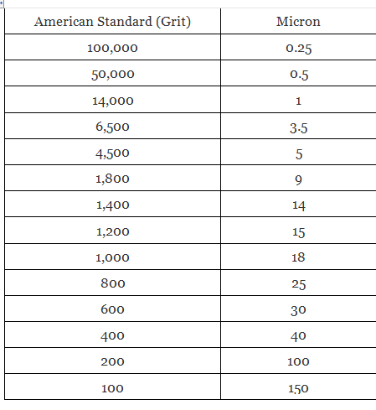

It is recommended the instructor help the students acquire an intuitive, conceptual, cause-and-effect understanding of how these basic principles relate to the process of sharpening edged cutting tools, and why edged cutting tools are more effective and safer to use when they are sharp. This, of course, can be accomplished a number of different ways, including discussion and visualization, Socratic questioning, or (safe and supervised) hands-on experimentation. Here are a few examples of ideas that can be queried or tested:

- We know harder substances can abrade and remove material from softer substances. In order to sharpen a chisel, which must be harder, the chisel or the sharpening stone?
- If the sharpening stone is harder than the chisel; and, if the sharpening stone is abrading and removing material from the chisel, where is that abraded material going? Will that abraded material have any negative effect on the stone? How could we prevent this negative effect?
- Is it critical to maintain a precise, consistent angle between the chisel and the stone with each sharpening stroke? Why? If, yes, how might we maintain that precise and consistent angle?

Sharpening Supplies, Tools, and Techniques:

The word “whet” is a transitive verb that means: to sharpen by rubbing on or with something; or, to make keen or more acute. Hence, stones used to sharpen edged cutting tools are often referred to as “whetstones.”

The whetstone is the primary piece of chisel-sharpening equipment. It’s the abrasive tool used to form the chisel’s sharp edge. There are many varieties of both natural and synthetic whetstones readily available; but, they can all be separated into just three (3) general categories: water stones; oil stones; and, diamond hones.

Keep in mind, in order for the whetstone (aka Hone) to properly fulfill its function, it must be harder then the material of the chisel (or any other edged cutting tool needing to be sharpened). As the whetstone abrades the chisel, it is removing fine particles of the chisel’s material (steel) – it needs to do this in order to create a sharp edge on the chisel. These fine particles of steel, removed from the chisel, are known as “swarf.” According to the Oxford Dictionary, “swarf” is: “fine chips or filings of stone, metal, or other material produced by a machining operation.” Swarf is a problem for the whetstone. If the whetstone is not lubricated, the swarf is allowed to fill in the tiny voids on the surface of the stone, it will make the stone’s surface slick and smooth, diminishing its ability to abrade the blade. To prevent the inevitable swarf from filling the voids between the abrasive particles and damaging the whetstone, the stone must first be lubricated with an appropriate liquid that will keep the swarf suspended within the liquid and allow it to be easily removed. As their names imply, water stones require water as their honing lubricant; and, oil stones use a light weight honing oil as their lubricant. Diamond hones also use a lightweight honing oil. As should be obvious, the lubricant is applied to the whetstone prior to sharpening the chisel, suspending the inevitable swarf and enabling its easy removal.

In addition to being available in different styles, any given style of whetstone is also available in different grit ratings. Looking back at the technical concept of abrasive grit, it makes sense we would begin with a coarse grit stone (to repair or reform a chipped or very dull edge). After the edge is repaired or re-established, we then transition to a medium or fine grit; and, finally to an extra-fine grit. A coarse stone is typically near 320 grit; a fine stone is near 800 grit; and, an extra-fine stone is near 1,800 grit.

The technique of sharpening a chisel on a whetstone involves pushing the edge of the chisel along the surface of the stone, as if trying to slice off a thin layer of the stone. After successively honing like this on coarse, fine, and extra fine stones, the edge of the chisel will be much sharper than prior to honing; but, the honing process also can leave a flaw on the edge – a very sharp, thin burr extending out from the edge of the chisel. If the chisel is used without removing the burr, it typically folds back on itself, immediately dulling the edge. To remove this burr, prior to use, the edge of the chisel should be “stropped” or polished on a flat “strop” made with smooth, grain-side leather (or other suitable material), that is typically covered with a film of ultra-fine polishing compound.

Different than honing, stropping involves dragging the edge of the chisel backwards long the surface of the strop, as if trying to wipe something from the edge. Indeed, this is exactly what is happening – the burr is being wiped off the chisel’s edge.

In addition to a set of whetstones, honing lubricant, and a strop, another piece of sharpening equipment is very useful during the honing process: a honing jig. To properly hone the edge of any cutting tool, the angle of the blade against the stone must be precisely consistent with every honing stroke. This is extremely difficult to maintain just holding the chisel in one’s hand, if not impossible. This is the function of the honing jig – it locks the chisel into a fixed and consistent angle with every stroke across the stone, resulting in a precisely sharpened edge.

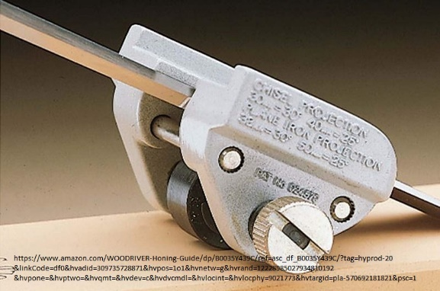

Show and Discuss the Lesson’s PowerPoint Presentation:

Accompanying this lesson is a PowerPoint presentation that illustrates builds upon the information presented, above. It may be used as-is or adapted by the instructor to suit his or her needs.

View and Discuss the Lesson’s YouTube Video:

Accompanying this lesson is a YouTube video that may be used by the instructor as she or he sees fit. The current video link is for a knife sharpening demonstration previously made by this lesson’s author: https://www.youtube.com/watch?v=nyDB_JXkxhA&t=1s

While this video shows knife sharpening, as opposed to chisel sharpening, it does illustrate the use of several grades of sharpening stones, starting with a coarse grit and moving to a fine grit, and then to a polishing strop. It also shows the use of a sharpening jig to maintain a precise, consistent angle between the cutting edge of the knife and the surface of the sharpening stone. These principles also apply to sharpening chisels. A STEM Guitar, chisel-sharpening video is planned as a specific, additional supplement to this lesson. Until that’s completed, here is a short video from Toolstop that may be useful: https://www.youtube.com/watch?v=SSXX0M9_LXU

Something demonstrated in the video that should NOT be allowed for students is testing the cutting-edge sharpness by shaving the hair from one’s arm or leg. Obviously, this would be a safety hazard in a classroom situation. That said, it clearly illustrates how very sharp the edge was made.

The other sharpness test, easily slicing and shaving the edge of a piece of paper, is useful (after safety discussion and with supervision by the instructor). Sharpness may also be tested by attempting to easily shave small, thin wafers and curls from a piece of scrap wood.

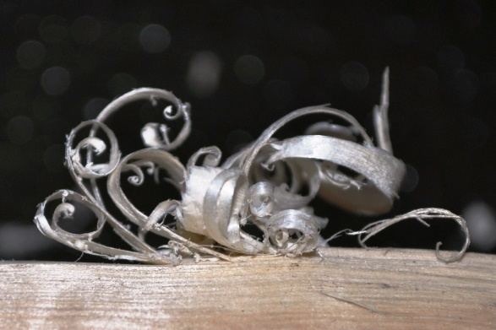
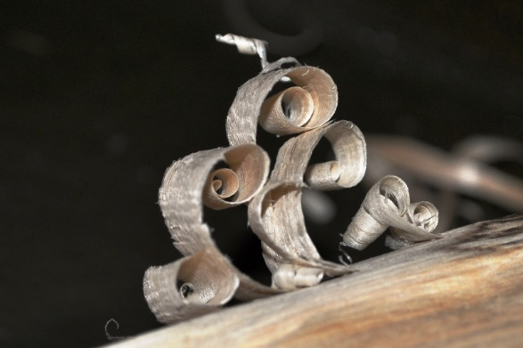

Application and Experience:

After receiving conceptual instruction, viewing relevant videos, seeing the instructor’s demonstration, and reviewing all appropriate safety instructions, engage the students in hands-on, chisel-sharpening experience:

- Provide the students with used, dull chisels.
- Following all safety procedures, have the students attempt to slice and shave the edge of a sheet of paper (as seen in the videos); and, have them attempt to easily shave small, thin wafers and curls from pieces of scrap wood, as shown in the photos, above.
- Provide the students with: coarse, fine, and extra-fine whetstones; appropriate honing lubricant; a chisel-honing jig; a leather strop; and a stick of chromium-oxide polishing compound.
- Guide the students through the process of properly mounting the chisels in the honing jigs, lubricating the whetstones, and honing the chisel through all three grit-grades of stone.
- Have the students apply the polishing compound to the strops; then guide the students through the stropping process.
- After the sharpening process is complete, have the students go back and repeat step #2, above.

After the students have successfully sharpened the chisels, they will be ready to use in the acoustic-guitar building process.

8. Assessment:

- The ability of a given material to resist being deformed, fractured, sheared, or abraded by a different material is a measure of its…
  - specific gravity
  - viscosity
  - hardness
  - brittleness

- An external influence that causes an affected object to be pushed or pulled in a certain direction is a definition of…
  - velocity
  - force
  - mass
  - acceleration

- Look back at #2, above. When the magnitude of this influence is divided by the resulting surface area it’s being applied to, we have calculated how much of this influence is being applied per unit area. This calculated result is known as…
  - pressure
  - density
  - force
  - penetration

- Grinding and abrasive tools are coated with uniform-size particles intended to abrade a target material. The relative roughness of these abrasives is denoted by an ANSI-standard number. This standard, roughness-grading number is known as the abrasive’s…
  - tooth
  - scratch-test
  - ABRA
  - Grit
- Look back at #4, above. Which of these ANSI-standard, relative-roughness numbers indicates an abrasive that is rougher than the other…
  - 800
  - 100

- When a steel chisel is honed on a proper whetstone, which is harder…
  - The chisel
  - The whetstone
  - Neither. They have the same, identical hardness levels

- Why must a proper honing lubricant be applied to a whetstone prior to honing a steel chisel?
  - To prevent schwartzing of the stone
  - To suspend the resulting schwartz and make it easy to wash away
  - To prevent the stone from becoming clogged and smooth
  - To make it easier to glide the chisel across the more slippery stone surface

- There are three (3) general categories of whetstones: water stones, oil stones, and…
  - Arkansas stones
  - Isoncyanurate hones
  - Diamond hones
  - Pebble hones

- What is the proper direction(s) to move a chisel’s bevel across a whetstone when honing it?
  - pushing the edge of the chisel forward, along the surface of the stone, as if trying to slice off a thin layer of the stone.
  - dragging the edge of the chisel backwards long the surface of the strop, as if trying to wipe something from the edge.
  - revolving the chisel in small circles on the surface of the stone.
  - moving the chisel back and forth on the surface of the stone in a direction parallel to the chisel’s edge.

- What is the primary purpose of a chisel honing jig?
  - The jig’s small, motorized wheel makes it easier to move the chisel across the surface of the whetstone.
  - The jig holds the chisel at a fixed and consistent angle during all the honing strokes of the chisel across the surface of the whetstone.
  - The jig is a PPE device that helps prevent finger cuts during the honing process.
  - The jig is designed to simultaneously clean the surface of the whetstone while the chisel is being honed.

