Strength of Steel Guitar String

Description of Activity
- Students will intentionally overtighten a steel guitar string while noting its frequency. Using the fundamental frequency right before it breaks, they will calculate the breaking strength of the steel. They will then compare it to tabulated values for commons steel alloys.
- Every material has a yield stress, the stress beyond which it will fail. The yield stress for the material used in guitar strings is surprisingly high – much higher than for most steel alloys. With a guitar and a tuning app for a cell phone, it is easy to determine the frequency at which a string breaks and to then calculate is stress at failure.
- This activity fits into a physics, engineering or math class in grades 9-12

Learning Objectives:

- Students will measure the fundamental frequency of a guitar string
- Students will be able to relate string tension to string frequency
- Students will calculate failure stress in a steel string

Standards:

Related Next Generation Science Standards:
Student Performance Expectations: | HS-PS1-1: Use mathematical representations to support a claim regarding relationships among the frequency, wavelength, and speed of waves traveling in various media.
Science & Engineering Practices | Disciplinary Core Ideas | Crosscutting Concepts
-Use mathematical and computational thinking | PS4.A: Wave Properties  The wavelength and frequency of a wave are related to one another by the speed of travel of the wave, which depends on the type of wave and the medium through which it is passing. (HS-PS4-1) | -Cause and effect

Related Common Core Math Standards:

MP.4: Model with Mathematics

Materials Required:

This experiment requires
- A guitar with steel strings. An acoustic guitar will work, but it’s a little easier to change strings on an electric guitar. If you use and electric guitar, you’ll need an amplifier. Any small practice amp will work.
- A tape measure or ruler at least as long as the guitar string
- A tuning app for a smart phone. The tuning app must display the frequency of the string along with the note.

Safety:

safetys:

- The string releases strain energy when it breaks, so it is important to wear safety glasses and to keep hands away from the string as much as possible. Guitar strings occasionally break while being played heavily and injury from breakage is very rare. This experiment has been performed many times without incident.
- Only perform this experiment on the smallest diameter string and not on a string with a diameter of more than 0.011” (0.28mm). This will ensure that the lowest possible strain energy is released.

References:

- This experiment is demonstrated in a YouTube video: https://www.youtube.com/watch?v=QV2XZihMMoA&t=3s
- A comprehensive list of material properties is available at ww.matweb.com
- Wikipedia article on wire drawing: https://en.wikipedia.org/wiki/Wire_drawing
- More information is available in Technology of the Guitar by Mark French. Springer 2012, ISBN 978-1-4614-1921-1
- A good online source of technical information on guitars is liutaiomottola.com

Activity:

- Start with a guitar with a fresh steel high E string (the smallest diameter string and the one at the bottom when they guitar is being played.
- Measure the length of the string from the inside edge of the nut to the saddle.

String Length

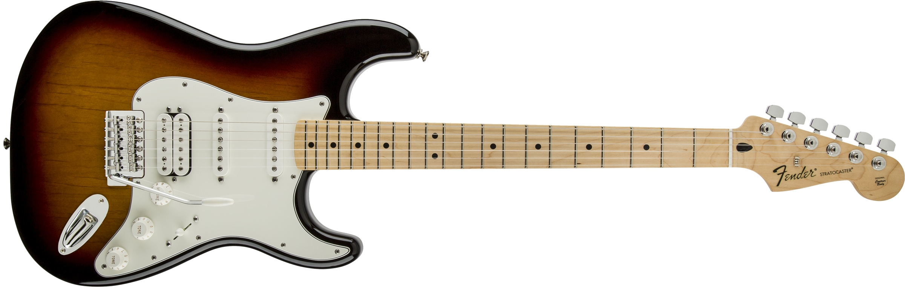
Use this string

- Start the tuner app on your smart phone, making sure you can see the frequency of the note, not just its name, as shown

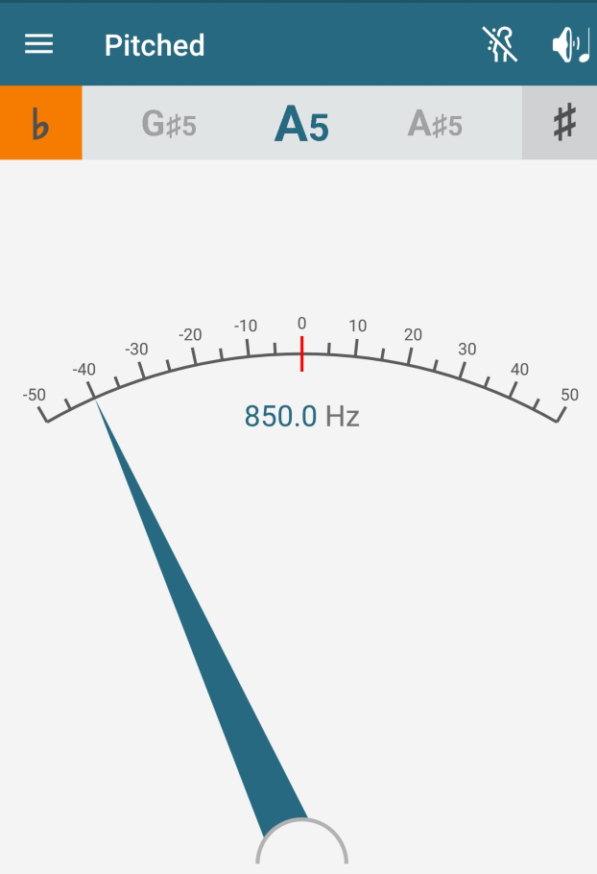

- Tune the string to its correct pitch of 329.6 Hz. This note is called E₄
- Start increasing the pitch of the string by tightening it using the tuning machine at the headstock. Pluck the string every few seconds and record the frequency. Use a guitar pick or a thin piece of plastic to pluck the string so that your finger isn’t touching it.
- Keep tightening the string and recording the frequency until it breaks.

The engineering quantity that describes the strength of a material is stress. Stress is represented by the Greek letter sigma, σ, and is force applied over and area

$$σ=\frac{F}{a}$$

It’s easy re re-arrange this equation to describe force in terms of stress

$$F=σ∙a$$

The frequency, f, of a stretched string with negligible bending stiffness is

$$f=\frac{1}{2π}\sqrt{\frac{T}{ρ}}$$

Where f is the frequency in Hz, T is tension (the force acting one the string) and ρ is the mass per unit length. ρ is defined as

$$ρ= ρ_{steel}×a$$

Where ρ_{steel} = 7850 kg/m³ and a=cross-sectional area of the string.

Where L is the length, T is the tension and ρ is mass per unit length. Force and tension are different words for the same thing, so T=F. Also, ρ=ρ_{steel}∙a, where ρ_{steel} is the density of steel, 7850 kg/m³.

$$f=\frac{1}{2L}\sqrt{\frac{σ∙a}{ρ_{steel}∙a}}=\frac{1}{2L}\sqrt{\frac{σ}{ρ_{steel}}}$$

Solving for stress gives

$$σ=4f^{2}L^{2}ρ_{steel}$$

We now know the frequency of the string at its yield stress. Note that cross-sectional area, a, doesn’t appear in this equation. This means that we can find the string of the string without knowing its diameter.

As an example, a class at Purdue did this experiment and we found that a string with a length of 0.648m (25.5 in) broke as the frequency reached 415 Hz. This gave a breaking stress of 2271 MPa.

Try it for yourself:

- Frequency measured: ______________ Hz

- Calculated stress: ______________MPa

There seems to be a problem with this number, since the yield strength of a common grade of steel (AISI 1010) is listed at 240 MPa.

- How many times greater is the stress you calculated in Part C as compared to the AISI 1010 standard of 240MPa?

Is it possible that a guitar string can be this strong? It is.

Guitar strings are made of ASTM A228 steel. It has 10x as much carbon as mild steel and the drawing process that produces wire makes it stronger. Matweb shows that strength goes up as the diameter of the wire goes down. The drawing process affects the microstructure of the steel.

The result is that music wire really is much stronger than steel used for routine applications like beams in buildings and school furniture. It is interesting that music wire doesn’t include any especially unusual ingredients. Like other alloys, it is almost all iron (99%) and incudes small amounts of other elements. Its strength doesn’t come from exotic alloying elements, but from the way it’s processed.

The lower pitch strings have a music wire core and are wound with wire made from a different, softer material. Acoustic guitar strings are typically wound with brass or bronze wire. Electric guitar strings are often wound with nickel plated steel.

Quiz:

Correct answers are highlighted

- Compared to mild steel, the steel in music wire is:
  - Just as strong
  - Not as strong
  - Stronger
- Making a string longer (making a guitar bigger) while still tuning it to the same pitch has what effect on the stress in the strings?
  - No effect
  - Reduces stress
  - Increases stress
- If the length of the string in the example problem was reduced to 0.60m, the resulting stress would be
  - 2271 MPa
  - 1947 MPa
  - 4747MPa
  - 173.6MPa
- If the string could be made of high strength aluminum with a density of 2700 kg/m³, the stress in the string would
  - Decrease
  - Increase
  - Not Change
- Classical guitar strings are made of nylon, with a density of 1250 kg/m³. What would the stress in a nylon E string with a length of 650mm?
  - 1250 MPa
  - 363.8 MPa
  - 363.8 Pa
  - 650 Mpa
- What is a Pascal? (Pick one answer)
  - A unit of pressure
  - A unit of stress
  - A pound per square inch
  - A and B
  - A and C
  - A, B and C
- If the diameter of the string in the example (648mm and 415Hz) is 0.254mm, what is the tension?
  - 2271N
  - 115N
  - 7850N
  - 1994N
- Increasing the diameter of the string by 10% would have what effect on the failure stress?
  - Lower stress
  - Higher stress
  - No effect
- Decreasing the diameter of the string by 10% would have what effect on the failure stress?
  - Lower stress
  - Higher stress
  - No effect
- Which is stronger?
  - A228 music wire, 1.00mm in diameter
  - A228 music wire, 0.400mm in diameter
  - A228 music wire, 0.100mm in diameter
  - No difference

Reviewing Faculty Cohort Members:

- Dr. Debbie French, Wake Forest University
- Dr. Mark French, Purdue University

