Section 1 Questions

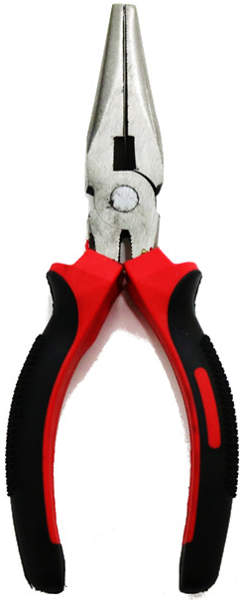
- What is this?
  - Pliers
  - Scissors
  - Wire Stripper
  - Screwdriver
  - Crimper
  - Multimeter
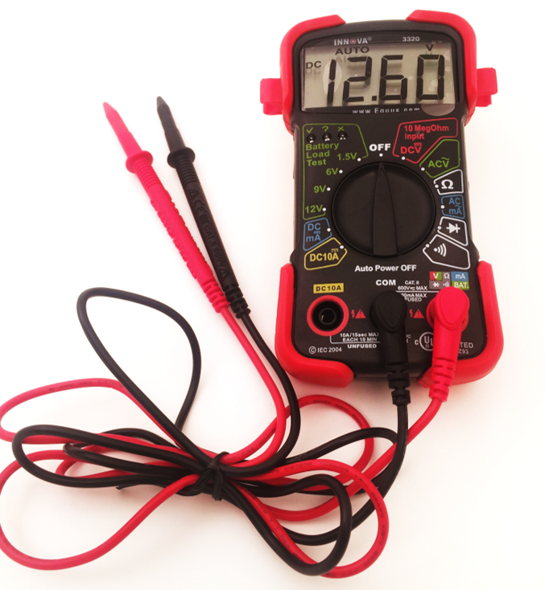
- What is this?
  - Pliers
  - Scissors
  - Wire Stripper
  - Screwdriver
  - Crimper
  - Multimeter
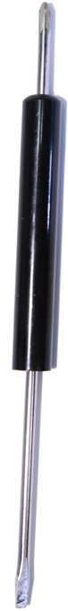
- What is this?
  - Pliers
  - Scissors
  - Wire Stripper
  - Screwdriver
  - Crimper
  - Multimeter

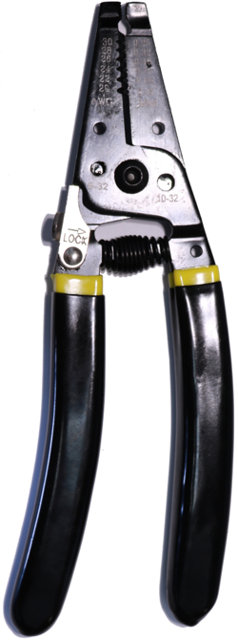
- What is this?
  - Pliers
  - Scissors
  - Wire Stripper
  - Screwdriver
  - Crimper
  - Multimeter

- What are the colors of a 220Ω resistor?
  - Red, Red, Brown
  - Blue, Red, Red
  - Yellow, Violet, Brown
  - Brown, Black, Red
  - Orange, Red, Brown
  - Brown, Black, Orange

- What are the colors of a 470Ω resistor?
  - Red, Red, Brown
  - Blue, Red, Red
  - Yellow, Violet, Brown
  - Brown, Black, Red
  - Orange, Red, Brown
  - Brown, Black, Orange

- What are the colors of a 1000Ω resistor?
  - Red, Red, Brown
  - Blue, Red, Red
  - Yellow, Violet, Brown
  - Brown, Black, Red
  - Orange, Red, Brown
  - Brown, Black, Orange

- What are the colors of a 10000Ω resistor?
  - Red, Red, Brown
  - Blue, Red, Red
  - Yellow, Violet, Brown
  - Brown, Black, Red
  - Orange, Red, Brown
  - Brown, Black, Orange

- An RGB LED has 3 prongs.
  - True
  - False

- An RGB LED has 2 prongs.
  - True
  - False
- An RGB LED has 4 prongs.
  - True
  - False

- Which component(s) was/were not included in your kit? (Circle all that apply)
  - Potentiometer
  - Transistor
  - 1 μF Capacitor
  - Relay
  - 550 Ω Resistor
  - RGB LED

- The kit came with green, red, and yellow LEDs.
  - True
  - False

- The kit came with green, red, yellow, and white LEDs.
  - True
  - False

- Are columns on the breadboard numbered or lettered? (Circle one)

- Are rows on the breadboard numbered or lettered? (Circle one)

- How many columns are on the breadboard?
  - 20
  - 40
  - 36
  - 30
  - 45
  - 25

- How many rows are on the breadboard?
  - 5
  - 6
  - 7
  - 8
  - 9
  - 10

- What is the estimated price of the whole kit?
  - $50
  - $75
  - $80
  - $100
  - $110
  - $150

- Which component(s) was/were included in your kit? (Circle all that apply)
  - Heater
  - Motor
  - Multimeter
  - Precision cutter
  - Power Source
  - All of the above

- How many resistors came in your kit?
  - 20
  - 35
  - 10
  - 15
  - 25
  - 30

- How many capacitors came in your kit?
  - 2
  - 4
  - 3
  - 5
  - 1
  - 6

- Match the names of the components with their respective pictures
  - Potentiometer
  - Slide switch
  - Push-button switch
  - Inductor
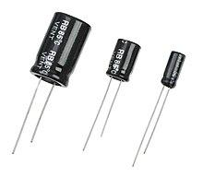
  - Photoresistor
  - Transistor
  - Thermistor
  - Relay
  - Diode
  - Capacitor
  - Resistor
  - LED
  - RGB LED

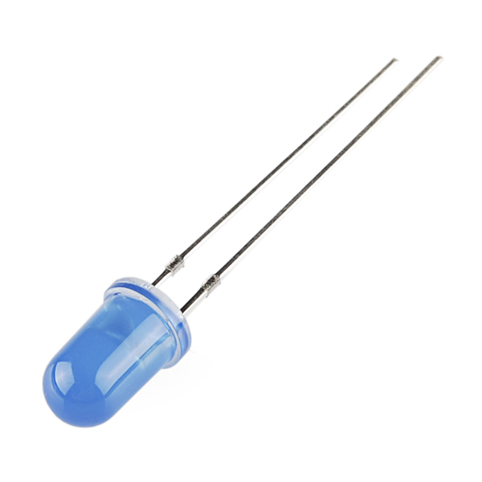
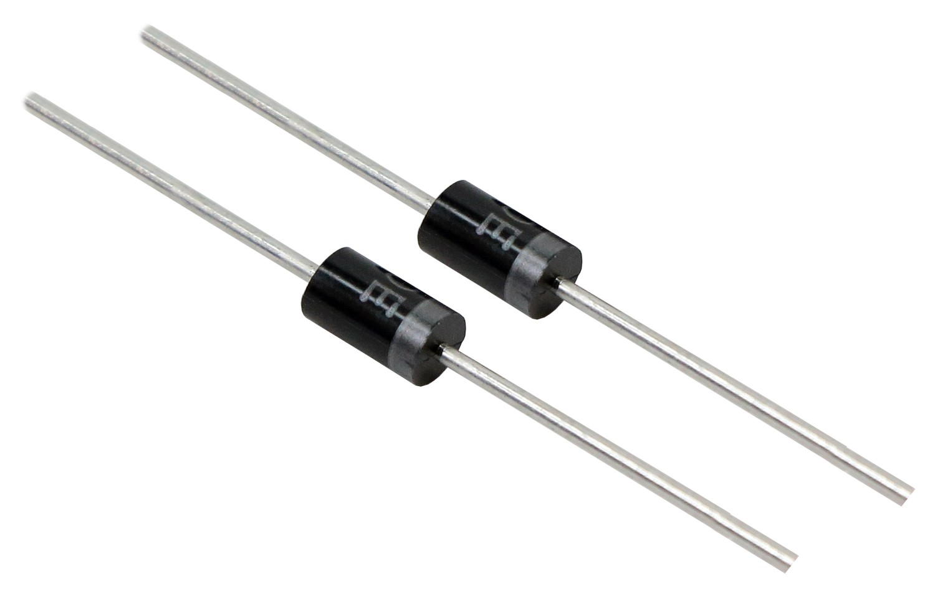

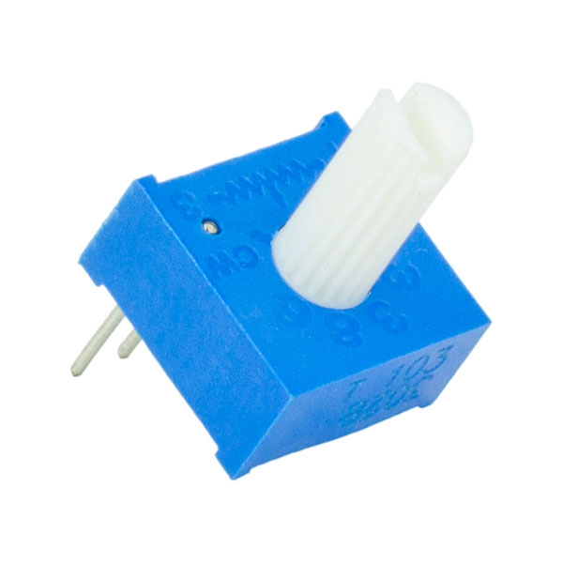
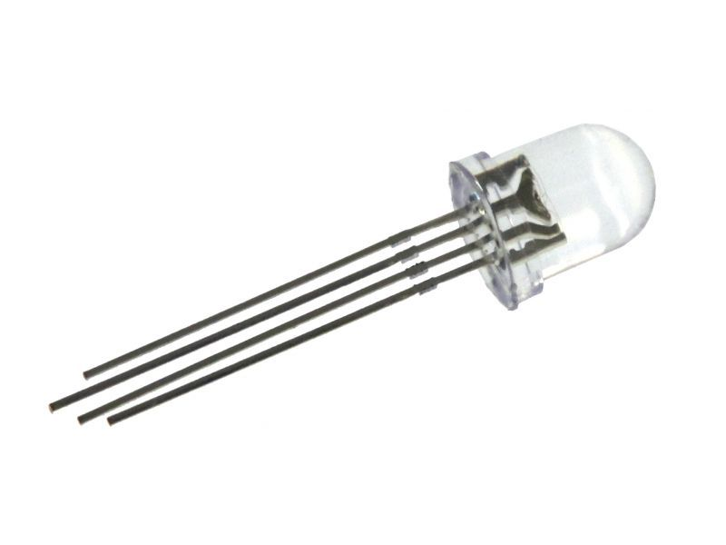
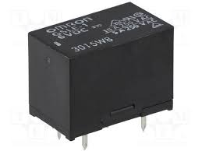
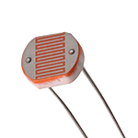

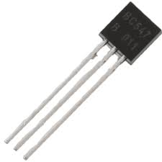
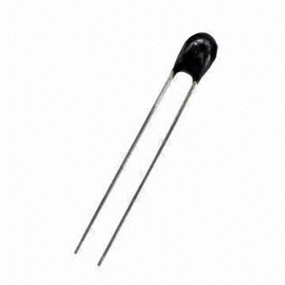
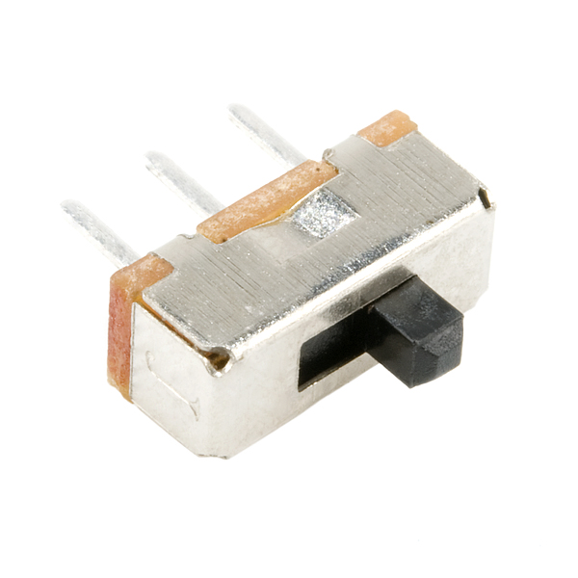
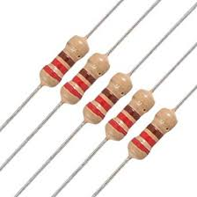

- What is electricity?
  - The flow of electric charge
  - The potential difference between the strength of the electron supply and the electron shortage
  - A measure of a material’s opposition to the passage of electric current.
  - The supply of mechanical or electrical energy
  - The measure of work
  - The total amount of resistance

- Electricity moves best through which material?
  - Silicon
  - Plastic
  - Glass
  - Rubber
  - Aluminum
  - Cotton

- Electricity is prohibited from flowing easily in which kind of material?
  - Conductors
  - Inductors
  - Semiconductors
  - Transistors
  - Insulators
  - Diodes

- Electricity can easily flow in which kind of material?
  - Conductors
  - Inductors
  - Semiconductors
  - Transistors
  - Insulators
  - Diodes

- Electricity can flow easily under certain conditions in which kind of material?
  - Conductors
  - Inductors
  - Semiconductors
  - Transistors
  - Insulators
  - Diodes

- How many valence electrons does copper have?
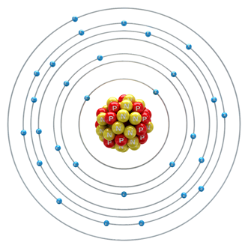
  - 1
  - 2
  - 3
  - 4
  - 6
  - 11

- What is always true about conductive materials?
  - They have a lot of valence electrons
  - They have few valence electrons
  - They are shiny
  - They are dull
  - They produce light
  - They produce heat

- How do electrons move?
  - From the positive terminal to the negative terminal of the battery
  - From voltage shortage to supply
  - From the right to the left
  - From the left to the right
  - From the negative terminal to the positive terminal of the battery
  - From east to west

- Electrons travel from the___________to the____________.
  - Shortage, supply
  - High, low
  - Low, high
  - Digital, analog
  - Supply, shortage
  - Analog, digital

- Conventional current travels from________to________.
  - High, low
  - Low, high
  - Negative, positive
  - Positive, negative
  - Electron, proton
  - None of the above

- Electrical resistance is best described as:
  - The potential difference between the strength of the electron supply and the electron shortage
  - The sum of the electron supply and shortage
  - The net flow of electrons
  - The measure of a material’s opposition of electric current
  - The measure of a material’s strength of electric current
  - None of the above

- Voltage is best described as:
  - The potential difference between the strength of the electron supply and the electron shortage
  - The sum of the electron supply and shortage
  - The net flow of electrons
  - The measure of a material’s opposition of electric current
  - The measure of a material’ s assistance of electric current
  - None of the above

- ____________is the measure of how badly electrons want to cover a distance.
  - Current
  - Voltage
  - Torque
  - Resistance
  - Work
  - Capacitance

- Why do some materials conduct better than others?
  - They are stronger
  - They are shiny
  - They are heavier
  - They do not have any free electrons
  - They do not have any electrons
  - None of the above

- Which of the following is an insulator?
  - Copper
  - Plastic
  - Gold
  - Aluminum
  - Silver
  - Salty water

- The conductivity of a material is based on the material’s_____________.
  - Weight
  - Density
  - Number of protons
  - Number of valence electrons
  - Number of electric dipoles
  - Atomic number

- Electrons can be best described as:
  - Positively charged particles
  - Neutral particles
  - Negative charged particles
  - Electric charged particles
  - Small particles
  - Large particles

- Which of the following is a semiconductor?
  - Diamond
  - Glass
  - Copper
  - Rubber
  - Transistor
  - Aluminum

- A material with eight valence electrons would work best as a(n):
  - Conductor
  - Resistor
  - Power source
  - Semiconductor
  - Insulator
  - LED

- The path taken by an electron can be best described as:
  - Straight
  - Curved
  - Scattered
  - Diagonal
  - horizontal
  - None of the above

- The potential difference between the strength of the electron supply and the electron shortage is the:
  - Current
  - Voltage
  - Temperature
  - Torque
  - Equivalent Resistance
  - Breadboard

- _____________ is the potential difference between the strength of the electron supply an electron shortage.
  - Current
  - Voltage
  - Temperature
  - Torque
  - Equivalent Resistance
  - Breadboard

- What does AC stand for?
  - Air Conditioning
  - At Current
  - Alternating Current
  - Alternating Condition
  - Air Current
  - At Condition

- What does DC stand for?
  - Dead Current
  - Direct Condition
  - Direct Current
  - Danish Cuisine
  - Dead Condition
  - Depended Current

- What is the voltage of a standard US power outlet?
  - 90V
  - 100V
  - 110V
  - 120V
  - 130V
  - 140V

- AA batteries produce how many volts?
  - .5V
  - 1V
  - 1.5V
  - 2V
  - 2.5V
  - 3Vcolumns

- What do you call the columns on the breadboard that are used to provide voltage for multiple circuits built on the board?
  - Power bus
  - Bus Stop
  - Power Strip
  - Bus Strip
  - Power Line
  - Voltage Line

- What setting do you use to measure the voltage coming from your Arduino on your breadboard?
  - DCmA
  - DC10A
  - DCV
  - ACV
  - ACmA
  - Battery Load Test

- What is the main difference between the multimeter pinchers and probes?
  - They are different colors
  - They plug into different ports
  - They are different lengths
  - You must hold probes with your hands
  - They are made of different materials
  - There are the same

- You must hold the multimeter probes with your hands.
  - True
  - False

- The standard voltage of an AA battery is 3V.
  - True
  - False

- The voltage of a US power outlet is 120V.
  - True
  - False

- The ___________ connects the battery to the Arduino.
  - Headphone Jack
  - Barrel Jack
  - Colby Jack
  - Car-Jack
  - Alternate Jack
  - USB Cable

- You use the ACV setting on your multimeter to measure the voltage coming from your Arduino to your breadboard.
  - True
  - False

- Outside of the bus strip, the rows are connected but not the columns.
  - True
  - False

