Section 3 Questions

- What is power?
  - work performed per unit coulomb
  - resistance to change
  - work performed per unit time
  - how much force you can apply on an object
  - work done over a net distance
  - None of the above

- Is there a relationship with units that will give us power? If so, what is it?

P = I * V or Power = Current * Voltage

- Arlo does 1500 J of work in climbing a set of stairs. If he does the work in 5 seconds, what is his power output?

P = W/t = 1500J / 5 seconds = 300 Watts

- A crane lifts a load of steel, that weighs 570 N, a distance of 120 m. It takes 6 minutes to complete the task. How much work is done by the crane? How much power does the crane produce?
  - Work = 58500 W Power = 670 J
  - Work = 68400 W Power = 190 J
  - Work = 48800 W Power = 400 J
  - Work = 58500 J Power = 670 W
  - Work = 68400 J Power = 190 W
  - Work =48800 Power = 400 J

W = F * d = 570N * 120m = 68400 J
P = W / t = 68400J / 360 seconds = 190 W

- If a D-Cell battery (1.5V) supplies 6W of power to a small bulb, find:
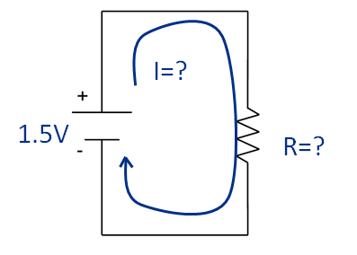
  - The current through the bulb

P = I * V => I = P / V = 6W / 1.5V = 4 A or 4 Amps

  - The resistance of the bulb

V = I * R => R = V / I = 1.5V / 4A = 0.375 Ω

- The unit of electrical current is an Amp. The basic units which define an Amp are:
  - meter^3 /second
  - Joule/coulomb
  - Joule/second
  - Electrons/meter^3
  - Electrons/ohm
  - Coulomb/second
  - Electrons/bushel

- The unit of voltage is a Volt. The basic units which define a Volt are:
  - meter^3 /second
  - Joule/coulomb
  - Joule/second
  - Electrons/meter^3
  - Electrons/ohm
  - Coulomb/second
  - Electrons/bushel

- A light bulb is powered using an AA battery (1.5 V) which has a current of 56.8 mA. The battery lasts for 150 hours before the light bulb ceases to emit light. What is the resistance of the light bulb?
  - 0. 1129Ω
  - 8.124Ω
  - 17.687Ω
  - 220Ω
  - 56.97Ω
  - 26.408Ω

V = I * R => R = V / I = 1.5V / .0568A = 26.408 Ω

- Rewrite the power equation to have R instead of V.

V = I * R P= I * V = I^2 * R

- Write the Power equation without the use of current.

V = I * R => I = V / R P = I * V = V^2 / R

- Ohm's law is the relationship between voltage, current, and resistance in an electrical circuit.
  - True
  - False

- Ohm’s law is represented by V = I * R.
  - True
  - False

- Ohm’s law is represented by V = I^2 * R.
  - True
  - False

- Ohm’s law is the relationship between voltage and resistance in an electrical circuit.
  - True
  - False

- A toaster oven is plugged into an outlet that provides 150 V. What power does the oven use if the current is 25A?
  - 2500 W
  - 2580 W
  - 3000 W
  - 3460 W
  - 3730 W
  - 4000 W

P = I * V = 25A * 150V = 3750 W

- Charlett’s laptop consumes 47 Watts of electricity. How much voltage is used, if the current is 22A?
  - 0.245 V
  - 0.788 V
  - 1.567 V
  - 2.136 V
  - 2.789 V
  - 3.241 V

P = I * V => V = P / I = 47W / 22A = 2.136 V

- A calculator uses a 7V battery and draws 0.1A current. How much power does it use?
  - .7W
  - .8W
  - 1.76W
  - 2.57W
  - 2.77W
  - 3.14W

P = I * V = 0.1A * 7V = .7 W

