Circle the letter of the correct answer.

- What are the colored bands on a 470Ω resistor?
- Red, Red, Brown
- Blue, Red, Red
- Yellow, Violet, Brown
- Brown, Black, Red
- Orange, Red, Brown

- What is electricity?
  - The flow of electric charge
  - The potential difference between the strength of the electron supply and the electron shortage
  - A measure of a material’s opposition to the passage of electric current.
  - The supply of mechanical or electrical energy
  - The measure of work

- Electricity moves best through which material?
- Silicon
- Plastic
- Glass
- Rubber
- Aluminum

- Electricity is prohibited from flowing easily in which kind of material?
- Conductors
- Semiconductors
- Transistors
- Insulators
- Diodes

- Electricity can easily flow in which kind of material?
  - Conductors
  - Inductors
  - Semiconductors
  - Transistors
  - Insulators

- Electricity can flow easily under certain conditions in which kind of material?
  - Conductors
  - Inductors
  - Semiconductors
  - Transistors
  - Insulators

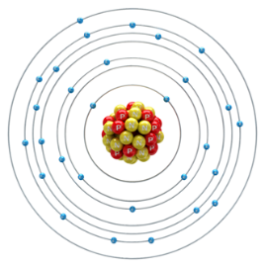
- How many valence electrons does copper have?
  - 1
  - 2
  - 3
  - 4
  - 6

- What is always true about conductive materials?
  - They have a lot of valence electrons
  - They have few valence electrons
  - They are shiny
  - They produce heat

- How do electrons move?
  - From the positive terminal to the negative terminal of the battery
  - From voltage shortage to supply
  - From the left to the right
  - From the negative terminal to the positive terminal of the battery

- Conventional current travels from________to________.
- High, low
- Negative, positive
- Positive, negative
- Electron, proton

- Electrical resistance is best described as:
- The sum of the electron supply and shortage
- The net flow of electrons
- The measure of a material’s opposition of electric current
- The measure of a material’s strength of electric current

- Voltage is best described as:
- The potential difference between the strength of the electron supply and the electron shortage
- The sum of the electron supply and shortage
- The net flow of electrons
- The measure of a material’s opposition of electric current

- The potential difference between the strength of the electron supply and the electron shortage is the:
- Current
- Voltage
- Temperature
- Equivalent Resistance

- What are the units for electric current:
  - Coulomb
  - Amperes
  - Coulomb per second
  - Joules
  - Ohms
  - b and c

- The electric current, I, is the amount of charge passing a point per unit time.
  - True
  - False

- Ohm’s Law relates_____________, ____________, and _____________ to each other.
  - Voltage, current, resistance
  - Voltage, current, power
  - Voltage, resistance, power
  - Current, resistance, power
  - Current, energy, power

- Given the following circuit, what is the voltage of the power source?
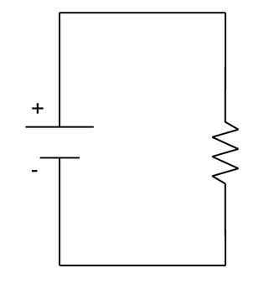
Given:
I= 0.06A
R= 470Ω
  - 78.33V
  - 28.2V
  - 12.766V
  - 7.833V
  - 6V
  - 1V

- What is power?
  - work performed per unit coulomb
  - resistance to change
  - work performed per unit time
  - how much force you can apply on an object
  - work done over a net distance
  - None of the above

- Arlo does 1500 J of work in climbing a set of stairs. If he does the work in 5 seconds, what is his power output?

- A crane lifts a load of steel, that weighs 570 N, a distance of 120 m. It takes 6 minutes to complete the task. How much work is done by the crane? How much power does the crane produce?
  - Work = 58500 W Power = 670 J
  - Work = 68400 W Power = 190 J
  - Work = 48800 W Power = 400 J
  - Work = 58500 J Power = 670 W
  - Work = 68400 J Power = 190 W
  - Work =48800 Power = 400 J

- If a D-Cell battery (1.5V) supplies 6W of power to a small bulb, find:
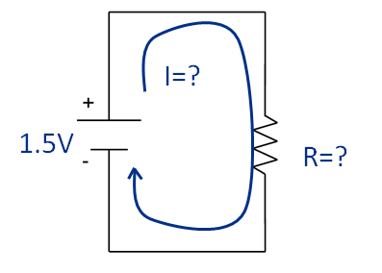
  - The current through the bulb

P = I * V => I = P / V = 6W / 1.5V = 4 A or 4 Amps

  - The resistance of the bulb

V = I * R => R = V / I = 1.5V / 4A = 0.375 Ω

- A light bulb is powered using an AA battery (1.5 V) which has a current of 56.8 mA. The battery lasts for 150 hours before the light bulb ceases to emit light. What is the resistance of the light bulb?

V = I * R => R = V / I = 1.5V / .0568A = 26.408 Ω

- A toaster oven is plugged into an outlet that provides 150 V. What power does the oven use if the current is 25A?

P = I * V = 25A * 150V = 3750 W

- Charlett’s laptop consumes 47 Watts of electricity. How much voltage is used, if the current is 22A?

P = I * V => V = P / I = 47W / 22A = 2.136 V

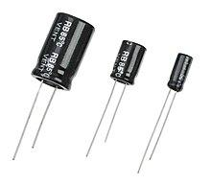
- Match the names of the components with their respective pictures. Write the matching letter on each picture.
D
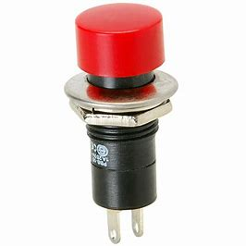
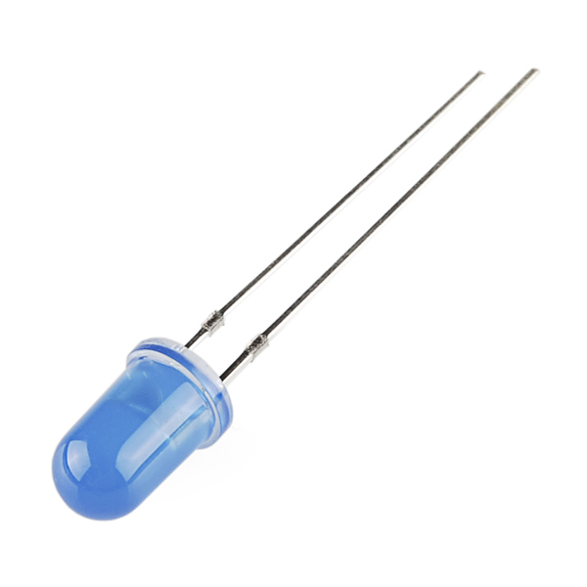
- Potentiometer
J
- Slide switch
C
L
- Push-button switch
- Inductor
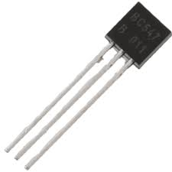
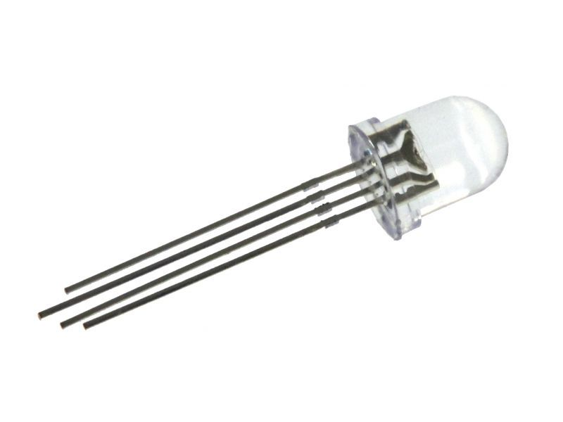
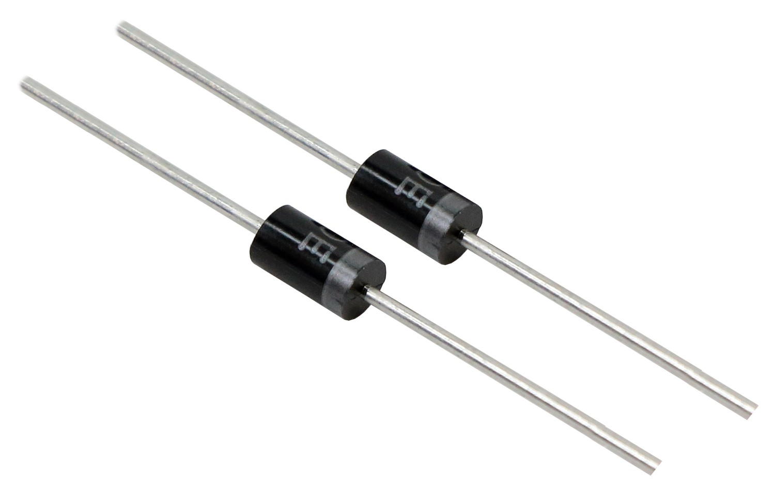
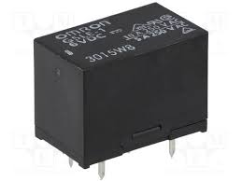
- Photoresistor
- Transistor
I
H
- Thermistor
M
F
- Relay
- Diode
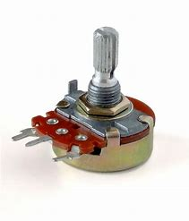
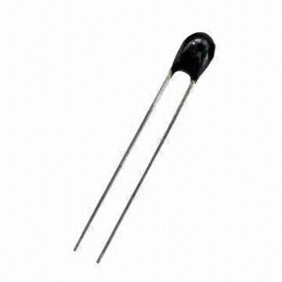
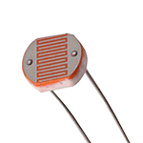
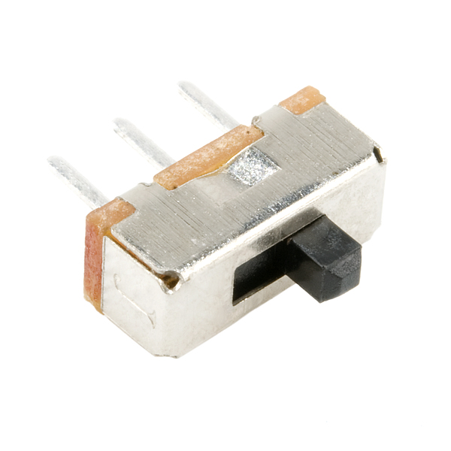
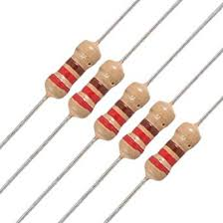
- Capacitor
G
- Resistor
E
- LED
A
- RGB LED
K
B

