Circle the letter of the correct answer.

- If five resistors are in series, how is the equivalent resistance calculated?
- By adding the inverse of the resistance
- By adding all five resistors together
- By adding a fraction of each resistor
- By multiplying all five resistors together
- By multiplying each resistor by the current and then dividing them by the voltage
- None of the above

- The current entering a node equals the sum of current leaving the node.
True
False
- According to Kirchhoff's Voltage Law the algebraic ______ of voltages around any _______ _______ in a circuit is _______.

  - Product, open loop, one
  - Sum, open loop, zero
  - Difference, open loop, one
  - Product, closed loop, zero
  - Sum, closed loop, zero
  - Difference, closed loop, zero

- The multimeter becomes part of the circuit when measuring:
  - Voltage
  - Power
  - Current
  - Equivalent resistance
  - All of the above
  - None of the above

- What is the equivalent resistance of the circuit below?
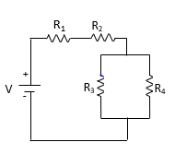
- 890Ω
Given:
R₁= 470Ω
R₂= 220Ω
R₃=100Ω
R₄= 100Ω
- 740Ω
- 710Ω
- 690Ω
- 50Ω
- 38Ω

- What is the value of a yellow, violet, brown resistor? (circle one)
470Ω 220Ω 560Ω 1000Ω 700Ω 630Ω

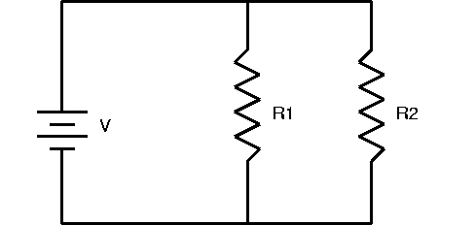
- Is the circuit below in series, parallel, neither, or both?

- Series
- Parallel
- Neither
- Both

- In the following circuit, what is the voltage drop across the 220Ω resistor?
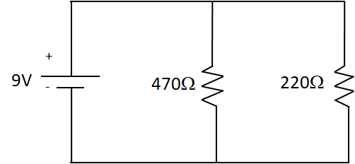
- 2.87V
- 3.00V
- 4.23V
- 5.12V
- 9.00V
- 13.21V

- In the following circuit, what is the voltage drop across the 470Ω resistor.
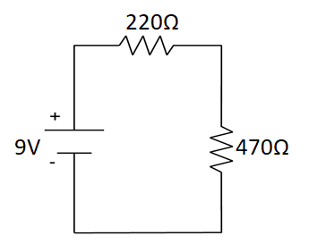
- 2.87V
- 3.00V
- 4.21V
- 6.13V
- 9.00V
- 13.21V

- What is the equivalent resistance of the circuit below?

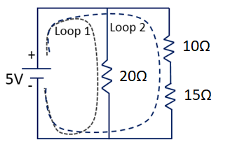
- 5.03Ω
- 10.43Ω
- 11.11Ω
- 20Ω
- 25Ω
- 45Ω

In this circuit, find the following: (Round each answer to 1 decimal place.)
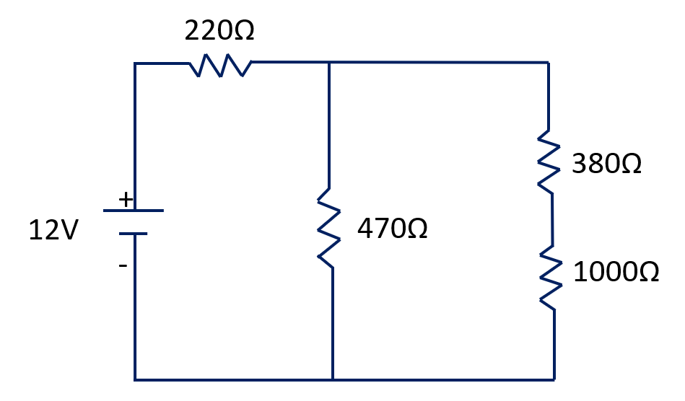
- Find the equivalent resistance.

570.6 Ω

- Find the source current. (in mA)

21.0 mA

- Find the voltage drop across the 220Ω resistor.

4.62V

- Find the current in the 470Ω resistor. (in mA).

15.7 mA

- Use KCL to find the current through the 380Ω resistor.

5.3 mA

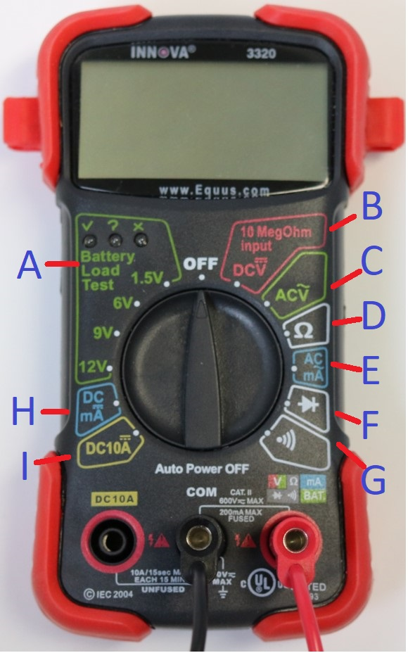
For questions 16-22 use the image shown. Circle the correct letter.

- What setting, on a multimeter, do you measure DC volts?

A B C D E F G H I

- What setting, on a multimeter, do you use to measure AC volts?

A B C D E F G H I
- What setting, on a multimeter, do you use to measure resistance?
A B C D E F G H I

- What setting, on a multimeter, do you use to test continuity between two points?

A B C D E F G H I

- What setting, on a multimeter, do you use to measure DC current in mA (0-200mA)?

A B C D E F G H I

- What setting, on a multimeter, do you use to measure DC current in MA (0-10A)?

A B C D E F G H I

- What setting, on a multimeter, do you use to measure AC current in mA 0-200mA?

A B C D E F G H I

