- _________ are programmed to read inputs and perform various tasks.
  - Transistors
  - Potentiometers
  - Microcontrollers
  - Resistors
  - Breadboards
  - USB ports

- The _________ prints out information from the Arduino onto the computer screen.
  - Tab control
  - Upload button
  - Verify button
  - Serial monitor
  - Message area
  - Text editor

- _________ functions in a program (sketch) only run once.
  - Void
  - Loop
  - Setup
  - Serial
  - Output
  - Input

- ________ functions run indefinitely.
  - Void
  - Loop
  - Setup
  - Serial
  - Output
  - Input

- In what units are Delays written in?
  - Microseconds
  - Milliseconds
  - Seconds
  - Minutes
  - Hours
  - Days

- You must have both the setup function and the loop function in your sketch in order for it to work even if you do not have any code written in one of them.
  - True
  - False

- The serial monitor can be used for:
  - Troubleshooting purposes
  - Monitoring the status of something in your sketch
  - Getting feedback or data
  - Communicating with another Arduino
  - a, b, and c
  - None of the above

- Where can you put the print statement to make the text appear only once on the serial monitor?
  - Loop function
  - Setup function
  - Input section
  - Output section
  - Serial monitor
  - None of the above

- An int represents an integer that ranges from:
  - -1 to 1
  - -1023 to 1023
  - -32768 to 32767
  - -43256 to 43256
  - -50000 to 50000
  - -1000000 to 1000000

- What value should be put into the delay function to make an LED turn on for 1 second?
  - 1
  - 100
  - 1000
  - 10000

- When implementing a for loop, what does the statement “ for(int i=100; i>20; i--) ” do?
  - Increment i by one each time (0,1,2,3,4)
  - Decrement i by one each time (100,99,98,...,22,21)
  - Increment i by 2 each time (0,2,4,6,...,76,78)
  - Decrement i by 5 each time (50,45,40,35,...,5,0)
  - Multiply i by 1.5 each time (2,3,4,6,9,13, 19, 28,42, 63, 94)
  - None of the above

- What does the “ for(int i=0; i<80; i+=2) ” do?
  - Increment i by one each time (0,1,2,3,4)
  - Decrement i by one each time (100,99,98,...,22,21)
  - Increment i by 2 each time (0,2,4,6,...,76,78)
  - Decrement i by 5 each time (50,45,40,35,...,5,0)
  - Multiply i by 1.5 each time (2,3,4,6,9,13, 19, 28,42, 63, 94)
  - None of the above

- A ________ switch contains a basic on/off function which holds the state that the switch is set to.
  - Momentary
  - Maintained
  - McCarthy
  - Monotonous
  - Micro
  - Mixed

- The sketch below is supposed to be used to blink an LED, why is it not working?
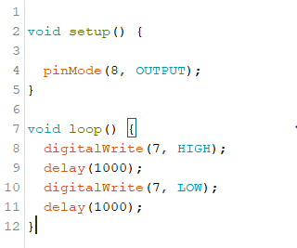

  - The pinMode (line 4) should be in the void loop
  - digitalWrite should be changed to analogWrite in line 8
  - The digitalWrite in line 7 should be HIGH
  - The pinMode (line 4) should be changed to 7 instead of 8
  - The pinMode (line 4) should be changed to an input instead of an output
  - Nothing is wrong with this sketch

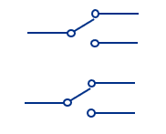
- What type of switch is pictured below?
  - SPST
  - DPST
  - SPDT
  - DPDT
  - All of the above
  - None of the above

- A form of programming PLCs that uses a schematic representation of components connected between power and ground lines/busses is called___________.
  - Block Diagram
  - Ladder Logic
  - Instruction List
  - Structured Text
  - Sequential Function Chart

- The schematic shown depicts a resistor in series with a ________________.
  - photoresistor
220Ω
  - light emitting diode
  - potentiometer
  - thermistor
  - inductor

- What type of switch is pictured below?
  - SPST
  - DPST
  - SPDT
  - DPDT
  - All of the above
  - None of the above

- What type of switch is pictured below?
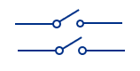
  - SPST
  - DPST
  - SPDT
  - DPDT
  - All of the above
  - None of the above

- The momentary switch schematic shown indicates that this switch is a
  - Normally Open Push Button
  - Normally Closed Push Button
  - Normally Open Toggle
  - Normally Closed Toggle

- A capacitor is placed in parallel with a switch to
  - Hold the switch output constant
  - Protect the switch from burning out
  - Minimize the effects switch bouncing
  - All of the above
  - None of the above

- A Wheatstone bridge is used to
  - Provide a constant voltage to a circuit
  - Provide a constant current source
  - Accurately measure changes in the resistance of a component
  - Connect two circuits together in parallel
  - Connect two power supplies together

- A ____________ resistance changes with temperature.
  - Photoresistor
  - Potentiometer
  - Thermistor
  - Capacitor
  - None of the above

- Industrial Programmable Logic Controller (PLC) based systems typically include the use of the following:
  - Ruggedized Computers / Microcontrollers
  - 6 VDC Power Supplies
  - Digital I/O Modules
  - Analog I/O Modules
  - All of the above
  - a, c, and d only

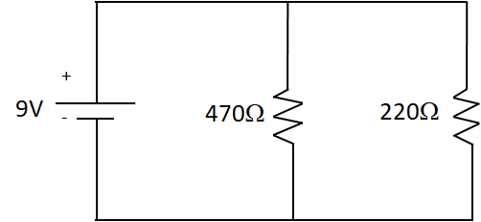
- Find the equivalent resistance (R_{eq}) and the current passing through the 470Ω resistor for this circuit. SHOW WORK.

I₄₇₀ =
R_{eq} =

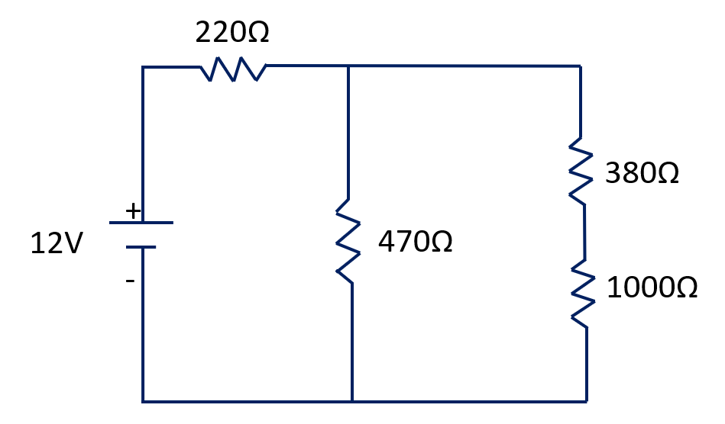
- Find the equivalent resistance (R_{eq}) and source current (I_{s}) for this circuit. SHOW WORK.

R_{eq} =
I_{s} =

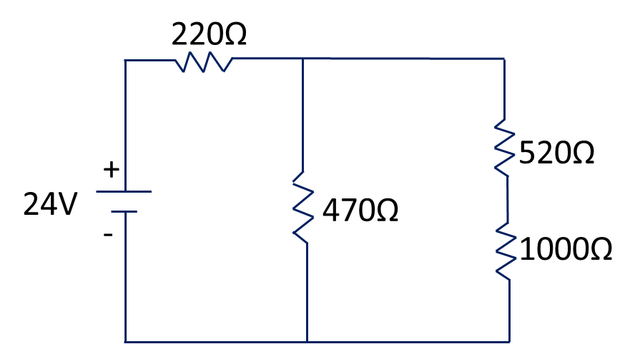

- Find the source current (I_{s}) and current in the 470Ω resistor for this circuit. SHOW WORK.

I₄₇₀ =
I_{s} =

Performance Task

Wire the following circuits on your breadboard.

5V
220Ω
digital pin 8
0.1uFΩ
470ΩΩ

