Circle the letter of the correct response(s).
- Excel Workbooks contain _________.
  - Documents
  - Folders
  - Portfolios
  - Envelopes
  - Spreadsheets
- The equation =A6/$B$6 uses___________________.
  - Relative referencing
  - Absolute referencing
  - Relative and absolute referencing
  - Total referencing and no referencing
  - Formulas and data
  - Total referencing
- The equation =C3/B12 uses______________.
  - Relative referencing
  - Absolute referencing
  - No referencing
  - Total referencing
  - Complete referencing
  - None of the above
- The “coefficient of determination,” more commonly referred to as r^2, will be used to determine the “goodness of the fit”.
  - True
  - False
- A _________ measures electrical resistance changes with temperature.
  - Breadboard
  - Resistor
  - Photoresistor
  - Thermistor
  - Potentiometer
  - Capacitor
- A ________ is a data type that allows for decimal values to be included in the sketch.
  - Boolean
  - Byte
  - Int
  - Long
  - Float
  - Char

- How many combinations can a 4-bit register represent?
  - 8
  - 10
  - 12
  - 14
  - 16
  - 18
- How do you incorporate a delay for 5 seconds?
  - delay(5);
  - delay(50);
  - delay(500);
  - delay(5000);
- What are the uses for comments when coding programs? (circle all that apply)
  - To explain what your code is doing
  - To print instruction onto the Serial monitor
  - To make your code readable for others
  - For you to look back on, to better understand your own code
  - To flex your superior knowledge
  - To comment out certain part of code to test isolated code for issues or improvements
- What two things do you need inside digitalWrite(____ ,____)?
  - Digital Pin #, Input/Output
  - Analog Pin #, Input/Output
  - Digital Pin #, HIGH/LOW
  - Analog Pin #, ON/OFF
  - Analog Pin #, HIGH/LOW
  - Analog Pin #, TRUE/FALSE
- A ___________ is a semiconductor device that can be used as an “electrical switch” or as an amplifier.
  - Resistor
  - Transistor
  - LED
  - Relay
  - Capacitor
  - Inductors
- Transistors can be used to have a small current control a larger current.
  - True
  - False
- In a _____________ relay, the contacts are closed when no current is passed through the coil and passing a current through the coil causes the contacts to open.
  - Normally open
  - Normally closed
  - Consistently open
  - Consistently closed
  - Mainly open
  - Mainly closed
- The amount of current that can pass through the contact leads without damaging the relay is called the:
  - Contact voltage
  - Coil voltage
  - Contact current
  - Coil current
  - Contact output
  - Contact coefficient
- Why are flyback diodes used in a circuit?
  - To go back through the circuit to create a larger current.
  - To stop the flow of electrons to fix an issue in the circuitry.
  - Relays will not work without them.
  - To help protect circuit elements.
  - Both b and c
  - None of the above
- General purpose diodes are designed to allow current to flow in one direction and block the flow of current in the opposite direction.
  - True
  - False
- A component that has the ability to store electrical charge is a/an:
  - Resistor
  - Inductor
  - Diode
  - Capacitor
  - Transistor
  - Switch

- Electric capacitance is measured in:
  - Ohms
  - Farads
  - Volts
  - Henrys
  - Flux
- The working voltage indicates the maximum allowable voltage that may be applied to the capacitor without damaging it.
  - True
  - False
- What factors affect capacitance in a parallel plate capacitor? (circle all that apply)
  - Plate area
  - Distance between plates
  - Dielectric material between plates
  - Applied voltage
  - Applied current
  - All of the above
  - None of the above
- The higher the dielectric constant, the more capacitance.
  - True
  - False
- In and RC circuit, as capacitance ___________, discharge time increases.
  - Decreases
  - Increases
  - Remains constant
- On a capacitor charge plot, once the voltage reaches ____% of the entire charged voltage, the amount of time that has elapsed is equal to the time constant.
  - 5.5%
  - 10.23%
  - 31.4%
  - 31.6%
  - 52.97%
  - 63.2%
- The value of a process variable (e.g. temperature, pressure, depth, rpm…) that a process control system attempts to maintain is called the setpoint.

Constructed Response
- What is the capacitance if 𝝉=2.4s and R= 1kΩ?
  - 0.0024μF
  - 2400μF
  - 2.4μF
  - 24μF
  - 0.24μF
  - 0.024μF
- Determine the amount of charge stored on either plate of a capacitor, 4.0 x 10^-6 F, when connected across an 18 volt battery.
C = q/v
4 x 10^-6 F = q / 18
q = 7.2 x 10^-5 C

- A parallel plate capacitor is constructed of metal plates, each with an area of .7 m^2. The capacitance is 9.876 nF (9.876 x 10 ^-9 F). Determine the plate separation distance, if teflon (permittivity of 2.1) is used as the dielectric.
C =( 8.854 x 10^-12 F/m) εA/ d
9.876 x 10^-9 F = (8.854 x 10^-12 F/m) ((2.1)(.7 m^2)) / d
D =.001318 m = 1.318 mm

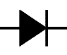
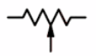
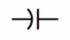
- Name the following components from their schematic symbols. Be specific:

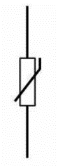
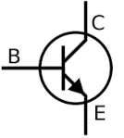
_________________________ _________________________ __________________________
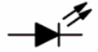

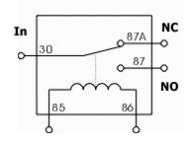
_________________________ _________________________ __________________________
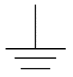
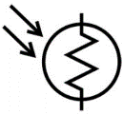

_________________________ _________________________ __________________________

Microsoft Excel Performance Task
Create a spreadsheet in Excel to do the following:
- 1st Column: List the following resistance values: 220, 380, 470, 550, 700, 1,000
- 2nd Column: Use a formula to compute the current through each resistor given a 9V power supply. (Use relative addressing).
- Place headings above each column in bold print.
- List the current value to 3 decimal places.
- Plot resistance versus current.
- Select a trendline option that is a best fit for the data.
- List the equation for the trendline and the r-squared value on the chart.
- Add a chart title and axis titles.
- Have Excel sum the resistance values at the bottom of the first column.
BONUS: Place the voltage value at the top of the spreadsheet (above the graph) and use absolute addressing to recompute the current values….so that you can change the voltage value at the top of the spreadsheet and have the spreadsheet automatically recompute the current and replot the graph.
Save the file and email to marvin.nelson@bossierschools.org.

Solution
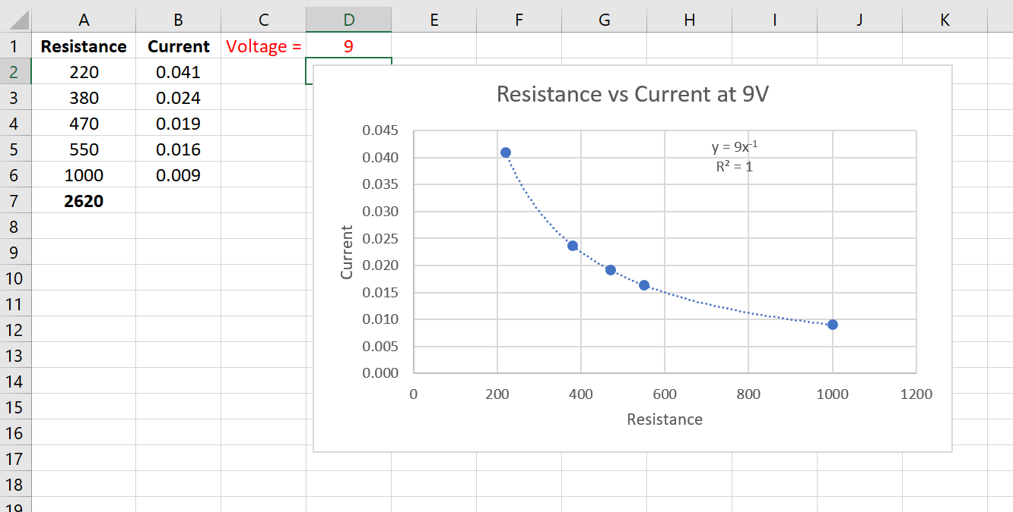

$C = \frac{q}{v}$ $C = \left(8.854×{10}^{-12}F/m\right)\frac{εA}{d}$ $τ=RC_{p}$

