Ref. | Unit 4 Concepts & Definitions | Terms, Notation, Formulas, Diagrams
 | In a Wheatstone Bridge, the circuit is said to be balanced when the output voltage is ______.
 | A variable resistor is also called a ________. | 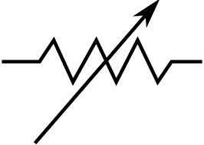
 | ____________ vary their resistance under different lighting conditions. | 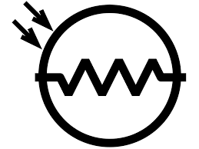
 | ______ systems represent information using a continuous range of values.
 | _______ systems represent data information using discrete (discontinuous) values; typically, high (1) or low (0).
 | _______ will return a value of HIGH (1) if the voltage at the digital input pin is greater than 3 volts or LOW (o) if the voltage is less than 2 volts.
 | The ______ function returns a value between 0 and 1023, where 0 is zero volts and 1023 is 5 volts.
 | A method of plotting a “line of best fit” (or trendline) to a set of data is called -
 | The _____, indicates the “goodness of the fit” of a line to a set of data. The closer to 1, the better the fit. The closer to 0, the worse the fit.
 | A _______ is used to measure temperature. As its temperature increases, its resistance decreases. | 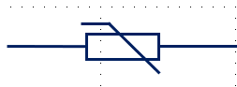
 | A ____________, using a thermistor, correlates analog values to temperature values.
 | Predefined ________ allow you to choose the best form for a variable
 | If you want to use decimals in your program, you need to use the _________ data type.
 | There are 8 bits in a -
 | Whole number, signed (+ or -), most common data type -

