Place correct letter in blanks on the right.
Letter
Using ______ an operator must visually monitor a process and make corrections as needed.
Process of utilizing instruments to measure and control process variables to manufacture products safely and efficiently.
Federal agency that enforces safety and health regulations.
The _______ develops measurement standards.
______ are parameters or quantities that we wish to measure and control at the correct limit.
The desired value of a process variable (e.g. fluid level). Value at which PV is maintained.
When the process variable deviates from the set point.
The amount of deviation from the set point.
The difference between the minimum and maximum values of a process variable.
The difference between the maximum and minimum values of a range
The ability of a sensor to provide the same result under the same conditions.
The smallest change in a variable that can be detected by a sensor.
The gradual change in a measurement over time when the process conditions are constant.
The degree to which a measured value matches the actual process value.
The milliamp signal (value) and the corresponding value of the process variable are _______ to one another.
The arrangement of instruments designed to measure and control a process.

- Accuracy
- Drift
- Error
- Industrial (Process) Instrumentation
- Instrument Loop
- Manual Control
- National Inst. of Standards and Technology
- Occupational Safety and Health Administration (OSHA)
- Process Upset
- Process Variables
- Proportional
- Range
- Repeatability
- Sensitivity
- Set Point
- Span

Place correct letter in blanks on the right.
The ______ is typically an electrical device (e.g. a level measuring instrument) that measures the process variable and converts the measurement into a value (electrical signal).
The ______ receives a signal from the primary element (PV), compares it to a set point, and sends a signal (corrective action) to the final element to keep the process variable at the set point.
In order to maintain (control) the process variable set point (e.g. the level in a tank), a _______ must be changed to control the final element (e.g. an actuator controlled valve).
Receives a signal from the control element and adjusts the manipulated variable in order to keep the process set point.
In ______, the final control element is either on or off depending on whether the process variable is above or below set point. (tends to overshoot or undershoot the set point)
In ______, the final control element changes proportionally to the amount of deviation from the setpoint. (more precise)
Ensures that the output of the transmitter is proportional to the Process Variable.
Lists instruments used by tag number.
Contain applicable codes, standards, wiring and cable requirements, ventilation requirements, power supply requirements, etc.
Provide information and requirements for proper mounting and connections of a specific instrument.
Identify where an instrument is to be installed.
Detailed drawing of equipment, piping, and instrumentation on a project.
Identify instrumentation location, function, and related instrument loop.
Identify location of instrument when the process is spread across multiple buildings or areas.

- Area Designation Numbers
- Calibration
- Control Element
- Final Element
- General Instrumentation Specifications
- Installation Detail Drawings
- Instrumentation Index
- Location Drawings
- Manipulated Variable
- On/Off Control
- Piping and Instrument Drawing (P&ID)
- Primary Element
- Proportional Control
- Tag Numbers

- Draw the P&ID symbol for a discrete, field mounted, instrument.

- Draw P&ID the symbol for a control valve.

- Draw P&ID the symbol for a ball valve.

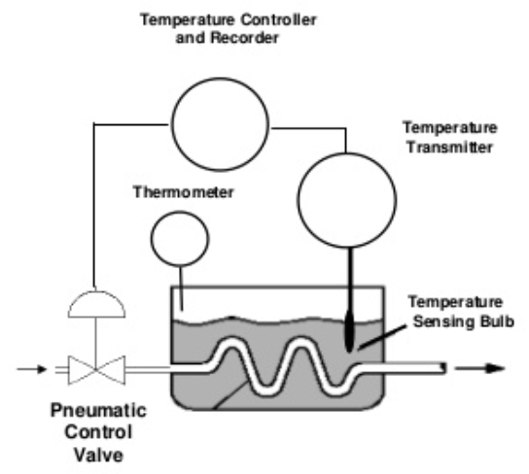
- In the control loop shown, steam is delivered through a pipe to maintain a desired temperature in the tank.
PLC
Temperature Sensor

  - Label the primary element, control element and final element.
  - What is a typical current range for signals in a control loop? _________________
  - Describe the manipulated variable under a proportional control scenario.

