LAB: THE ROLE OF DEVICES IN SYSTEMS

Electronic Devices

Student Name: ___________________________________________________

Acknowledgements
Subject Matter Expert: Dr John Robertson, Arizona State University, AZ

Purpose
Electronic devices provide the critical enabling technology for today’s advanced systems. Their performance and limitations depend on a long and complex chain of features that stretch from materials to system architectures. The purpose of this module is to demonstrate some of these features through reverse engineering.

Systems Rationale
The technology that goes into the design, production and testing of integrated circuits and circuit boards requires specialized tools and vast capital resources. These functions are increasingly the province of a few experts in specialized companies that serve the global market. However, the much larger number of people involved in implementing, maintaining and extending electronic systems need to understand what determines performance (and limitations) for troubleshooting and efficient operations.

System Concepts
This system covers the following system concepts (signified by an X):
_X_ S1. A system can be defined in terms of its functional blocks i.e., a “structured functional unit.”
_ _ S2. A system has a purpose, transforms inputs into outputs to achieve a goal.
_ _ S3. A system is defined by the flow of materials, energy and information, between its functional units.
_ _ S4. A system may be open or closed. In an open system additional inputs are accepted from the environment.
_X_ S5. A system is more than the sum of its parts. Individual components can never constitute a system.
_ _ S6. A system provides feedback to the operator and services to the user. Some system functions may involve operator action.
_X_ S7. Systems have unique problems.

Student Learning Outcomes
For a full course SLOs, click the link and click SLO tab.
http://www.esyst.org/Courses/DC-AC/_delivery/index.php

Prerequisite Knowledge & Skills
- Understanding of ac and dc circuit operation using R, L and C passive components.
- Energy generation, storage and dissipation in simple circuits.
- Measurement of voltage and current as a function of time.

Learning Objectives
Relevant knowledge (K), skill (S), or attitude (A) student learning outcomes include:
K1. Identify typical components on a complex circuit board.
K2. Recognize special functional features such as rf circuits and power management.
K3. Know and recognize the signal, power and ground lines with associated components.
S1. Classify IC functions, packages and board assembly techniques.
S2. Relate the behavior of a complex function to its block diagram and board layout.
S3. Use the skills to navigate the layout of a board that has not been seen before.
A1. Explain the outcomes for a non-expert.

Process Overview
Electronic components form the vital building blocks of all modern systems. Their capability to collect and process data for control and records provide the means to make the complex systems used to manage government, communications, manufacturing, transportation, finance and health care (to name only the major sectors of the economy). The variety of electronic functions that can be created is near infinite but they all share many common characteristics.

The purpose of this lab activity is to decompose a few typical small systems to the board level and then classify and analyze the common attributes of all boards. Once the most important signposts are known, the key features of any board can be more quickly recognized and used to support troubleshooting and more efficient applications.

Time Needed
Lab Performance:
It should take students approximately 4 hours to complete the practical teardown work and lab documentation.

Lab Deliverables:
It should take students approximately 3 hours to identify and classify the major components, and an additional 3 hours to write a report and about 1 hour to demonstrate their skills by navigating through the major feature of another student’s project.

Equipment & Supplies
Item | Quantity
A scrap electronics box with no energy source attached. | 1
A mechanical tool kit with the capability to undo (or drill out) specialized fasteners.

Special Safety Requirements
There should be no attached energy source so the main safety issues are concerned with springs and handling.

Lab Preparation
- Read the paper on systems in the Appendix.
- Form teams (if necessary) and select a box for teardown. Allocate roles.

Introduction
The electronics world has changed a lot in the last 30 years. Then, it was possible (and often necessary) to design circuits or replace components to suit individual applications. With hand soldering and relatively large components, this was a simple and effective process. Now, ICs and chip capacitors or resistors are placed on a board by robot arms, glued in place and then reflow soldered. This makes it impossible to repair damaged boards so the circuit board is now the lowest level part of a system that can be replaced.

There are two types of job now: those who make and assemble the components and circuit boards and those who use them in systems. The manufacturing process is expensive and highly automated so it is only economical for huge production runs. Wherever possible, production is aimed at world markets. These are good jobs but only available in a few localities and with a few companies.

By contrast, application of the circuit boards is a huge and diverse market that requires a good understanding of the underlying technology and the specific user needs. The right combination of electronic functions has to be selected. Boards have to be programmed or customized to fit the application and replaced if faulty. When there are problems, the user-related causes have to be disentangled from the underlying electronics module behaviors. Finally, systems are never static so new functions are continuously being added or the technology upgraded.

This is the new world of systems engineering and this lab activity is intended to provide an overview of what’s involved.

Task
Every electronic system fulfils different tasks. That can be a daunting prospect if you have to fix it or extend its functionality. However, they all have some common features and you will see some of them in this lab activity. It’s like navigating with a map. Once you know the features and conventions, you can quickly find your way around even if the territory is new to you.

The technique used is called reverse engineering. We take an existing design and literally tear it apart to see what’s inside. The process shows the typical mix of components, any special steps taken to handle unusual signals or power, how it has been manufactured and many of the complex design decisions that had to be made to balance performance, adaptability and cost.

Execution of Lab Activity
- As you look at the electronic box with your disassembly tools in hand, pause and think how you will record what you do. Even though the part is scrap and non-functional, treat it as if it were to be restored to its original condition. That means you have to document every activity as you progress. You can’t wind the clock back to see what you did and you certainly won’t remember. Even the smallest screw is important so prepare to write it all down. It usually helps to take photographs as you progress.
- The fun part comes next. Dismantle all the parts of the system. After the box, mechanical components and interface connectors have been removed, you are left with a complex circuit board.
- Review the pile of parts. Nothing is there by chance. Someone made a deliberate decision to make the system that way. What can you tell about the decisions that were made? Can you see any obvious reasons for these decisions - such as functionality, size or cost?
- Now examine the circuit board. Count, list and identify all the components on the board. Classify them by function, manufacturer, package type, assembly technique and country of origin.
- Look for special features such as the largest chip, memory, big heat sinks, rf shielding covers and any packages that might contain several chips in a sub-module. Can you identify the functions and why that layout was chosen (remember, nothing in a design occurs by whim or accident; there are reasons for every design outcome).
- Describe what you have deduced or learned. This is hard. However, reports are important. Yours could save someone else from doing all that work again.
- The most important skill you have acquired is that you can now find your way around a complex circuit board. Certainly, every board has a different function. They use different components and connections but in a sense, they are all the same. Once you have this familiarity, you will have the confidence to tackle new systems.
- Finally, prove what you have learned. Examine another student’s board and try to identify its main features.

Deliverable(s)
Your report is largely factual. Describe the components in your little system and any special features associated with them. What makes it difficult is that there are a lot of parts and you can organize the information you have collected in many ways. You also have to expect that you might not be able to find out what some components are or what function they perform. Even if you had a circuit diagram to view (which you probably don’t), you should expect some parts to resist identification. They may have lost their markings or have been damaged. It can be unsettling to work on a system you do not fully understand but that is pretty common. However, always make sure it is disconnected from any power source and safe to open.

If you have a choice, make a presentation rather than deliver a written report. With all the images you will have, a slide show is easier to prepare. However, a word of caution - photos make a file size large very quickly. Don’t use more resolution than you need. Conversion to pdf format can also reduce file size significantly.
Appendix: From Components to Systems

What is an electronic system?
The widespread use of complex electronic systems has driven major technology changes over the past 20 years. It could be considered as computer applications but that is only part of the story; there are many other essential functions involved. A modern system is about collecting, organizing and using information. The scale is vast. Consider a hospital, a factory, an airline or even a casino. Each has many functions that have to be available to many users so there is a big network for information flow. It becomes even more complex when we consider networks to cover the whole health-care system or a major company or the Army.

How do we design, build and maintain complex systems?
Complexity is managed by making the system modular. Each module has a specified function and is connected to all the others. Thus, connectivity for effective data flow becomes vital. Take the casino example. The electronic lock on each hotel room door and the user card for slot machines provide computer inputs. The complex interaction of many users can be reduced to typical behavior patterns that can then be optimized for revenue generation. The basic building blocks for any system all typically have the same block diagram:

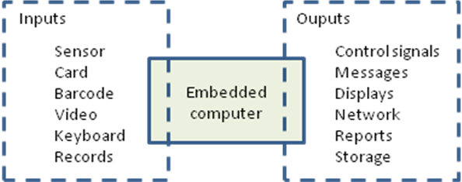

This mix of functions can be achieved on one board or through the interconnection of many. Since modern boards cannot easily be repaired, system assembly and repair is usually done by substitution. That’s easy in principle but only if the fault can be diagnosed correctly. That in turn means that the proper operation of any board has to be understood.

What’s on a board?
In the days of vacuum tubes, electronic components were large so they had to be secured individually to a rigid chassis. Free-standing wires and small components were added to make the required circuit connections. This mounting technique is still used for high power control and transmitting devices. With the advent of transistors and the early ICs in the 1970s, components were small enough to be carried on a printed circuit board. Usually, there was an etched copper track on one side only.

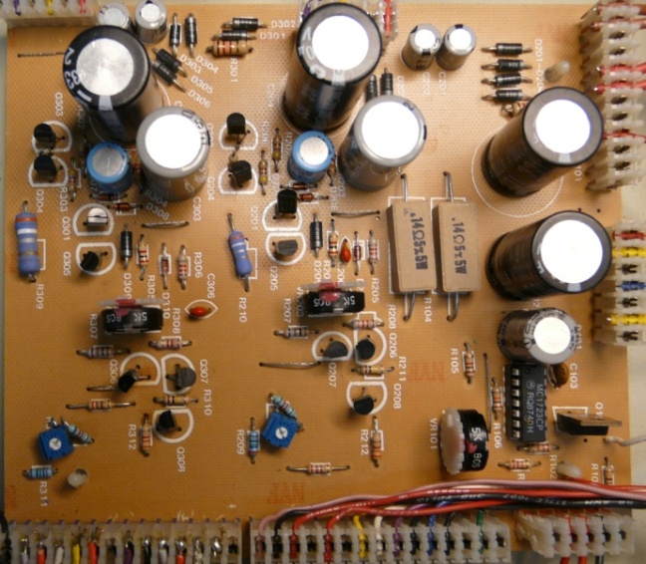

In the 1980s and 90s, the copper tracks were narrower, ICs became more powerful and multi-layer boards were introduced.

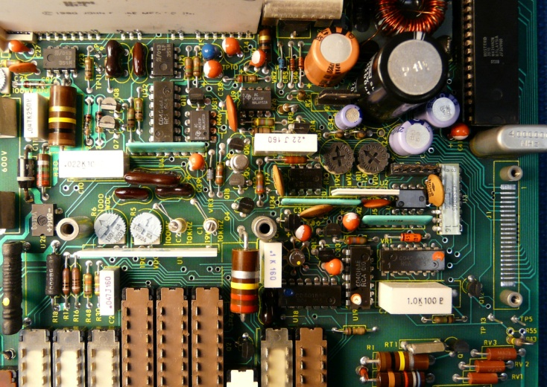

Although the overall packing density had increased, large capacitors and mechanical switches were still needed. ICs used edge connectors with 2.5 mm pitch and all components had connection wires inserted through holes in the board to be soldered to a copper trace on the opposite side. This process limited board capacity and it was difficult to introduce automated assembly since a misaligned pin regularly stopped the process.

The need to make large numbers of high performance personal computers and cell phones drove the next generation of board enhancements. Three parallel strategies were used:

- Make all functions digital. This allows more functional adaptation using software and many mechanical switches and bulky connectors can be avoided.
- Integrate all electronic functions on to the minimum number of integrated circuits. They are smaller, cheaper and more reliable than any alternatives and one common CPU chip today easily outperforms the leading supercomputer of 20 years ago. However, each IC requires some decoupling capacitors and perhaps line termination resistors. There are usually dozens of these components, each less than 1mm square.
- Use surface mount technology to locate components on both sides of an 8 – 20 layer circuit board. Pin pitch can be reduced to < 0.5 mm or to a ball grid array under the ICs. Assembly can be done by pick-and-place robots. This gives a great boost to the capability of each board but the price is that repairs are next to impossible.

An example of current technology is the Blackberry main board:

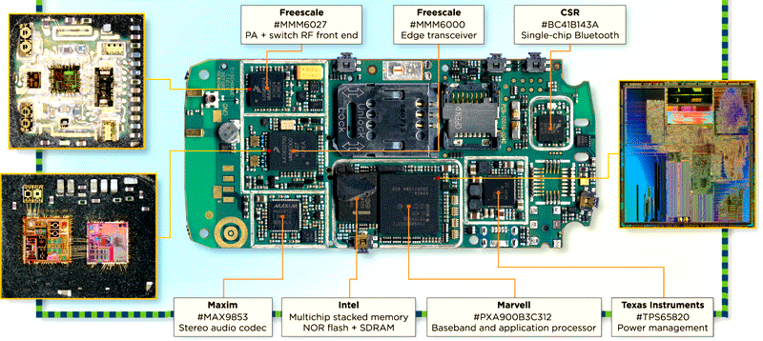
Source: Portelligent

When you tear down your box of electronics, these assembly techniques should be clearly visible to indicate the age of the technology. You may find combinations or old technology in new products. In these cases, look at the cost constraints for the product.

It is hard to estimate the number of different ICs that are currently available. A good guess is that it’s more than 200,000. That gives a very large number of combinations that can be found on assembled boards. The total number of IC packages sold per year is around 400 B. That means that the number of boards produced is probably between 10 and 100 B. There are therefore many varieties – but they all look superficially like the Blackberry example above.

What determines board size?
The application usually determines size, especially for portable devices such as cell phones. At the upper end, it is a matter of cost. Since boards cannot easily be repaired, the economic balance between reliability and replacement cost limits size.

