Control Panel Simulation Activity

The system layout:
- Red LED that is on and stays on when the system is not being used.
- Green LED that turns on and stays on when the system is being used.
- Yellow LED that simulates a function (like a crane moving large parts across the plant floor) moving) happening in the plant. The yellow LED should turn on only when a button at switch board is being pressed.
- On the control panel monitor (aka serial monitor) print:
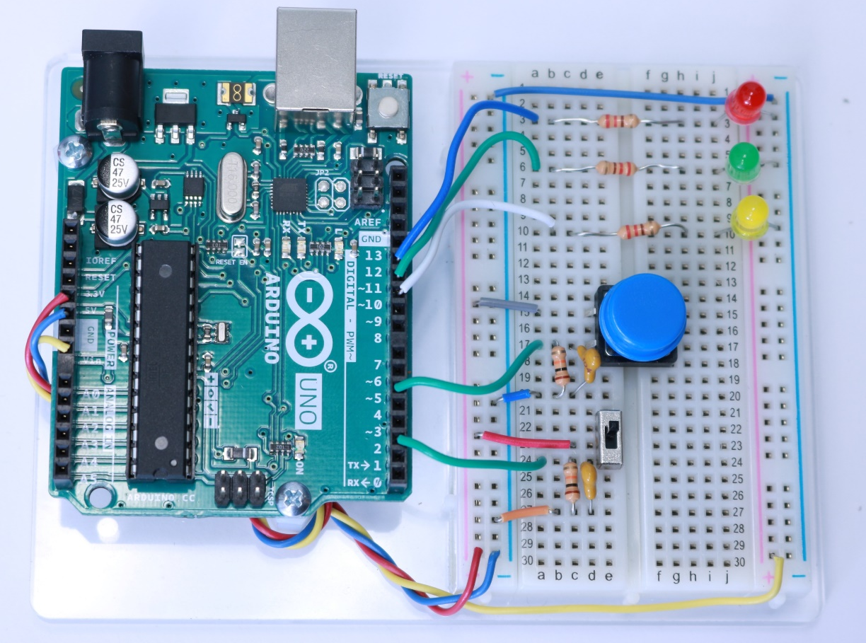
  - when the system turns on
  - when the function is happening
  - when the system turns off

int switch1;
int switch2;
void setup() {
Serial.begin(9600);
pinMode(2,INPUT);
pinMode(5,INPUT);
pinMode(12,OUTPUT);
pinMode(11,OUTPUT);
pinMode(10,OUTPUT);
}
void loop() {
switch1 = digitalRead(2);
switch2 = digitalRead(5);
Serial.print("switch1 = "); Serial.print(switch1);
Serial.print(" switch2 = "); Serial.print(switch2);
if (switch1==0){
Serial.println("The system is OFF");
digitalWrite(12, HIGH);
digitalWrite(11, LOW);
}
if (switch1==1){
Serial.println("The system is ON");
digitalWrite(12, LOW);
digitalWrite(11, HIGH);
}
if (switch2==1){
Serial.println("The function is in progress");
digitalWrite(10, HIGH);
}
if (switch2==0){
Serial.println("The function is NOT in progress");
digitalWrite(10, LOW);
}
}
int switch1; | Name 2 switches used in this program and set their values as integers
int switch2;
void setup() {
Serial.begin(9600);
pinMode(2,INPUT); | Set digital pins as INPUTs (to read switches) or OUTPUTs to read switches and light LEDs.
pinMode(5,INPUT);
pinMode(12,OUTPUT);
pinMode(11,OUTPUT);
pinMode(10,OUTPUT);
}
void loop() {
switch1 = digitalRead(2); | Read switches to determine their states (0 or 1).
switch2 = digitalRead(5);
Serial.print("switch1 = "); Serial.print(switch1); | Print states of switches to the Serial Monitor
Serial.print(" switch2 = "); Serial.print(switch2);
if (switch1==0){ | If switch1 is low (0), print system state (OFF) and turn on PIN 12 LED and turn off PIN 11 LED.
Serial.println("The system is OFF");
digitalWrite(12, HIGH);
digitalWrite(11, LOW);
}
if (switch1==1){ | If switch1 is high (1), print system state (ON) and turn off PIN 12 (Red) LED and turn on PIN 11 (Green) LED.
Serial.println("The system is ON");
digitalWrite(12, LOW);
digitalWrite(11, HIGH);
}
if (switch2==1){ | If switch2 is high (1), print system state (in progress) and turn on (Yellow) PIN 10 LED.
Serial.println("The function is in progress");
digitalWrite(10, HIGH);
}
if (switch2==0){ | If switch2 is low (0), print system state (in progress) and turn off (Yellow) PIN 10 LED.
Serial.println("The function is NOT in progress");
digitalWrite(10, LOW);
}
}

