MC / Fill-In-The-Blank (Circle Letters)
- _________ are programmed to read inputs and perform various tasks.
  - Transistors
  - Potentiometers
  - Microcontrollers
  - Resistors
  - Breadboards
  - USB ports

- The _________ prints out information from the Arduino onto the computer screen.
  - Tab control
  - Upload button
  - Verify button
  - Serial monitor
  - Message area
  - Text editor

- _________ functions in a program (sketch) only run once.
  - Void Loop
  - Void Setup
  - Serial
  - Output
  - Input

- ________ functions run indefinitely.
  - Void Loop
  - Void Setup
  - Serial
  - Output
  - Input

- In what units are Delays written in?
  - Microseconds
  - Milliseconds
  - Seconds
  - Minutes

- You must have both the setup function and the loop function in your sketch in order for it to work even if you do not have any code written in one of them.
  - True
  - False

- The serial monitor can be used for:
  - Troubleshooting purposes
  - Monitoring the status of something in your sketch
  - Getting feedback or data
  - Communicating with another Arduino
  - a, b, and c
  - None of the above

- Where can you put the print statement to make the text appear only once on the serial monitor?
  - Loop function
  - Setup function
  - Input section
  - Output section
  - Serial monitor
  - None of the above

- An int represents an integer that ranges from:
  - -1 to 1
  - -1023 to 1023
  - -32768 to 32767
  - -43256 to 43256
  - -50000 to 50000
  - -1000000 to 1000000

- What value should be put into the delay function to make an LED turn on for 1 second?
  - 1
  - 100
  - 1000
  - 10000

- When implementing a for loop, what does the statement “ for(int i=100; i>20; i--) ” do?
  - Increment i by one each time (0,1,2,3,4)
  - Decrement i by one each time (100,99,98,...,22,21)
  - Increment i by 2 each time (0,2,4,6,...,76,78)
  - Decrement i by 5 each time (50,45,40,35,...,5,0)
  - Multiply i by 1.5 each time (2,3,4,6,9,13, 19, 28,42, 63, 94)
  - None of the above

- What does the “ for(int i=0; i<80; i+=2) ” do?
  - Increment i by one each time (0,1,2,3,4)
  - Decrement i by one each time (100,99,98,...,22,21)
  - Increment i by 2 each time (0,2,4,6,...,76,78)
  - Decrement i by 5 each time (50,45,40,35,...,5,0)
  - Multiply i by 1.5 each time (2,3,4,6,9,13, 19, 28,42, 63, 94)
  - None of the above

- A ________ switch contains a basic on/off function which holds the state that the switch is set to.
  - Momentary
  - Maintained
  - Fixed
  - SPST
  - DPST
  - Universal

- Convert 75 to binary:

- The sketch below is supposed to be used to blink an LED, why is it not working?
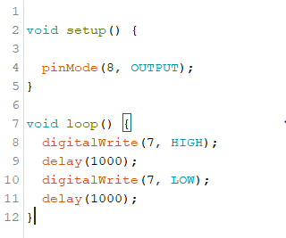

  - The pinMode (line 4) should be in the void loop
  - digitalWrite should be changed to analogWrite in line 8
  - The digitalWrite in line 7 should be HIGH
  - The pinMode (line 4) should be changed to 7 instead of 8
  - The pinMode (line 4) should be changed to an input instead of an output
  - Nothing is wrong with this sketch

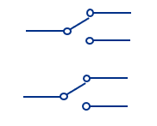
- What type of switch is pictured below?
  - SPST
  - DPST
  - SPDT
  - DPDT
  - All of the above
  - None of the above

- Convert 101101 to decimal:

- A form of programming PLCs that uses a schematic representation of components connected between power and ground lines/busses is called___________.
  - Block Diagram
  - Ladder Logic
  - Instruction List
  - Structured Text
  - Sequential Function Chart

- The schematic shown depicts a resistor in series with a ________________.
  - photoresistor
220Ω
  - light emitting diode
  - potentiometer
  - thermistor
  - inductor

- What type of switch is pictured below?
  - SPST
  - DPST
  - SPDT
  - DPDT
  - All of the above
  - None of the above

- What type of switch is pictured below?
  - SPST
  - DPST
  - SPDT
  - DPDT
  - All of the above
  - None of the above

- The momentary switch schematic shown indicates that this switch is a
  - Normally Open Push Button
  - Normally Closed Push Button
  - Normally Open Toggle
  - Normally Closed Toggle

- A capacitor is placed in parallel with a switch to
  - Hold the switch output constant
  - Protect the switch from burning out
  - Minimize the effects of switch bouncing
  - All of the above
  - None of the above

- A Wheatstone bridge can be used to
  - Provide a constant voltage to a circuit
  - Provide a constant current source
  - Accurately measure changes in the resistance of a component
  - Connect two circuits together in parallel
  - Connect two power supplies together

- A ____________ resistance changes with temperature.
  - Photoresistor
  - Potentiometer
  - Thermistor
  - Capacitor
  - None of the above

- Industrial Programmable Logic Controller (PLC) based systems typically include the use of the following:
  - Ruggedized Computers / Microcontrollers
  - 6 VDC Power Supplies
  - Digital I/O Modules
  - Analog I/O Modules
  - All of the above
  - a, c, and d only

- Excel Workbooks contain _________.
  - Documents
  - Folders
  - Portfolios
  - Envelopes
  - Spreadsheets

- The equation =A6/$B$6 uses___________________.
  - Relative referencing
  - Absolute referencing
  - Relative and absolute referencing
  - Total referencing and no referencing
  - Formulas and data
  - Total referencing

- The equation =C3/B12 uses______________.
  - Relative referencing
  - Absolute referencing
  - No referencing
  - Total referencing
  - Complete referencing
  - None of the above

- The “coefficient of determination,” more commonly referred to as r^2, will be used to determine the “goodness of the fit”.
  - True
  - False

- A _________ measures electrical resistance changes with temperature.
  - Breadboard
  - Resistor
  - Photoresistor
  - Thermistor
  - Potentiometer
  - Capacitor

- A ________ is a data type that allows for decimal values to be included in the sketch.
  - Boolean
  - Byte
  - Int
  - Long
  - Float
  - Char

- How many combinations can a 4-bit register represent?
  - 8
  - 10
  - 12
  - 14
  - 16
  - 18

- How do you incorporate a delay for 5 seconds?
  - delay(5);
  - delay(50);
  - delay(500);
  - delay(5000);

- What two things do you need inside digitalWrite(____ ,____)?
  - Digital Pin #, Input/Output
  - Analog Pin #, Input/Output
  - Digital Pin #, HIGH/LOW
  - Analog Pin #, ON/OFF
  - Analog Pin #, HIGH/LOW
  - Analog Pin #, TRUE/FALSE

- Programmable Logic Controllers typically provide _______ VDC to connected devices.
  - 5
  - 6
  - 12
  - 24
  - 60
  - 120

- __________ sensors convert a variable quantity into a signal that the control system / PLC can understand.
  - Digital
  - Analog
  - Temperature
  - Pressure
  - Transistor

Performance Task 2
Microsoft Excel Performance Task

Create a spreadsheet in Excel to do the following: (Note: Graph may not be linear. Choose a best fit curve.)
- 1st Column: List the following resistance values: 220, 400, 480, 680, 750, 1100
- 2nd Column: Use a formula to compute the current through each resistor given a 12V power supply. (Use relative addressing).
- Place headings above each column in bold print.
- List the current value to 3 decimal places.
- Plot resistance versus current.
- Select a trendline option that is a best fit for the data.
- List the equation for the trendline and the r-squared value on the chart.
- Add a chart title and axis titles.
- Have Excel sum the resistance values at the bottom of the first column.
BONUS: Place the voltage value at the top of the spreadsheet (above the graph) and use absolute addressing to recompute the current values….so that you can change the voltage value at the top of the spreadsheet and have the spreadsheet automatically recompute the current and replot the graph.

Save the file and email to marvin.nelson@bossierschools.org.

Performance Task 1

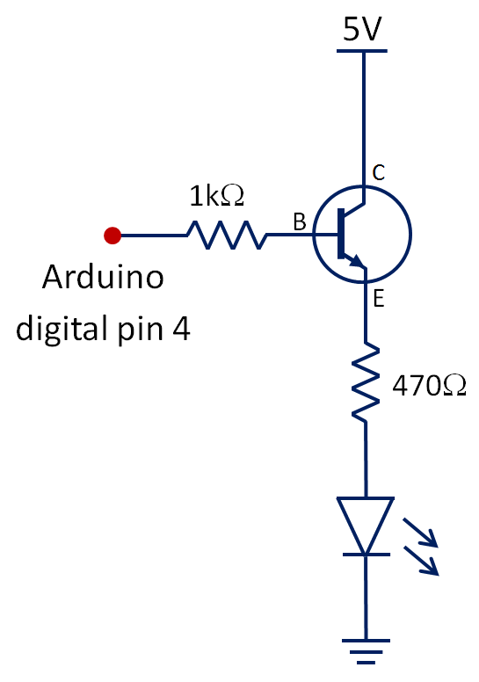
Wire the following circuits on your breadboard.

5V
10kΩΩ
0.1uF∗
Arduino analog pin 7

* Use any ceramic capacitor.

Solve this problem on this sheet.

If the voltage across the 10k resistor is 2.7V,
Find the analogRead value on pin 7. (Show work.)

