Ref. | Unit 3 Concepts & Definitions | Terms, Notation, Formulas, Diagrams
 | In circuits, sources and loads are connected in: Series, | 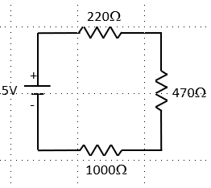
 | Parallel, or | 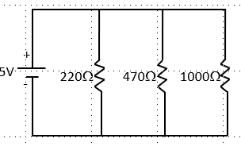
 | Series and Parallel combinations. | 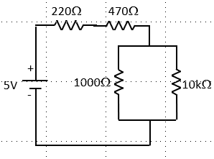
 | Series Resistance Formula:
 | Parallel Resistance Formula:
 | Kirchhoff’s Voltage Law states that the algebraic sum of voltages around any closed loop in a circuit is zero.
 | Kirchhoff’s Current law state that the current entering a junction point, or node, equals the sum of currents leaving a node.
 | Type of switch with a basic on/off function that holds the state that the switch is set to.
 | Type of switch that is only in “on” state when activated. Used for intermittent user-input.
 | Number of separate circuits the switch can control.
 | Number of positions each of the switch’s poles can be connected to.
 | Single Pole Single Throw | SPST 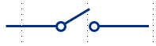
 | Single Pole Double Throw | SPDT 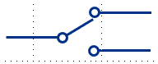
 | Double Pole Single Throw | DPST 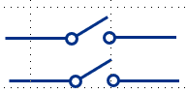
 | Double Pole Double Throw | DPDT 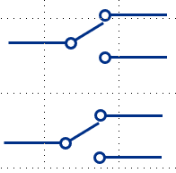
 | Normally Open (NO) Switch: contacts on switch are open and will close when the switch is activated. | 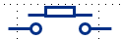
 | Normally Closed (NC) Switch: contacts on switch are closed and will open when the switch is activated. | 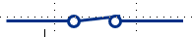
 | ___________ store electric charge and can be used to overcome the issues with switch bouncing.
 | Capacitance is measured in ___________.
 | A ______________, connected between a switched input and ground, gives current a safe path to take and ensures either a LOW (0) or HIGH (1) pin state.
 | A ______________, connected between a switched input and power, gives current a safe path to take and ensures either a LOW (0) or HIGH (1) pin state.
 | Defining your variable at the beginning of your sketch before the setup function will set a _______, defined for the whole sketch.
 | Defining a variable inside the loop function, will make it a _________, which can only be referenced locally in that function.
 | To perform a function based on a specific condition, you can use an __________.
 | To test multiple conditions in one if statement, you can use a _____________.

