Circle the letter of the correct response(s).
- __________ capacitors must be forward biased to avoid overheating which can cause them to burst?
  - Ceramic
  - Electrolytic
  - Variable
  - Filter
- A ___________ is a semiconductor device that can be used as an “electrical switch” or as an amplifier.
  - Transistor
  - LED
  - Relay
  - Capacitor
  - Inductor
- Transistors can be used to have a small current control a larger current.
  - True
  - False
- In a _____________ relay, the contacts are closed when no current is passed through the coil and passing a current through the coil causes the contacts to open.
  - Normally open
  - Normally closed
  - Consistently open
  - Consistently closed
  - Mainly closed
- The amount of current that can pass through the contact leads without damaging the relay is called the:
  - Coil voltage
  - Contact current
  - Coil current
  - Contact output
  - Contact coefficient
- Why are flyback diodes used in a circuit?
  - To provide more current to the coil.
  - To hold the contacts in the ON state.
  - Relays will not work without them.
  - To help protect circuit elements from induced current.
  - Both b and c

- General purpose diodes are designed to allow current to flow in one direction and block the flow of current in the opposite direction.
  - True
  - False
- A component that has the ability to store electrical charge is a/an:
  - Resistor
  - Inductor
  - Diode
  - Capacitor
  - Transistor
- AnaolgRead returns a value of 762 from a voltage divider wired between 5V and ground. What is the voltage measured?
  - 1.4V
  - 2.6V
  - 3.7V
  - 4.1V
- Electric capacitance is measured in:
  - Ohms
  - Farads
  - Volts
  - Henrys
  - Flux
- The working voltage indicates the maximum allowable voltage that may be applied to the capacitor without damaging it.
  - True
  - False
- What factors affect capacitance in a parallel plate capacitor? (circle all that apply)
  - Plate area
  - Distance between plates
  - Dielectric material between plates
  - Applied voltage
  - Applied current
  - All of the above
  - None of the above
- The higher the dielectric constant, the more capacitance.
  - True
  - False
- In and RC circuit, as capacitance ___________, discharge time increases.
  - Decreases
  - Increases
  - Remains constant
- On a capacitor charge plot, once the voltage reaches ____% of the entire charged voltage, the amount of time that has elapsed is equal to the time constant.
  - 5.5%
  - 10.2%
  - 63.2%
  - 75.4%
  - 80.0%
  - 100%
- The value of a process variable (e.g. temperature, pressure, depth, rpm…) that a process control system attempts to maintain is called the _______________________ .
- A device that can store electrical energy in a magnetic field is a/an _________.
  - Capacitor
  - Transistor
  - Inductor
  - Resistor
  - Diode
- If a constant DC current is flowing through an RL circuit, the voltage drop across the resistor will __________.
  - Decrease over time
  - Remain constant
  - Increase over time.
  - Be zero.
- Factors that influence inductance of an inductor are _______. (circle all that apply)
  - Number of turns of coil wire
  - Spacing of coil windings
  - Coil wire insulation material
  - Cross-sectional area of the core
  - Permeability of the core

Constructed Response: (Formulas are on the bottom of page 3)

- Determine the amount of charge stored on either plate of a capacitor, 4.0 x 10⁻⁶ F, when connected across an 18 volt battery.

- A parallel plate capacitor is constructed of metal plates, each with an area of 0.7 m². The capacitance is 9.876 nF ($9.876×{10}^{-9}F$). Determine the plate separation distance, if teflon (permittivity of 2.1) is used as the dielectric.

- What is the capacitance in an RC circuit if 𝝉=2.4s and R= 1kΩ?

Constructed Response: (Formulas are on the bottom of page)
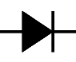
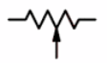
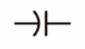
- Name the following components from their schematic symbols. Be specific:

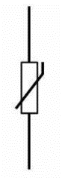
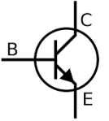
_________________________ _________________________ __________________________
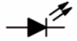

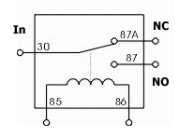
_________________________ _________________________ __________________________
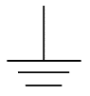
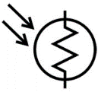

_________________________ _________________________ __________________________

A
M

_________________________ _________________________ __________________________

$C = \frac{q}{v}$ $C = \left(8.854×{10}^{-12}F/m\right)\frac{εA}{d}$ $τ=RC_{p}$ $τ=\frac{L_{i}}{R}$

Wire this circuit on a breadboard.

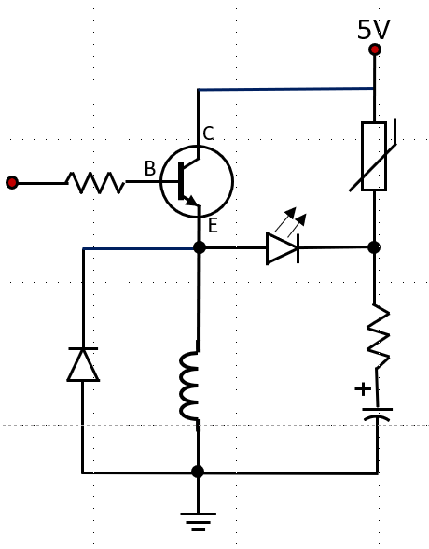

5V

