Electrical Technology Related Tools and Equipment
Build Your Tool Kit
Basic Tools & Test Equipment Identification
- Locate each tool/piece of test equipment on local Lowe’s, Grainger or other relevant websites.
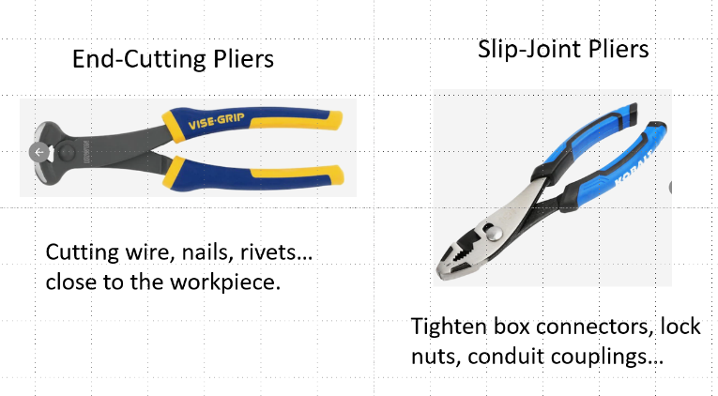
- In a PowerPoint:
  - Use a blank page layout
  - Place a snipped picture of the item
  - List the name of the item above it (36 point font)
  - Add the description of typical electrical worker use(s) below it. (32 point font)
- Slip-Joint Pliers: Tighten box connectors, lock nuts, small couplings
- Tongue-and-Groove Pliers: Gripping, turning and bending.
- Long-Nose Pliers: Bending and cutting wire and positioning small components.
- Side-Cutting (Lineman’s) Pliers: Cutting cable, removing knockouts, twisting wire, deburring conduit.
- Locking Pliers: Lock on to a workpiece.
- Electrician’s Hammer: Mount electrical boxes and drive nails.
- Straight Pipe Wrench: Tighten and loosen pipes and large conduit.
- Chain Pipe Wrench: Tighten and loosen pipes and large conduit.
- Fuse Puller: Safely remove cartridge fuses
- Wire Stripper/Cutter: Remove insulation from small-diameter wire.
- Wire Crimper: Crimp Terminals
- Hole Saw: Make clean, circular cuts in walls, floors, ceilings
- Pipe Vise (Chain): Firmly hold conduit for cutting & threading
- Fish Tape: Pull wires through conduit
- Ratcheting PVC Pipe Cutter: Cut PVC up to 2”
- Cable Tie Gun: Tie bundles of small-diameter wires or cables together
- Hand Conduit Bender: Bend EMT, IMC, and RMC conduit
- Hacksaw: Cut conduit and other metal
- Reciprocating Saw: Cut holes in walls, floors, ceilings, to install boxes and conduit.
- Power Cable Cutters: Cut electrical and fiber-optic cables.
- Hammer Drill: Drill into masonry, concrete, wood, and metal.
- Digital Multimeter: Measure current, voltage, and resistance.
- Clamp-On Ammeter: Measure current in large cables without disconnecting / inserting a meter. Uses the strength of the magnetic field around the conductor.
- Megohmmeter: Detects insulation deterioration by measuring high resistance values under high test voltages.
- Oscilloscope: Measuring and observing electrical signals.
- Signal Generator: Apply waveforms to circuits for testing purposes.
- Continuity Tester: Tests for a complete path for current to flow.
- Voltage Tester: Indicates approximate voltage level present.
- Soldering Iron: Solder wires together. Solder components onto circuit boards.
- Heat Gun: Apply heat shrink to electrical connections.

