Lab 2.3: SLC-500 Basic Relay Instructions
Upon completion of this lab exercise the student should be able to:
- Explain the operation of the OTE, OTL and OUT instructions
- Create a new SLC-500 project and configure the I/O
- Enter address symbols and descriptions in RSLogix500
- Monitor the input/output image tables in RSLogix500
- Configure channel 1 for a both an SLC-5/04 and SLC-5/05
- Toggle the address symbols and descriptions on and off

*This lab could be performed in the Terra PLC Lab.

Part 1: Creating a Project with Relay Instructions:
The following videos will show how to perform the various tasks in this lab exercise:
Creating lab 2.3 project with symbols 120622: https://youtu.be/iyq_iXsRukI

Lab 2.3 Operation of the program 120622: https://youtu.be/S9ucfLHSy4Q

- Configure a new project and key in the following program with the address symbols and descriptions as shown in Figure 1.
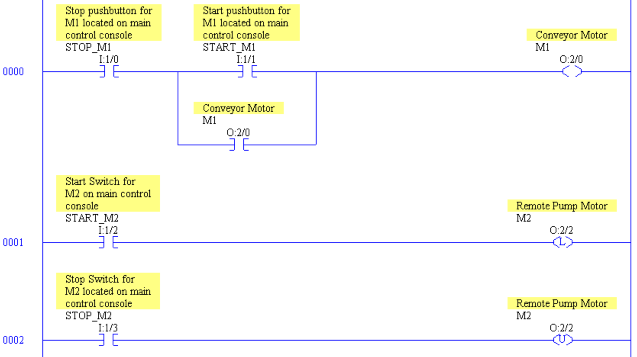

Figure 1. Program with various relay type of instructions.

- Verify the project and save it to an accessible location on your computer hard drive or on a memory stick. Also make sure the Project File Search Path is setup to the same location as where the project was stored as shown in Figure 2.

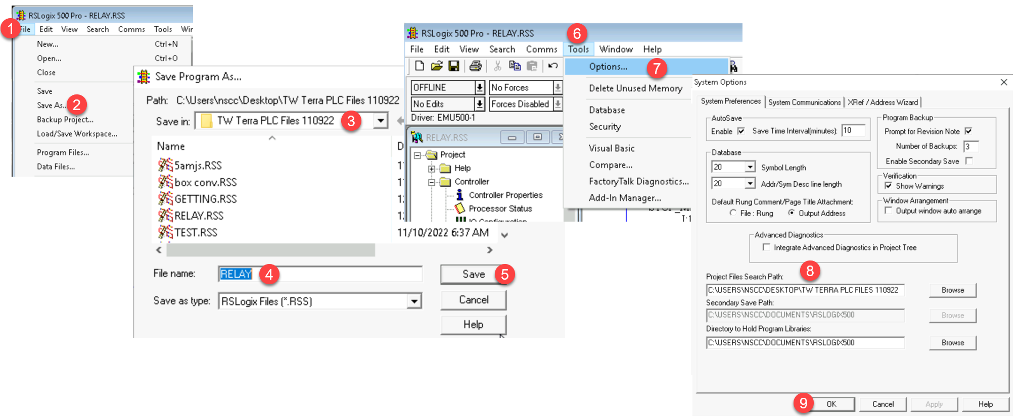

Figure 2. Saving a Project and verifying the Search Path.

- Make sure the Save As path and the Project File Search Path is setup correctly using the steps in Figure 2:
- Click on the File pull down menu
- Choose the Save As option
- Select a folder that is accessible to students on the computer (or use a memory stick)
- The file name defaults to the processor name (they do not have to be the same)
- Click save to save the .RSS project file
- Go to the Tools pull down menu
- Choose Options
- Make sure the Project File Search Path is the same as the Save As path
- Click the OK button
Important Information: It is important to have the Project Files Search Path setup to the same location as the File-Save As path, to assure that RSLogix500 can show the correct symbols and descriptions on the ladder view, when going online. When RSLogix500 goes online to the processor, it matches the processor name (in the processor) with the processor name in the .RSS file (in the Project File Search Path) then shows the symbols and descriptions from the .RSS file on the online screen
Part 2: Testing the Operation of the Program
- Download the program and go online to the controller and go Online.

- Change the SLC-500 processor back to the Remote Run mode.

- Turn off all toggle switches on the input simulator and do not actuate any pushbuttons.

- Are there any instructions that are highlighted? ____________________

- Momentarily actuate the start pushbutton. Does O:2/0 output come on? _________

- Release the start pushbutton. Does O:2/0 remain on? ___________

- Turn on the START_M2 input switch. Does M2 come on? _______________

- Do both the OTL and OUT instruction highlight when M2 comes on? ____________

- Turn off the START_M2 input toggle switch. Does the M2 output remain on? _______

- Turn on the STOP_M2 input toggle switch. Does the M2 output turn off? _______

Part 3: Turning the address symbols and description on and off
Figure 3 shows the different objects found on a ladder logic display in the RSLogix500 software. It is important to know that the Symbols by default have a background color of lime green (the same as logic power flow). This can be distractive to the Technician, so in Figure 3, the background color was changed to white. The colors can be changed in the View Properties menu.

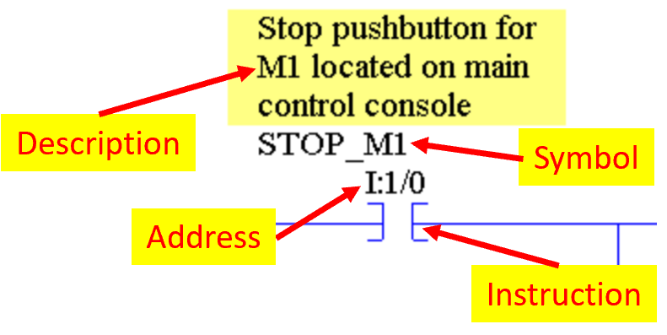

Figure 3. Defining the objects on a ladder display.
Important Information: Symbols in RSLogix500 are character strings that logically explains what an address is for. It can be 15 character long and is unique to an address (it cannot be used for another address). It will show up as all capital letters with no spaces. The description is a more in-depth explanation for the address. Both symbols and addresses are beneficial for troubleshooting. It is important to understand that the symbols and descriptions are stored in the .RSS file on the computer, so when the user goes online to the processor with RSLogix500 the screen will show the instruction and address stored in the processor, and the symbols and descriptions from the computer. The processor name and the Project File Search Path (under Options) is what synchronizes the information together in the online view.
- Figure 4 shows the steps to get to the View Properties menu:
- Click on the bar at the top of the ladder display window
- Choose the View pull down menu
- Choose the Properties option
- The View Properties menu appears, and uncheck the box for Show Descriptions to shut off
- The user can uncheck the Show Symbols option to shut off the Symbols
- Click the OK button to make the changes

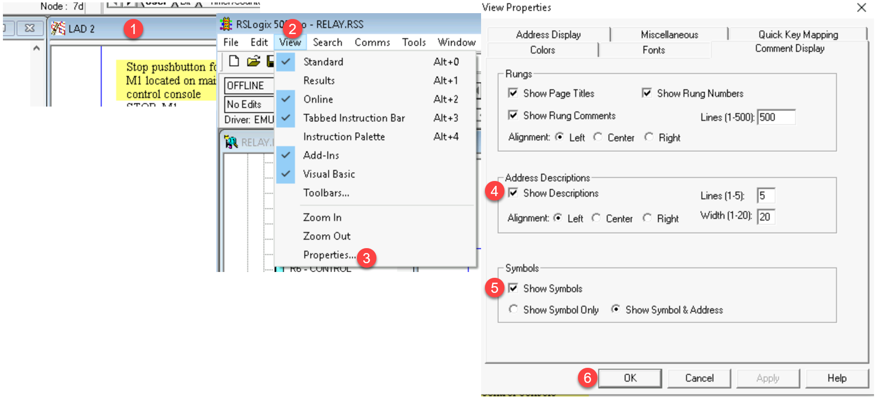

Figure 4. Steps to turn the symbols and descriptions on and off.
Part 4: Configuring Channel 1 on an SLC-5/04 & SLC-5/05
The SLC-5/04 and SLC-5/05 processors are legacy processors, and was also the first to have software configurable communication ports, versus configuring with DIP switches. The ports can be configured offline, then saved and downloaded through the RS-232 port (Channel 0).
Important Information: It is important to know that the user must be Offline in RSLogix500 to configure Channels in the processor.

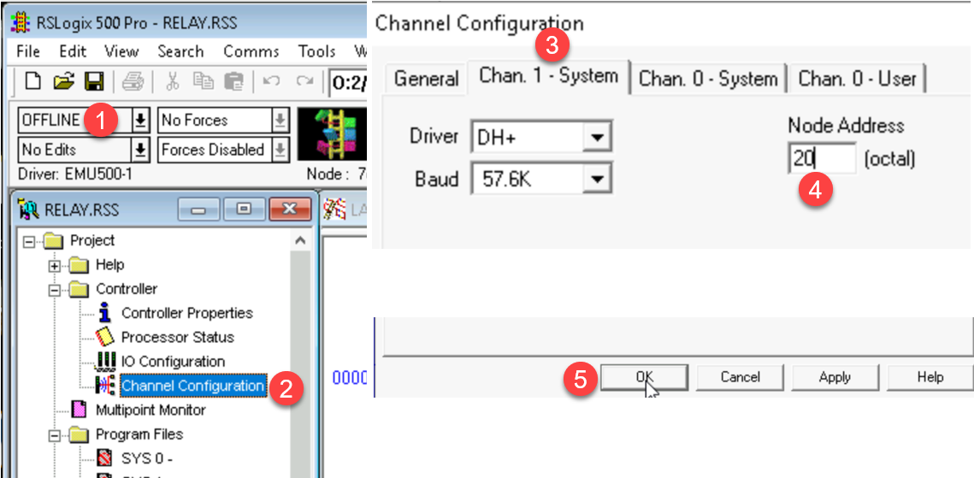

Figure 5. Configuring Channel 1 on an SLC-5/04 processor.

- Figure 5 shows the steps to configure Channel 1 on an SLC-5/04 processor, which is a Data Highway Plus (DH+) port. Configure the processor for DH+ station 20
**Important** - Coordinate with other students in the room who are doing this lab to use sequential station numbers: 20, 21, 22, etc. so there are no duplicate DH+ addresses. If there is a duplicate address, the network will not work correctly. Go to RSLinx and view all DH+ station addresses through the ControlLogix Gateway to prevent duplicate addresses.
- Make sure RSLogix500 is Offline
- Click on Channel Configuration
- Choose the Chan. 1 System tab
- Enter a value of 20 for the station number
- Click the OK button

- If will be important to verify your project before saving
- Download the project to the SLC-5/04 processor and verify that it is connected by viewing the DH+ stations through the ControlLogix Gateway.

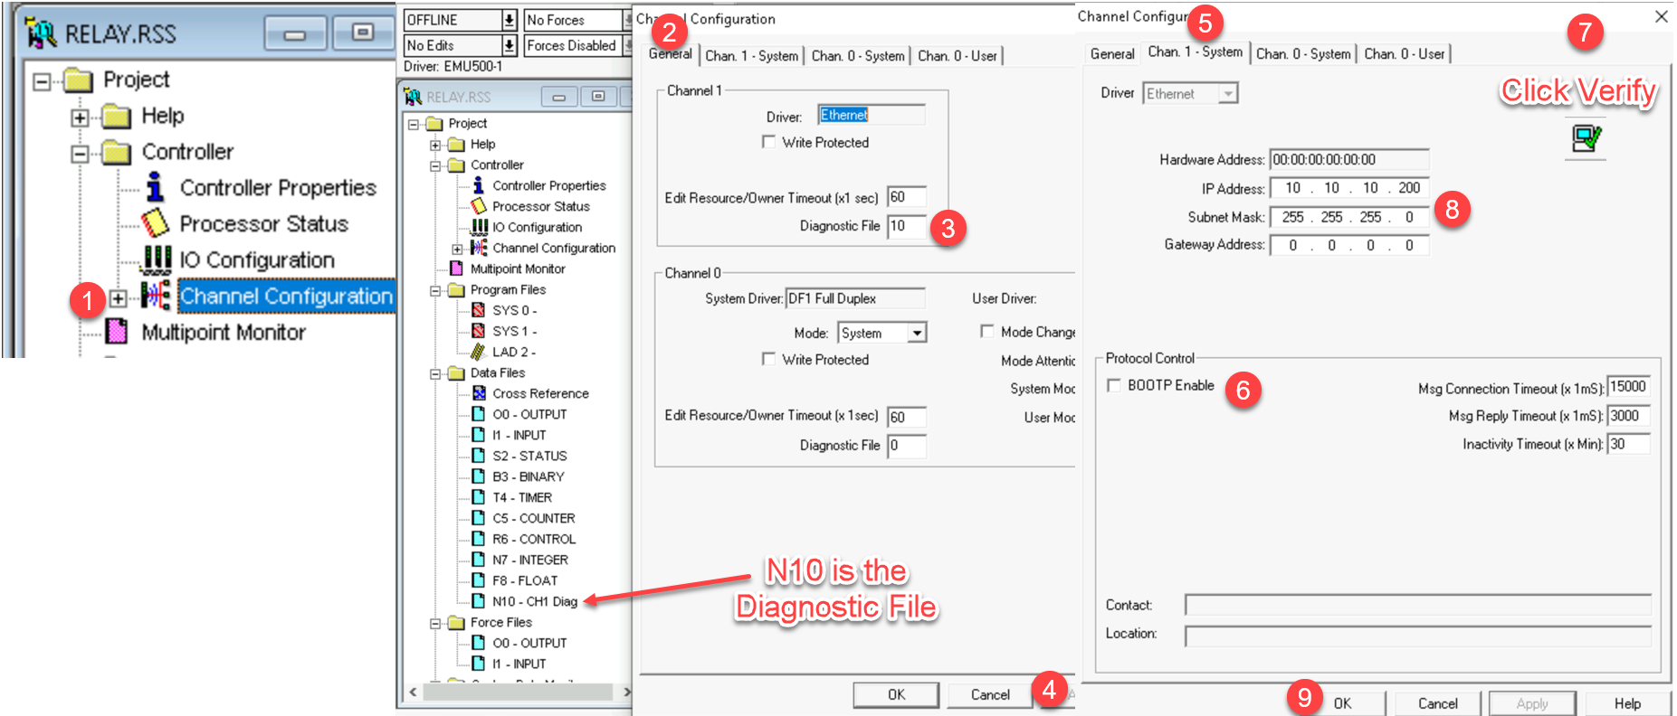

Figure 6. Configuring Channel 1 on an SLC-5/05 processor.

- Figure 6 shows the steps to configure channel 1 on an SLC-5/05 processor for a specific Ethernet address. There may be a tag on the PLC training unit that specifies what the IP address should be, and you can also verify through an Ethernet IP driver in RSLinx, what IP addresses are being used by other processors and Ethernet modules on the Ethernet network. Duplicate IP addresses will cause the Ethernet network to not work correctly.
Configure Channel 1:
- Go to Channel Configuration
- Click on the General Tab
- Enter a value of 10 for the Diagnostic file
- Click Apply to create the diagnostic file (data file N10)
- Click on the Chan. 1 System tab
- Uncheck the BOOTP Enable option
- Click on Verify in the toolbar section of RSLogix500
- Enter an IP address of 10.10.10.200, and a subnet mask of 255.255.255.0
- Click the OK button, then reverify the project and save.
- Download the project into the processor and go to the Ethernet IP driver in RSLinx to view the SLC-5/05 processor.

Some important things to know about this lab:
- The user can change the colors of all the objects in the ladder display by going to the view properties and click on the color tabs. There is a default button to change back to factory defaults.
- An OTE coil must have logic power flow to it to turn on, and keep the bit on.
- An OTL coil will turn on a bit when it gets logic power flow, and the bit will remain on when logic power flow is lost.
- An OTU will turn off a bit when it gets logic power flow. The OTL and OTU are usually used together. If the bit is on, both the OTL and OTU instructions are highlighted..
- Channel 1 on an SL-5/04 (DH+) and the SLC-5/05 (Enet) are both configured in RSLogix500 when offline. The settings will then need to be downloaded with the project to the processor.

Questions:
- What is the address symbol for O:2/0?

- What is the address description for address O:2/2

- How does the user get to the menu to run off the symbols and descriptions on the ladder display?

- Why does both the OTL and OTU instructions highlight when the OTL instruction for address O:2/2 gets logic power flow?

- Why in the first rung of the ladder logic program is the XIC instruction used for the Stop pushbutton?

- What data file is the input image table stored in?

- What data file is the output image table stored in?

- Which communication type is Channel 1 on an SLC-5/05 processor?
- DH+
- Ethernet
- Can be configured for either DH+ or Ethernet

- How is the station number for Channel 1 setup on an SLC-5/04 processor?
- Dip Switches
- Software configurable
- Setup by the vendor and cannot be changed

- What communication state must RSLogix500 be in, to configure Channel 1 on the SLC-5/04 and 5/05 processors?
- Online
- Offline
- Either Online or Offline

This material is based upon work supported by the National Science Foundation under an NSF ATE project awarded to Terra State Community College (ATE-DUE #2201982: Creating Relevant, Effective and Accessible Technical Education for Electrical Skilled Trades – CREATE). Any opinions, findings, and conclusions or recommendations expressed in this material are those of the author(s) and do not necessarily reflect the views of the National Science Foundation.

This work is licensed under a Creative Commons Attribution 4.0 International License.

