**Learning Activities 4.4: Gas Pressure and Amontons’ Gas Law**

**Summary of Learning Activities:**

* Measuring pressure of a gas at different temperatures to validate Amontons’ law.

# Student Learning Objectives:

1. Collect pressure and temperature measurement data.
2. Verify Amontons’ law.
3. Report calculated values with appropriate significant figures.

**Suggested Pre-lab Assignment:**

Describe two everyday examples where Amontons’ law applies.

**Theoretical Background:**

The relationship between the temperature of gas and the absolute pressure exerted by a constant amount of gas is stated in **Amontons’ law (Gay-Lussac’s law)**. Mathematically, Amontons’ law can be expressed as:   
  
 *P1/T1 = P2/T2,*  
  
where *P1*and *T1* are the initial pressure and absolute temperature of the system and *P2*and *T2* are final pressure and absolute temperature of the system. So theoretically, as long as the amount of gas and volume do not change, the ratio of pressure over temperature should not change. In real life under these conditions, the ratios of pressure over temperature will not be exactly equal for changing conditions due to possible gauge reading errors, limitations of the apparatus set up, or gas leaks.

# Equipment and Materials:

1. Closed metal vessel with a fixed volume
2. Hot plate
3. Pressure measurement gauge connected to the fixed volume vessel
4. Thermocouple thermometer

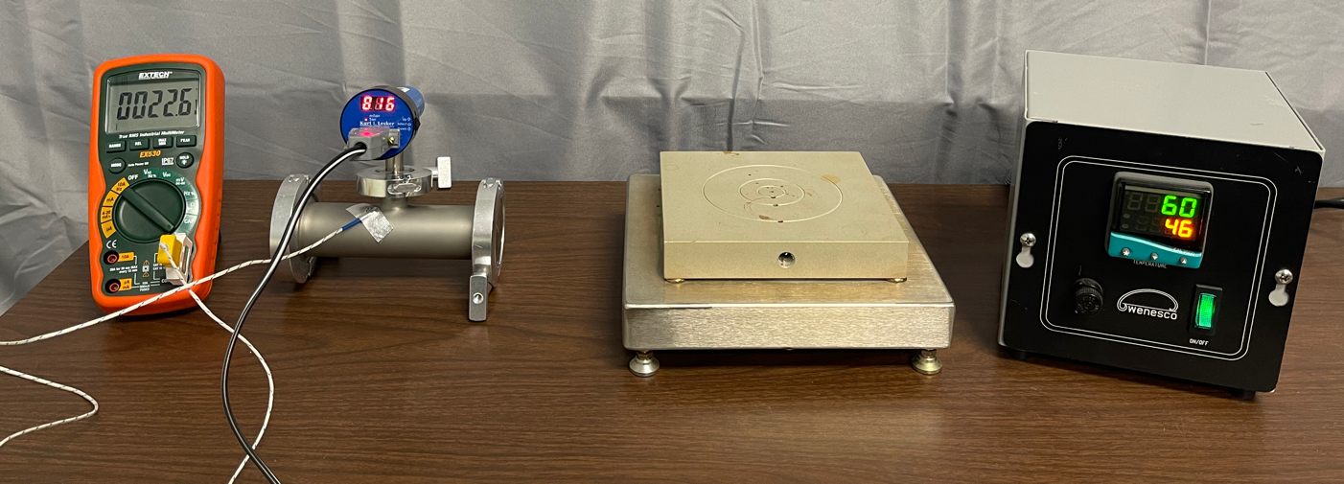

Figure 4.4.1. Sample system Setup 1 with hot plate.   
Photo provided by E. Brewer, SUNY Erie Community College.

**Procedure:**

* 1. Preheat hot plate to up to 158°F (about 70°C ).
  2. Apply power to the pressure gauge.
  3. Wait for the measurement value reflected on the pressure gauge to stabilize.
  4. **In Table 4.4.1, record the pressure value in the closed metal vessel from the pressure measurement gauge.**
  5. Connect the thermometer measuring unit. Wait for the measurement value reflected on the thermometer to stabilize.
  6. **In Table 4.4.1, record the temperature using the thermometer to reflect room temperature in the closed metal vessel.**
  7. Place the closed metal vessel on a pre-heated hot plate.
  8. Allow the temperature of the vessel to increase to a level of 90 - 115°F (32.2 – 46.1°C). You may want to change the orientation of the vessel on the hot plate periodically to insure more uniform heating. See Figure 4.4.2. Wait for the pressure and temperature measurement values reflected on the measuring devices to stabilize.  
       
       
      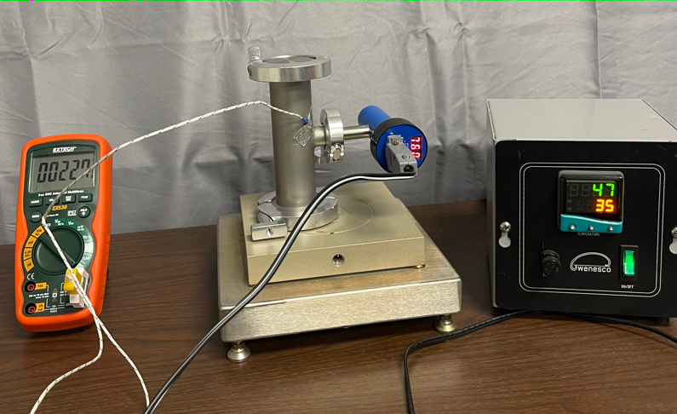  
      Figure 4.4.2. Different orientations of the vessel on the hot plate.   
      Photo is provided by E. Brewer, SUNY Erie Community College.
  9. **In Table 4.4.1, simultaneously record the pressure from the pressure gauge and temperature using the thermometer.**
  10. Turn off the hot plate.
  11. Let the temperature of the vessel drop approximately 5°F (2.8°C).
  12. **In Table 4.4.1, simultaneously record the pressure from the pressure gauge and temperature using the thermometer when the temperature has decreased by 5°F (2.8°C).**
  13. Remove power from the pressure gauge.

Name: ___________________________ Date: __________________

**Table 4.4.1: Amontons’ Law Data**

|  |  |  |  |
| --- | --- | --- | --- |
| **Measurement** | **Pressure  (Torr)** | **Temperature (°F)** | **Temperature (°C)** |
| **Initial P1, T1 (STEP 4 and STEP 6)** |  |  |  |
| **Second P2, T2 (STEP 9)** |  |  |  |
| **Third P3, T3 (STEP 12)** |  |  |  |

**Analysis of Results:**

1. Convert each measured temperature value to Kelvin and record in Table 4.4.2.
2. Calculate the ratio of P/T for the measurement values obtained in Steps 4 and 6. Be sure to use the temperature value reflecting units of Kelvin when calculating P/T. Report the calculated value with the appropriate number of significant figures. Record the result in Table 4.4.2.
3. Calculate the ratios of P/T for the measurement values obtained in Steps 9 and 12. Report the calculated values with the appropriate number of significant figures. Record the results in Table 4.4.2.
4. Calculate the percentage difference between the P/T ratios. Record the results in Table 4.4.2.

**Table 4.4.2: Amontons’ Law Calculations**

|  |  |  |  |  |
| --- | --- | --- | --- | --- |
| **Measurement** | **Pressure  (Torr)** | **Temperature (K)** | **P / T (Torr/K)** | **% diff. (%)** |
| **Initial  (STEP 4 and STEP 6)** |  |  |  |  |
| **Second (STEP 9)** |  |  |  |  |
| **Third (STEP 12)** |  |  |  |  |

1. How well does the measured data fit with the model of Amontons’ law? Does *P1/T1 = P2/T2* ?  
   What could be some limitations to both sides of the equation being equal?

