**THE WHEATSTONE BRIDGE AND STRAIN GAUGE LOAD CELL**

The Wheatstone bridge is a simple series-parallel circuit designed to measure resistance. The circuit is very sensitive to small changes of resistances in any of the parallel branches. When one branch of the circuit matches the other, then the voltage measured across the bridge is 0V and the bridge is said to be balanced. When there is a mismatch in resistances between the branches, the bridge is unbalanced which results in a non-zero voltage developed across the bridge. This characteristic makes the bridge useful in detecting unknown resistance values. The circuit is also very useful detecting the change in the resistance of transducer sensors such as strain gauges and thermistors. Thus, the bridge circuit provides the means to convert changes in pressure or temperature into an electrical signal which can be displayed on common products like scales and thermometers.



R3

(Decade box)

Bridge

Output

1. Use the bridge circuit shown above for your calculations and experiments. The ratio of resistances for the bridge is R1/R3 =R2/R4. Therefore, any one of the resistances can be determined when the other resistances are known. In this circuit, R3 will be a variable resistance such as a decade box. R1 = R2 = 33kΩ; R4 =27kΩ. Calculate the value of R3 needed to balance the bridge using R3 = R1 (R4/R2).
2. Do a complete set of calculations on this circuit to determine the branch currents and each resistor voltage drop for the balanced condition. Do your calculations prove the bridge voltage is 0V?
3. Build the circuit using a decade box for R3. Set the decade box to the resistance value you calculated in step 1 and then measure the voltage across the bridge to confirm balance.
4. Change the decade box value to 18kΩ. Now measure and record the bridge voltage. How can you tell that the bridge is unbalanced?
5. Change the decade box resistance to 38kΩ and re-measure the bridge voltage. What is different about this unbalanced measurement?
6. Do a complete set of calculations on the circuit when R3 was set to 38kΩ to determine the branch currents and each resistor voltage drop for the unbalanced condition. Do your calculations prove the bridge voltage is not 0V?
7. Next you will apply the theory of operation of the Wheatstone bridge to test a pressure transducer – the strain gauge load cell.

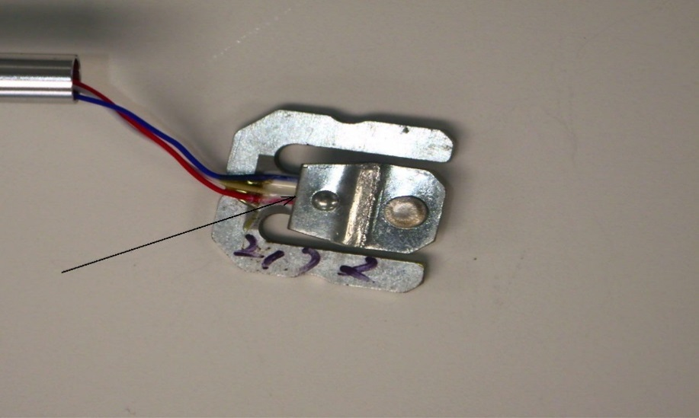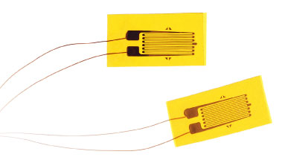

Figure – 1 Figure - 2

This lab will direct you through the operation of a load cell, and its application within the Wheatstone bridge configuration. Figure -1 is an image of a load cell. The arrow points to a metal plate that covers the strain gauges, which are pictured in Figure - 2.

Materials Needed:

1. - 1K Resistors, 1 – Load Cell, 1 – 5K Potentiometer, 1 – Voltmeter, DC Power Supply
2. Examine the SEN-10245 50kg load cell. The following data supplied by sparkfun.com:

|  |  |
| --- | --- |
| Capacity kg 40-50  Comprehensive  Error mv/v 0.05  Output Sensitivity mv/v 1.0±0.1  Nonlinearity %FS 0.03  Repeatability %FS 0.03  Hysteresis %FS 0.03  Creep (3min)%FS 0.03  Zero Drift (1min)%FS 0.03  Temp. Effect on  Zero %FS/10℃ 1  Temp. Effect on | Output %FS/10℃ 0.05  Zero Output mV/V ±0.1  Input Resistance Ω 1000±20  Output Resistance Ω 1000±20  Insulation  Resistance MΩ ≥5000  Excitation Voltage V ≤10  Operation Temp.  Range ℃ 0--+50  Overload Capacity %FS 150 |

1. Construct a Wheatstone bridge with resistors R1 and R2 = 1K. R3 is a decade box and R4 the load cell.

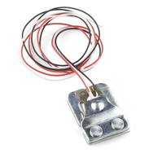

White

R4 Load cell

Use White and Red wires

Red

1. Attach a voltmeter across the bridge. Adjust the decade box until the bridge voltage is as close to zero (balanced) as possible. Do this without any pressure on the load cell. Write down the decade box resistance value.
2. Apply pressure to the cell. You may need to place a stiff board or piece of metal over the cell in order to apply sufficient pressure. If it is possible to secure the base of the load cell in a vice then you will see good results when flexing the metal cantilever portion of the load cell. Record the bridge voltages at full pressure and approximate half pressure. You should expect to see the voltage change by a few millivolts.
3. Use your knowledge of the Wheatstone bridge to calculate the resistance of the load cell at the balanced condition.
4. Disconnect the load cell from the circuit and measure the resistance. Is your measurement similar to your calculated value?
5. The small change in bridge voltage may surprise you, especially given the amount of force necessary to cause the change. In a digital scale, the output from the load cell is amplified for use by the processing circuitry to display weight. The Wheatstone bridge’s sensitivity to small changes in resistance makes it possible to use unique sensors like the load cell in useful products.