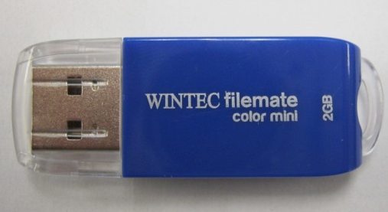
USB Flash Drive Basics

Lab Topic:
Topic: Study the Wintec filemate USB flash drive.

Student Learning Outcomes:
- Understand the basic components of the USB flash drive and their function in that device.

Assignment:
You will split into groups of one, two, or three to perform the lab and gather information.

Each of you will need your own pencil and notebook to proceed with this lab.

Before leaving the lab, make sure:
- Equipment is put away properly:
The USB flash drive is put back together and returned to the front of the lab.
- Lab materials / components are put away properly.
- Your work area is cleaned up:
No trash, bits of paper, etc.
The computer is shut down / turned off properly.

Lab Overview:
The point of this lab is to understand the basic components of the USB flash drive and their subsequent function.

Lab Outline / Steps / Procedures:

- Obtain a USB flash drive to begin reverse engineering.

- Use a small screwdriver to pry the front and back plastic pieces apart.

- Identify the components marked with numbers in figures 1 and 2 and take notes on them on the USB you have.

- Make a table called “Table 1” on a separate sheet of paper relating the numbers with their components.

- For all components give a brief description of their function in your notes with their corresponding numbers.

- Once component 1 is determined, use the Internet to determine what the different pins are for the USB.

- Create a table called “Table 2” that will have each pin number, their name and a brief description of their purpose.

- Once component 5 is determined, on the Internet find the corresponding data sheet and record in your notes the type of storage, amount of storage, operating voltage and type of surface mount used. Also write a brief description of the purpose of this component.

Figure 1)
1
2

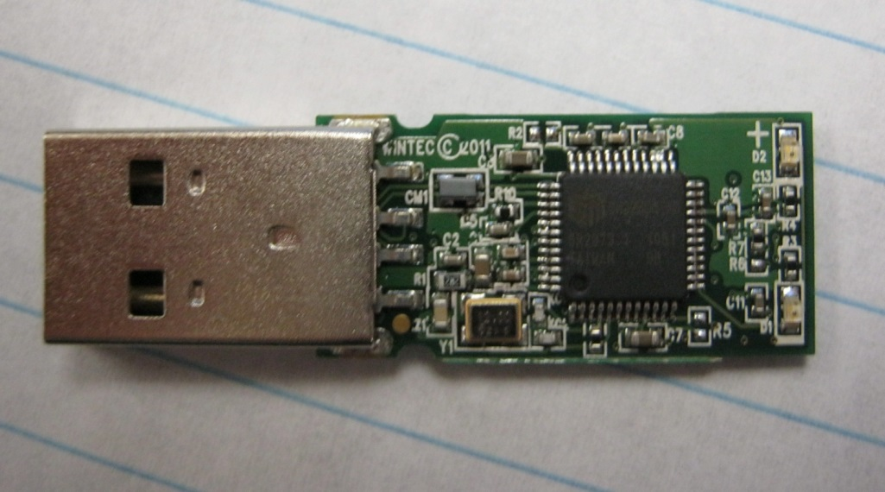
3
4

Figure 2)
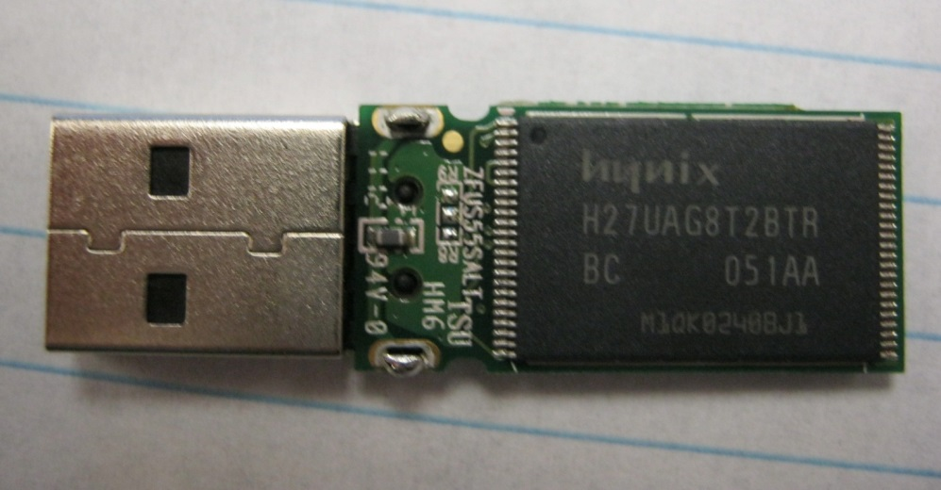
5

Questions:

- What kind of circuitry technology is used in this device?
- What is one limitation of this technology?
- What is the primary material used to manufacture chips such as the memory chip in the USB?
- Explain why a crystalline material is used as a base in the construction of these chips.
- What is the time and number of steps required to create a chip on a wafer?
- What are the large process machines called that the semiconductor uses to process wafers?
- Research and describe in your own words the “law” describing electronic advancement over the years and explain how it is applicable to the USB flash drive.

Possible Answers to Questions (Professors Discretion):

- This circuit technology is an Integrated Circuit (IC).

- The main limitation is the number of physical input-output (I/O) pins. The actual silicon chip is very small but the number of inputs and outputs dictates that the chip package be physically larger. Many clever packaging technologies such as surface mount have been developed to address this problem.

- The primary material is silicon (Si). Chips are fabricated, thousands at a time upon silicon wafers.

- Silicon is a semi-conductor. When silicon is formed with a perfect crystalline lattice structure, an excellent electrical base is created for the chip’s circuits.

- Chip fabrication is a lengthy process that takes 1-2 months to complete with up to 1500 individual process steps required.

- The semiconductor industry calls the individual process equipment specifically designed for each step “tools.” These tools require many technicians to support continued operations. Some common tool names are photolithography, etch, chemical mechanical planarization (CMP), ion implant and diffusion. Tools cost range from $1 million dollars to several hundred million dollars.

- The electronics industry calls the law describing fabrication advancement Moore’s Law. This law is not a physical law, but rather a trend stating that over a period of time (1.5-2 years) the number of components that will fit on a certain size chip doubles. This law is easily observed by looking back in history at the amount of memory available per chip.

