Industry Tour Day for High School Students

Northeast Wisconsin Technical College

For our industry tours, students typically go to manufacturing companies first. They then go to the Green Bay NWTC campus. There they receive a tour of campus and also complete a hands-on math and welding activity.

On the following pages are two versions of the activity that the students go through to calculate what the weight of their round stock stick figure or dog would be. After they calculate the weight and make a guess they go into the welding lab and received a demo from a welding instructor and then have the opportunity to weld together the parts of their stick figure or dog. They then weigh their finished project and the top three students with the closest guessed weights receive a prize.

Supplies Needed:

**For Steve**: seven pieces of ½” diameter round stock approximately 3 inches long for each student, a washer for each student,

**For Buddy**: (lengths are approximate and all ½” diameter round stock): 1-3” length for body, 4-1.25” lengths for the legs, 1-1” length for the neck, 1-.5” length for the nose, 1 wing nut for the head, a small coated piece of wire for the tail

**For Steve and Buddy**: measuring tools, scale, white board or poster to keep track of guessed and actual weights, pencils, and calculators

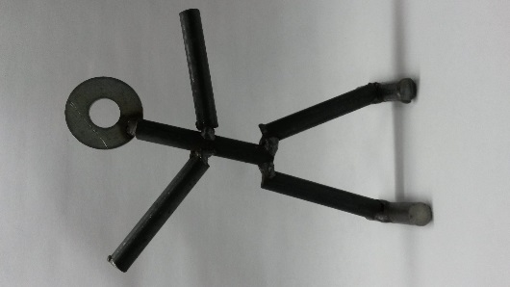Making “Steve”

Hi, I’m Steve! Can you guess how much I weigh? Then can you put me together?

**Step 1**: Get the parts needed and measure Steve’s parts in order to calculate what he will weigh. Use the information on the back of this sheet to help you determine the weight.

Work for calculating the rods (arms, body, legs, feet):

My Calculation for Steve’s arms, body, legs, and feet:

The weight of Steve’s head: about 1 ounce

My Total Calculation for Steve:

My Guess of what my Steve will weigh in standard form – pounds and ounces

____ lbs ____ oz to the nearest .05 oz:

Now, put your Name and Guessed Weight on the Board.

**Step 2**: Take your parts into the welding lab and put “Steve” together.

**Step 3**: Bring Steve back to the classroom and weigh him. See how close you are. There will be a prize for the top students who get their actual weight closest to their guessed weight!

From Ryerson.com:

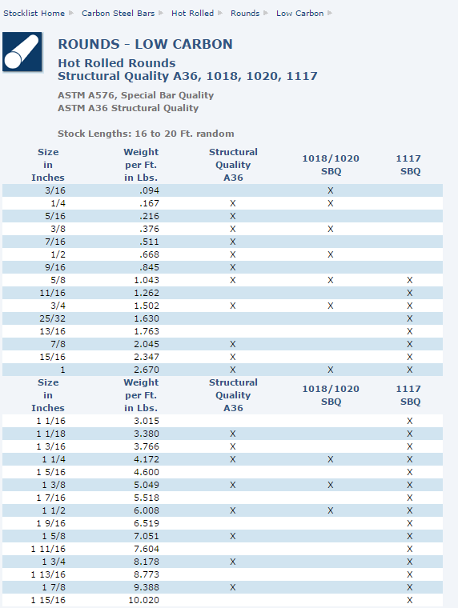

This material is based on work supported by the National Science Foundation under Grant No. DUE-1406857. Any opinions, findings, and conclusions or recommendations expressed in this material are those of the author(s) and do not necessarily reflect the views of the National Science Foundation.

This work is licensed under the Creative Commons Attribution 4.0 International License. To view a copy of this license, visit http://creativecommons.org/licenses/by/4.0/.

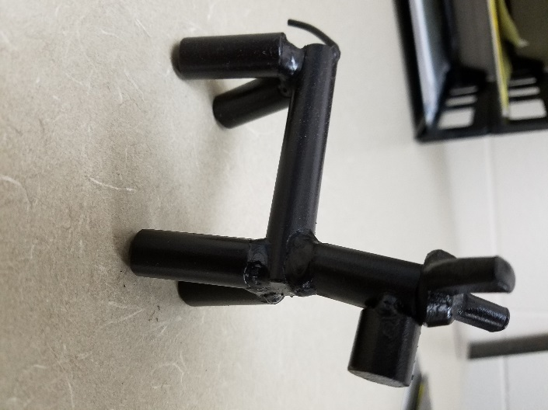

Making “Buddy”

Hi, I’m Buddy the dog! Can you guess how much I weigh? Then can you put me together?

**Step 2**: Take your parts into the welding lab and put “Buddy” together.

**Step 1**: Get the parts needed and measure Buddy’s parts in order to calculate what he will weigh. Use the information on the back of this sheet to help you determine the weight.

Work for calculating the rods (body, legs, neck, and nose):

My Calculation for Buddy’s body, legs, neck, and nose:

The weight of Buddy’s head: about 1 ounce

My Total Calculation for Buddy:

My Guess of what my Buddy will weigh in ounces: _______ oz (to the nearest .05 oz)

Now, put your Name and Guessed Weight on the Board.

**Step 3**: Bring Buddy back to the classroom and weigh him. See how close you are. There will be a prize for the top students who get their actual weight closest to their guessed weight!

From Ryerson.com:

The size in inches is the diameter.



This material is based on work supported by the National Science Foundation under Grant No. DUE-1406857. Any opinions, findings, and conclusions or recommendations expressed in this material are those of the author(s) and do not necessarily reflect the views of the National Science Foundation.

This work is licensed under the Creative Commons Attribution 4.0 International License. To view a copy of this license, visit <http://creativecommons.org/licenses/by/4.0/>.