**HOW A THERMOSTAT WORKS**

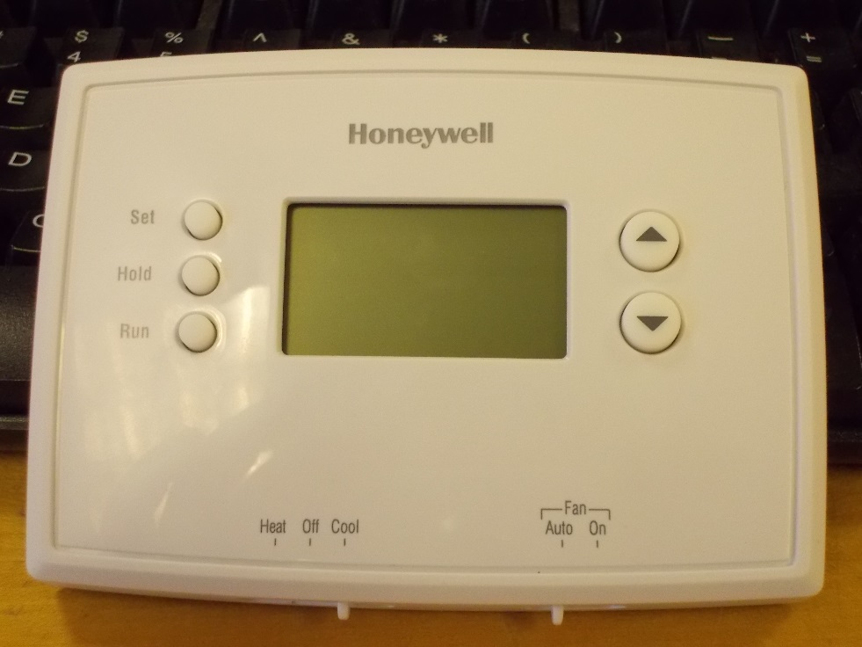

* This lab will give you a general idea of how a thermostat is used as a control system.
* Each element built in this lab will represent a real world element that will be controlled by the thermostat.



B O G Y W NOT R RC

USED

*Fig 1(Schematic of the lab layout)*

**Parts Needed**

1. 1 thermostat
2. 2 relays
3. 2 LEDs
4. 2 100Ω resistors
5. Jumper cables and alligator clips
6. 5V and 3V power supplies

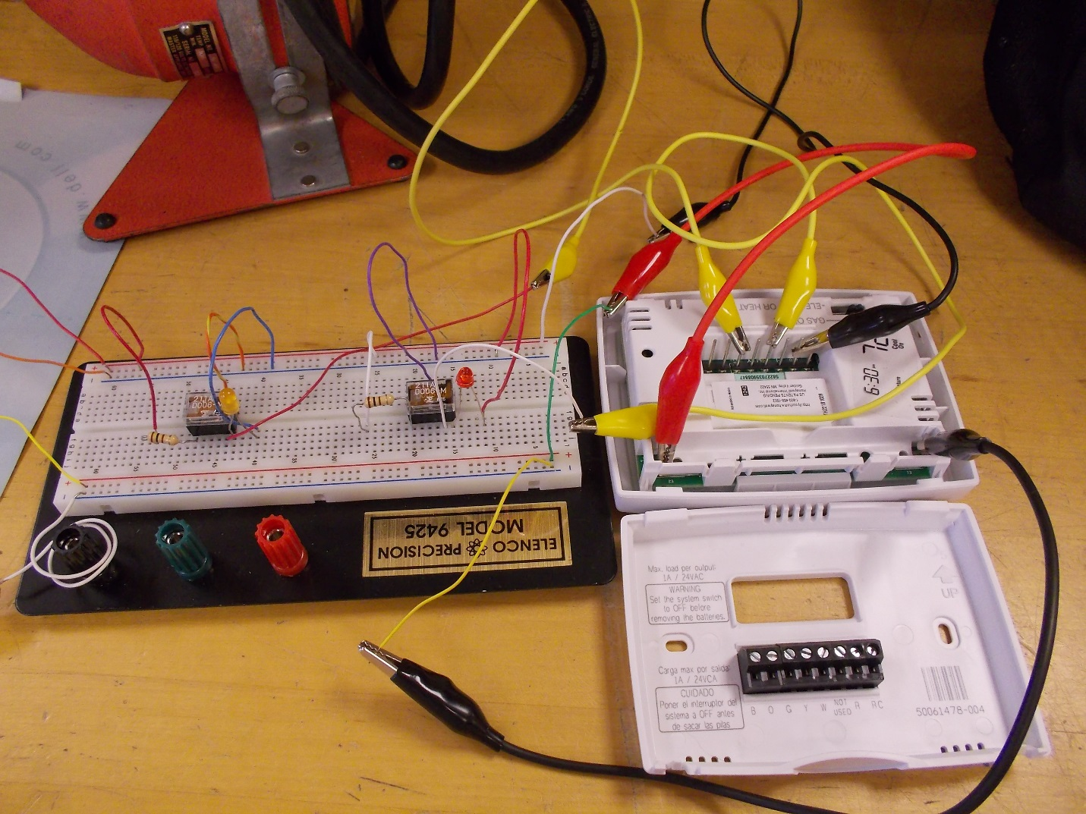

*Fig 2(Final connections)*

**Building the Circuit**

1. Remove the wall plate from the thermostat. Make note of the pin layout.

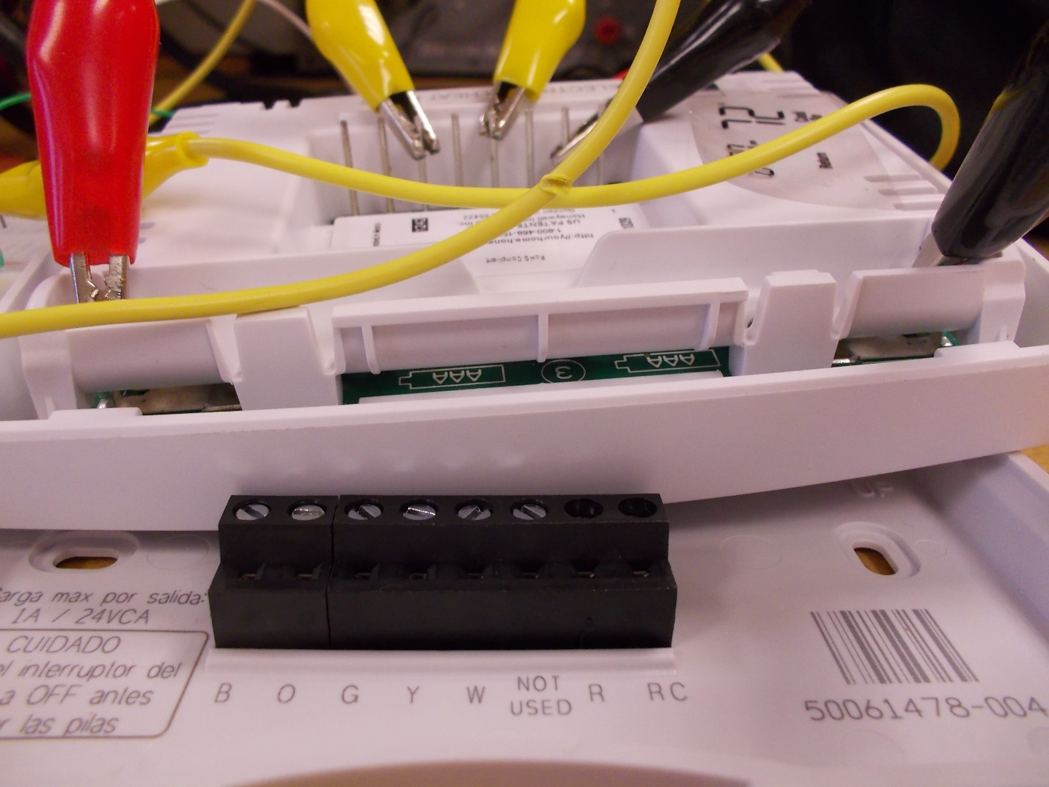

Negative Battery   
Terminal

Positive Battery Terminal

*Fig 3(Pin and terminal layout of thermostat)*

1. Connect the 3V power source to the battery terminals of the thermostat. This supplies power to the circuitry of the thermostat.
2. Connect the positive end of the 5V power supply to both the R and RC pins on the back of the thermostat. This supplies power to the other pins.
3. Connect the G pin to one of the coil pins of Relay1, and the other to ground. This will supply power to the coil of Relay1 when the thermostat turns on the heat connection.
4. Connect the W pin to one of the coil pins of Relay2, and the other to ground. This will supply power to the coil of Relay2 when the thermostat turns on the fan connection.
5. Connect a resistor to one of the normally open pins of Relay1 and the positive of the 5V power supply. This is to limit the current flowing through the LED.
6. Connect an LED to the other pin of the normally open pin on Relay1 and ground.

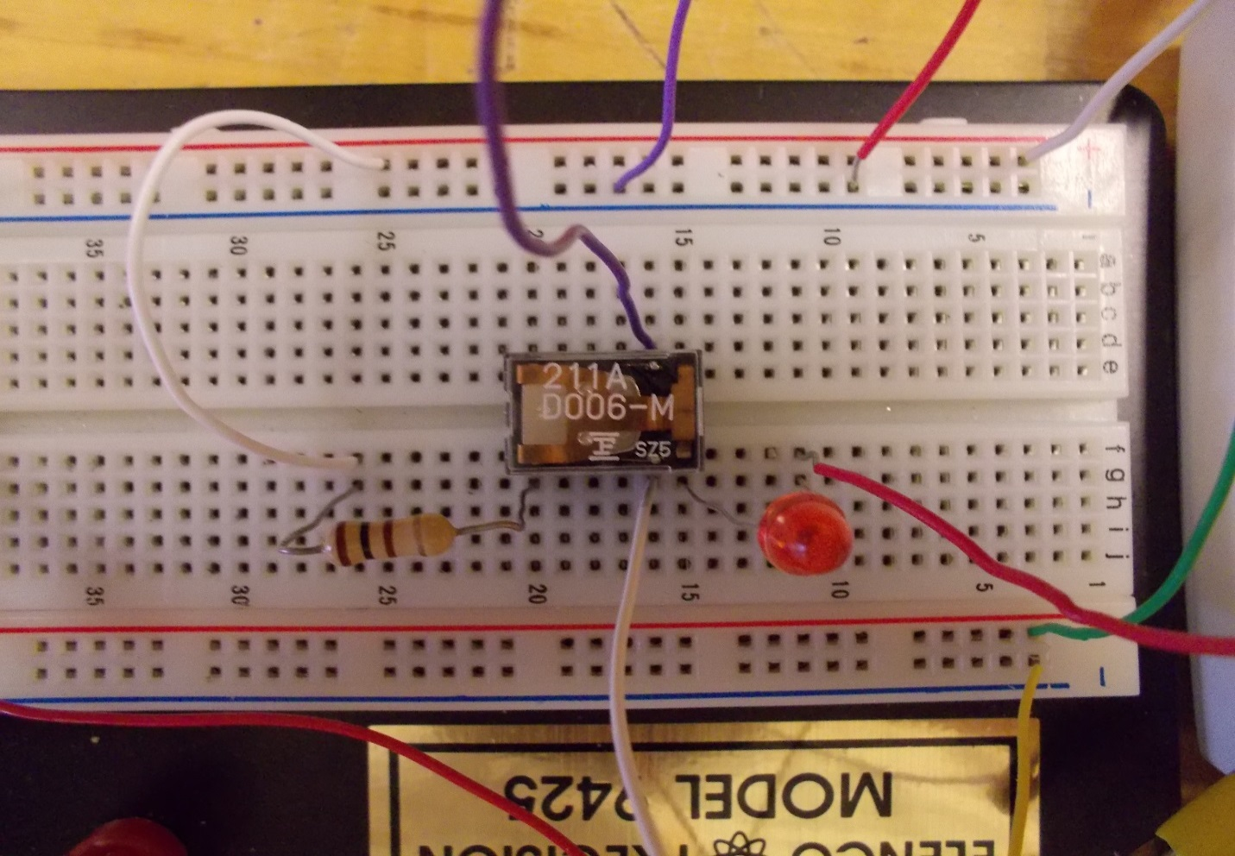

To battery + terminal -

Coil to GROUND

From PIN G

5 volts to resistor

3 Volts + -(GROUND)

LED to GROUND

5 Volts to R and RC pins

5 Volts + -(GROUND)

*Fig 3 (Connections for heat)*

*(Relay pin layout may differ. Confirm pin layout for your specific relays.)*

1. Repeat steps 6 and 7 for Realy2.
2. Check with your instructor to make sure all your connections are correct and with their permission power on the circuit.

**Testing Heating Control of a Thermostat**

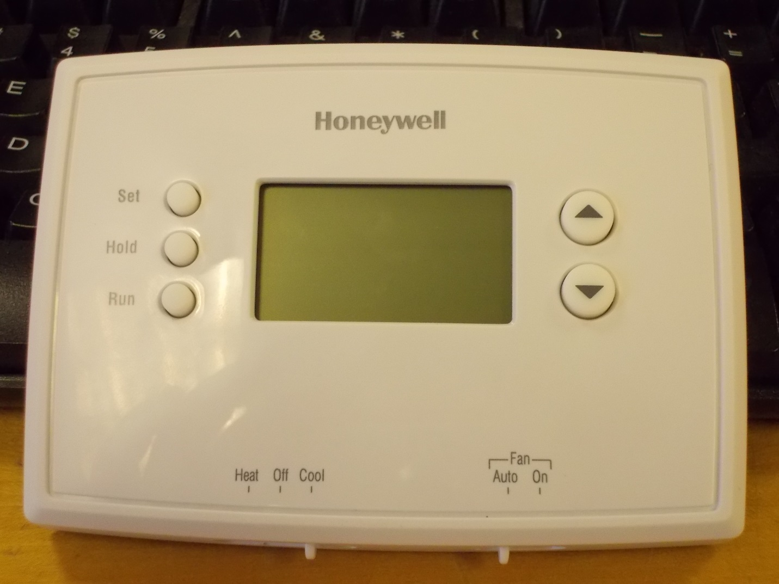

System Switch

Temperature Controls

1. Set the System switch to heat.
2. Set the thermostat to one degree above room temperature and the heat LED will light.

Room Temperature:______________ Set Temperature:______________

1. Apply heat with a heat gun held about a foot away from the thermostat for 5-10 seconds, the heat LED will go off. Take note of the temperature when the LED turns off.

Temperature when LED turns off:______________

1. Apply cool air to accelerate the cooling process. When the temperature gets below the set temperature the heat LED will turn on again. Take note of the temperature when the LED turns on.

Temperature when LED turns on:______________

**Testing Cooling Control of a Thermostat**

1. Set the System switch to cool.
2. Set the thermostat to one degree below room temperature and the cooled will light.
3. Apply cool air until the cool LED turns off. Take note of the temperature when the LED turns off.

Temperature when LED turns off:______________

1. Apply heat with a heat gun held about a foot away from the thermostat for 5-10 seconds, the cool LED will turn on. Take note of the temperature when the LED turns on.

Temperature when LED turns on:______________