Social VR Professional Development Workshops
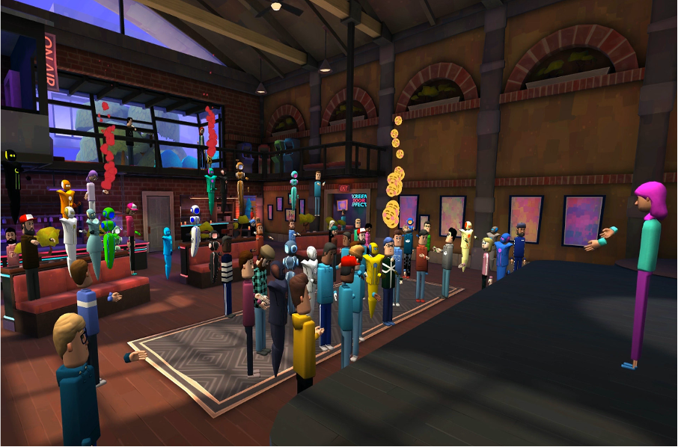

A Guide to Developing and Implementing Effective and Engaging Social VR Events

April 2021

Contents
A Guide to Developing and Implementing Effective and Engaging Social VR Events 0
April 2021 0
Forward 3
Problem Statement: The Rush to Get Online 4
Background: Virtual Reality, Augmented Reality, Mixed Reality, and Social VR 4
Why Now? 5
A Promising Solution for Education 5
The Autonomous Vehicle Technology Sensors: Air, Land, Sea Workshop – October 2020 6
Other SOCIAL 6
VR platforms 6
Technical Resources Required 6
Interview with Mark Gill, Visualization Engineer, Director of St. Cloud State University’s Visualization Lab, and NCAT Senior Personnel 6
Basic Equipment needs 7
Human Resources 9
Team of Individuals Interviewed and Their Roles/Contributions for VR Event 9
Key Learning: Developing and Delivering a Successful Social VR Event/Workshop 12
What Worked 12
Suggested Improvements 14
Participant Voices: Perspectives on a Social VR Event 16
What Participants Loved 16
Overcoming Skepticism and Knowing What to Anticipate 17
Conclusion 18
Contact NCAT 19
Appendix 1: Teaching Using Social VR 20
Appendix 2: Examples of Pre-Workshop Resources for Participants 21
22
Appendix 3: Examples of Social VR Platforms 24
Appendix 4: SCSU VizLab 26
References 27

Forward

Thank you for your interest. The emergence and inescapability of Social Virtual Reality (Social VR) is changing STEM education, STEM fields, and the STEM related technician workforce. The National Center for Autonomous Technologies (NCAT) offers this white paper, Social VR Professional Development Workshops: A Guide to Developing and Implementing Effective and Engaging Social VR Events, to educators and students.
Along with the educational audience, NCAT specifically wants to reach out to young people, parents, and families. Public/community involvement and support are critical to advancing Autonomous Technologies, Social VR, and future technologies. NCAT endeavors to be diverse, equitable, and inclusive across initiatives and engagements. Educational events in Social VR reaching audiences in different time zones and geographical locations is one way to reach a broader audience and engage not only educators and students but also the community at large.

Jonathan Beck

NCAT Principal Investigator

The need for Diversity, Equity, and Inclusion (DEI) in STEM education and STEM fields has never been greater or more urgent. NCAT’s ability and willingness to help engage students, educators, and colleges in navigating Social VR safely and effectively – even as the technology is changing and expanding in real time – is a step towards integrating DEI perspectives, practices, and resources into our work. NCAT promises to share what we learn along the way.

Chelsea Bladow

NCAT Equity & Inclusion Communications Director

Problem Statement: The Rush to Get Online
In 2020, NCAT became a leader in the use of Social Virtual Reality by quickly responding to pandemic imposed closures by offering educators some of the earliest opportunities to learn how to teach in Social VR or social virtual reality.
This white paper uses the example of a professional development workshop conducted entirely in Social VR to guide the reader through the process of developing and implementing effective and engaging Social VR events that support learning, participation, and fill the void of inter-personal connections that have long been the downside of distance learning in any form.

Background: Virtual Reality, Augmented Reality, Mixed Reality, and Social VR
Let’s start by defining some terms: As early as 1994, a paper from the ISEE defined virtual reality (VR) as: “virtual reality involves the creation and experience of environments. Its central objective is to place the participant in an environment that is not normally or easily experienced. This objective is satisfied by establishing a relationship between the participant and the created environment.”
Augmented Reality overlays digital information on real-world elements. Pokémon GO* is among the best-known examples. Augmented reality keeps the real world central but enhances it with other digital details, layering new strata of perception, and supplementing your reality or environment.
Mixed Reality brings together real world and digital elements. Although the term “mixed reality” was coined as far back as 1994, it is trending in 2021. Mixed Reality is defined as “a blend of physical and digital worlds, unlocking the links between human, computer, and environment interaction. This new reality is based on advancements in computer vision, graphical processing power, display technology, and input systems.” At the March 2021 Ignite Conference hosted annually by Microsoft for developers and IT professionals, the day one keynote is all about how "mixed reality is transforming the way we work, live, and play.” A recent report from the World Economic Forum argues that “connecting more people to AR and VR technologies could transform everything from education and healthcare to mining and tourism.” The education market intelligence analyst, HolonIQ, finds that “global spending on artificial and virtual reality in education is expected to soar from $1.8 billion to $12.6 billion annually by 2025.
More recently, PC Magazine defined Social VR as: “getting together in a simulated world using a virtual reality (VR) system and Social VR app. Participants appear as avatars in environments that can be lifelike or fantasy worlds.”
Forbes magazine points out the inevitability of VR adoption and adaptation in all spheres of education and the need for equity in the technological landscape:
For educators in the midst of a pandemic, online classrooms can transform into 3D virtual lecture halls with state-of-the-art technology…Ultimately though, the question with this technology is not if, but rather when it will be implemented. Equitable adoption of virtual reality will require tremendous resources in an already asymmetric technological landscape. But this is not a problem of capital investment; money follows innovation without fail. Instead, it is a problem of human perception. And of the inescapable reluctance associated with impending change.

Why Now?

A Promising Solution for Education
A pandemic lockdown which curtailed almost all in-person educational experiences, combined with the much-increased availability, accessibility, and usability of virtual reality platforms, created a perfect storm for education to venture into a “third space” beyond in-person and online. Virtual and augmented reality technologies have transitioned from being a source of exciting but supplemental activities to providing daily, necessary, core experiences for both faculty and students. The need for Social VR spaces arises from a confluence of factors:
- Innovations and alternatives in online education
- Online replacement of cancelled face-to-face functions
- Social engagement
- Zoom fatigue

Beyond the Pandemic: Social VR based professional development workshops can:
- Increase access and inclusivity for educators unable to travel to in-person workshops
- Provide needed support, connection, communities of practice
- Introduce educators to new technologies in both their discipline and in VR
- Offer flexible time/place professional development opportunities for underserved communities
- Present opportunities for hands-on learning and safe risk-taking
- Save travel expenses and time
- Reduce carbon emissions

Once the domain of hobbyists and high-tech enthusiasts, AR and VR are becoming increasingly integrated into everyday education delivery and learning processes. To address the ubiquity of these technologies and to provide a roadmap for educators, this white paper explores the “why” and the “how to” of using Social VR to bridge the gap between current and cutting-edge teaching/learning tools. Even when there are no pandemics.
The white paper discusses the key learnings from the development and implementation of a professional development workshop in VR by NCAT. While this workshop was created using AltspaceVR, however the lessons learned are applicable to development of events in a variety of Social VR platforms. The white paper is largely based upon interviews with Center personnel who led, built, and coordinated the event.

The Autonomous Vehicle Technology Sensors: Air, Land, Sea Workshop – October 2020
This Social VR workshop was designed to deliver a primer on the sensor technologies impacting the aerospace, automotive, heavy equipment, and marine autonomous technologies industries. Educators from these disciplines face many challenges from the rapid integration and prohibitive financial nature of these technologies. Jobs of the future will require a foundational level of knowledge of these sensors. Through hands-on experience and discussion, the workshop covered industry trends and the future impact of advanced technology integration resulting from autonomous technologies. Participants learned how to use Social VR technology in their classroom using portable, cost efficient experimentation and exercises.

Technical Resources Required
Engage
Mozilla Hubs
Glue
Every platform:
- Has a ‘Sandbox’
- Imposes limitations
- Experiential limitations
- Some platforms are more open that others
- Every platform is proprietary
- Every platform provides different tools
  - Videos, Slides, Web Pages
  - Interactable (whiteboard)
All the platforms have a 2D version for non-VR users:
- Streaming into video conference or recording
- 2D might be the better client for presenting
- Lacks engagement of Immersive version

Other SOCIAL

VR platforms

DIY VR is possible. The key and labor-intensive component to VR is onboarding everyone, bringing everyone up to speed. Anything that can leverage, accelerate, and ease that part of a Social VR experience (the onboarding) is critical. NCAT’s work is about contributing to a body of knowledge. The general concepts of Social VR, the benefits of VR, and the uses of VR, are constant from one platform to another. The platforms may change and/or the requirements may change, but the purpose remains the same. See Appendix 3 for examples.

Interview with Mark Gill, Visualization Engineer, Director of St. Cloud State University’s Visualization Lab, and NCAT Senior Personnel

Mark was responsible for the design and implementation of NCAT’s first Social VR based professional development workshop.

What was your role?
My biggest role was being the one to say “Hey, we could do this!” NCAT was a great team to be on. They took the idea and really ran with it. Everybody on the VR team was productive.
I designed the space. The big upside to Social VR is that it maintains social connections. It is an organic communication missing from other virtual platforms such as Zoom and Teams and others.

What is the cost of a workshop like this?
Cost – that depends on what I need to develop. With AltspaceVR by Microsoft, there are templates of “spaces” and preconfigured spaces. You can create something with minimal effort, without a lot of customization. A space with a custom look and feel/brand/logos or bringing different organizations’ presence into the space would require significant development time.
An effort usually starts with functional requirements. For the NCAT VR workshop, I provided the initial set of requirements with input from the VR team workgroup through several iterations. For the more basic worlds (e.g., use of templates, little customization, etc.), I would estimate about 100 development hours to put a world together. I have built worlds that have taken 200-300 development hours – these are more complex and involved with significant customization.

Basic Equipment needs

One of the following:

A Gaming PC with a tethered VR Headset

An Oculus Quest/Quest2

A Mac or PC and the 2D Client
Onboarding participants with content delivery, familiarity/orientation sessions, equipment testing and navigation in the VR experiential space, that also must be factored into the cost of developing a workshop like NCAT’s VR Sensors Technology workshop. There can be anywhere from a few to dozens of trainings ahead of the real time event.
Logistically, onboarding your support staff is critical. They need to have serious hours to dedicate, be comfortable with the VR spaces, have technical expertise, have an orientation to the space and environment, and stand ready to assist everyone. For each one of those people, they will invest minimum 10-20 hours of using/testing/playing around with the platform, equipment, hardware, etc.
The largest cost of a VR project is in human resources/person power. With AltspaceVR for example, it is free to use and freely accessible. Buying headsets as an option is based on a per person cost. The biggest cost is the people involved.

How much time does a workshop like this take to design and implement?
With no onboarding, I could put together a VR event in an afternoon. As noted, the key is educating and onboarding your audience and stakeholders – internal event team members; event presenters; and event participants.

Based on your role, what technical skills would a team need to ensure success?
A VR event effort needs somebody with skills in content creation if you want anything that is customized or branded in another sort of way. From a technical standpoint, there is no programming or software engineering. There is a critical IT level effort required – even as time goes, and the technology gets easier. There is a need for someone with 3D modeling skills who can work with tools and create new original content. There is currently nowhere in the Minnesota system where this background (in content creation) is taught or learned.
Pre pandemic our team at SCSU focused on group collaboration (e.g., MN-NICE initiative trying to build an environment for 20-30 people to be able to see each other and collaborate with both VR and physical dimensions). The entire model collapsed with COVID-19. Our Lab also had students working on projects for Social VR and event development.
Even with isolation and losing the collaborative VR work the Lab was engaged with before the pandemic, this has been the best year ever for me professionally – assisting teams and efforts with Social VR.

What other team resources are necessary for a college/team/department to successfully offer a VR based workshop?
Jon Beck, Jill Zande, and key others at NCAT are true believers and champions. You need to have people on the team who are invested in Social VR and who can motivate others to be invested, dedicate their time and attention, and sustain a focus on the project from concept through delivery.
With both physical and virtual events, a lot of the challenges, hurdles, and solutions are the same. The skills to run a VR event are the same skills as face to face. Example: What to do with an unruly audience member? Give them a warning, then tell them to leave! The solutions are the same in the VR world and physical world. The best is to have team members who want it to work; who see that it can work; and who convey enthusiasm to others.

What did you learn?
Honestly, I learn new stuff every day. Where do you start? For a singular lesson though, I would say I learned a lot about configuring a space for large audiences – designing one space that does everything and would be suitable for everything. I learned smaller spaces with refined focus – that are linked together – are more efficient from a technical standpoint.
Every time I do something like this, I learn. From every world, every event I host or moderate, every world I built, I learn. Probably would not do them if they didn’t facilitate my learning.

What did not go as well as you hoped?
Of course, I would have wanted more time to spend working on the space. Before Covid, I intended to go the Northland Community and Technical College campus (Thief River Falls, Minnesota) and take reference photos for myself. The original concept of the world for the workshop was based on using the entire NCTC campus. What was created for the VR workshop was something that I hoped was evocative and reminiscent of the space. I would still like to do a VR replica Northland – visiting the campus and building that out.

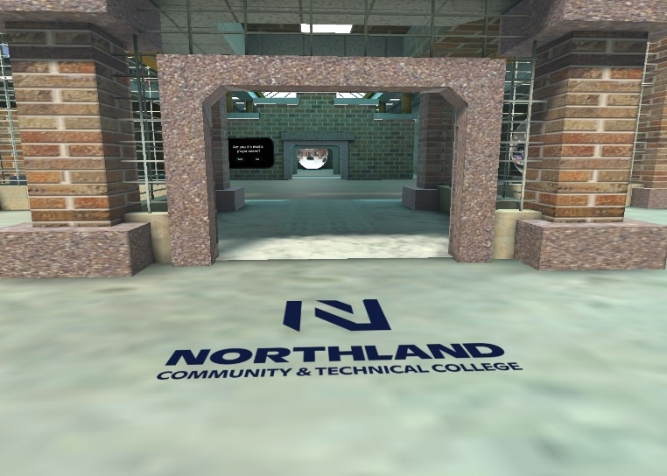
Human Resources

Team of Individuals Interviewed and Their Roles/Contributions for VR Event
Everyone named here contributed in a variety of roles as the VR Sensors Technology Workshop was designed, developed, tested, and delivered. The VR Event Workgroup and Leads met consistently starting in March 2020 to advance development of the VR workshop and deliver the workshop in October 2020. The timeline of 7-8 months from concept (of the workshop being done with VR due to the pandemic) was the minimum time needed to produce and launch a successful VR event.

The following list of Contributors is a potential staffing template for leaders and teams considering a Social VR Event.
These individuals on the NCAT team fulfilled multiple overlapping roles to successfully deploy the requisite Human Resources in the design and delivery of the VR Sensors Technology workshop. Please see Appendix 2 for pre-workshop preparation materials developed by the team and sent out to participants and presenters in advance.
- NCAT PI and Executive Director, Jon Beck, Northland
  - Vision Lead
  - Host of Event/Key Participant
  - Administrator/User/Tester
- NCAT Associate Director, Anton Bergee, Northland
  - Technology Forward Team Leader for VR Workshop Development
  - Onsite Camera Support for Orientations, Practice Sessions, and Real Time Delivery
  - Administrator/User/Tester
- NCAT Administrator, Havie Lee, Northland
  - Onsite Support for Orientation Sessions and Real Time Workshop Support
  - Key Participant
  - Administrator/User/Tester
- NCAT Technical Director, Zach Bladow, Northland
  - Technology Hands on Facilitator for Design, Development, and Delivery
  - Technical Support and Troubleshooting Lead
  - Onsite Support for Development, Orientations, Practice Sessions, and Real Time Delivery
- NCAT Communications/DEI Director, Chelsea Bladow, Northland
  - Communications and Diversity Equity & Inclusion (DEI) Lead for Workshop
  - Key Participant
  - Administrator/User/Tester
- NCAT Senior Personnel and Architect of VR Workshop, Mark Gill, Director of Visualization Lab, St. Cloud State University
  - Vision and Technology Lead/Chief Architect of VR Workshop
  - Educator/Facilitator/Presenter for NCAT Team and Workshop Presenters/Participants
  - Onsite Experiential Guidance, Troubleshooting, and Support
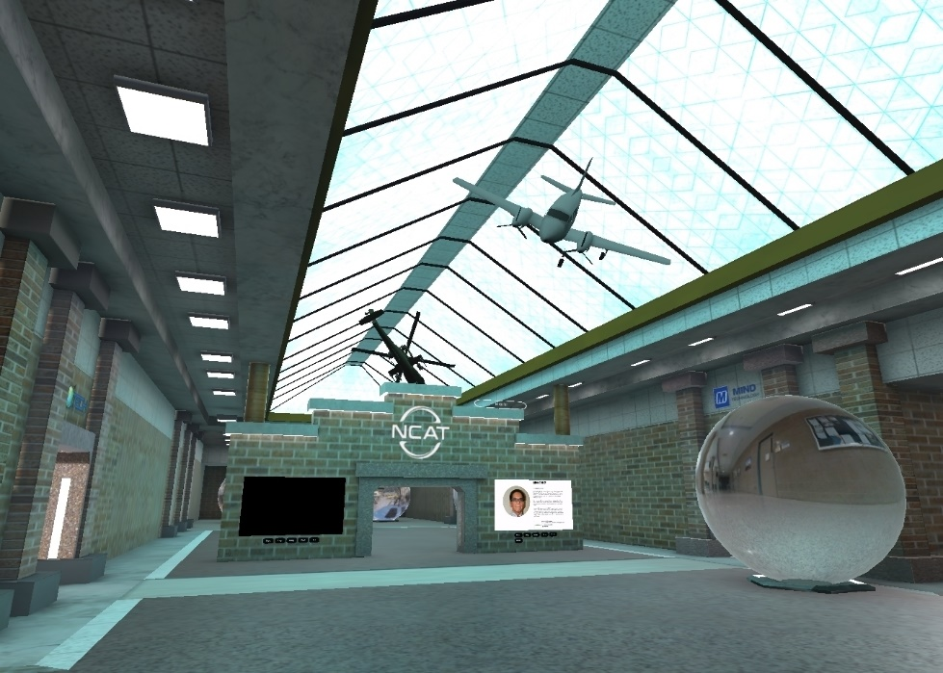
- NCAT Senior Personnel and Presenter, CAAT Director, Ben Cruz, Macomb Community College
  - Presenter on Proximity Sensors and Radars for Automotive Applications
  - Key Participant/ Troubleshooter in Orientations, Practice Sessions, and Real Time Delivery
  - User/Tester
- NCAT Co-PI, UAS Instructor, Zack Nicklin, NCTC
  - Project Director and Workgroup Organizer/Communicator/Facilitator
  - Leader/Host for VR Orientations, Practice Sessions, and Real Time Delivery
  - Presented on Thermal Sensors and Introduced All Presenters
- NCAT Co-PI, MATE Executive Director/President, Jill Zande
  - Facilitator and Industry (Subject Matter Expert) Connector
  - Key Participant in Orientations, Practice Sessions, and Real Time Delivery
  - Champion and Supporter/User/Tester
- NCAT Co-PI and MN Transportation Center of Excellence Executive Director, Chris Hadfield, Dakota Community and Technical College
  - Opening Presenter and Host in Online Orientations and Real Time Delivery
  - Key Participant in Orientations, Practice Sessions, and Real Time Delivery
  - User/Tester/Troubleshooter
- NCAT Subject Matter Expert and Presenter, Kirk Steuve, Geography Professor, SCSU
  - Workshop Presenter on Underwater Sonar Technology, Capabilities, and Applications
  - Subject Matter Expert
- NCAT Industry Partner and Presenter, Jon Robertson, Manager, Teledyne Imaging
- Presented on Teledyne Marine Acoustic Imaging
- Subject Matter Expert

Key Learnings: Developing and Delivering a Successful Social VR Event/Workshop

This professional development workshop yielded a series of important lessons (what to do and not do). This section breaks down the key learnings into Technical, Logistical, and Tactical areas – all of which must come together to create a smooth, user-friendly experience.

What Worked
  - Technical:
- Comprehensive behind the scenes/back-end IT expertise and support
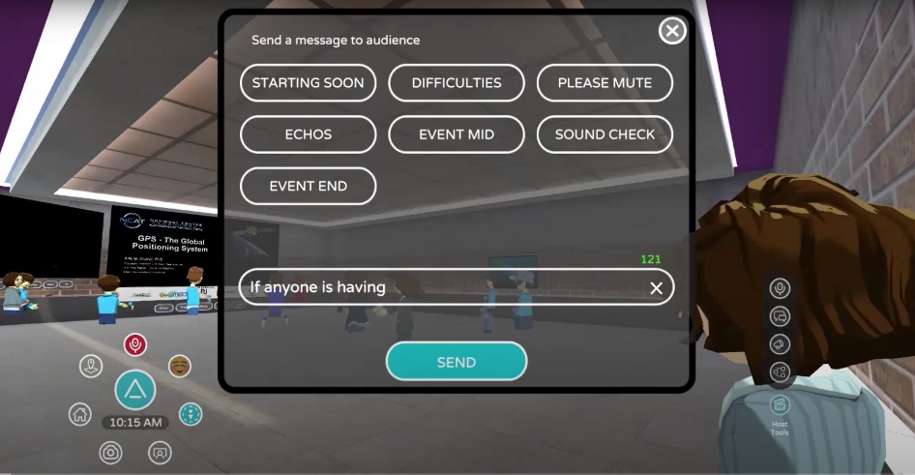
- Real-time troubleshooting during dry runs and during event
- Choices of 2D and 3D – give presenters and participants the option they prefer
- Engaging displays in front of the virtual building
- Ability to walk into bubbles and look at labs
- Clear instructions for users on how to:
  - adjust straps on goggles
  - create boundaries
  - disconnect
- Instructional videos to watch ahead of time to learn how to move around and interact in the space
- Using real names for avatars (bubble over their head)
- Ensuring presenters were comfortable (drives the vibe of room) and ready to present in that format
- Understanding where peoples’ starting points are with VR
- Participating in the advance trainings was key to the successful delivery of live event
- Allowing adequate time to settle in with equipment and the environment
- Learning there’s a speaker/presenter mode/voice. Like the “school principal” voice, wherever you were, you needed to listen
- Letting participants know that if your avatar faces you, you hear better – just like in real world
  - Logistical/Tactical:
- Opportunities for everyone to get in the environment early and practice
- Taking care of issues before the event which helps presenters and participants
- Scaling for success of event (rather than go big/do everything and not be as successful)
- Dry run trials really helped organize and professionalize the workshop and presentations
- Bringing folks in early and often
- Adequate technical and logistical staffing bandwidth
- Fewer words, bigger fonts on slides
- Entertainment: give participants something to do (e.g., throw snowballs or basketballs) in the environment in addition to SME presentations
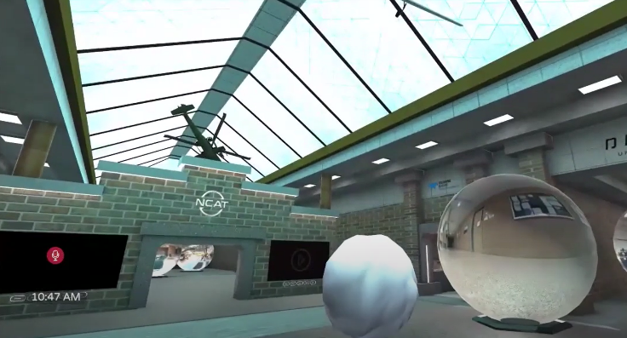
- Breaks are important. Sometimes you need to remove the goggles headset and take a physical break
- Gained data/insights on how to do a workshop/do a project with multiple people all over the place geographically in different time zones

Suggested Improvements
  - Technical:
- Compile a tip sheet on how to use the goggles
- Ensure participants get goggles before and start to adjust a few weeks before
- Ensure people knew how to counterweigh the goggles to minimize pressure
- Offer a second platform: Another chance to open the door for more registrants, for example, first 20 get VR and others can sign on Zoom
- Live stream on social media to get social media more involved
- Make the networking formal; allocate time and space to have follow ups post sessions/presentations
- Add networking time between sessions. Maybe more focused time for breakout sessions
- Structure networking and conversations where participants feel free to mingle and interact
- Require early commitments, requirements, practice sessions from presenters
- Be prepared to figure out the audio communication glitches during the live event, e.g. intermittent drops
- Reduce information on each slide and talk through (do not overload slides with too much content)
- Offer multiple display set up options. Quote from presenter: “I would have liked to have a screen or window in my screen to see my presentation instead of having to look at the presentation as the audience was seeing it. Easier presenting as if in person on a stage with a computer and your slides in front of you”
- Make suggestions on how to have interaction and hands-on experiences, e.g., “something to do” that is connected to the content of the workshop
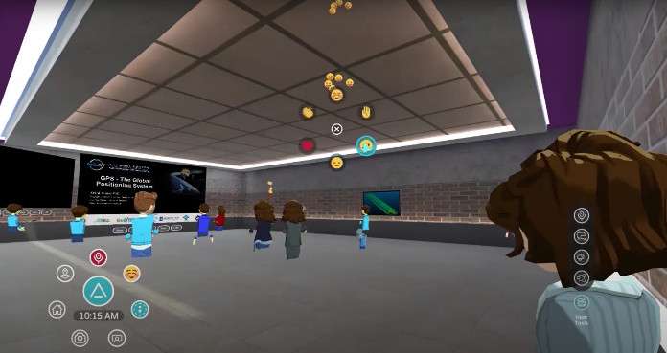
- Encourage/require use of all the pre-workshop resources/materials sent out before the workshop which could have taken care of many questions
- Offer day of workshop exercises for people to try out all the features offered by a platform -- like emojis, hover over a name. Trying out all the cool features makes it more fun and more engaging

  - Logistical/Tactical:
- Firm close on the registration: This impacts shipping, welcome letters, etc. (see Appendix 2 for registration materials, resources/samples)
- Set up phone call communications with presenters and whoever is putting on the event
- Require minimum 2 weeks lead time for all presenter materials to be submitted
- Have a moderator to streamline questions and answers during the event
- Increase the time frame to coordinate, build, and test the environment
- Understand what scale of VR can be accomplished in given time frame
- Offer more interactive environment and interactions around the SMEs’ content and topics (i.e., not only throwing snowballs and basketballs)
- Get equipment out as early as possible to all (support team, presenters, participants) so they have more time to explore
- Research and have a plan on how to engage participants in the environment and have it related to the content of the presentation
- Include ice breakers, social/VR “happy hours” or “coffee breaks,” and social networking aspects between participants both inside and outside sessions
- Go through a dry run of the workshop itself (for the team), not just the technology
- Formalize the peer review of presentations for each other to increase effectiveness, efficiency. Have the workspace open, walk around, see the others’ presentations

Participant Voices: Perspectives on a Social VR Event

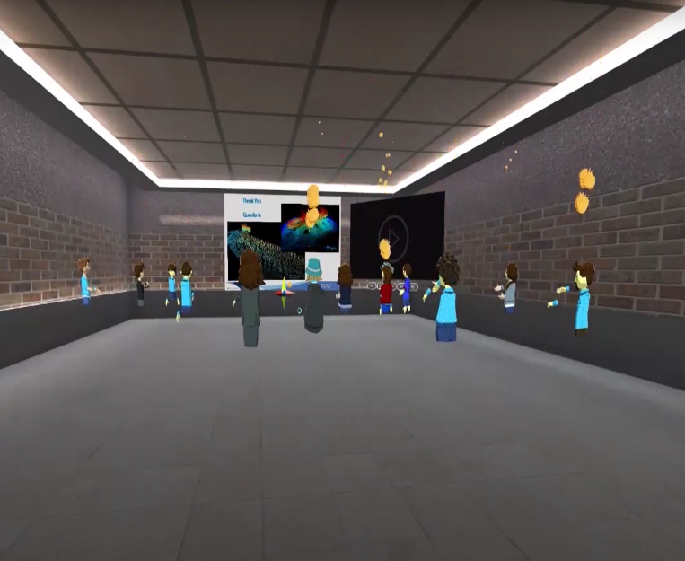
What Participants Loved
“Free rein to access site ahead of event for exploration, familiarity, practice, comfort.”
“Getting people into the site early prevented problems and decreased anxiety.”
“You are more tuned in and engaged because of VR.”
“You can tell when someone takes off their goggles, so you know if they are still participating.”
“The social experience was enjoyable, especially since we are so limited with social experiences right now. Would love to have another VR workshop!”
“Social/virtual experience showing emotions. People were good about asking questions. Fun to send messages to each other. Do things like gather in the lobby throwing snowballs.”
“Leaving the VR environment, I walked out the door like I would at a real conference. As opposed to just taking off the headset and having my avatar bow her head!”
“The interaction with others in the virtual conference was positive. Felt like I was more in a conference environment than just doing a screen sharing presentation/Zoom meeting.”
“Having a sidebar conversation with people one on one to answer questions. Some folks do not like to ask questions in front of the whole group. This environment allowed follow up conversations with individuals -- a great feature.”
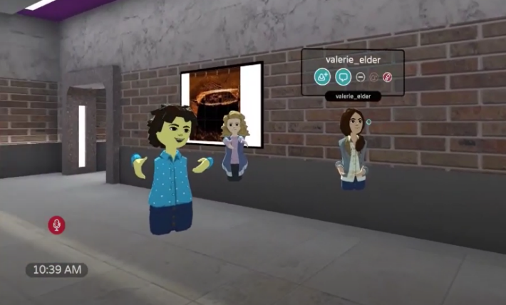
“Going to workshop or conference, an important part of it is networking. Technical/professional discussions and things of that nature that occur inside the room or in the hallways outside the room (of the presentation). Can that magic still occur in virtual world? It did occur!”
“Skeptic turned cheerleader for VR.”
“We are all Zoomed out, so it was refreshing to have something different.”

Overcoming Skepticism and Knowing What to Anticipate
“None of us knew what to expect during practice session.”
“Finding a way to counterweigh the goggles.”
“Goggles pressed on nose and gave me headaches.”
“Learned I could adjust the straps on the goggles.”
“Making sure the presenters were comfortable as that drives the vibe of the room.”
“My biggest thing was not getting sick/nauseous with the goggles and equipment.”
“Disconnecting – I ran into a couch during one of the practice sessions.”
“Didn’t end up using the equipment because it made me dizzy.”
“Keep both 2D and 3D as options.”
“I was 50/50 comfort and skepticism.”
“Technology made me nervous at first.”
“I was extremely skeptical it would work.”

Conclusion
With new and emergent technologies changing teaching and learning today and for the foreseeable future, NCAT is committed to helping its partners and stakeholders stay current. NCAT strives to make informative and useful advanced technology content, such as Social VR for Education, accessible to students, educators, administrators, and the public -- especially young people in the community.
NCAT's endeavors to advance Social VR for Education concepts and practices are informed by focused attention to diversity, equity, and inclusion. As discussed in this white paper, the critical keys to success in the world of Social VR are dedicated human resources and technology applications responsive to emerging needs of users. NCAT's mission to lead the nation's technician education for Autonomous Technologies -- Air, Land, and Sea, is supported and complemented by strategic initiatives, such as Social VR, VR accessibility, and other rising technologies.
Teaching in Social VR is an evolving and expanding field with rapid growth predicted in the near future. NCAT team hopes this White Paper will serve as a useful resource for others in STEM education and invites you to collaborate and share your interests and comments.

Contact NCAT

Jonathan Beck | Executive Director and PI
National Center for Autonomous Technologies
National Science Foundation ATE Program
UAS Technology Instructor
Northland Community and Technical College
13892 Airport Drive
Thief River Falls, MN 56701
O - (218) 683-8831
jonathan.beck@northlandcollege.edu | ncatech.org

Published April 2021

Appendix 1: Teaching Using Social VR
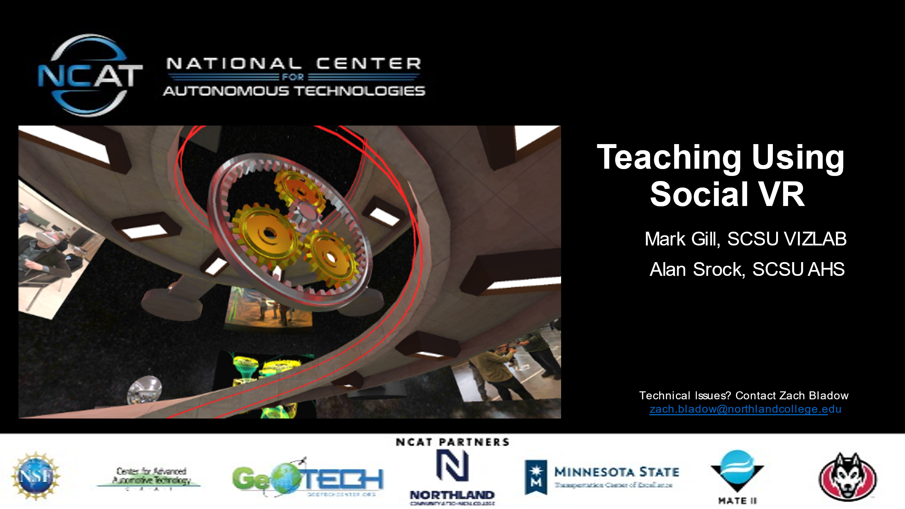

Teaching Using Social VR is available at:

https://ncatech.org/videos/#uael-video-gallery-7093db2-8

Appendix 2: Examples of Pre-Workshop Resources for Participants

2.1 How to Use the NCAT Oculus Quest Package

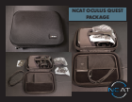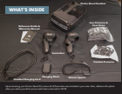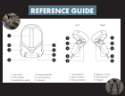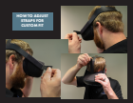
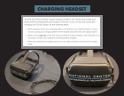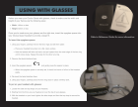

2.2 Registration
Thank you for being a part of the VR Accessibility group. We have virtual reality equipment ready to ship to you but first we need the following things:

Register on the NCAT website as a new user if you haven’t already https://ncatech.org/user-registration/.
If you do not need equipment please confirm by email with the NCAT team at ncat@northlandcollege.edu, (the equipment checkout process below is not required if you have your own equipment).
Complete the equipment checkout: https://ncatech.org/equipment-rental/

Once your equipment checkout form is processed you will receive a confirmation email regarding the shipment of your equipment.

For basic tutorials on your VR setup and AltspaceVR event information visit: https://ncatech.org/autonomous-vehicle-technology-sensors/.

For technical assistance please contact Zach Bladow at zach.bladow@northlandcollege.edu | (218) 683-8851.

For general questions please log in to the NCAT forum at: https://ncatech.org/community/

Thank you for being part of this amazing opportunity. Please don’t hesitate to contact the NCAT team at ncat@northlandcollege.edu.

2.3 Set Up and Use
Your VR equipment has been sent, once you receive your equipment:
Once the equipment is received please check to make sure everything is in working order and contact NCAT immediately with any problems (ncat@northlandcollege.edu).
Attached is an equipment information sheet for your review.
You will receive a reminder email to return equipment roughly two weeks prior to the required return date. If you’d like to request an extension, please provide this in writing to ncat@northlandcollege.edu.
When you are ready to return the equipment email the NCAT team ncat@northlandcollege.edu for a return shipping label. The equipment can be packaged in the original box or a large flat rate Priority Mail USPS box.

For basic tutorials on your VR setup and AltspaceVR event information visit: https://ncatech.org/autonomous-vehicle-technology-sensors/.
For technical assistance please contact Zach Bladow at zach.bladow@northlandcollege.edu | (218) 683-8851.
For general questions please log in to the NCAT forum at: https://ncatech.org/community/.
Thank you for being part of this amazing opportunity. Please don’t hesitate to contact the NCAT team at ncat@northlandcollege.edu.

Appendix 3: Examples of Social VR Platforms
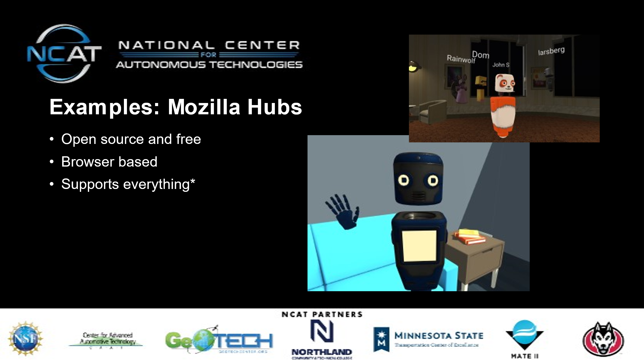
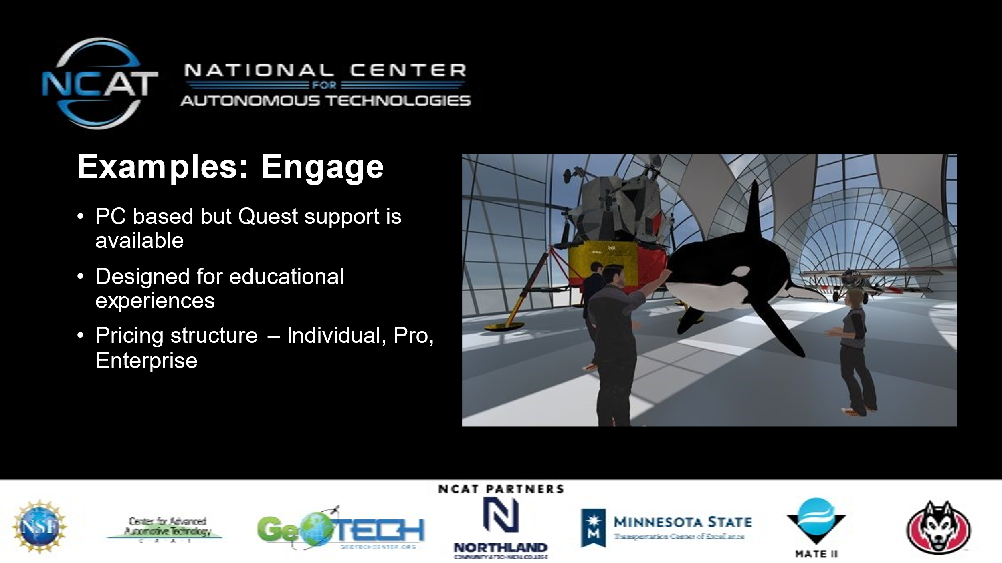
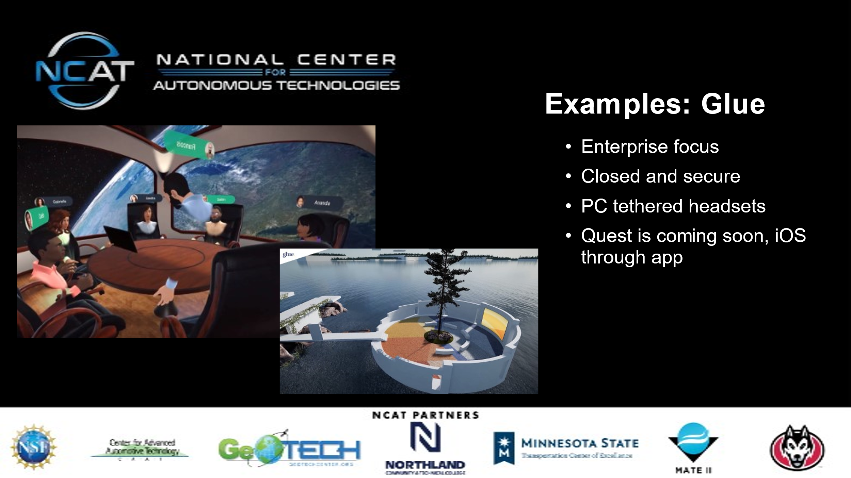

Appendix 4: SCSU VizLab
Established in 2014, as part of the Integrated Science and Engineering Laboratory Facility (ISELF), the St. Cloud State University’s (SCSU) VizLab serves as a cross-discipline workspace for specialized application development catering to a wide variety of stakeholders within and without the University system. The primary mission of the SCSU VizLab is to provide student engagement through creating software solutions to real world challenges. Additionally, the VizLab has pursued the latest in emergent visualization and educational technology.

References

J. N. Latta and D. J. Oberg, "A conceptual virtual reality model," in IEEE Computer Graphics and Applications, vol. 14, no. 1, pp. 23-29, Jan. 1994, doi: 10.1109/38.250915.
https://www.intel.com/content/www/us/en/tech-tips-and-tricks/virtual-reality-vs-augmented-reality.html
https://docs.microsoft.com/en-us/windows/mixed-reality/discover/mixed-reality
https://www.zdnet.com/article/microsoft-to-talk-about-the-future-of-mixed-reality-at-ignite-conference-next-week/
https://www.weforum.org/agenda/2021/02/virtual-reality-augmented-reality-sustainable-development/
https://www.holoniq.com/edtech/10-charts-that-explain-the-global-education-technology-market/
https://www.pcmag.com/encyclopedia/term/social-vr#:~:text=Z,vTime%20Social%20VR
https://www.forbes.com/sites/alishahbaz/2021/02/21/can-your-company-use-virtual-reality-instead-of-zoom-yes-heres-how/?ss=diversity-inclusion&sh=4ccdaaf26b98

