Name: Date:
Infrared Transmitter and Receiver
Infrared light is electromagnetic radiation with wavelengths longer than visible light but shorter than radio waves, making it just beyond the spectrum of visibility for the human eye. It has many natural sources; everything from the sun to humans produces infrared light, though in varying quantities (e.g. the sun emits far more than people do.) Even ice has been found to emit infrared light! In 1800, William Herschel discovered infrared light by monitoring the temperature changes between the colors of the visible spectrum. Temperatures increased from blue to red, and continued to increase even beyond red on the spectrum. The temperature that he was measuring was from infrared light!
Infrared signals are a cheap and efficient way to transmit data, which is why this technology is widely used in consumer electronics. When a button is pressed on a remote for a TV, an infrared signal is transmitted to the TV, and a certain action is performed. Different companies utilize different protocols in their infrared data transmission; regardless of what protocol is used, the data being transmitted is wrapped by start and stop bits. The start bits alert the receiver that a command will soon follow, and the stop bits indicate that the transmission has ended. One downfall of using infrared for data transmission is the presence of infrared sources other than the data transmitter. Because of this environmental infrared noise, infrared transmitters are designed to oscillate at a certain frequency. The receiver is simply “tuned” to react to that frequency. It will ignore any infrared signals that are outside of that carrier frequency, much the way your radio is tuned to your favorite FM channel.

The Infrared (IR) Receiver Parts List:
1-4.7µF Capacitor
1-100Ω Resistor
1-Vishay P4833 Phototransistor

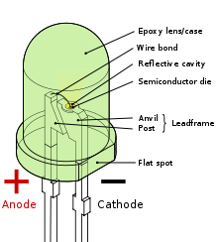
The Infrared (IR) Transmitter Parts List:
1-IR LED
1-100Ω Resistor

- Use the following schematic to build your Infrared Receiver. Be sure to connect your oscilloscope leads properly.
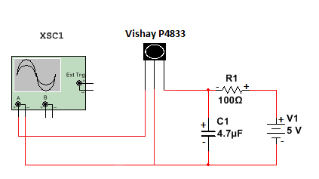
- Set Channel 1 of your oscilloscope to DC coupling. Apply power to the circuit. Record your voltage here:

- Use the following schematic to build your Infrared Transmitter, ensuring the LED is placed within a short distance of the sensing part of the phototransistor, with no obstructions between them.
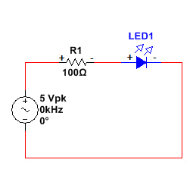

- Set the function generator to 5Vpk at 29 kHz and connect this circuit to Channel 2 of the oscilloscope. Increase the frequency by 1 kHz increments, noting any changes in Channel 1 and documenting your findings in the table below.

**Hint** if you are not finding a change in the output voltage of your receiver, try using your camera phone to check that your IR LED is functioning properly. Our eyes cannot detect IR, but our camera phones sure can!!

Freq. | 29 kHz | 30 kHz | 31 kHz | 32 kHz | 33 kHz | 34 kHz | 35 kHz | 36 kHz | 37 kHz
IR Receiver V-Out

- Notice what frequencies the receiver reacts to. This is a result of the band pass filter that is integrated within the phototransistor. The image below is a block diagram representation of the Vishay P4388 phototransistor. The band pass filter allows a certain “band”, or range, of frequencies through, and attenuates, or blocks all the rest. What does this tell you about the filter built into the phototransistor? What is the approximate range?
What is the center frequency?
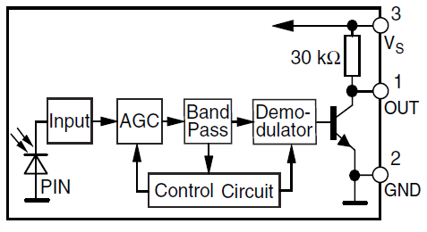

The receiver is in its default state when no IR light is present in the defined frequency band. This is called the “space” state. When IR light is present within the defined frequency, the receiver is in its “mark” state. It is the combination of spaces and marks that make up the data transmission.

- Use an IR remote in place of the IR transmitter circuit. Monitor the output of the receiver on Channel 1 of the oscilloscope. Press any button on the IR remote. Did you capture an IR data transmission? Configure your oscilloscope’s trigger function to pulse to better capture the data transmission.

