**The Future of Maritime Engineering   
and Logistics:**

**Automated Shipping Cranes**

**Research Paper and Associated Experiment**

**for High School   
(9-12 grade) STEM classes**

**by**

**Carina Stocker**

**Student, Roanoke Valley Governor’s School**



**Abstract**

The objective of this project was to create a small-scale autonomous gantry crane which could move containers on and off of a docked boat.

The components of this project included an Arduino Uno board, a Parallax shield, two Parallax servos, an ultrasonic sensor, a color sensor, various structural pieces, fishing wire, six travel-sized toothpaste boxes, plastic containers, and four neodymium magnets. First, the crane structure was assembled and the servos and sensors were tested and attached. Then the main code was written and the parameters for the sensor and servo functions were measured. The crane system was then tested twice with each stack configuration (there could be 0–3 containers in stack A and 0–3 containers in stack B).

Data was collected for the number of successfully moved containers, the occurrence of ultrasonic errors, and the success of the routine. Of 26 trials, 75.86% of the containers were moved successfully, an ultrasonic error occurred 3.85% of the time, and the 57.69% of the runs were completed without any errors.

This system’s performance would not be acceptable in a real-world shipping port scenario. However, several issues impaired the system’s consistency, including the trolley gear slippage, servo imprecision, and the hoist wire occasionally slipping off the hoist pulley. The system also consistently required manual assistance to position the spreader for an accurate ultrasonic scan and to release containers on the dock stack. If these limitations on precision and accuracy were to be minimized, the system’s performance would be greatly improved.

**Introduction**

The industry of maritime trade is one of the oldest in human history. The logistics, communication, finances, and even engineering components involved in the multimodal transport off goods have driven the advancement of technology since the time of the earliest civilizations. Today, the technology of marine-based trade involves far more complex technical arrangements than merely ships and crates of goods; it includes composite and precise intermodal logistics, innovative engineering, and even robotic systems.

Logistics is one of the most prevalent constituents of the shipping industry. By definition, logistics is the coordination of the transportation of people or supplies; maritime logistics is “the primary means of transporting parts and finished goods…on a global scale” (Song & Lee, 2009). Logistical analysis is instrumental in the transportation of goods, particularly concerning intermodal means of transporting merchandise; almost all goods produced in modern institutions travel from producer to consumer by more than one mode of transportation. For example, clothing from a factory may be moved on trucks, by container cranes at a port, on a container ship, and on another truck all in the same journey. Various exporting and importing industries also require varied methods of transport, and different companies within each industry have individual preferred methods as well; this complexity leads to a high demand for human labor. According to a study of American lumber exports, “exporters differ significantly in their transportation methods…they were also significantly larger than expected in their total production and employment” (Parhizkar, 2008). Naturally, a great deal of mathematics and algorithmic problem-solving is invested into these logistics. However, not all logistical improvements are particularly complex; one of the current proposed changes to American ports is simply widespread expansion, allowing service to larger ships (Burnson, 2014). This would prevent many smaller ports from being forced to turn away customers.

While the importance of logistics in shipping is relatively well known, many people who have little personal involvement in the shipping industry underestimate the prevalence of engineering and computer technologies in the modern world of trade. Engineers are using modern technologies to improve every aspect of the shipping process. For example, LiDAR (infrared) scanners can be employed to accurately record the speed and location of a crane moving on a rail (Wrobel, 2013). As ships become larger to haul more cargo, ports must compensate by dredging deeper ports; these underwater landscaping projects require careful planning and advanced engineering strategies. Maritime engineers must also consider the location, size, and accessibility of individual ports and how these constraints to efficiency can be reduced. Advanced maritime docks, particularly the dry docks used for shipbuilding and maintenance, are some of the most complex engineering feats in the world. Unusual or precarious methods of cargo movement such as ship-to-ship transfers by ship-mounted cranes may offer more convenient or efficient cargo movement at the cost of complex engineering (Masoud, 2000).

Many military operations also depend on high-efficiency logistics of maritime-based cargo. For example, onshore troops may urgently require cargo from offshore vessels in the absence of an established port structure. Cranes, roll-on/roll-off vessels, and even helicopters are sometimes used to transfer such cargo from ship to shore, but these methods “significantly increase the complexity, difficulty and manpower required to sustain a similar throughput”; therefore, autonomous transfer systems such as ship-launched parafoils carrying cargo containers are currently in development (J. Dexter Bird).

As major shipping ports grow in size, greater numbers of longshoreman must be hired to operate the cranes through remote control systems. This high dependence on human control causes an economic drain on the industry; employee salaries and benefits are expensive, and human drivers are often inefficient and may damage equipment or goods if they do not operate the system with care. Maritime engineers have responded to this problem with automated cranes. Just as robotic delivery systems are gaining popularity in hospitals (DeBenedette, 2011), they are also being implemented on a much larger scale in shipping ports. One of these systems is called Maxview; it is an autonomous shipping container handling system which eliminates the possibility of human error in arranging shipping containers. With LiDAR scan data, the Maxview software can locate targeted containers, avoid other container stacks, and regulate the speed of the crane spreader’s movement to ensure accuracy and prevent damage in the relocation of containers. There are also limited versions of the system, where a human driver controls the crane and the autonomous Maxview system only overrides during container lowering and landing (TMEIC Corporation). Though these autonomous systems have not been perfected and have only been implemented in some of the largest international ports, their implementation has been an overall success in the global shipping industry.

This primary objective of this project was to design a small autonomous system which simulated the functions of a ship-to-shore container crane. The secondary objective of this project was to modify this crane system so it could be marketable to schools as an educational kit, promoting careers in engineering and the maritime industry to children and young adults.

Autonomous shipping cranes, which have already been implemented at several large international ports, are the probable future of the shipping industry and therefore the entire global economy. If this project is successfully promoted to younger generations, it will hopefully promote the maritime technology careers which are necessary for the maintenance and improvement of modern trade.

**Methods and Materials**

The crane was constructed from various metal structural components and hardware (screws, bolts, washers, etc.), including VEX Robotics hardware (Figure 1). The trolley was originally designed as a metal plate which slid up and down the crane arm, but the friction proved too great for the trolley servo to move without the gear skipping, so the trolley was recreated from light cardboard which rolled up and down the arm on two LEGO wheel pieces. The trolley gear is a LEGO piece, and the rack gear below the arm is a 3D-printed piece which was designed in Autodesk Inventor (Figure 2). Two segments of fishing wire were used as the hoist cables.

The six containers were travel-sized toothpaste boxes (still containing the toothpaste tubes) covered on top with sheet magnet and covered in paper on the other sides. One end of each container has a piece of Velcro which can attach to either a red or blue cardstock “color tag,” which is also backed with Velcro.

The dock setup consisted of two medium-sized plastic containers. One was turned upside-down as a dock for the crane to rest on, and the other was placed perpendicular to the first and filled with water for the barge to float in. The barge (or boat) on which container stacks A and B were placed was a small plastic container covered with a foam board rectangle. It was moored in place from all four corners with twine cord.

Two Parallax continuous rotation servos were used to extend and retract the trolley along the crane arm and to lift and lower the hoist. The hoist servo was attached to the back of the crane arm with rubber bands. The Parallax PING ultrasonic sensor was placed in the spreader facing downward; a hole was drilled in the metal spreader frame to allow the sensor to scan the stacks below. The Parallax ColorPAL color sensor was attached to the spreader by wooden standoffs which positioned the sensor to meet the color patches on a container. A Parallax Piezo speaker was used to play various tones which indicated different stages of the system routine to the experimenter.

The spreader, which connected to containers with 4 round neodymium magnets, had no mechanism for container release; therefore, the experimenter manually removed containers from the spreader when necessary. However, an electromagnetic system was originally intended to reverse the magnetic fields of several 1/8 inch cube-shaped neodymium magnets (which would be holding the container when the electromagnets were not turned on). This system included 2 metal bobbins, fine electrical wire, 8 1/8 inch neodymium magnet cubes, and a 6V battery compartment that held 4 D batteries (Figure 4). In lab tests, this system worked as intended occasionally, but not consistently enough to be implemented in the final crane design. A Sainsmart 5V relay, which is not visible in the appendix diagram since it was not necessary for testing the electromagnets, would have been used to control the electromagnets (so they could be turned on and off through the Arduino board).

The servos and sensors were controlled through an Arduino Uno board with a Parallax Board of Education Shield. Arduino Code was used to program the robot (Figure 3).

For data collection, the crane system routine was run twice with each boat stack configuration (0-3 containers in stack A and 0-3 containers in B). However, varying containers in stack B were not tested when there were 3 containers in stack A; unless the PING sensor misread the height of stack A (which was highly unlikely), the dock would be filled by the 3 containers in stack A and the spreader would never check stack B. Therefore, while stack A had 3 containers, the containers in stack B were irrelevant.

For each routine, data was collected on the number of containers successfully moved to the dock, the occurrence of PING sensor errors, and the successful completion of the routine (meaning that as many containers were moved from the boat to the dock as possible). The data was then analyzed to determine the percentage of successfully moved containers, the frequency of the PING sensor errors, and the percentage of successful routines. See Table 1 of the appendix for the collected data and statistics.

**Results**

Of 58 total containers, 44 (75.86%) were successfully moved from the boat to the dock stack. In 26 total trials, a PING ultrasonic sensor error occurred once (3.85% of the time). Of 26 total trials, the routine was successfully completed 15 times (57.69% of the time).

During data collection, two manual adjustments had to be repeatedly made by the experimenter. The containers were connected to the spreader by magnets, but the spreader had no mechanism to release the containers since the electromagnetic release system did not work; therefore, the containers required manual removal from the spreader once placed on the dock stack.

The spreader also needed to be rotated slightly before each PING ultrasonic scan. The extension of the trolley often caused the spreader to tilt, offsetting the PING scanner’s line of sight from the containers. The scanner would still operate correctly, but it would not be measuring the distance from the spreader to the topmost container in the stack.

**Conclusions**

Due to this crane system’s relatively poor performance, it would not be an effective replacement for manual crane controls in real shipping ports. Approximately 24% of the containers that should have been moved were either not picked up or dropped, and about 42% of the overall routines were not executed properly. However, the system flaws which caused these large error statistics could be reduced or eliminated with further research.

These complications included the imprecision of the servos (which also operated from slightly inaccurate parameters), trolley gear slippage, and hoist wire slippage. The servo functions in the code depended on manually measured time values. For example, to extend the trolley from stack A to stack B, the trolley servo needed to run for approximately 1300 milliseconds. However, if the trolley gear slipped or something impeded the servo’s regular speed for even a miniscule amount of time, the trolley might not have extended far enough to hold the spreader over stack B. The more movements the crane made, the more the spreader’s position was offset from its proper position. This problem could potentially be solved by the use of more precise servos or the use of more ultrasonic scanners to base servo movements on relative distances rather than pre-measured parameters.

The hoist wire slippage was a less frequent problem that was instantly fatal to the crane system routine. If the spreader was lowered to far when picking up a container, the wire would accumulate enough slack on the hoist pulley to slip off the pulley entirely. This would instantly prevent any vertical movement of the spreader. This problem could be easily prevented with a more suitable hoist pulley design.

The only inexplicable problem which had no clear solution was unwanted servo coordination; occasionally, when the hoist servo was directed to rotate and the trolley servo was directed to remain still, both servos would still rotate at the same speed. This also contributed slightly to the previously mentioned complication of servo imprecision.

Despite the high rate of errors in the system’s performance, the project was an overall success because it was able to simulate the functions of a real-world ship-to-shore gantry crane with an automated software system. If the previously mentioned sources of error were to be resolved, the system’s performance would be significantly improved and the project would better demonstrate the potential of robotic systems in the shipping industry.

# Literature Cited

**Non-Peer Reviewed**

Burnson, P. (2014, October 8). *Logistics Managers can help ports achieve their infrastructure goals*. Retrieved from Logistics Management: http://www.logisticsmgmt.com/article/logistics_managers_can_help_ports_achieve_their_infrastructure_goals

DeBenedette, V. (2011, October 15). *Robotic medication delivery enhances patient care*. Retrieved from Modern Medicine Netword: Drug Topics: http://drugtopics.modernmedicine.com/drug-topics/news/modernmedicine/modern-medicine-feature-articles/robotic-medication-delivery-enhance?page=full

**Peer-Reviewed/Scholarly**

J. Dexter Bird, I. P. (n.d.). Autonomous Movement of Cargo From Ship to Shore. Hampton, Virginia, United States of America: Craft Engineering Associates, Inc. Retrieved from Virtual Acquisition Showcase: http://www.virtualacquisitionshowcase.com/

Masoud, Z. N. (2000, December 4). *A Control System for the Reduction of Cargo Pendulation of Ship-Mounted Cranes.* Retrieved from Virginia Tech University Libraries: http://scholar.lib.vt.edu/theses/available/etd-01222001-144048/unrestricted/Thesis.pdf

Parhizkar, O. (2008, March 21). *Identifying Impact Factors on Successful Exporting of the United States Hardwood Industries to Mexico, Asia, and Europe.* Retrieved from Virginia Tech University Libraries: https://vtechworks.lib.vt.edu/bitstream/handle/10919/26560/OmidParhizkar_Dissertation.pdf?sequence=1

Song, D.-W., & Lee, P. T.-W. (2009, March 20). Maritime logistics in the global supply chain. *International Journal of Logisitcs Research and Applications: A Leading Journal of Supply Chain Management*, pp. 83-84.

TMEIC Corporation. (n.d.). *The Maxview Smart Landing System.* Retrieved October 3, 2013, from TMEIC Global: http://www.tmeic.com/Repository/Others/Maxview%20Smart%20Landing%20Fact%20Sheet%20_Rev%20F_1.pdf

Wrobel, S. A. (2013). *Multi-Function Lidar Sensors for Non-Contact Speed and Track Geometry Measurement in Rail Vehicles.* Blacksburg, VA: Virginia Polytechnic Institute and State University.

**Appendix**

Figure 1

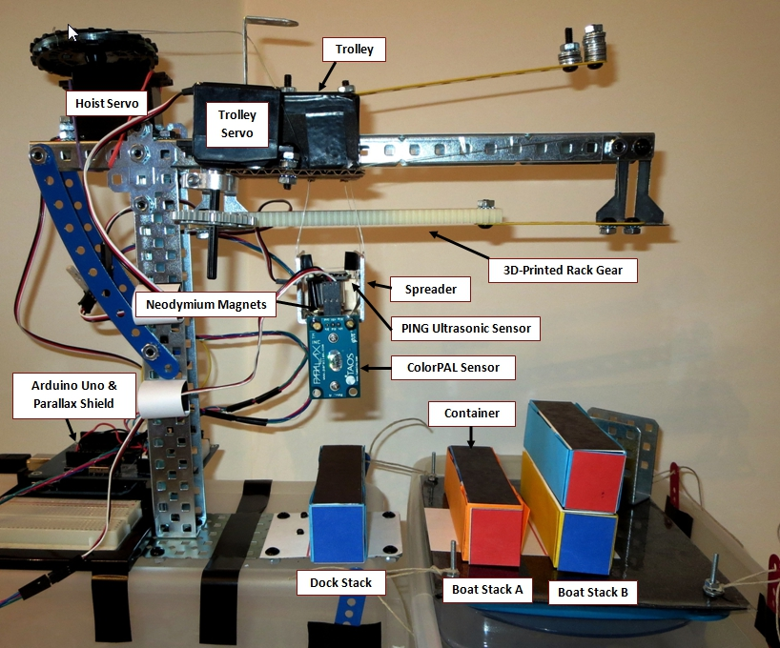

Dock Setup and Crane Design Diagram

Figure 2

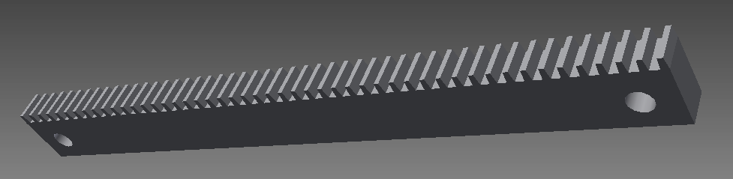

3D-Printed Rack Gear in Autodesk Inventor

Figure 3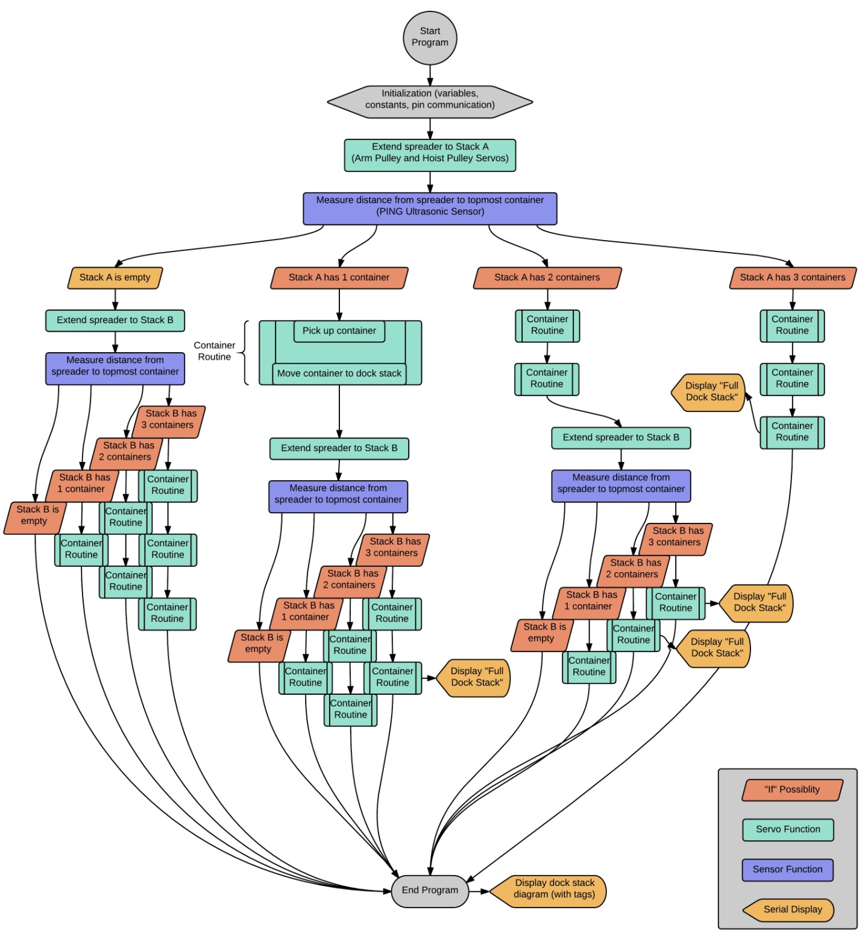

Code Flowchart

Figure 4

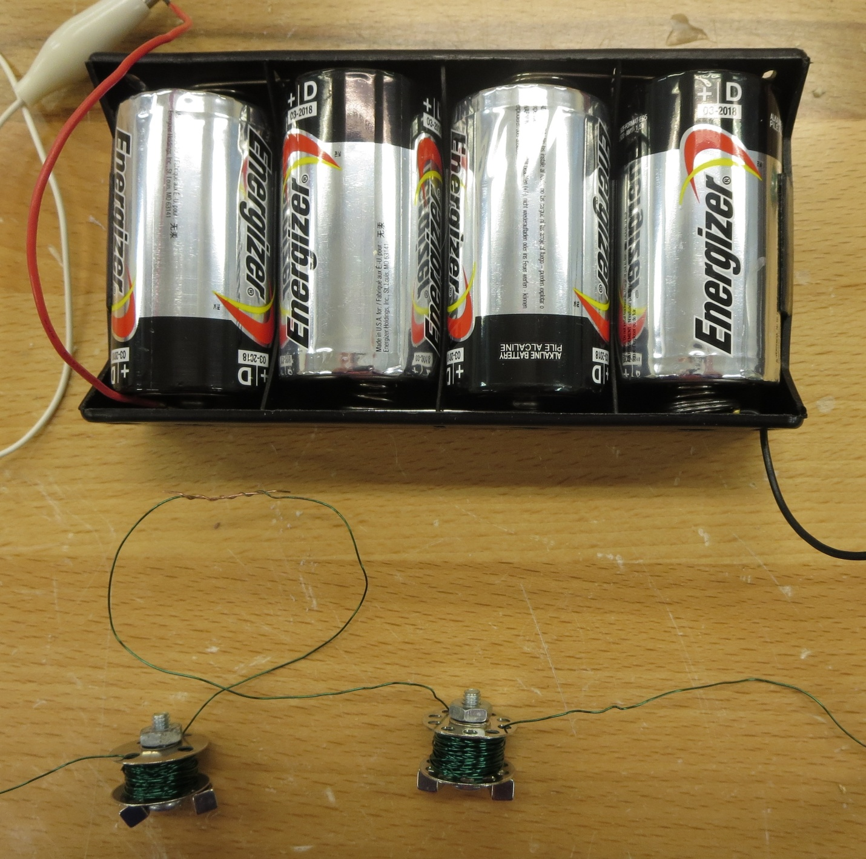

**6V Battery Pack**

**Steel Bolt**

**Neodymium Permanent Magnet Cubes**

**Metal Bobbin**

**Wire Coil**

Electromagnetic Release System Setup

Table 1



Data Collection and Statistics