SMART Girls STEaM Ahead!

A Career Exploration Unit for
High School Girls (Grades 9-12)
Classroom or Club-Based Activity

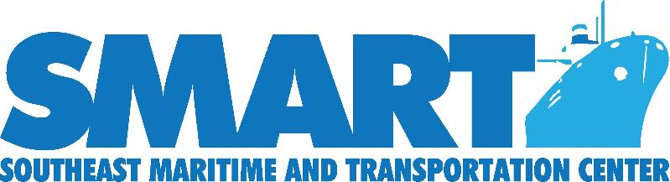

Additional modules can be found at:
www.maritime-technology.org
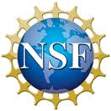
This material is based on work supported by the National Science Foundation under Grant No. 1003068. Any opinions, findings and conclusions or recommendations expressed in this material are those of the author(s) and do not necessarily reflect the views of the National Science Foundation.

Author
Jeanette Wangler, MBA
2015 SMART Maritime and Transportation Institute Alumni

Purpose
SMART Girls STEaM Ahead! is a hands-on learning module for female high school students. The goal is to expose girls to careers in STEaM (science, technology, engineering, art, math) fields, including maritime and transportation.

Duration
One class period or club meeting and homework

Materials
- Computer with internet access for each student
- Room for presentation and hands-on activity
- Small incentive prizes for participation (i.e. t-shirts with SMART logo)

Task
Students will create a personalized presentation describing a SMART STEaM career field of interest to them. The goal of this SMART STEaM event is to increase career awareness among high school girls of STEaM careers in the Maritime and Transportation industries. By utilizing technology, a hands-on creative exercise, and a homework research project with classroom presentation, it is expected the participants will become much more aware of STEaM careers and their related career pathways.

Process

- Welcome students to the SMART STEaM event! Explain what each acronym stands for and how careers in these fields are very important to women, given the critical shortage we have of employees in general, and women specifically as this is a nontraditional career field.

- Show the “Make the SMART Choice: Sarah Canclini” video found at www.maritime-technology.org. Discuss how Sarah found her way and your job is to assist your students in finding their way to successful, rewarding careers as well.
- Go to www.stemtype.stemjobs.com and have students register and take the 15 minute quiz to discover their STEM jobs category types. They can also use this website to explore careers of interest.

- Tell students now that they have a better understanding of STEM career fields, it’s time for some hands-on fun. They will now ‘go float a boat’. Given very limited supplies (one foil sheet 12x12) and limited time (5 minutes), they are to design and build a boat that will float and hold the most weight (as measured by pennies). The teacher will have a nearby water source (½ filled water bucket) that students can use to test their watercraft during assembly. (Teachers may feel free to elaborate on this event - i.e. - sailboats made with foil, straws, and small pieces of fabric that are then tested for how far they will travel when blown upon).
- After floating their boats, discuss with students the relevance of this simulation to real-world careers. Many maritime careers allow you the satisfaction of seeing your project through to completion, not just being part of a process you never see finished. Also, discuss how desperately the industry needs the input of females in careers - how women are often better welders, etc., due to attention to detail, focus, etc.

- Direct students to www.maritime-technology.org and the tab for women. Give them time to explore the videos and information available to them.

Homework assignment: Select the career of your choice on the SMART website and investigate it further. Prepare a PowerPoint or Prezi to demonstrate to your classmates what you have learned. Your presentation must include: Job Title, Educational Requirements (be specific - certifications, community college, 4 year college, apprenticeship, etc.), where the job is located, how you find these jobs, websites of employers who offer these careers and apprenticeships, whether or not you personally would consider a military pathway to these careers, and the future outlook/job growth expected. (Hint for students: www.maritime-technology.org/ has a wealth of information as well as many links to other sites that will hold the information you need.)

Evaluation
Students will be graded according to the following rubric:

Presentation: 5 - Strong 4 - Good 3 - Minimal Detail
Clearly organized
Job Title and Location
Educational Requirements
Career Pathway is clearly described
Employer Websites were noted
Future Outlook
Presentation is neat, attractive, and well-presented

Tags
SMART, STEaM, STEM, high school females, girls in STEM, maritime, transportation, careers, career pathways, hands-on activity, nontraditional career fields, apprenticeships, college, military pathways, research project, grading rubric.

