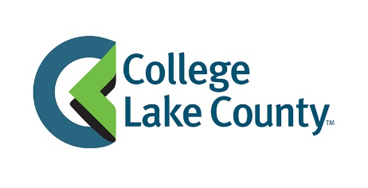
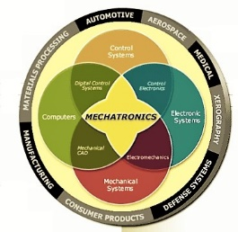
CLC Mechatronics Career Pathway

CLC Certificate- 30 credits Professional Development NEW Applied Science Degree
Employment & Siemens Level I Certification Supported by NSF Employment & Siemens Level II certification
$16- $22/hr. + benefits $23-$32/hr. + benefits
Job placement- 85-100%

*Mechanical Systems I, II, III H.S. Summer Working Connections 30 credit hour certificate
*Electrical Systems I, II, III Florida State College Jacksonville- July 24-28, 2017 Automation Systems
*Robot Design & Construction I, II, III *Five seats available for CLC district & (FSCJ, AACC) Advanced Mfg. Processes
Fundamentals of High Tech Mfg. I, II, III Five days, $100 stipend/day Mechanics and Machine Elements
*CAD I, II, III Travel, lodging, food included Process Control
Automation I, II, III Intro to Totally Integrated Mfg.
Automation IV, V, VI *Selection Criteria: 1. Bachelor’s Degree in related field, Advanced Motor Control
2. Interest in teaching dual-credit, 3. Basic electrical and
Capstone I, II, III mechanical background, 4. Industrial experience a plus, General Education- 15 credits
5. Recommendation from Principal, 6. One page proposal
Pneumatics & Hydraulics I, II, III addressing items 1-5. Submit to Margie Porter by April 1,
2017 (MargiePorter@clcillinois.edu).
STEM Readiness I, II, III

Bolded- H.S. Dual-Credit Certificate- 15 credits. All courses 1 credit meeting 22.5 hours each.
*Project Lead the Way credit- TBD

CLC Contacts- Margie Porter, NSF P.I. 847-543-2904 (MargiePorter@clcillinois.edu) or Gary L. Morgan, Grant Coordinator 847-767-1376 (gmorgan@clcillinois.edu)
Other Developments- Low Cost trainer (under $1,000/trainer) development to support the teaching of bolded courses

