Mechanical Subsystems of the Hybrid Electric Transmission

This simulation will demonstrate the usage of a planetary gear set as a transmission in a hybrid electric vehicle.

General Introduction

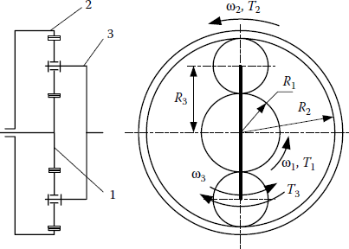

Planetary gear sets are commonly used for power-splitting applications in HEVs as a speed-coupling device. Planetary gearsets are a three-port mechanical device. The three parts of the gearset are able to move relative to each other: the sun gear, ring gear, and planet gears attached to a planet carrier.

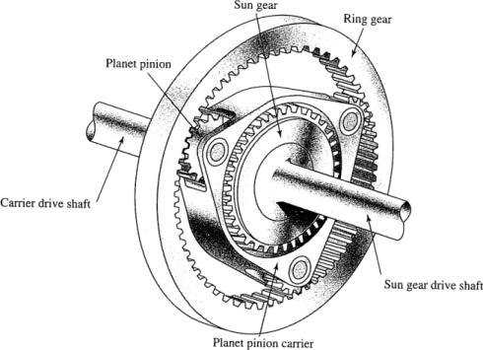

In this example, the sun gear connects to an electric motor, the ring gear is connected to the vehicle’s final drive and wheels, and the planet carrier to the engine.

**Speed Coupling**

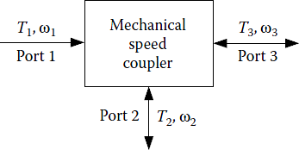

* One port may be connected to an ICE with unidirectional energy flow.
* The other two ports may be connected to the final drive and an electric motor, allowing bidirectional energy flow.

Planetary Gear Set Equations

The planetary gear set has a basic ratio, k, which can be described in terms of the radii or number of teeth of the sun and ring gears:

$$k=\frac{N_{r}}{N_{s}}=\frac{r_{r}}{r_{s}}$$

Where Nr is the number of teeth on the ring gear and Ns is the number of teeth on the sun gear. rr is the ring gear radius and rs the sun gear radius. The planetary gear set has the following speed relationship:

$$\frac{N_{r}}{N_{r}+N_{s}}ω_{r}+\frac{N_{s}}{N_{r}+N_{s}}ω_{s}=ω_{c}$$

or

$$\frac{k}{k+1}ω_{r}+\frac{1}{k+1}ω_{s}=ω_{c}$$

Where ωr, ωs, and ωc are angular velocities of the ring gear, sun gear, and planet carrier. For the hybrid transmission example: ωc = ωe (engine speed), ωs = ωm (electric motor speed), and ωr = Kf ωw (final drive gear ratio x wheel speed ).

Torque is given by the following equations:

$$T_{s}=\frac{N_{s}}{N_{r}+N_{s}}T_{c}=\frac{1}{1+k}T_{c}$$

$$T_{r}=\frac{N_{r}}{N_{r}+N_{s}}T_{c}=\frac{k}{1+k}T_{c}$$

Note that the torques are linked together. While two speeds can be selected independently, the torques cannot be. Thus, knowing one torque allows the other two to be calculated.

Simulation Model

This computational model focuses on the showing the relationship between the input data and the output of the planetary gear set transmission, which include the torque and speed.

The first part of the model demonstrates the speed-coupling usage of the gear set. A rotation speed of the engine and linear speed of the vehicle are input. The output is the necessary rotation speed of the electric motor to achieve that vehicle speed for the given engine speed. In this sense, the speed of the motor can be used to control the engine speed (for this example, to maintain a constant engine speed for the changing vehicle speed).

The desired engine speed can be changed by double-clicking on the “engine speed (rpm)” block and entering a new value.

The motor speed is calculated as vehicle speed is increasing (note that as the slope of the vehicle speed input is set to 1, the end time of the simulation will be the final speed of the vehicle, and the numeric displays will show data for this value. For example, to see the results for a vehicle speed of 10 mph, the simulation should be run for 10 seconds.

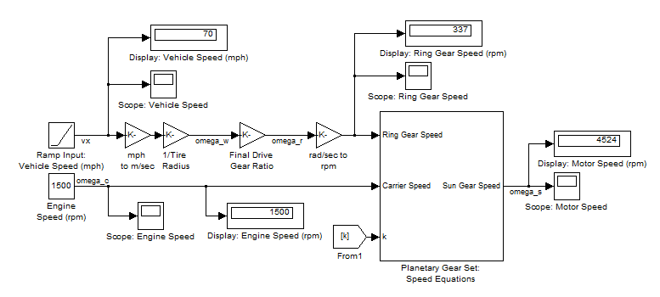

The vehicle’s linear speed is proportional to the ring gear speed. The linear speed is transformed into angular speed by dividing by the tire radius (0.287 m). It is then modified by the vehicle’s final drive gear (gear ratio = 3.93).

The Speed equation can be viewed by double-clicking on the “Planetary Gear Set: Speed Equation” subsystem box:



This subsystem implements the equation linking the speeds of the gears in the planetary gear set:

$$ω_{r}\frac{k}{1+k}+ω_{s}\frac{1}{k+1}=ω_{c}$$

Ratio k can be changed by setting the number of teeth on the ring and sun gears, Ns and Nr:



The second part of the model demonstrates the relation between torques of components connected to the planetary gear set:

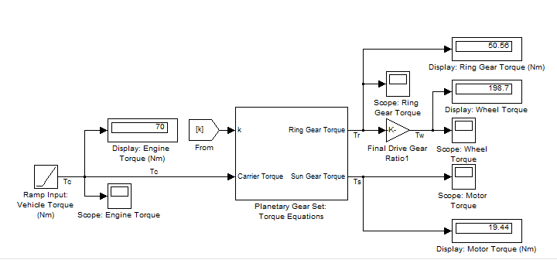

Engine torque is the input. The torque split to the other two parts of the gear set (ring and sun gears) is shown as the carrier torque is varied. Torque output to the wheels is increased by the final drive ratio. As with the speed model, the end time of the simulation will be the final torque, and the numeric displays will show data for this value.

The Torque equation can be viewed by double-clicking on the “Planetary Gear Set: Torque Equation” subsystem box:



This subsystem implements the relationship of the carrier torque, sun gear torque and ring gear torque. The equations are the following:

$$T_{s}=\frac{1}{1+k}T_{c}$$

$$T_{r}=\frac{k}{1+k}T_{c}$$

The split of engine torque is based on the number of teeth on the gears of the planetary set. For a gear set with Ns = 30 and Nr = 78, 72% of torque goes to the ring gear and 28% to the sun gear.

Simulation Result

Vehicle Speed

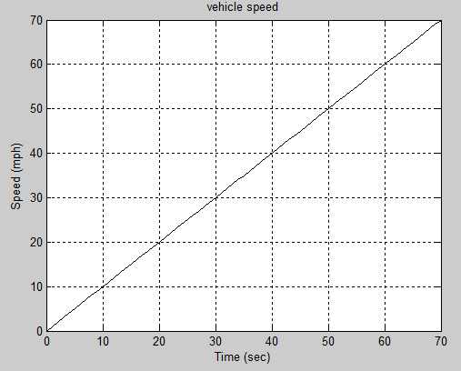

Engine Speed

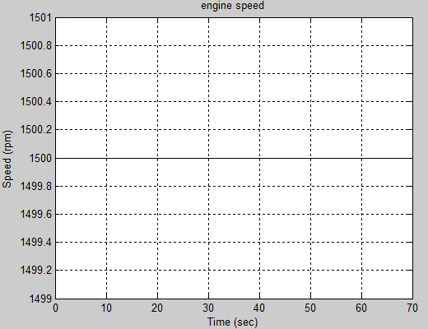

Ring Gear Speed

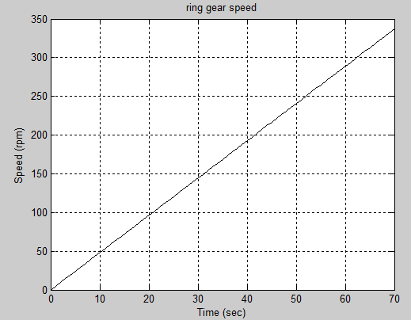

Motor Speed

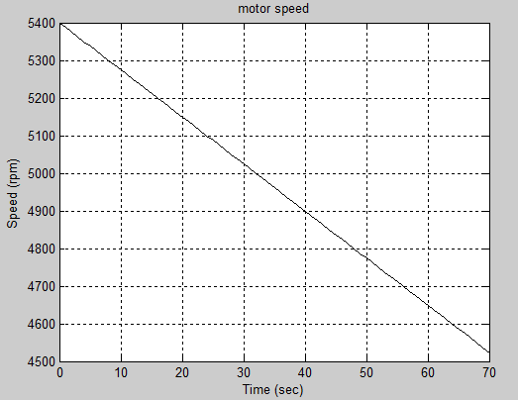

Engine Torque

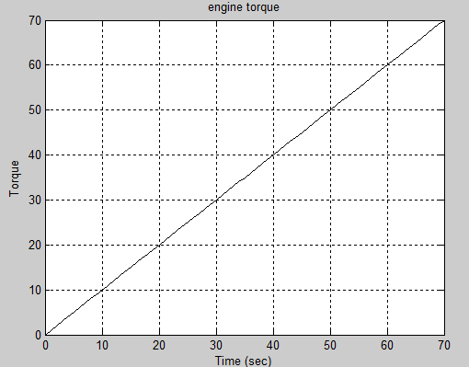

Ring Gear Torque

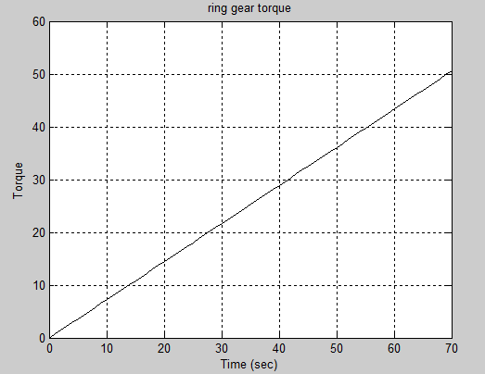

Wheel Torque

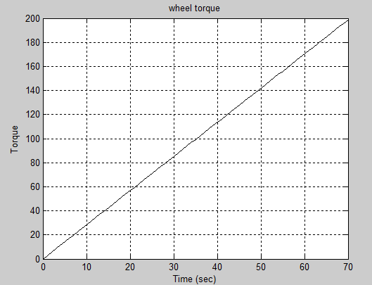

Motor Torque

