Military Veterans 4-Fold Brochure
Customizing Brochure

- Image 1 shows the outside panels for the 4-fold ARMY Veterans brochure. 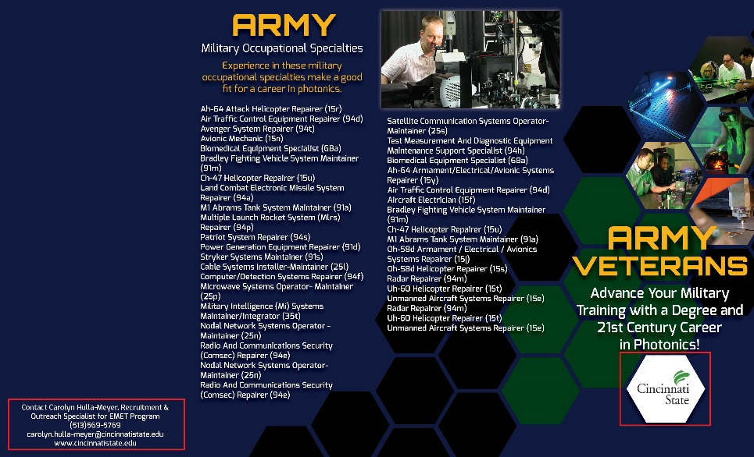
OUTSIDE
Panel 7
OUTSIDE
Panel 8
BACK
Panel 6
FRONT
Panel 1
Image 1
- Image 2 shows the inside panels of the 4-fold ARMY Veterans brochure.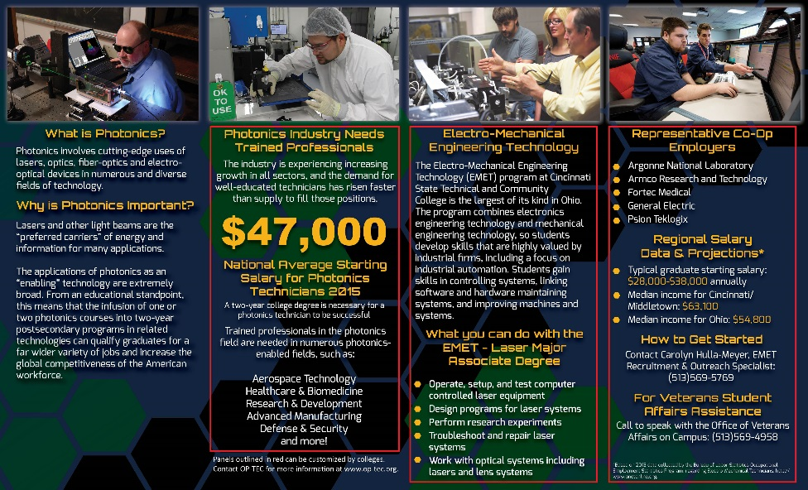
INSIDE
Panel 2
INSIDE
Panel 3
INSIDE
Panel 4
INSIDE
Panel 5
Image 2

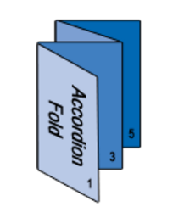
- The 4-panel brochure should be folded accordion fold as shown in Image 3.

Panel 1 is the front cover. Panels 2-5 will be the inside of the brochure.

Image 3

- Panel 1 and 6 are customizable.
- Replace logo with your logo.
- Panel 6 contact info should be replaced with your contact info.
1
6
- Panels 2 and 3 can be customized.
- Panel 3 content is optional. You can replace the content with information about photonics and the industry.
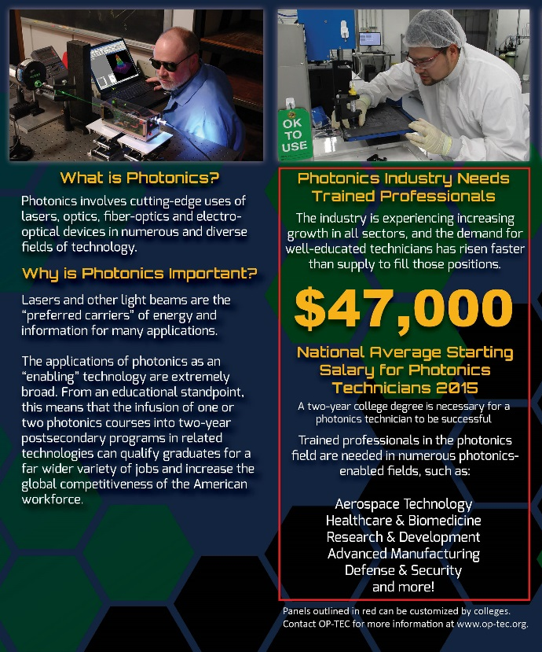
- The salary listed on panel 3 can be changed to fit your region or state.

3
2

- Panels 4 and 5 are customizable.
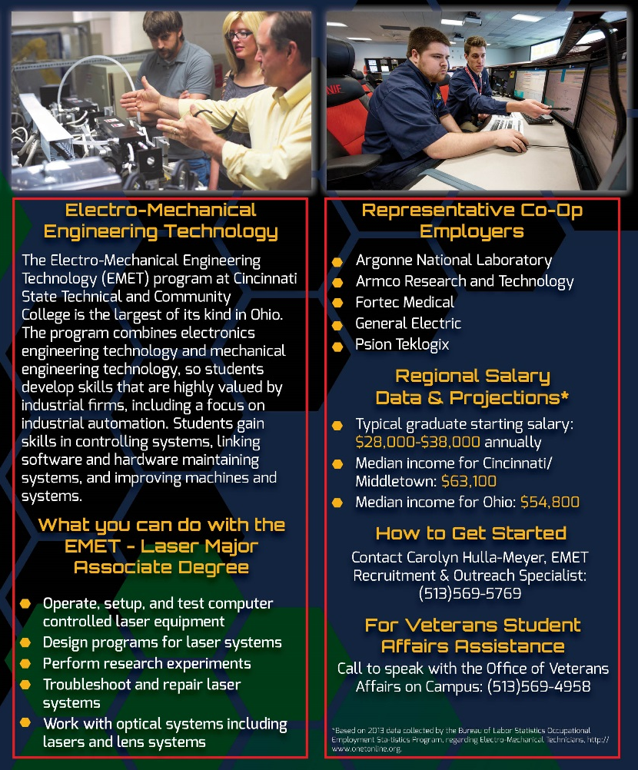
4
5
For example, panels 4 and 5 shown in image 4, display Cincinnati State Technical & Community College’s (CSTCC) program information. Panels 4 and 5 should be tailored to your program. Do not use the information displayed in the example.
Type of information you should consider providing in the brochure:
- About program
- Degrees, Certificates, and courses offered
- Department Chair, instructors, and student recruiter contact info
- Veterans Student Affairs Assistance contact information
- Veterans Student Affairs organizations
Image 4

