Military Veterans 3-Fold Brochure
Customizing Brochure

- Image 1 shows the outside panels for the 3-fold Air Force Veterans brochure.
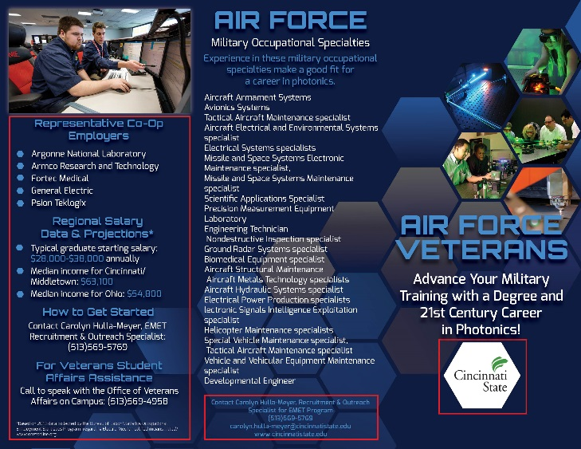
Image 1
INSIDE FLAP
Panel 5
BACK
Panel 6
FRONT
Panel 1

- Image 2 shows the inside panels of the 3-fold Air Force Veterans brochure.
INSIDE
Panel 2
Image 2
INSIDE
Panel 4
INSIDE
Panel 3

- The 3-panel brochure should be folded 3-panel roll fold as shown in Image 3.
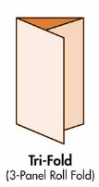
3
Panel 1 is the front cover. Panel 5 will be the inside flap of the brochure. Panel 3 is the center inside panel.
5
1
Image 3

- Panel 1, 4, and 5 are customizable.
- Replace logo with your logo.
4
5
Image 4
1
For example, panels 4 and 5 shown in image 4, display Cincinnati State Technical & Community College’s (CSTCC) program information. Panels 4 and 5 should be tailored to your college. Do not use the information displayed in the example.
Type of information you should consider providing in the brochure:
- About program
- Degrees, Certificates, and courses offered
- Department Chair, instructors, and student recruiter contact info
- Veterans Student Affairs Assistance contact information
- Veterans Student Affairs organizations

- Panels 2 and 3 can be customized.
- Panel 3 content is optional. You can replace the content with information about photonics and the industry.
- The salary listed on panel 3 can be changed to fit your region or state.
6
Panel 6 - The contact info box outlined in red should be replaced with your contact info.
3
2

