Wave Behavior of Guitar Harmonics

Marna Chamberlain

mchamberlain@piedmont.k12.ca.us

Description of Activity
- Students will review concepts regarding wave basics: types, anatomy, and calculations in order to determine wavelengths of guitar harmonics. Using a frequency app, students will measure the frequency for various harmonics to determine the speed of sound in air. Students will graph the relationship between wavelength and frequency to predict the shape of the graph in the next octave on the guitar.
- Include purpose statement. The purpose of the lesson is to connect the harmonics on the guitar to wave properties. Students will model how energy transfers from the guitar string to the ear hearing the harmonic.
- Physics Grade 9-12

Learning Objectives:

- Students will be able to measure wavelength of the first four harmonics on the guitar
- Students will determine the mathematical trends for the variables of wavelength and frequency in a constant media by graphing data collected.
- Students will be able to use technology to record the frequency of the first four harmonics.
- Students will be able to model the properties of transverse and longitudinal waves.
- Students will diagram and label the energy transfer for hearing sound from the guitar.

Standards:
CCSS.Math.Content.HSF-IF.C.7e Graph exponential and logarithmic functions, showing intercepts and end behavior, and trigonometric functions, showing period, midline, and amplitude.
NGSS HS-PS4-1. Use mathematical representations to support a claim regarding relationships among the frequency, wavelength, and speed of waves traveling in various media.

NGSS HS-PS3-3 Energy Design, build, and refine a device that works within given constraints to convert one form of energy into another form of energy.*

NGSS Cross Cutting Concepts
1: Patterns
2: Cause and Effect
4. Systems and system models.
5. Energy and matter: Flows, cycles, and conservation.
NGSS: SEPs
2. Developing and using models
3. Planning and carrying out investigations
4. Analyzing and interpreting data
5. Using mathematics and computational thinking
6. Constructing explanations (for science)

Materials Required:

- Guitar, Frequency tuner, ruler, calculator, white boards, erasers and markers

Safety:

safetys:

- None are applicable.

References:

- Standing Wave Harmonics on Guitar Strings Youtube by Doc Schuster
- Longitudinal and Transverse Waves Bozeman Biology Youtube Channel
- https://www.nextgenscience.org/
- How the Ear Works Youtube: javitzproductions

Activity:

Part 1: Harmonics and Wavelength

- Students watch the video Standing Wave Harmonics on Guitar Strings . to be able to define the following terms: node, antinode and wavelength
- After watching the video, direct students to draw on whiteboards how to determine the wavelength on the guitar in at least 3 different places. After two minutes, allows students time to re-watch parts of the video if needed. Next share and compare your white board diagram with a partner. Check in with teacher before moving on. Draw your own diagram for the procedure of measuring wavelength.
Diagram:

Watch Longitudinal and Transverse Waves

Identify the type of wave a guitar string makes: Draw a diagram with arrows to show the direction of the energy flow and the direction the material moves.

Practice: Using a ruler calculate the wavelength (λ) for the first 3 Harmonics. Show your work.

Harmonic | Wavelength | Diagram of Harmonic
 |  | 
 |  | 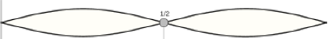
 |  | 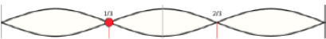

Check your answers with your teacher/key.

Application: Repeat this procedure using your guitar.

Harmonic | Wavelength | Diagram of Harmonic

Part 2: Harmonics Frequency and Velocity

Using a frequency app on your phone or other device, record the frequency of each of the first 3 harmonics.
Harmonic | Frequency (Hz)

What mathematical trend or pattern does the data create? How could you strengthen your argument for this trend?

Collect more data so you can graph at least 6 points.


Identify the mathematical relationship expressed in this graph. Choose
Linear
Inverse
Exponential
Quadratic

Identify the:
Independent variable: ____________________________

Dependent variable:
____________________________

Using the data collected above calculate the velocity of these harmonics using v = fλ. Show your work and convert into meters. Remember Hz = 1/s
Harmonic | Frequency (f) Hz | Wavelength (λ) m | Velocity (m/s)

What is the average velocity of the waves for the 3 harmonics?

In dry air at 20 °C (68 °F), the speed of sound is 343 meters per second. The speed of sound in an ideal gas depends only on its temperature and composition.

How does this standard value compare to your calculations above? Explain any discrepancies may have given a different number in your experiment.

Part 3: How do you think the energy from the string makes sound?

Watch How the Ear Works to understand how you are able to hear the guitar harmonics. Draw a model that incorporates the anatomy and the ear for how that sound reaches your ear to hear? Identify the type of wave, arrow and label node, antinode, and wavelength, frequency

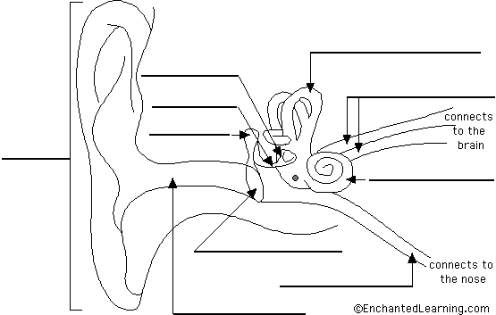


Assessment: After completing your investigation and gathering your data, create an Infographic that explains what harmonics are on the guitar, how each note has distinct sound even though the speed of sound is “constant”. Next show how the guitar transfer energy and sound to the ear. Use Red arrows for energy transfer and label the types of energy on the arrow.

Use concise scientific vocabulary. Less is more. The poster that is the most effective of getting the information across in a clear and creative manner will be posted on the website.
Vocab:
Medium mechanical wave longitudinal wave transverse wave harmonics
sound node antinode Wavelength frequency resonance velocity ear anatomy

Quiz:

- Pre Assessment/Post Assessment

Reviewing Faculty Cohort Members:

- Discusses with Brent on our drive to and from the Institute

Answer Keys and Cheat Sheets:
