Safety and Common Equipment Introduction!

Modestos Modestu

Description of Activity
- During this activity, students will be able to get familiar with some of the general shop safety rules and some of the equipment/tools that will be used during the construction of the electric guitar. The instructor will demonstrate how to use some special tools and equipment.
- Everyone has to take the pre-test quiz in order to begin working on their guitar. If you have any questions, please feel free to contact me at modestos.modestou@kctcs.edu

Learning Objectives:

- Learn some of the basic safety shop rules that everyone has to follow.
- Personal Protection Equipment, (PPE) that everyone has to have during the lab time.
- Learn some of the equipment that is going to be used during the construction of the guitar.
- Students will be required to turn in a safety report every week describing how safe their classmates were and what they have to do in order to correct their unsafe behavior.

Materials Required:

- Safety glasses
- Ear protection
- Dust mask
- Bench saw
- Drill press
- Guitar kit tools
- Guitar Kit
- Access to YouTube

Safety:

safetys:

- Safety Glasses.
- Dust Mask.
- Ear Protection.

References:

https://www.ccohs.ca/oshanswers/prevention/ppe/ear_prot.html
https://www.youtube.com/watch?v=dBf6BTX1bmM

Activity:

Watch the following video and pay close attention. During this video criticize yourself. Do you have any unsafe behaviors? Be honest and strict. This is the time to correct it without any suffering.

Safety Video:

https://www.youtube.com/watch?v=dBf6BTX1bmM

Now let’s get familiar with some of the basic safety personal protection equipment that you will have to have on you at all times. You don’t always have to use them but I am recommending to have them on you at all times, that way it is easier to access them at the needed time.

- Safety Glasses:

Safety glasses are one of the most important safety tools that you will use. It is used just about everywhere and at any project. For example, you can use your safety glasses while working on your guitar, mowing your lawn, working on your car etc. Below are some of the different safety glasses that you can get in the market. Safety glasses are usually very inexpensive so there is no reason not to own at least one pair.

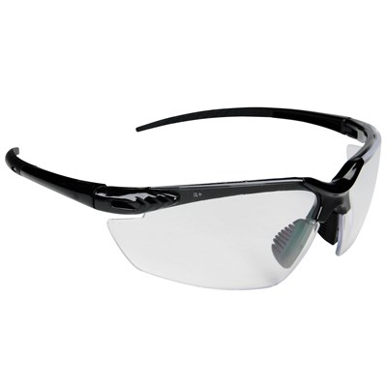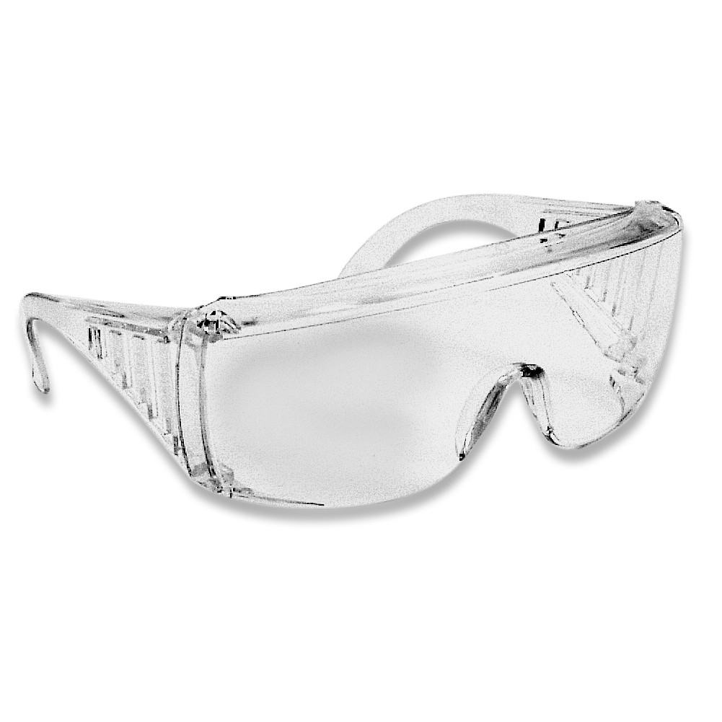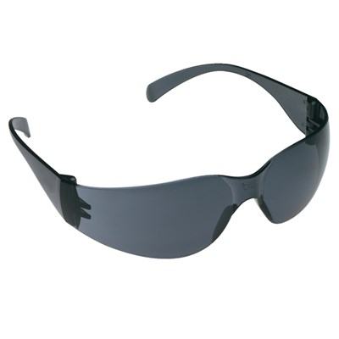
Reference:
https://www.northernsafety.com/safety/safety-products/eye-protection/safety-glasses-by-type
https://www.discountsafetygear.com/cryusagl.html

Below you will see some of the close calls that some smart people had during using their safety glasses. What would the results be without their safety glasses?

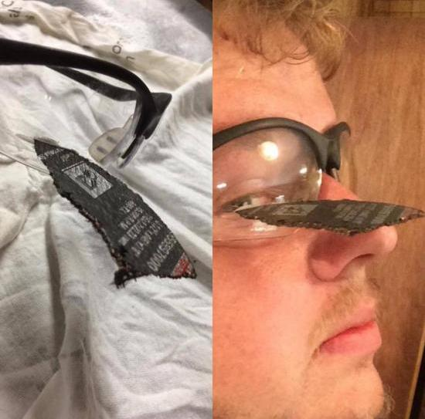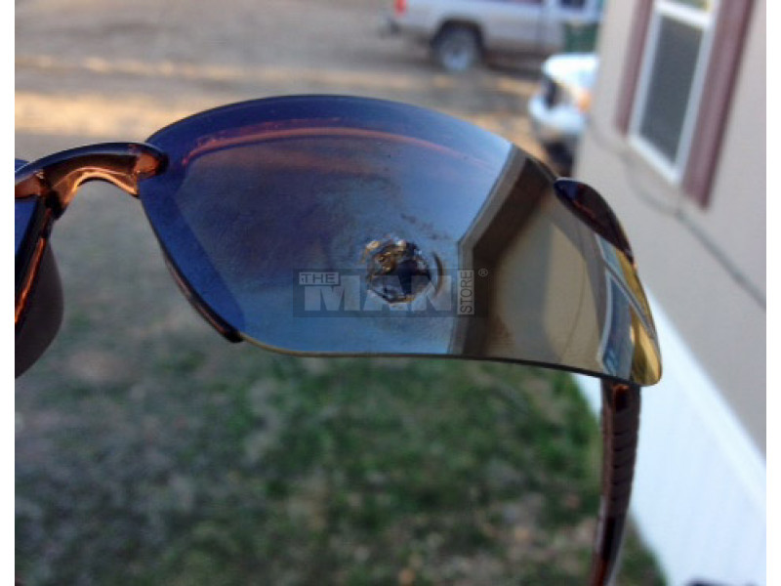
Reference:
https://www.reddit.com/r/pics/comments/4npyfu/safety_specs_saved_this_guys_eye_from_an/
https://www.themanstoreonline.com/crossfire-es4-safety-glass-series.html
.
- Ear Protection:

Ear protection refers to devices used to protect the ear, either externally from elements such as cold, intrusion by water and other environmental conditions, or specifically from noise.

According to OSHA:

People should wear a hearing protector if the noise or sound level at the workplace exceeds 85 decibels (A-weighted) or dBA. Hearing protectors reduce the noise exposure level and the risk of hearing loss.

If hearing protection is required, then a complete hearing conservation program should be implemented. A hearing conservation program includes noise assessment, hearing protector selection, employee training and education, audiometric testing, maintenance, inspection, record keeping, and program evaluation.

The effectiveness of hearing protection is reduced greatly if the hearing protectors do not fit properly, if they are worn only periodically, or if they are removed even for a short period of time. To maintain their effectiveness, the hearing protection should not be modified. Radio/music earphones or headsets are not substitutes for hearing protectors and should not be worn where hearing protectors are required to protect against exposure to noise.

Select hearing protection that is:

Correct for the job. Refer to the Canadian Standards Association (CSA) Standard Z94.2-14 “Hearing Protection Devices - Performance, Selection, Care and Use” or contact the agency responsible for occupational health and safety legislation in your jurisdiction for more information.
Provides adequate protection. Check the manufacturer's literature.
Compatible with other required personal protective equipment, or communication devices.
Comfortable enough to be accepted and worn.
Appropriate for the temperature and humidity in the workplace.
Able to provide adequate communication and audibility needs (e.g., the ability to hear alarms or warning sounds)

Please note:

I DO NOT require you to wear your ear protection all the time, but you must wear them while using power tools and high pitching machines. It is although required that you have them on you, (pockets) at all times.

Below are some of the typical ear protection plugs:

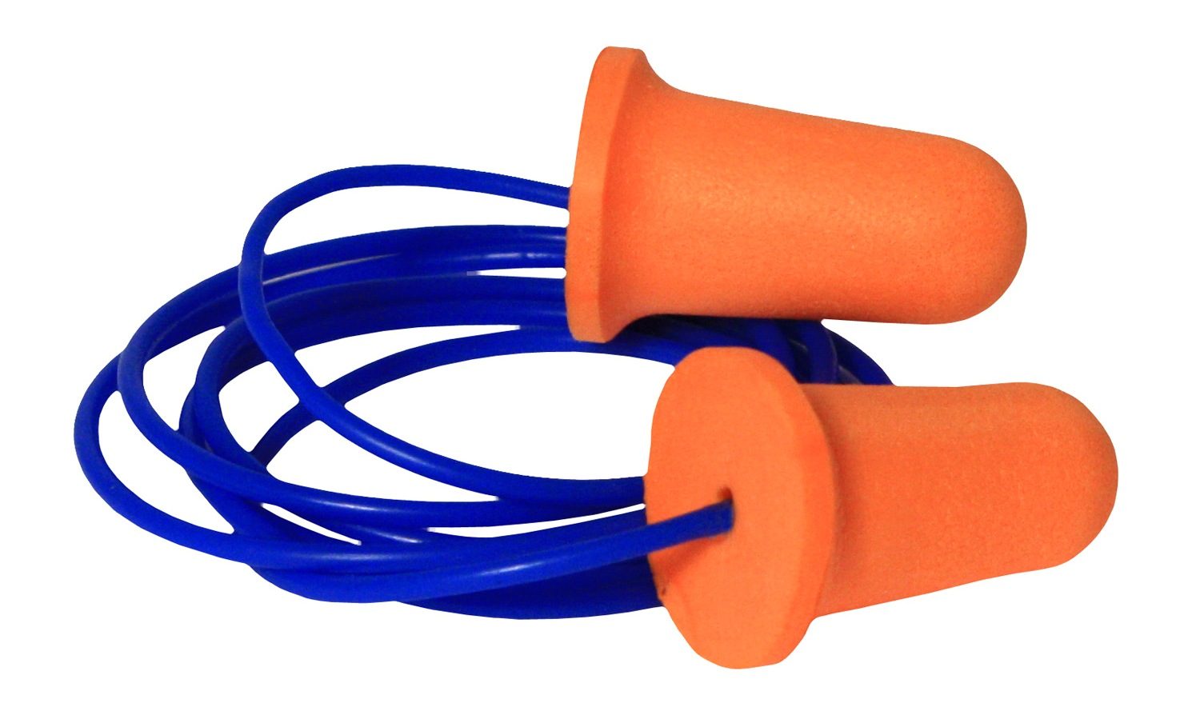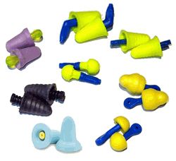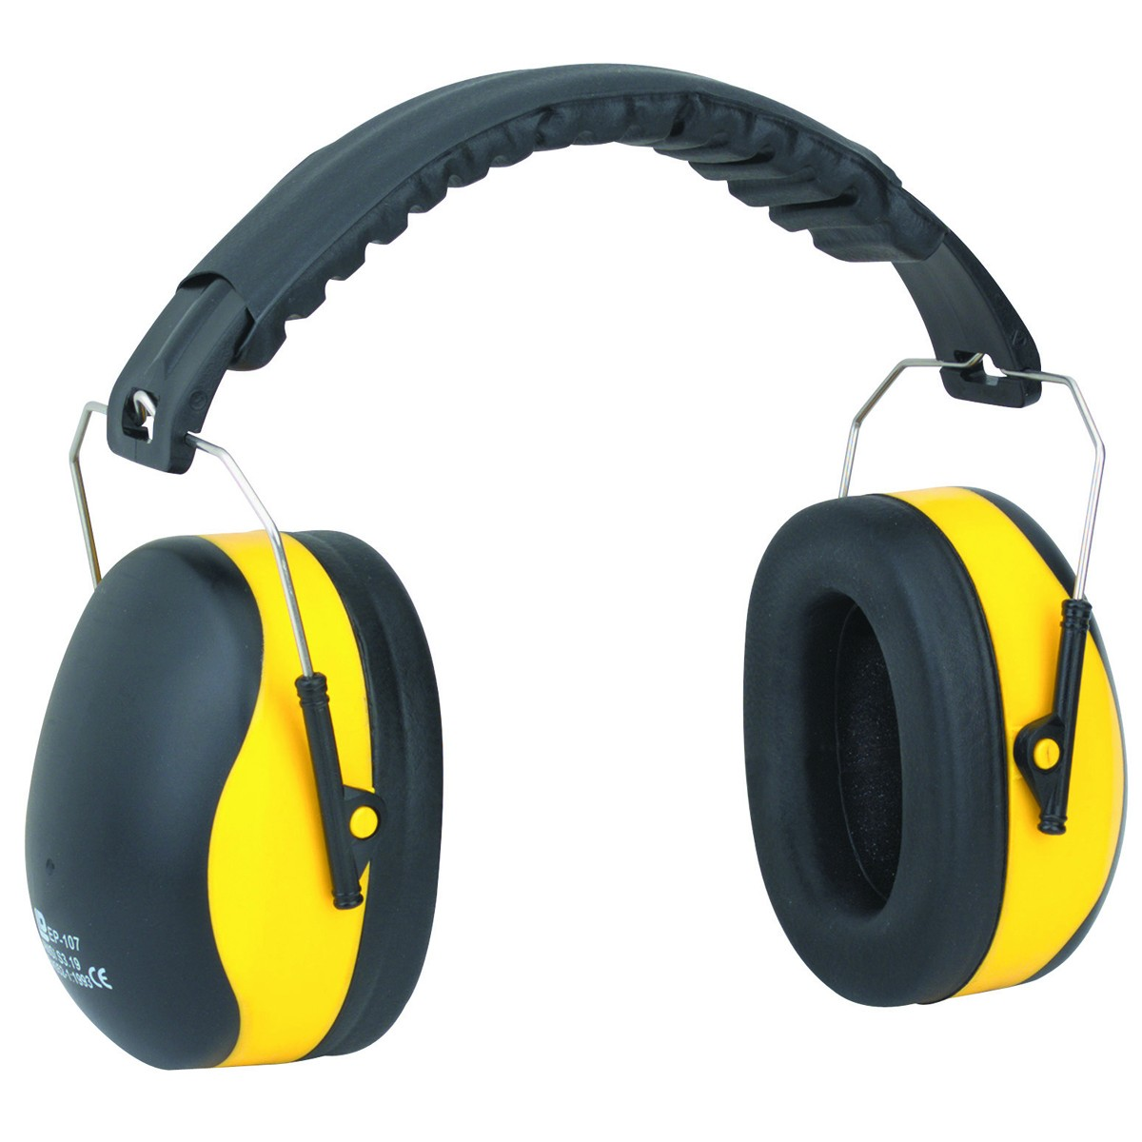
Reference:
http://www.earplugstore.com/radians-deviator-corded.html
http://www.earplugstore.com/no-roll-earplugs.html
https://www.reddit.com/r/sysadmin/comments/67owwi/hearing_protection/

- Dust masks:

A dust mask is a flexible pad held over the nose and mouth by elastic or rubber straps to protect against dust encountered during construction or cleaning activities, such as dust from drywall, brick, wood, fiberglass, silica (from ceramic or glass production), or sweeping.

Dust masks will be very important in this class. There are dust masks in the lab for everyone. Since almost every equipment is equipped with a vacuum, there will not be a lot of dust in the air. I would still recommend that you wear your dust mask but that is up to you. I would although require you to wear your dust mask when using a sanding paper on your work station.

Below you will find some of the typical dust masks that are used in the industry:

Dust masks:

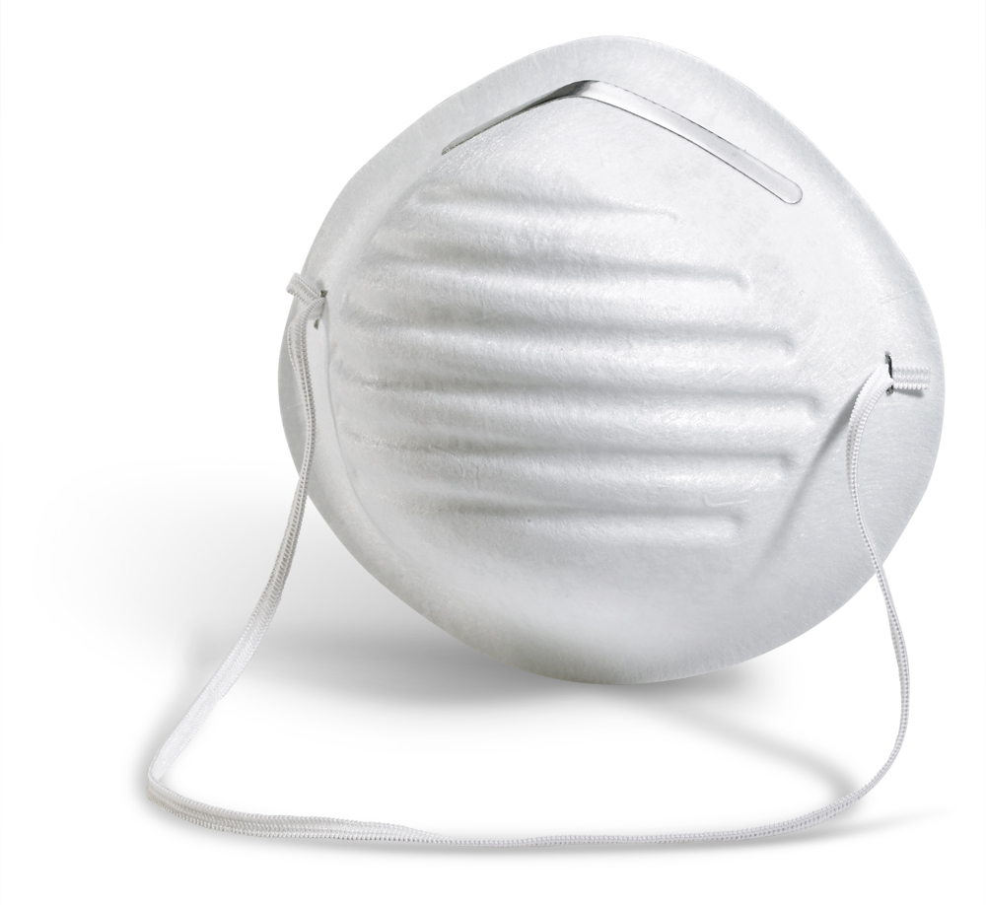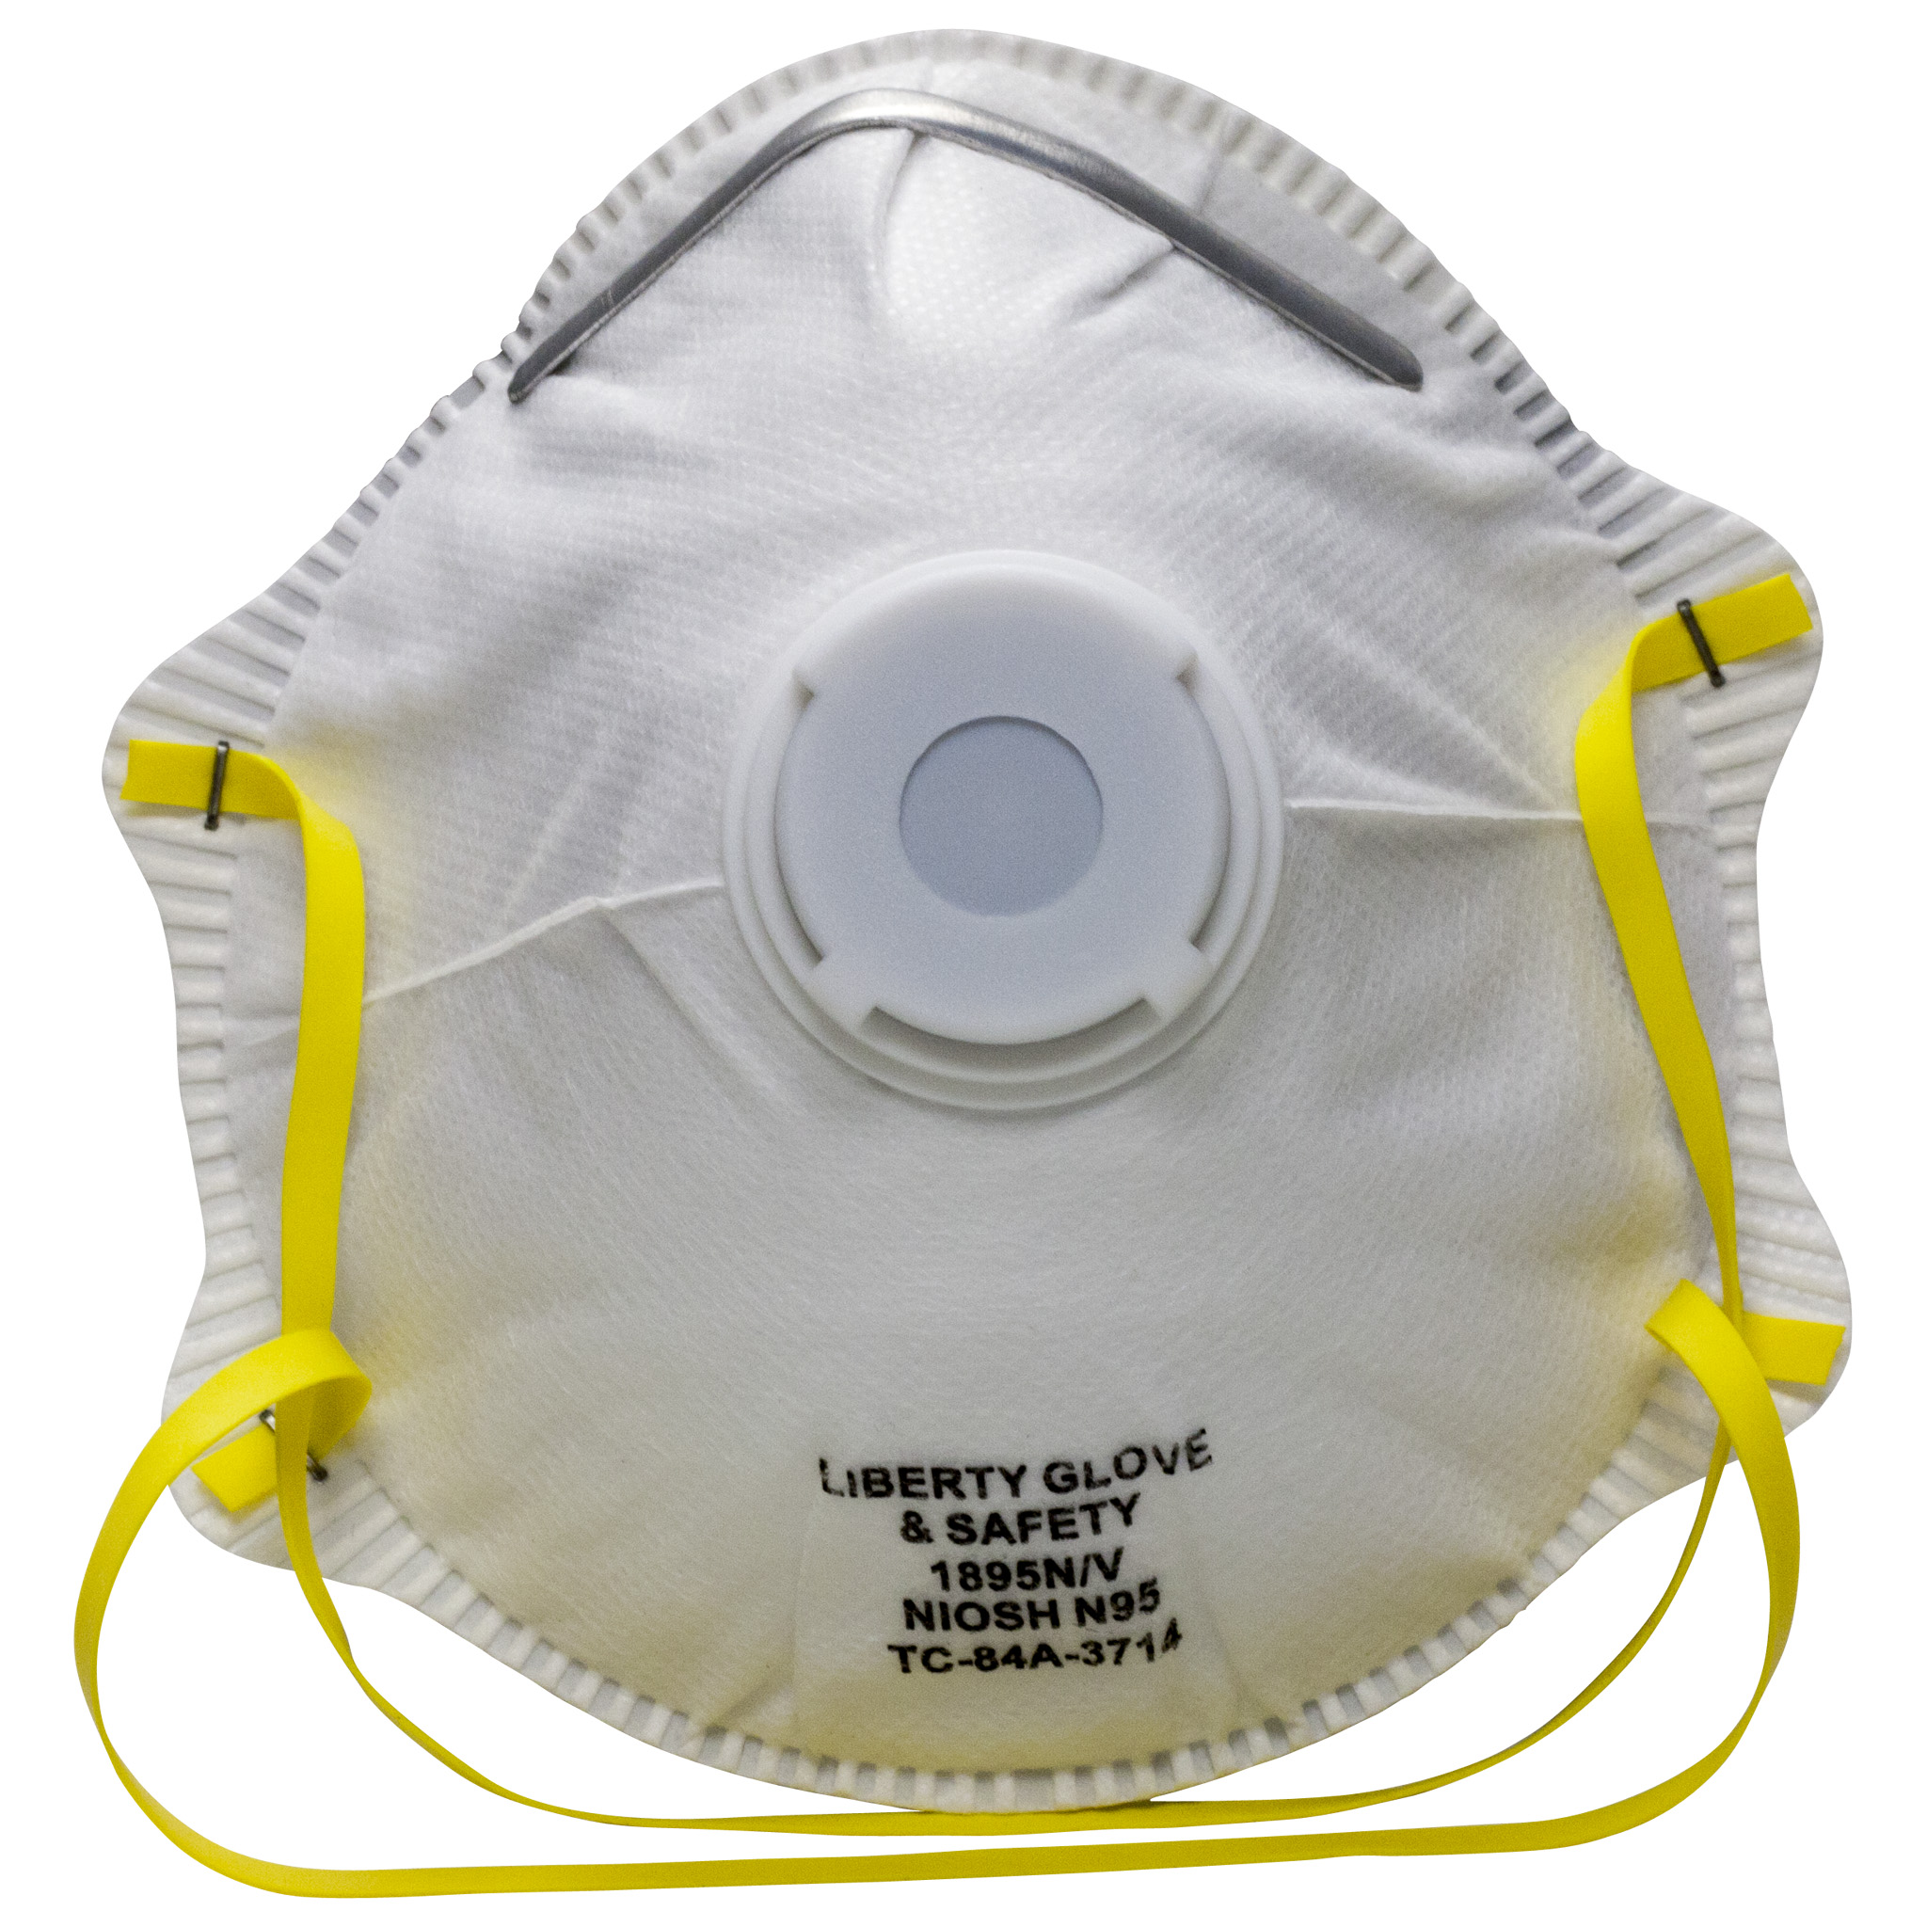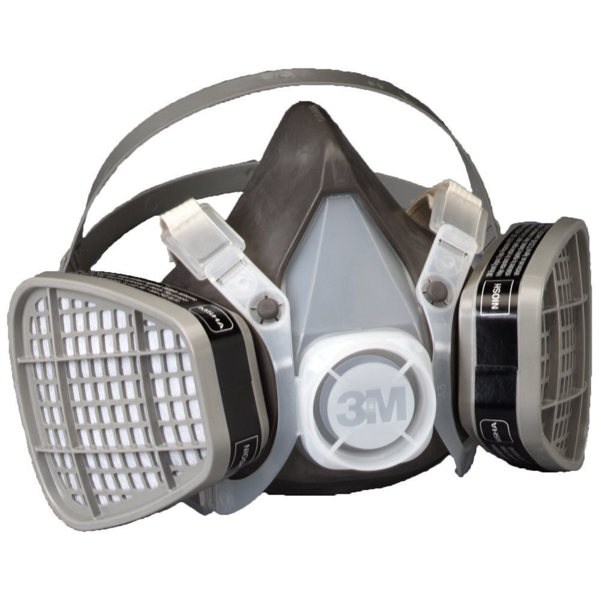
Reference:
http://www.safetyshack.co.uk/101901-new-b-brand-comfort-dust-masks-respirator-50-pack-.html
http://www.domyownpestcontrol.com/n95-valved-respirator-mask-p-1408.html
https://www.ebay.com/p/3M-Dust-Mask-Half-Face-Respirator-Filter-Protect-Smoke-Gas-Large-5103/1300928834

Power Equipment:
Drill Press
Bench Saw

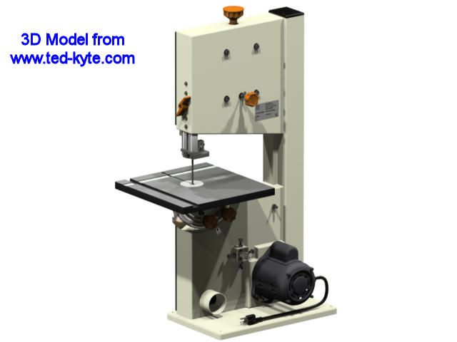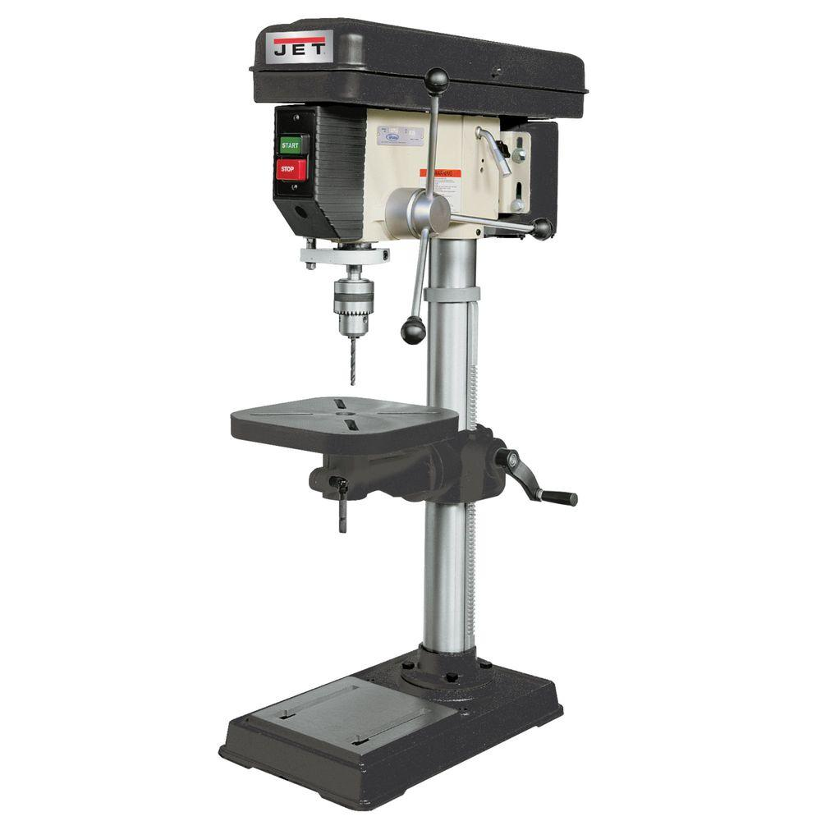

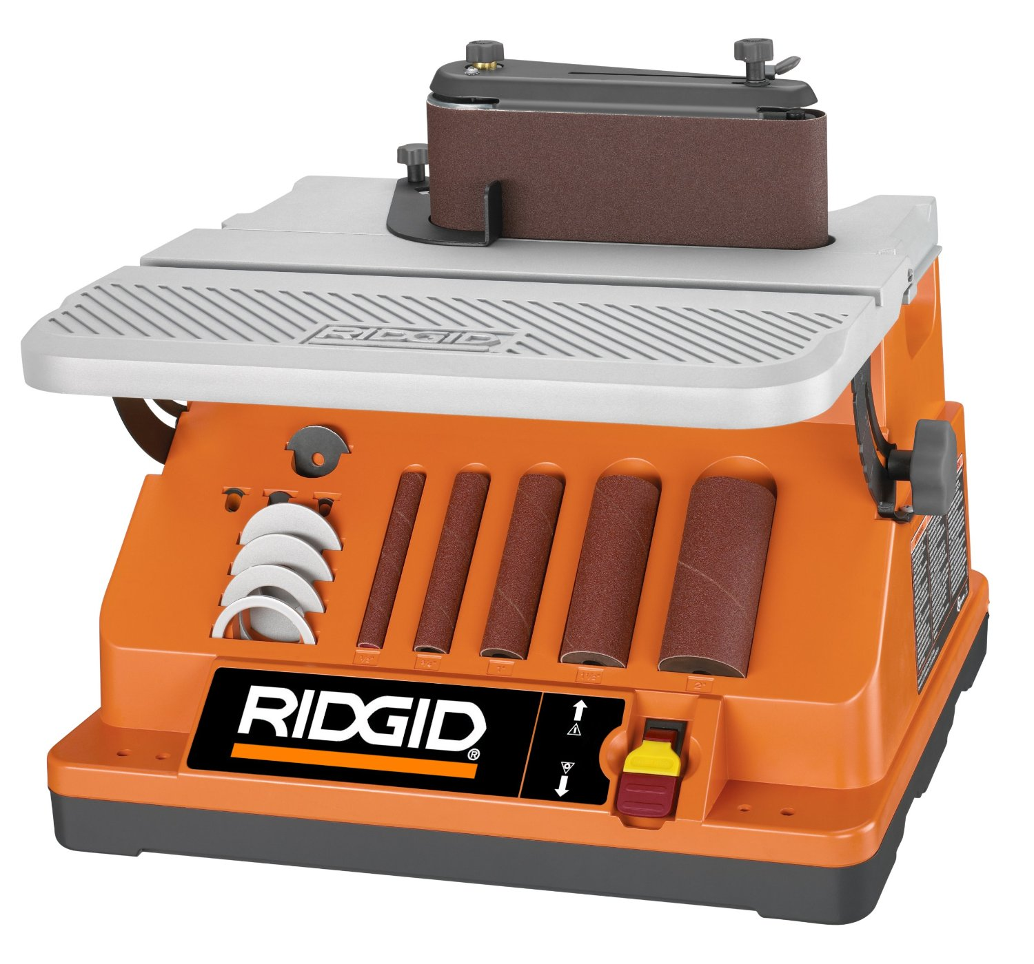
Belt Sander
Reference:
http://www.ted-kyte.com/3D/List-Tools.htm
http://www.homedepot.com/b/Tools-Power-Tools-Woodworking-Tools-Drill-Presses/N-5yc1vZc2dj
https://www.ridgid.com/us/en/oscillating-edge-belt-spindle-sander

Very Important:

The next time you walk into the shop, take the time and go locate this equipment. There will be a demonstration by your teacher on how to use them so please do not try to turn them on.

Safety Precautions:

The three power tools above will be used throughout the semester for the construction of your guitar. If you have not used one yet, please do not worry at all. These machines are well designed and user-friendly when using them the right way. Below are some safety rules that everyone has to follow when using power tools.

- Before turning ON the machine, ask yourself: Do I wear all necessary PPE?
- Before turning ON the machine, make sure you know what to do in case of an emergency.
- Make sure the machine is not ON already.
- Don’t get distracted while cutting or sanding. It is dangerous.
- Make sure your hair and clothes are out of the way.
- If you do not feel comfortable using the power tools please let your instructor know. The instructor will help you get familiar with the tool.
- Before leaving the equipment, make sure it is OFF, AND the head stopped rotating.

General Safety Rules:

- Keep the shop and your workplace clean. Sweep and throw your trash away before leaving.
- If you get hurt, let your instructor know immediately. But you won’t get hurt!!
- Be a good class mate and help other that fall behind
- Take pride in good craftsmanship. We have plenty of time to complete this project so take your time and fight for perfection.

Quiz:

Please take this Pre-Test quiz. Answer ALL question to the best of your knowledge. This grade will NOT be a part of your final grade but you have to complete it in order to get your guitar kit.

Pre Test Quiz:

- Circle all unsafe behaviors that you may carry with you into this class:
- Leaving the workplace dirty
- Not using PPE
- Use a machine without proper training
- Use power tool with untied long hair and loose clothes.
- Don’t respect/help your classmates
- What does PPE stand for?
- Personal Power Equipment
- Personal Protection Equipment
- Power Point Era
- People Personal Estates

- While cutting on the bench saw, what type of PPE do you have on you?
- Safety glasses
- Ear plugs
- Dust mask
- All the above
- What is the name of the equipment below?
http://www.ted-kyte.com/3D/List-Tools.htm

- Drill Press
- Belt sander
- Press
- Bench Saw

- What is the name of the equipment below?
https://www.ridgid.com/us/en/oscillating-edge-belt-spindle-sander

- Drill Press
- Belt sander
- Press
- Bench Saw

- What is the name of the equipment below?
http://www.homedepot.com/b/Tools-Power-Tools-Woodworking-Tools-Drill-Presses/N-5yc1vZc2dj

- Drill Press
- Belt sander
- Press
- Bench Saw
- In a case of an emergency, who do you notify first?
- Your parents
- Your best friend
- Your instructor
- Police
- Before leaving a power tool, you have to:
- Turn the machine OFF
- Tell your classmate that you are done
- Make sure it completely stopped rotating
- Leave your guitar on it
- a & c

- What is the name of the following tool?
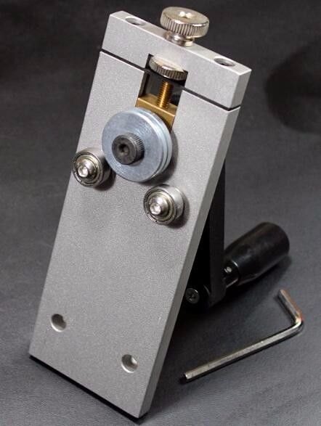
https://picclick.com/Fret-Bender-Unbender-Bending-Straighten-Fretwire-Adjustable-121799695731.html

- High adjustment tool
- Fretboard wire bender
- File sharpener
- Fretboard wire cutter

- What is the name of the following tool?
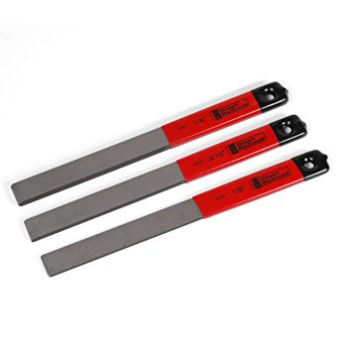
https://www.amazon.com/StewMac-Seating-Files-Stringed-Instruments/dp/B01NAJJB53

- Knives
- Regular files
- Chisel
- Nut repair files

**You will be taking this same test at the end of this class, so please do not feel bad if you do not know something. You will know everything by the end of your guitar project!

Reviewing Faculty Cohort Members:

- Eric Anderson – CTC - eric.anderson@hopkins.kyschools.us

