Aquatic Ecology Laboratory
The Northwest Center for Sustainable Resources is an Advanced Technological Education project funded by the National Science Foundation.

Aquatic Ecology Laboratory was developed at Chemeketa Community College, Salem, Oregon. Materials were prepared by Wynn Cudmore, Ph.D., Principal Investigator for the Center. Cudmore holds a Ph.D. degree in Ecology/Systematics from Indiana State University and a B.S. degree in Biology from Northeastern University.

Technology education programs in which this course is incorporated are described fully in the Center’s report entitled, “Visions for Natural Resource Education and Ecosystem Science for the 21st Century.” Copies are available free of charge.

The authors and the center grant permission for the unrestricted use of these materials for educational purposes. Use them freely!

Course materials will also be posted on our website:

www.ncsr.org

Please feel free to comment or provide input.

Wynn Cudmore, Principal Investigator
Wynn.cudmore@chemeketa.edu
503-399-6514

Susie Kelly, Project Director
Northwest Center for Sustainable Resources

Preface

What is the Northwest Center for Sustainable Resources?

The Northwest Center for Sustainable Resources (NCSR) is a partnership whose mission is to improve natural resource education programs at the high school and community college level. It is a collaborative effort of partners from high schools, community colleges, four-year colleges and universities, private industry, government agencies, and Native American tribes. The partnership assures input by all principal stakeholders, providing students with the best education to meet the demands of the Twenty-First Century work place. The Center is coordinated from Chemeketa Community College in Salem, Oregon and includes partners from Oregon, Washington, California, Maryland and Minnesota. Funding for the Center is provided by the Advanced Technology Education Program of the National Science Foundation.

Five community colleges in Oregon, Washington and California have developed programs in major natural resource areas — agriculture, fisheries, forestry and wildlife. Other colleges throughout the nation have tested and modified these “lead programs”. Core courses in Geographic Information Systems and Environmental Science have been developed to be incorporated into each program. Curriculum development efforts are documented in “enhanced syllabi” which will be disseminated to interested individuals. The curriculum is characterized by:

- increased levels of mathematics and science
- incorporation of ecosystem concepts
- application of advanced technologies
- increased field opportunities for students
- incorporation of input from potential employers of program graduates

Environmental Science as a Model for NCSR Curriculum

Environmental Science was developed at Chemeketa Community College as a sequence of three courses that addresses environmental topics. Each 4-credit course requires a 3-hour lab that meets once per week and 3 hours of lecture. The courses are targeted towards several audiences including:

- students in natural resource areas (e.g. Forestry, Fish and Wildlife, Agriculture)
- transfer students in areas other than biology who need a lab science course or sequence
- biology majors who wish to broaden their background in environmental biology
- anyone interested in learning more about environmental issues

The courses were developed to be “Environmental Science for the Citizen” and emphasize those concepts and issues that should be understood by all citizens. The approach is science based and a distinct effort is made to present opposing viewpoints in contentious environmental issues. The three-term sequence was added as a requirement for students in the Forest Resources Technology
Program at Chemeketa where it serves primarily to introduce students to basic ecological concepts and environmental issues that relate to natural resource management. The following goals have been established for the sequence:

- Introduce students to science as a “way of knowing”
- Introduce students to basic ecological concepts
- Introduce students to environmental problems at local, national and global scales
- Work cooperatively in small groups
- Communicate effectively in written and oral formats
- Apply appropriate technology to scientific exploration
- Access and use supplemental information relevant to course topics
- Engage students in hands-on, field and laboratory experiences that require critical thinking
- Use ecosystem management as a major theme in natural resource management
- Introduce students to societal aspects of environmental issues
- Apply mathematical concepts to scientific inquiry

This document describes several laboratory activities that have been developed for Environmental Science in an attempt to meet these general goals. It is my hope that others who have similar goals for related courses will find them useful.

Table of Contents
Development of Chemeketa’s Aquatic Ecology Laboratory ..........................................................1
Introduction .........................................................................................................................1
Facility design and estimated costs .....................................................................................3
Use of the facility ................................................................................................................5
Aquatic Ecology Laboratory curriculum—Examples and Summaries ...............................6
Cultural Eutrophication Lab ...........................................................................................................9
Introduction .........................................................................................................................9
Procedure.......................................................................................................................... 10
Background information .................................................................................................. 11
Results .............................................................................................................................. 13
Materials .......................................................................................................................... 15
Constructed Wetlands for Wastewater Treatment—Lab I: Literature Review ........................... 16
Introduction ...................................................................................................................... 16
The Aquatic Ecology Laboratory ..................................................................................... 16
Procedure.......................................................................................................................... 17
Questions .......................................................................................................................... 17
Constructed Wetlands for Wastewater Treatment—Lab II: Design and Construction ............... 18
Introduction ..................................................................................................................... 18
Summary of literature review .......................................................................................... 18
Initial conditions .............................................................................................................. 23
Constructed Wetlands for Wastewater Treatment—Lab III: Preparation for Treatment ............ 25
Introduction ...................................................................................................................... 25
Procedure.......................................................................................................................... 25
Materials .......................................................................................................................... 28
Water quality measurement protocols ............................................................................. 29
How should we interpret water quality measurements? .................................................. 33
Constructed Wetlands for Wastewater Treatment—Lab IV: Addition of Wastewater ............... 40
Introduction ...................................................................................................................... 40
Procedures ........................................................................................................................ 41
Plant height measurements in constructed wetlands ........................................................ 42
Constructed Wetlands for Wastewater Treatment—Lab V: Analysis and Interpretation ........... 43
Data summary .................................................................................................................. 47
Primary Production in Constructed Wetlands Lab ...................................................................... 50
Introduction ...................................................................................................................... 50
Procedure.......................................................................................................................... 51
Materials .......................................................................................................................... 52
Analysis ........................................................................................................................... 53
Sample results .................................................................................................................. 60
Ecosystem Analysis Lab............................................................................................................... 62
Introduction ...................................................................................................................... 62
Constructed wetland description ...................................................................................... 62
Procedure.......................................................................................................................... 62
Materials .......................................................................................................................... 67
Literature Cited and Additional Resources .................................................................................. 68
Aquatic Ecology Lab - Introduction
INTRODUCTION

The Northwest Center for Sustainable Resources places a very high value on field studies in our courses because we believe the educational and experiential payoffs outweigh the inconvenience and added cost. Although off-campus field trips make up the majority of these experiences, several colleges in the partnership also have on-campus sites that provide students with opportunities for field-like experiences. The Model Watershed Project at Grays Harbor College, the Holistic Resource Laboratory at Shasta College, and the Wild Trout Hatchery at Feather River College are notable examples. Most recently, an “Aquatic Ecology Laboratory” has been designed and installed at Chemeketa Community College. The facility is an outdoor array of simulated aquatic ecosystems (stock tanks) located on campus. This document describes the development of this facility and provides some curriculum examples to assist those at other institutions who may wish to duplicate our efforts.

Curriculum development efforts address several elements of the National Science Foundation’s Advanced Technological Education Program. These include curriculum improvement in science and mathematics, student experiences with appropriate technology, and instructional approaches that encourage writing, oral presentations, group-learning experiences and long-term projects. In addition to meeting these educational goals, simulated ecosystem studies provide several advantages over the alternatives of off-campus field sites or indoor laboratories:

- proper scientific methodology can be more easily applied by students (hypothesis testing, experimental design, controlled experimentation, analysis and interpretation)
- entire populations can be measured and observed
- environmental variables can be more easily manipulated
- ecosystems are readily accessible and thus can be studied more intensively, over longer periods of time
- time constraints due to travel to and from field sites are eliminated
- transportation costs are eliminated
- safety concerns are reduced
- locating and obtaining permission to use natural sites is avoided
- improved access is provided to persons with disabilities

Controlled, semi-natural habitats have been used in science education to model terrestrial and aquatic ecosystems (Marcus, 1994; Murphy, et al., 1992). They are also used frequently in ecological research to test current hypotheses about community structure, energy flow, population dynamics, predator-prey interactions, animal responses to environmental variables, and life history strategies (Larsen, et al. 1986; Wilbur 1987). A suggested link between amphibian decline and UV radiation was established through investigations of various amphibian species in controlled environments in Oregon (Blaustein and Wake 1995). The scientific value of mesocosm studies conducted in facilities similar to the Aquatic Ecology Laboratory has been reviewed by Rowe and Dunson (1994). In addition to gaining insight into the complexities of aquatic systems, practical skills that students may use in job situations can be learned and practiced. These include, among others:

- the identification of aquatic plants (required for wetland identification and delineation)
- the identification of algae (wastewater treatment)
- the use of monitoring equipment (measurement of organic and inorganic components in water supplies to identify contaminants)
- microbiological techniques (e.g. coliform counts)
- practical applications of aquaculture and sewage treatment

Other skills can go far beyond the level of information and content. These include educational experiences that encourage team building, improved communication and analytical skills, critical thinking and hands-on learning. Students also have the unique opportunity to design and implement open-ended, long-term investigations that extend well beyond the 2 or 3-hour time frame of most laboratories.

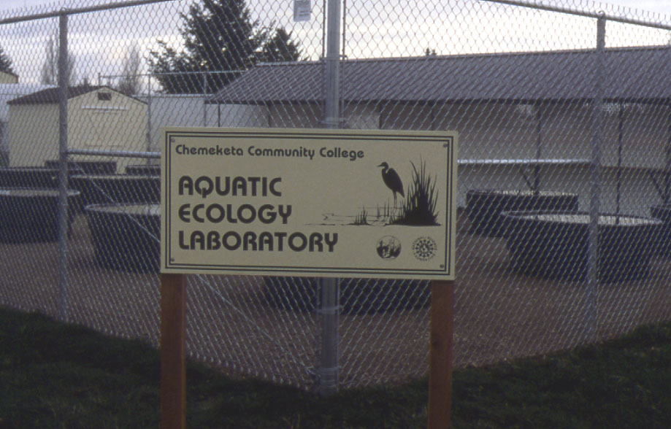
Figure 1. Aquatic Ecology Laboratory at
Chemeketa Community College, Salem, Oregon

FACILITY DESIGN AND ESTIMATED COSTS

The facility is essentially a collection of stock tanks that serve as simulated aquatic ecosystems. The number and arrangement of tanks should be matched to the predicted use of the laboratory (number of different courses, number of laboratories and number of students using the laboratory). Our facility consists of eighteen 300-gallon polyethylene tanks arranged in a 3 X 6 array with a footprint of approximately 3535 square feet (76' X 45.5') (Figure 1). The tanks sit on a base of compacted crushed rock. For security purposes, the perimeter is enclosed with an 8' chain link fence and a single locked 8' gate. In addition to the tanks themselves, the fence also encloses an 8' X 8' wooden storage building and 66 linear feet of covered bench tops for student work. Water and electrical service are provided to the facility. Electrical outlets are located along bench tops.

An environmental monitoring system is used to measure physical variables such as air temperature, rainfall, relative humidity and solar radiation. These data are correlated with biological changes in the tanks during student experiments. The data can be recorded continuously or at preset intervals, stored and displayed graphically. Using available software and a modem, students and faculty will eventually be able to access this information remotely from computers on and off campus.

Estimated costs (as of 1998) for the facility are summarized below. Similar educational objectives could be met at lower costs by purchasing less durable materials (e.g. small swimming pools rather than polyethylene tanks) or less sophisticated instrumentation.

Materials/Service Source Cost
Site preparation Local contractor $500

Install water service (3/4" PVC pipe) Local contractor $1000

Install electrical service Local contractor $1000

Provide and install Local contractor $3500
chain link fence and 8' gate

18 - Polyethylene tanks - 300 gal. Agricultural supply $3150
5' dia. X 2' high with drain cocks

Install 66 linear feet, Local contractor $200
2' wide bench tops

Install 66 linear feet, corrugated Local contractor $1400
metal roofing over bench tops

Install 8' X 8' wooden storage shed Building supply $1000

Continued on next page….
Environmental Monitoring Equipment - available from Davis Instruments - Hayward, CA:

GroWeather System $495
System Shelter $180
GroWeatherLink ET Hardware $195
GroWeatherLink Software $100
Anemometer $160
Solar Radiation Sensor $185
Temperature/Humidity Sensor $150
Rain Collector $95
Mounting brackets and arms $175
____________________________________________________________________
TOTAL (includes previous page) $ 13,485

USE OF THE FACILITY
The Aquatic Ecology Laboratory currently supports courses in Environmental Science, General Biology and General Zoology. Approximately 300 students and six faculty members use the facility on an annual basis. Term-long Environmental Science laboratories are conducted at the facility during Fall and Spring terms. These activities include “experimental” tanks that vary with respect to some environmental variable, “replicates” of experimental tanks and “controls”. General Biology students study trophic relationships in freshwater ecosystems and General Zoology students use the facility for a term-long study of factors that influence amphibian development. In general, each tank is assigned to a lab group of three to four students. Students are actively involved in all stages of these studies including background literature work, experimental design, setup, data collection, analysis, interpretation of results and reporting in written and/or oral formats. It is quite conceivable that some of this work could be published in scientific journals.

Two or three tanks are maintained as reservoirs for fish, amphibians, aquatic plants, algae, phytoplankton, zooplankton and water. These tanks are not part of experiments per se but are used as a source of biological materials for a number of courses. Previously, these materials were either purchased from biological supply houses or collected from the field.

AQUATIC ECOLOGY LABORATORY CURRICULUM

Facilities such as ours could be used to support a number of Life Science and Physical Science courses. Some examples of types of laboratory activities for these courses follow:

1. Long-term Ecosystem Studies

Aquatic ecosystems such as ponds, marshes, riparian zones, and other wetlands can be modeled by establishing several tanks that differ in one or more variables and monitoring over long periods of time. Stock tanks serve as microcosms of functioning ecosystems although compromises due to miniature scales must be recognized. Treatments may differ in the following variables:

A. Nutrient levels
- Nitrates and phosphates from sewage or agricultural lands impact groundwater quality and cause eutrophication in ponds and lakes

B. Biotic Components
- Impacts of initial levels of bacteria, protozoans, algae or aquatic plants may be evaluated
- Impacts of introduction of exotic species or apex predators to established ecosystems may be examined

C. Physical Components
- Amounts and wavelengths of solar radiation may be varied with shade cloths and filters to model the influence of vegetation in riparian zones along rivers, creeks or ponds
- Temperature may be varied in a similar manner to test for the influence of thermal pollution
- pH may be altered to model the effects of acid rain
- Effects of pesticides, herbicides and turbidity on living organisms may be studied

D. Open vs. Closed Systems

Using netting, glass, opaque materials or other materials, effective filters can be established that allow students to test the stability of closed (or partially closed) systems and compare them to open systems. Analogies with the Biosphere II Project in Oracle, Arizona may be established to make students aware of difficulties in maintaining closed systems.

2. Aquaculture

The production of plants and animals in controlled aquatic situations has been proposed as an alternative method of human food production. Aquaculture is currently being used to “farm” a number of fish species (salmon, trout and catfish) for human consumption. Algae, Azolla (a floating, nitrogen-fixing fern), and perhaps tilapia or catfish would seem to be good subjects for this study. Students may be required to maximize production of a single species by manipulating variables within each tank. These studies may be used in conjunction with aquaculture simulation software such as Fish Farm (Kosinski 1993) to broaden the experience.

3. Waste Treatment
Students may model methods of wastewater treatment using aquatic plants (e.g. cattails, water hyacinth or algae) to absorb or metabolize organic and inorganic waste. Initial levels of certain contaminants (e.g. heavy metals, nitrates, phosphates) could be measured and then monitored regularly to evaluate the effectiveness of various plants (Brown, 1995). Comparisons with municipal sewage treatment operations that use this type of technology and are currently in operation may be made.

4. Wetland Creation

Wetland creation and restoration are frequently used as a means of mitigating for the loss of natural wetlands due to development. Our knowledge of the success of these human-created wetlands is minimal. Model wetlands have been used to test hypotheses concerning the initial conditions required to design a wetland (Mitsch, et al. 1998).

5. Population Studies

Aquatic invertebrates, small fish and amphibians are convenient models for the study of basic ecological principles and applied ecology. Such studies may include:

- the effects of overpopulation (e.g. density-dependent growth rates, stunting)
- competition between two species with different biological characteristics
- the effects of different stocking levels and conditions
- the effects of nutrient input
- the effects of siltation
- the measurement of population parameters (e.g. age distribution, reproductive rates, mortality)
- estimates of population size, carrying capacity and standing crop
- competition for resources
- animal behavior studies
- biological control studies

AQUATIC ECOLOGY LABORATORY CURRICULUM SUMMARIES

The following laboratory activities were developed and tested for a 3-term Environmental Science course at Chemeketa Community College. Procedures for each lab are described and background information is provided to place the activity in some broader context. Student handouts and samples of student-collected data are also included. These are mostly long-term projects continually under testing and revision.

Four laboratory activities are described:

1. Cultural Eutrophication - The Effects of Nutrient Input in Simulated Pond Ecosystems

Students evaluate the impacts of nitrate and phosphate input into aquatic ecosystems by adding known quantities of these nutrients to tanks and then measuring several physical and biological variables over several weeks.

KEY CONCEPTS: nutrient cycling, eutrophication, aquatic communities, respiration, decomposition

2. Constructed Wetlands for Wastewater Treatment

Students research current literature concerning the design of constructed wetlands for the treatment of wastewater. This information is then used by students to design their own wetlands. The effectiveness of these wetlands to treat wastewater is then evaluated by comparing the physical and biological qualities of water before and after treatment. Students gain an understanding of above and below-ground processes that occur in wetlands. As described here, this activity is taught as a series of five laboratory exercises.

KEY CONCEPTS: wetland communities, bioremediation, aquatic ecosystems

3. Primary Production in Constructed Wetlands

Students are introduced to the importance of primary production in ecosystems and then measure primary production in constructed wetlands using a “clip method”. Factors that influence primary production are evaluated.

KEY CONCEPTS: energy flow, primary productivity, respiration, biomass

4. Ecosystem Analysis

This laboratory is designed to familiarize students with the structure and function of ecosystems. Constructed wetlands that were designed by students to study the treatment of agriculture wastewater are used as model ecosystems. It establishes the foundation for more sophisticated and quantitative laboratories to follow.

KEY CONCEPTS: aquatic ecosystems, energy flow, nutrient cycling, ecological succession
Aquatic Ecology Lab - Cultural Eutrophication

INTRODUCTION

Of the various sources of water pollution, the input of excess nutrients such as nitrogen and phosphorus has long been among the most common and troublesome. Roughly 80% of the nitrogen and 75% of the phosphorus that enter U.S. lakes and streams come from human activities. Runoff from agricultural fields, septic tanks, sewage treatment plants and feedlots all contribute to the nutrient load of both surface waters and ground water. In some areas atmospheric deposition of nitrates and nitric acid also contributes significantly to nitrates in surface waters. The process resulting from the addition of nutrients to a body of water is called eutrophication and when the sources of these nutrients are primarily from human activities it is called cultural eutrophication. When excess nutrients accumulate in aquatic systems a number of changes occur that may upset the natural balance of the aquatic ecosystem:

- since nitrogen and phosphorus are often limiting factors in aquatic ecosystems, when they are added to the system, algae and bacterial populations increase rapidly, creating what is called an algal bloom
- turbidity increases and the color of the pond or lake often changes
- the esthetic quality of the lake often declines and develops a bad smell and taste
- plant and animal diversity declines as species that tolerate high nutrient levels replace the naturally diverse community
- as algae accumulate on the surface, light penetration declines and algae in the water column die
- Biological Oxygen Demand (BOD) increases as respiration and decomposition increase and out-pace photosynthesis, causing dissolved oxygen levels to decline (recall that respiration and decomposition are oxygen-consuming reactions, while photosynthesis is oxygen-producing)
- when algae die and accumulate on the bottom, anaerobic bacteria proliferate and release hydrogen sulfide and methane, both of which are toxic to animals
- “game fish” (e.g. trout and bass) are replaced by “trash fish” (e.g. carp and suckers)

In extreme conditions, eutrophication may result in a spiraling of events that causes fish kills and the ultimate death of the lake or pond. As many as 70% of lakes in the U.S. may be eutrophic.

In today’s lab we will begin a study of the impacts of nutrient input into model aquatic ecosystems at the Aquatic Ecology Laboratory on Chemeketa’s campus.

PROCEDURE

- Establish initial nutrient conditions - Each pair of students will be assigned a tank to establish and monitor. Six tanks will be set up that vary only in nitrogen, phosphorus and potassium (NPK) content of the water. Tank #1 will be designated as a control and will contain ambient (natural) levels of NPK present in rainwater. NPK levels in other tanks will be manipulated by adding different amounts of a 16-16-16 NPK solution as indicated in the table below:
Tank # | 16-16-16 Fertilizer added (g)
1 | 0
2 | 80
3 | 160
4 | 320
5 | 640
6 | 1280

NOTE: The concentration for Tank #2 will achieve the approximate maximum standard for nitrates in drinking water of 11.3 mg/l. These amounts are based on full tanks of 300 gal (1136 liters).

- Establish initial biological community — Each tank will be “seeded” with approximately equal amounts of the same organisms - filamentous algae (submerged vegetation), duckweed (floating vegetation), cattails (emergent vegetation), aquatic snails, Pacific tree frog tadpoles and a zooplankton sample that contains copepods, cladocerans and other representative zooplankton. All of these organisms were collected from local ponds and are representative of aquatic organisms in the Willamette Valley. Equal numbers or quantities of each of these “pioneers” will be added to each tank. We will decide as a group what these initial quantities will be.

- Select parameters to be monitored — A number of physical and biological parameters will be monitored periodically throughout the remainder of the term. Instruments will be available to make these measurements. We will discuss these as a group and decide which parameters will be measured and what our operational definitions will be for each.
Some possibilities include:

Physical Parameters: Biological Parameters:
pH Growth of emergent vegetation
Temperature Cover of floating vegetation
Dissolved Oxygen Growth of filamentous algae
Turbidity Numbers of higher animals
Nitrate Numbers of zooplankton
Phosphate Development rates of amphibians
- Record initial conditions in the tanks according to decisions made in #3 above.

- State hypotheses — Based on your understanding of ecosystem structure and function as well as the attached background information, state some hypotheses that predict the outcome of these experiments. Be sure that there is a clear connection between experimental design and the hypotheses you have stated. For example, if dissolved oxygen is going to be measured, your hypothesis should make some prediction about changes in dissolved oxygen in the various tanks.

- Monitor tanks regularly — At regular intervals (once per week) throughout the term you will be responsible for repeating the measurements above to monitor changes in the tanks. Some scheduled lab time will be devoted to this activity, but time outside of class will also be required. Please work out a schedule with your lab partner.

BACKGROUND INFORMATION

You may find the following information helpful as you develop protocols for measuring parameters in the tanks and develop hypotheses. Additional information is available in Botkin and Keller (2000) Chapter 20, pages 416-425.

pH — pH is a measure or the acidity or alkalinity of a solution. A pH reading of 7 indicates neutrality (neither acidic nor basic); numbers less than 7 are acids, and those greater than 7 are bases (alkaline). Since the pH scale is logarithmic, a change of one pH unit represents a ten-fold change in the acidity of the solution. Most species can tolerate pH values from 6 to 8; optimal levels for most fish are between 7.1 and 7.8. Values above or below these values may affect some species. Amphibians and some aquatic insect larvae are particularly sensitive to acidic conditions. Probably more important than the direct effects of pH is the relationship between pH and ammonia. Ammonia in water may occur either as ammonium ion (NH₄ ⁺) or ammonia (NH₃). NH₃ is highly toxic to fish and other aquatic organisms. As pH levels increase, a greater portion of the ammonia exists in this toxic form.

Temperature — Water temperature in small ponds is closely tied to ambient temperature. Temperatures influence those organisms that can occur in ponds. In our area, high temperatures (causing thermal pollution) are generally more limiting than low temperatures. Water temperature also influences dissolved oxygen levels (see discussion below). Temperature is measured with a mercury or alcohol thermometer in degrees Centigrade.

Dissolved Oxygen — Low dissolved oxygen levels generally indicate polluted water and high Biological Oxygen Demand (BOD). Low dissolved oxygen readings can be expected in stagnant water with large amounts of organic material. When dissolved oxygen levels drop below a critical level, anaerobic bacteria break down the remaining organic material often producing toxic gases such as hydrogen sulfide and methane. Dissolved oxygen can influence the species that occur in a body of water. The amount of dissolved oxygen is also a function of water temperature - warmer water is less capable of retaining dissolved oxygen. Dissolved oxygen is measured in parts per million (ppm) with a dissolved oxygen meter or chemically with a Winkler Titration. Dissolved oxygen levels of 7-10 parts per million (ppm) are typical in unpolluted water. The primary sources of oxygen in the tanks are photosynthetic production by algae and higher plants and diffusion from the air above the tank.

Turbidity — Turbidity is a measure of the “cloudiness” of the water. Sediment, algae, bacteria and zooplankton all contribute to what is technically known as the Total Suspended Solids (TSS) that increase the turbidity. As turbidity increases, the degree to which sunlight penetrates the water column declines. This obviously has an impact on photosynthetic rates in algae and submerged vegetation. Turbidity is measured with a turbidimeter in Nephelometric Turbidity Units (NTU). Drinking water is generally very clear and would have a turbidity measurement less than 10 NTU. Very cloudy water would read about 1000 NTU.

Nitrates — Nitrates are common inorganic pollutants in water. They are a common component
of multi-nutrient fertilizers whose nutrient content is indicated by three numbers called the “grade”. The first of these numbers indicates the nitrogen content of the fertilizer. A fertilizer grade of 16-16-16, for example, contains 16% (by weight) nitrogen, 16% phosphate (P₂O₅) and 16% potassium (K₂O). This particular grade is commonly used to fertilize grass seed fields in the Willamette Valley and, for this reason, has been chosen for these experiments in the Aquatic Ecology Laboratory. Nitrates stimulate algal growth and may be responsible for causing cultural eutrophication. If ingested, they are converted to nitrites in the intestines of humans where they combine with hemoglobin in red blood cells causing the oxygen-carrying capacity to decline. In infants this condition may be fatal. Contamination of groundwater by nitrates that are applied as fertilizer is a widespread problem in agricultural regions of the country. Nitrates can be measured with water test kits.

Phosphates — Phosphorus tends to be less abundant than nitrates in freshwater ecosystems and is therefore often a limiting factor for algal growth. The addition of phosphorus, usually in the form of phosphates, often results in algal blooms. Domestic sewage (particularly those containing significant amounts of laundry detergents) and agricultural runoff are important sources of phosphates. Most sewage treatment plants remove only about 50% of the nitrogen and 33% of the phosphorus from domestic sewage. The remainder is dumped in the effluent into surface water. Phosphates can be measured with water test kits.

Growth of vegetation and algae (emergent, floating and submerged) — Since we will be adding three important plant nutrients to these aquatic ecosystems, an increase in plant growth might be expected. However, there are limits to this growth as other limiting factors come in to play. Also, too much NPK can damage plant tissues. Algae can have both positive and negative impacts on aquatic ecosystems. Algae produce oxygen through photosynthesis during the day, thus increasing dissolved oxygen concentrations. They also absorb both ammonia and nitrate and use them as nutrients. When algal blooms occur, however, turbidity is increased and algal die offs consume oxygen and release toxic substances such as ammonia, methane and hydrogen sulfide. Higher plants, such as cattails in natural and artificial wetlands, have been used to remove nutrients from sewage effluent that contains high levels of nitrogen and phosphorus.

Numbers of zooplankton and higher animals — As their food source increases, an increase in
population levels of these organisms might be expected. However, as with the plants, other limiting factors will set new limits and too much of a good thing can have a negative impact on populations.

Amphibian development — The rate of development of the Pacific tree frogs in the tanks is probably most closely related to temperature and food availability. Within limits, tadpoles will develop more rapidly at higher temperatures and with an abundant food supply.

RESULTS

The following data were collected and summarized by students during Spring Term 1997. They are shown here to illustrate the types of data that may result from an activity as outlined here. Students were required to summarize and present class data in an oral presentation to the class. Each group offered their own interpretation of the data and responded to questions posed by the group and the instructor after their presentation.

Measurements of these and other variables were taken at approximately one-week intervals by students. Tanks varied in levels of nitrate, phosphate and potassium which were altered by the addition of 16-16-16 commercial granular fertilizer. Tank 1 is the control with no added fertilizer, and levels increase with successively higher tank numbers (Tank 2 - 80 g added, Tank 3 - 160 g, Tank 4 - 320 g, Tank 5 - 640 g, Tank 6 - 1280 g). See “Procedure” section for details.

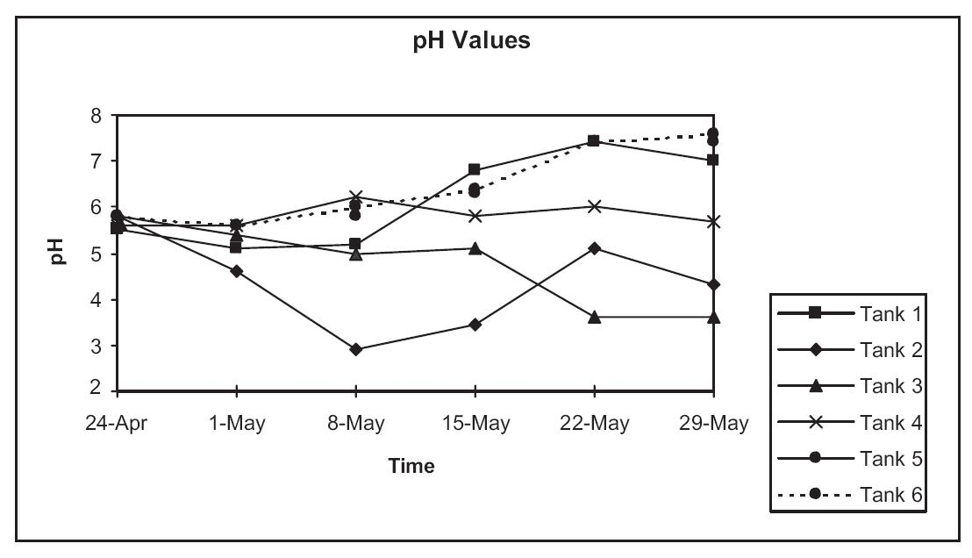

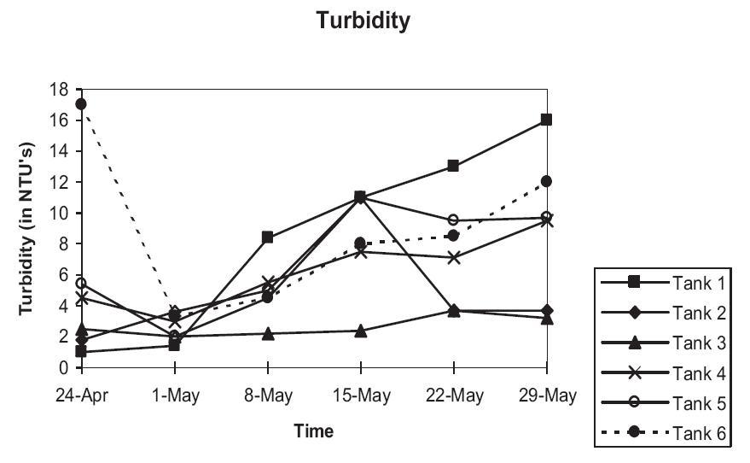

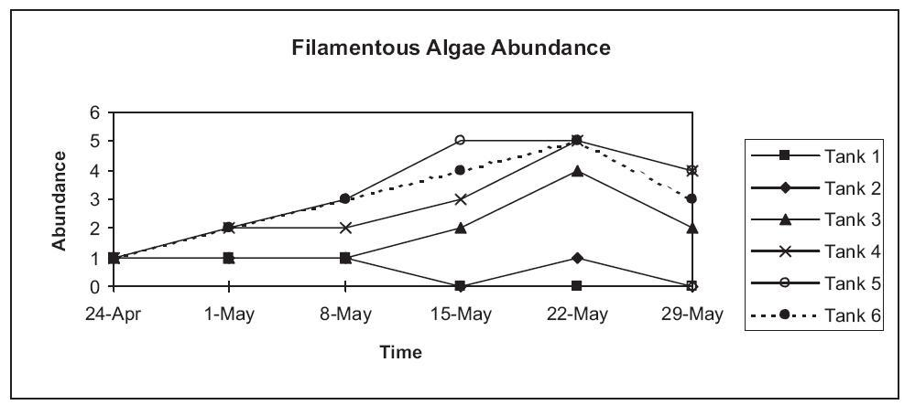

For this activity, the abundance of filamentous algae was estimated visually on a scale from “0”
(none) to “5” (very dense).

MATERIALS

QUANTITY ITEM
20 pounds 16-16-16 pelletized commercial fertilizer
6 2000 ml beakers
6 1000 ml beakers
12 250 ml beakers
6 5-gallon white plastic buckets
6 250 ml graduate cylinders
12 Clipboards
1 Orion portable pH meter
6 pH testers (hand-held)
3 Digital or triple-beam balances
1 box Latex gloves
1 Turbidimeter of Spectronic-20 spectrophotometer
6 LaMotte’s Limnology test kits (or Hach kits)
6 Alcohol centigrade thermometers
6 Meter sticks
6 Nalgene 5-gallon aquaria
6 Aquarium nets (small)

LIVE MATERIALS:

NOTE: Live materials should represent species that would be expected in a local
pond community and should be collected from local sources.

150 Pacific treefrog tadpoles
30 Aquatic snails
1 pound Duckweed
1 pound Filamentous algae (e.g., Oscillatoria)
500 ml Zooplankton sample

Constructed Wetlands/Lab I — Literature Review
INTRODUCTION

The treatment of wastewater from municipal, agricultural and industrial sources is of primary
concern in modern societies. Water that contains pollutants from raw sewage to chemical contaminants must be processed before entry into natural waterways to avoid environmental contamination and resulting threats to environmental quality and human health. For years, modern societies have constructed large, centralized wastewater-treatment facilities that treat large volumes of water using both chemical and biological processes. The utility of such facilities has come into question lately considering their high cost and increased demands put upon them by growing populations. Consequently, there has been a great deal of interest in the development of alternative methods of treatment that capitalize on natural processes that occur in ecosystems. Among these alternatives is the use of natural and constructed wetlands to replace or (more commonly) augment the actions of technology-based wastewater treatment plants. Arcata, California, for example, has used a wetland for treatment of domestic sewage from that community since the 1970’s. An elaborate constructed wetland at The Oregon Garden, a world-class botanical garden and arboretum in Silverton, Oregon, has been designed to treat wastewater from the city of Silverton. Large-scale efforts often provide secondary benefits as well such as wildlife habitat or even recreational opportunities.

THE AQUATIC ECOLOGY LABORATORY

Chemeketa’s Aquatic Ecology Laboratory provides an opportunity for students to study the design and effectiveness of constructed wetlands for wastewater treatment. Students will design and set up a system of tanks this term that will be used to study the process. Next term we will monitor and evaluate its effectiveness. The Aquatic Ecology Laboratory is an outdoor laboratory on Chemeketa’s Salem campus. Eighteen 300-gallon (height = 2', diameter = 5') polyethylene stock tanks serve as simulated aquatic ecosystems. Each tank has an outlet at the bottom and flow can be regulated with a spigot. In addition to the tanks themselves, a chain-link fence encloses a storage building and covered bench tops for student work. Water and electrical service are provided to the facility. Electrical outlets are located along the bench tops. We have also installed an environmental monitoring system that measures physical variables such as air temperature, rainfall, relative humidity and solar radiation. These data are recorded continuously and stored on the hard disk of a computer in the storage building. Using available software, this information can be displayed graphically and correlated with biological changes in the tanks during future experiments.

PROCEDURE

In preparation for this activity, students must make reasonable decisions about design based on what is already known about these systems. You will be assigned one of the following questions to research in the upcoming week. Any source is acceptable if it provides useable information concerning the design and operation of a constructed wetland. Results of the research will be summarized by the instructor and made available to each student.

Sources may include, but are not limited to, the following:

- Professional journals that publish articles on natural or constructed wetlands
- Books on natural or constructed wetlands
- Knowledgeable persons who work with constructed wetlands or wetland mitigation
- Private companies such as environmental engineering firms that construct wetlands
- Internet search for “constructed wetlands”

QUESTIONS

- What is a “constructed wetland”? What types of constructed wetlands have been attempted?
- What types of pollutants can be removed with constructed wetlands? What pollutants should be added to the water to be treated? How should this be determined?
- How do constructed wetlands work? What processes are involved in the removal of pollutants? Do these processes take place at the surface, in the water column or in the soil?
- As we monitor the effectiveness of a constructed wetland, what measurements should be taken? How often should these measurements be taken?
- Is the selection of plants important? What plant species are typically used? At what density should they be planted?
- Is the composition of the soil important? Organic soil and coarse sand will be available. What are the best depths for each? How should this be determined?
- Should these constructed wetlands be static systems in which the treated water simply sits in the tank for a period of time or dynamic systems in which there is some flow in the system? What are the advantages and disadvantages of each?
- What wetland animals, if any, may be important to the process? What species could reasonably be introduced considering the size constraints of these systems (alligators are probably out of the question). How should they be introduced?

Constructed Wetlands Lab II – Design and Construction

INTRODUCTION

In today’s lab we will discuss the results of our literature search and make some decisions regarding the design of our constructed wetlands. Once those decisions are made we will proceed to the Aquatic Ecology Laboratory to begin construction. We will separate into three groups, each of which will have responsibility for the construction of one model wetland.

Wetland plants were obtained from a local nursery that specializes in the culture of wetland plants for wetland mitigation and restoration projects. The nursery provided the following recommendations for planting these species:

Broadleaf cattail (Typha latifolia) — wet soil to 12" water, plant rhizome 3-4" deep
Slough sedge (Carex obnupta) — wet soil to 3" water, soil level to crown
Smooth rush (Juncus effusus) — wet soil to 3" water, soil level to crown
Yellow iris (Iris pseudacorus) — wet soil to 12" water, soil level to crown
Skunk cabbage (Lysichitum americanum) — wet soil to 3" water, plant deep so white part of stalk is covered

Drainage devices for six 300 gallon polyethylene tanks have been prepared to facilitate drainage. An 18" length of 3", perforated PVC pipe has been fitted to the spigot at the bottom of each tank.
Water that moves through the substrate should enter this pipe. We can then regulate the rate of
water movement by opening and closing the spigot. Two types of soil are available for our use—
coarse sand/fine gravel and organic soil.

SUMMARY OF LITERATURE REVIEW

The following information was gleaned from student research conducted prior to the design and
construction of the wetlands. Complete citations are given in the “Literature Cited and Additional Resources” section at the end of this document.

- What is a “constructed wetland”? What types of constructed wetlands have been attempted?

Constructed wetlands are manmade imitations of naturally found water habitats. They attempt to recreate the species diversity and ecosystem processes found in a natural wetland.

- What types of pollutants can be removed with constructed wetlands? What pollutants should be added to the water to be treated? How should this be determined?

- Organic materials such as sewage, animal manures and agricultural wastes can create a Biological Oxygen Demand (BOD) in bodies of water. Their aerobic decomposition consumes oxygen which lowers dissolved oxygen levels
- Nutrients — Nitrogen (as ammonia or nitrate), Phosphorus
- Metals (mostly from industrial waste) — some plants hyperaccumulate metals
- Sediment
- How do constructed wetlands work? What processes are involved in the removal of pollutants? Do these processes take place at the surface, in the water column or in the soil?

- Filtration/settling of sediment particles and nutrients (e.g. N, P, K) that are attached to these particles.
- Solid organic matter is mechanically filtered by soil in the wetland.
- Dissolved organic matter is consumed by microbes especially in an aerobic environment. Microbes associated with roots of plants are most important as a symbiotic relationship is formed — microbes require oxygen while breakdown products are used by plants.
- Plant stems and roots provide surface area for communities of microorganisms which convert organic nitrogen into inorganic nitrogen.
- Chemical reactions between sediments in water and oxygen (e.g., incoming sulfides may react with iron-rich soil to form iron sulfides which settle). Reaction rates are influenced by pH.
- Nitrification — ammonia combines with carbon dioxide to form nitrates and hydrogen gas. This process is aerobic.
- Denitrification — the conversion of nitrogen wastes to nitrogen gas which is released into atmosphere. This process is anaerobic. An alternating aerobic and anaerobic environment is required to completely remove nitrogen from wastewater. This process may take several days. The availability of carbon in wastewater is a limiting factor.
- In the anaerobic environment below the water surface plant roots exude oxygen, creating a rhizosphere — an active area for biological and chemical activity.
- Phosphorus chemically binds to soil, sand or brick (if used in substrate) under aerobic conditions, forming iron phosphate which locks up the phosphorus.
- Evapotranspiration — loss of water to atmosphere from plants.

All treatment processes work simultaneously so that by the time water flows out of the wetland the N, P, S and bacterial content can be greatly reduced. Rates of processing depend on the characteristics of the wastewater, climate, native vegetation and the amount of time spent in the system. Processes take place both within the water column and in the soil.

- As we monitor the effectiveness of a constructed wetland, what measurements should be taken? How often should these measurements be taken?

Water depth (fluctuation) pH Water temperature
Dissolved oxygen (DO) Color Odor
Total Suspended Solids (TSS) Rainfall Solar radiation
Soil saturation at different levels Nitrate Phosphorus
Growth rates of vegetation and density Sulfur Metals
Photographs of tanks at various stages may also be helpful

Environmental variables should be measured twice a week and others once a week. (Note: The environmental monitoring equipment in the aquatic laboratory will automatically measure environmental variables every day. We will have to take all other measurements manually.)

- Is the selection of plants important? What plant species are typically used? At what density should they be planted?

The type and amount of pollutants in wastewater will determine the best plants to use. Most systems use a variety of native aquatic plants but there are some non-natives that may process certain contaminants more efficiently.

Plants should:
- have an extensive root system to support large colonies of microbes
- be able to tolerate expected temperature extremes
- remain active throughout the year
- have a high rate of water and nutrient utilization
- have a good ability to resist disease
- be “obligate wetland species”

Duckweed (Lemma spp.) and pennywort (Hydrocotyl spp.) have a good capacity for nutrient absorption. Water lily and a variety of reeds, cattails, arrowhead, willows, sedges and rushes are commonly used.

Based on this information, the following species were ordered:
60 - Broad-leaf cattail (Typha latifolia)
180 - Slough Sedge (Carex obnupta)
180 - Smooth Rush ( Juncus effusus)
3 - Skunk cabbage (Lysichitum americanum)
6 - Yellow iris (Iris pseudoacorus)

- Is the composition of the soil important? We will have both organic soil and coarse sand available. What are the best depths for each? How should this be determined?

Composition of soil may be an important factor in the functioning of the constructed wetland. There are two types — Free Water Surface Flow (in which water flows over soils) and Sub-Surface Flow (in which water flows below the surface of the soils).

One system was designed as follows:

Coarse gravel near bottom — to allow water to pass through without being exposed to atmosphere
Sandy or clay loam — 16-24" — fertile soil for the propagation of plants
Organic soil — 2-6" — fertile soil with organics as a carbohydrate source

Another system:

Soils mimic permeable upland areas that soak up and cleanse runoff as it travels through the soil toward groundwater. Sand, crushed rock, brick and gravel are all used. One setup uses 12" of sand for drainage and filtration. Trial and error testing may be used to determine correct depth and composition.

For our tanks we should use an 8" layer of coarse sand/fine gravel at the bottom and 12" of organic soil on top. This would leave about 6" of head space for open water.
- Should these constructed wetlands be static systems in which the treated water simply sits in the tank for a period of time or dynamic systems in which there is some flow in the system? What are the advantages and disadvantages of each?

Static system — probably not a good system for treatment of agricultural waste. Plants may suffocate due to lack of flow and algae populations may explode due to high nutrient input. If water is high in sediments, the sediment would collect at the entry point. A mini-dredging operation may be required.

Dynamic system — probably a better choice. Flow assists filtration, reduces algal growth. Plants will slow flow and allow for further deposition of sediments. Dynamic is the way to go!

- What wetland animals, if any, may be important to the process? What species could reasonably be introduced considering the size constraints of these systems. How should they be introduced?

Aquatic larval stages of mosquitos, gnats, midges, and dragonflies as well as bacteria break down complex organic molecules. Most of these will either be present in the substrate, on plants used in the construction process or attracted to the wetlands soon after construction. Zooplankton samples from a local pond could be added to increase the probability of colonization.

Initial Conditions

On the basis of student-conducted research (summarized above) six identical model wetlands were constructed in February 1998 in Chemeketa’s Aquatic Ecology Laboratory. After construction, students were required to describe the initial conditions in the tank for future reference. Photographs were taken during construction and at completion.

Substrate:

Two layers of substrate were placed in each tank (Figure 2):
- coarse sand/gravel (3/4" diameter and smaller) mix — 6"
- organic soil — 11"
Since the tank height is 24", this left approximately 7" of head space at the top of the tank to allow for fluctuating water levels. The top layer of organic soil was slightly excavated. A 4" deep depression approximately 2' in diameter was created in the center of the tank. This was done to create two different water depths and/or saturation levels of soil to accommodate the different tolerance of flooding and submersion of plant species.

Plants:

The four species of aquatic plants selected before construction seemed adequate for our purposes. They are all obligate wetland (OBL) species with extensive root systems and all have been shown to have the capacity for absorbing large amounts of nitrate and phosphate nutrients, especially the rushes and cattails.

Iris and cattails were placed in the slightly depressed area in the center of the tank (Figure 3). Planting instructions indicated that they can tolerate up to 12" of water. Rushes and sedges were placed on a “shelf ” near the perimeter at a slightly higher elevation since they can tolerate only 3" of submersion.

Iris — a single plant was placed in the center of the wetland
Cattails — 12 plants were placed in a roughly circular pattern around the iris at approximately 4" spacing
Rushes — 30 rushes were placed on the “shelf ” at 4" spacing
Sedges — 30 sedges were placed on the “shelf ” at 4" spacing
Rushes and sedges were planted alternately.

Water:

Rainwater that collected in other tanks was used to saturate the soils in the wetlands (Figure 4).
Water level was brought up to approximately 10" below the rim of the tank which left some standing water in the center depression but did not cover the shelf. Water levels will be held relatively constant by either adding or draining water depending on inputs from rainfall and outputs from evaporation (Figure 5).
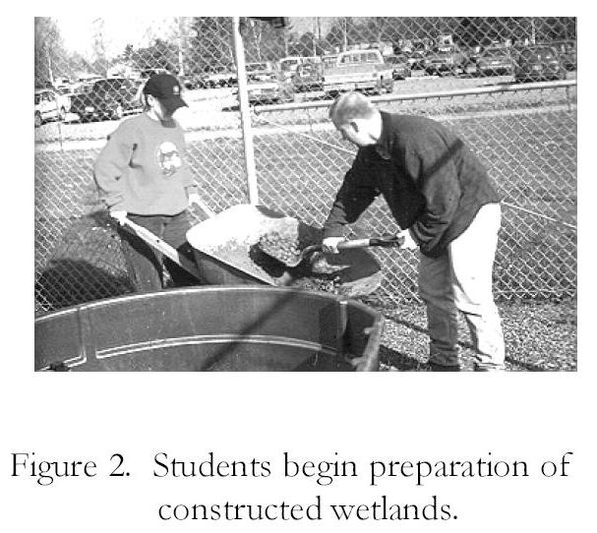
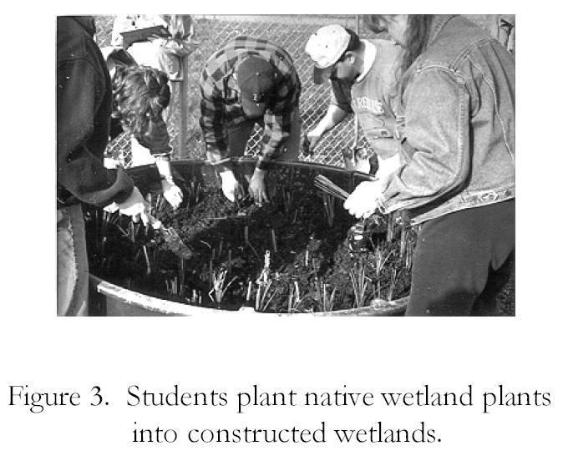
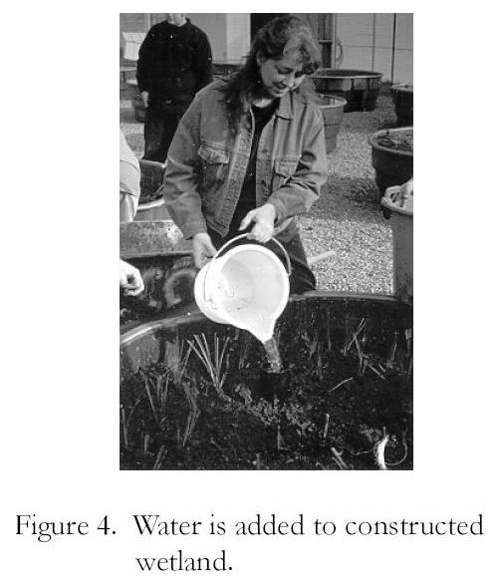
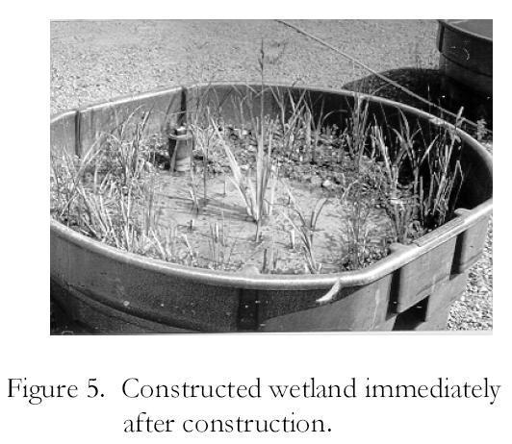
Constructed Wetlands Lab III—Preparations for Treatment
INTRODUCTION

Last term we investigated the use of constructed wetlands for the treatment of wastewater. We collected information on the types of pollutants that could be removed and the specific processes involved, the type of substrates, plants and animals that are typically used and the measurements that should be taken to monitor the effectiveness of constructed wetlands. Using this information, we constructed six artificial wetlands at Chemeketa’s Aquatic Ecology Laboratory. The initial conditions established in these wetlands are described previously in this document.

In today’s laboratory we will:

- Prepare the “wastewater” to be treated by the wetlands
- Measure the initial conditions in this wastewater
- Design an experiment that will test the ability of these wetlands to process wastewater
- Develop protocols to be followed for measurements

NOTE: The constructed wetlands plants (and perhaps microbial communities) have not matured to the point that they could be expected to process much wastewater. Therefore, we will wait for a couple of weeks before we apply any wastewater to the systems.

PROCEDURE

- Prepare Wastewater

Two tanks (approximately 300 gallons each) have been identified that contain water to be processed. Our goal is to add commercial fertilizer to this water such that it resembles agricultural runoff — i.e., high in phosphates and nitrates. We will bring one tank up to high levels of phosphates and nitrates while the second will have moderate levels. In this way we could test the ability of the wetlands to process two levels of contamination.

- Measure Initial Conditions in Wastewater

The wastewater should be carefully mixed before measurements are taken. (Don’t overdo it —
vigorous mixing could add oxygen to the water and influence the dissolved oxygen measurement.)

- pH
Follow the procedure described in the Limnology Test Kit to determine the pH of the wastewater or measure pH directly with the Orion pH Meter.

- Water temperature
Use an alcohol thermometer to determine the initial temperature of the wastewater.

- Dissolved Oxygen (DO)
Follow the procedure described in the Limnology Test Kit to determine the dissolved oxygen of the wastewater or measure DO directly with the Orion Dissolved Oxygen Meter.
- Turbidity/Algal Concentration
A device called a “spectrophotometer” will be used to estimate turbidity and algal concentration. This device passes a known quantity of light through a sample in a glass tube called a “cuvette”. A sensor on the opposite side of the cuvette detects the amount of light that passes through and displays this amount on a scale. The wavelength of light can be adjusted to measure the amount of various materials dissolved in the sample. We will use two wavelengths — one for turbidity and one for chlorophyll. The proper use of the spectrophotometer will be described in lab.

- Nitrate
Follow the procedure described in the Limnology Test Kit to determine the concentration of nitrogen in the form of nitrate in the wastewater.

- Phosphorus
Follow the procedure described in the Limnology Test Kit to determine the concentration of phosphorus in the wastewater.

- Odor
Describe any noticeable odor in the wastewater and its intensity as “strong”, “moderate” or “slight”. Some possibilities include — “rotten egg”, “musty”, “raw sewage”, or “none”.

- Microscopic Examination
The type of algae and protozoans in a water sample often provide some indication of water quality. Prepare a microscope slide and examine it under the compound microscope at 100X and 450X. Your instructor will describe the proper procedure for microscope slide preparation and the proper use of the microscope.

Use available guides to identify algal species and estimate the percent of each species.

Record this information on data sheet.

- Experimental Design

At this point we have six identical constructed wetlands. Design an experiment with replications and controls that tests the effectiveness of these wetlands to treat the wastewater we have made. In addition to replications and controls, be sure to include the following in your experimental design:

- How much wastewater should be added? (We will have about 600 gallons to treat)
- When should it be added and in what quantities?
- Should the water be added “all at once” or in “pulses”? If “in pulses”, how often?
- How should it be added? (e.g., Sprayed on surface?, Dumped on surface?, Dumped into drainage system?)
- How long should the wastewater remain in the wetland before a sample is taken for testing?
- How should the sample be taken?

- Protocols for Measurement

Once the “treated sample” is taken from the constructed wetland, describe:
- Those measurements that should be taken. (Use initial measurements on the wastewater as a guideline.)
- Protocols (step-wise instructions) for how these measurements should be taken. Include sufficient detail such that any student could pick up your instructions and follow them.

- Data Sheet Design

Design a data sheet that will allow you to record all information required for the study. Include
space for initial conditions of wastewater as well as treated samples in the future.

- Other Data Collection

All of the measurements described in “IV” above are taken on the treated water after it exits the wetlands. Last term we described additional variables that we may want to measure to monitor the effectiveness of the wetlands. Some examples included:

- Water depth (fluctuation)
- Rainfall
- Solar radiation
- Growth rates of vegetation and density
- Photographs of tanks at various stages

We will discuss the measurement of these variables at a later date. Most will be recorded automatically by the Environmental Monitoring Equipment permanently installed in the Aquatic Ecology Laboratory.

MATERIALS

QUANTITY ITEM
6 LaMotte’s Limnology Kits
1 Orion Portable pH Meter
1 Orion Portable Dissolved Oxygen Meter
6 Wash bottles
12 250 ml bottles with screw cap
3 Spectronic 20 Spectrophotometers
6 Cuvettes for Spectronic-20
6 Alcohol thermometers
25 Microscope slides
25 Coverslips
6 Algae Guides (Palmer, 1977)
6 Funnels
36 Filter paper
12 Distilled water in wash bottles
12 250 ml beakers
Water Quality Measurement Protocols

The following step-by-step protocols were developed by students in Environmental Science. Each group was assigned one or two procedures to perform on water samples. After conducting these tests they were asked to describe the protocol. Other students tested their protocols and made changes.

It is imperative that each group follow the same procedure each time that measurement is taken.

pH
NOTE: Follow the procedure described in the Limnology Test Kit to determine the pH of the wastewater.

- Take sample from spigot in 300 ml beaker after allowing 5 seconds of free flow
- Return free flow to tank Species
- Thoroughly mix sample
- Rinse a test tube (from Limnology Test Kit - pH Test) with the water sample
- Fill tube to 5 ml line with water sample
- Add 10 drops of indicator solution while holding dropper bottle (or pipette) vertically
- Cap and invert several times to mix
- Insert test tube into comparator and match sample color to color standard
- Record pH (Measurements can be verified with the Orion pH Meter.)

Temperature
- Obtain sample from spigot in a 300 ml beaker
- Place a thermometer into the beaker about half way down
- Allow to sit for one minute
- Pull out thermometer and record temperature

Dissolved Oxygen
NOTE: Numbers in parentheses refer to part and reagent numbers in the LaMotte’s Limnology Test Kits.

- Thoroughly rinse 25 ml sampling bottle (#0688-DO) with sample water
- Fill 25 ml sampling bottle completely with sample water
- Gently tap sides of sampling bottle to dislodge any bubbles
NOTE: Be careful not to introduce air into the sample while adding the reagents in the following steps. Simply drop the reagents into the sample. Cap carefully, and mix gently.
- Add 8 drops Manganese Sulfate Solution (#4167)
- Add 8 drops Alkaline Potassium Iodide Azide (#7166)
- Cap and mix by inverting sample several times and allow particles to settle below shoulder of sampling bottle before proceeding.
- Use the 1.0 g spoon (#0697) to add 1 g Sulfamic Acid Powder (#6286)
- Cap and mix until reagent and precipitate dissolves (sample is now “fixed”)
- Fill titration tube (#0299) to 20 ml line with “fixed sample” then cap titration tube
- Fill Direct Reading Titrator (#0377) with Sodium Thiosulfate (4169)
- Add one drop at a time to sample and swirl between each drop until color is faint yellow
- Remove titrator and cap
- Add 8 drops Starch Solution (sample should turn blue-black)
- Replace cap and titrator
- Continue to add Sodium Thiosulfate until the blue color just disappears
- Read the total amount of Sodium Thiosulfate added where plunger tip meets the scale. This reading is equal to dissolved oxygen concentration of the sample in ppm.
NOTES: Each minor division on the Titrator scale equals 0.2 ppm
If the plunger tip reaches the bottom line on the titrator scale (10 ppm) before the endpoint color change occurs, refill the titrator and continue adding drops. When recording the test result, be sure to include the value of the original amount of Sodium Thiosulfate added (10 ppm).
- Record dissolved oxygen (Measurements can be verified with Orion D.O. Meter)

Turbidity
A device called a “spectrophotometer” will be used to estimate turbidity and algal concentration. This device passes a known quantity of light through a sample in a glass tube called a “cuvette”. A sensor on the opposite side of the cuvette detects the amount of light that passes through and displays this amount on a scale. The wavelength of light can be adjusted to measure the amount of various materials dissolved in the sample. We will use two wavelengths - one for turbidity and one for chlorophyll. The proper use of the spectrophotometer will be demonstrated in lab.

- Turn on spectrophotometer and allow it to warm up for 10 minutes
- Select a wavelength of 550 nm and select correct filter position (if so equipped)
- Set spectrophotometer to 0% Transmittance using knob on left
- Place distilled water in cuvette (= blank) and wipe clean
- Insert the blank into spectrophotometer lining up white lines on cuvette with indicator line on spectrophotometer
- Adjust spectrophotometer to 100% Transmittance with light adjustment knob on right
- Remove blank
- Place cuvette with water sample in spectrophotometer
- Close lid and read % Transmittance from scale to tenth place. Record data.

Algal Concentration
- Turn on spectrophotometer and allow it to warm up for 10 minutes
- Select a wavelength of 660 nm and select correct filter position (if so equipped)
- Set spectrophotometer to 0% Transmittance using knob on left
- Place distilled water in cuvette (= blank) and wipe clean
- Insert the blank into spectrophotometer lining up white lines on cuvette with indicator line on spectrophotometer
- Adjust spectrophotometer to 100% Transmittance with light adjustment knob on right
- Remove blank
- Place cuvette with water sample in spectrophotometer
- Close lid and read % Transmittance from scale to the tenths place. Record data.

Phosphates (Orthophosphates only)
NOTE: Numbers in parentheses refer to part numbers for equipment and reagents in LaMotte’s Limnology Kits.
- Fill test tube (#0844) to 10 ml line with sample water.
- Use the 1.0 ml pipette (#0354) to add 1.0 ml of Phosphate Acid Reagent (V-6282).
- Cap and mix.
- Use second 0.1 g spoon (#0699) to add one level measure of Phosphate Reducing Reagent (V-6283).
- Cap and mix until dissolved. Wait 5 minutes.
- Remove cap. Place into Nitrate and Phosphate Comparator (#3120) with Axial Reader (#2071). Match sample color to color standard on reader.
- Record as ppm phosphate.

Nitrates
- Fill test tube (#0844) to 2.5 ml line with sample water.
- Dilute to 5 ml line with Mixed Acid Reagent (V-6278).
- Cap and mix. Wait 2 minutes before proceeding.
- Use the 0.1 g spoon (0699) to add one level measure of Nitrate Reducing Reagent (V-6279).
- Cap and invert 30 times in one minute. Wait 10 minutes.
- Mix and remove cap. Insert test tube into the Nitrate-N and Phosphate Comparator (#3120). Match sample color to a color standard.
- Record as ppm Nitrate-N

Odor
- Smell the water sample for any odor
- Record in classes:
3 - “strong” (“Yuk!”)
2 - “moderate” (easily detectable but not obnoxious)
1 - “slight” (barely detectable)
0 - “none” (not detectable)
- Identify odor as:
“Rotten egg” (Hydrogen sulfide)
“Musty” (Molds)
“Raw sewage” (Organic waste and bacteria)
“Frog pond” (Algae)
Additional categories of odors may be added, if appropriate.

Microscopic Examination
- Take one 100 ml sample from spigot in a small beaker
- Allow it to settle for 5 minutes
- Using a Pasteur pipette, extract a small sample from anywhere in the beaker where algae has settled (look for areas of green)
- Prepare a wet mount using a microscope slide and coverslip
- Examine at 100X and 450X using compound microscope
- Use identification guides to identify algal species
- Record presence or absence on data sheet
- Note whether species are indicators of clean water, slightly polluted water or heavily polluted water (see available references)
NOTE: If desired, most water quality measurements can be confirmed by sending samples to a private water quality testing laboratory.

How should we interpret
water quality measurements?

As we proceed with experiments designed to determine the effectiveness of constructed wetlands to treat agricultural wastewater, we will be comparing the initial conditions of the wastewater with the conditions of water that has been treated by the wetlands. The parameters that have been selected for measurement are representative of some of the best indicators of water quality. The following descriptions provide an indication of why these parameters are important and how the values you obtain might be interpreted.

A. pH
pH is a measure of the hydrogen ion (H⁺) concentration in a solution. Acid strength is based on how readily it releases hydrogen ions in water — strong acids release lots of H⁺, weak acids release smaller amounts. A pH reading of 7.0 indicates neutrality (neither acidic nor basic); numbers less than 7.0 are acids, greater than 7.0 are bases (alkaline). Since the pH scale is logarithmic, a change of one pH unit represents a ten-fold change in the acidity of the solution. Most species can tolerate pH values from 6.0 to 8.0; optimal levels for most fish are between 7.1 and 7.8 (Table 1). Values above or below these values may affect some species. Amphibians and some aquatic insect larvae are particularly sensitive to acidic conditions.

Table 1. Lethal pH Limits for Some Aquatic Organisms

pH Value | Impacts
4.0 to 4.5 | all fish, amphibians and many invertebrates dead
4.5 to 5.0 | caddisflies and mayflies dead
5.0 to 5.5 | salmonid eggs and alevin dead, decomposing bacteria decline
5.5 to 6.0 | most fish and amphibians decline
6.0 to 6.5 | snails and tadpoles decline
6.5 to 8.2 | most species can tolerate
8.5 to 9.0 | salmonids begin to decline with prolonged exposures
>11.0 | salmonids dead
>11.5 | most fish dead

Most biochemical reactions that occur in living organisms are sensitive to pH. Therefore, pH values that lie outside of a species range of tolerance can have direct effects on survivability and overall health of the organism. In addition to these direct effects of pH changes, there are indirect effects as well. Acidic conditions (low pH) can increase the release of metals such as aluminum or copper from sediments and increase their concentration in the water. These metals can disrupt gill function or cause deformities in fish. Another indirect effect is illustrated by the relationship between pH and ammonia. Ammonia in water may occur either as ammonium ion (NH₄⁺) or ammonia (NH₃). NH₃ is highly toxic to fish and other aquatic organisms. As pH levels increase, a greater portion of the ammonia exists in this toxic form.

High acidity (low pH) in waterways can be caused by carbon dioxide dissolved in water, tannic acid from the decomposition of conifer needles and bark, acid rain, coal mining operations and industrial pollutants.

B. Water temperature
Water temperature in small ponds is closely tied to ambient temperature. Temperatures influence those organisms that can occur in ponds (Table 2). Since most aquatic organisms are cold-blooded, water temperature controls metabolic rate and, often, the timing of reproductive activities. In our area, thermal pollution (high temperatures) is generally more limiting than low temperatures. Aquatic organisms are generally more susceptible to the influences of toxic chemicals, parasites and diseases at temperatures at the upper end of their range of tolerance. Water temperature also influences dissolved oxygen levels (see discussion below).

Table 2. Optimal Temperatures for Some Aquatic Organisms
(Adapted from Murdoch and Cheo, 1996)
Temperature Range |  | Species
˚C | ˚F
> 25 | > 77 | lethal for salmonids and some aquatic insects
20 to 25 | 68 to 77 | optimum for "warm water species" (bass, bluegill, carp, catfish, suckers, dragonflies, true flies, few caddisflies)
13 to 20 | 55 to 68 | optimum for "coolwater species" (coho, chinook, cutthroat, sturgeon, mayflies, caddisflies, stoneflies)
5 to 13 | 41 to 55 | optimum for "coldwater species" (steelhead, all salmon, most trout, most mayflies, caddisflies, stoneflies)

C. Dissolved Oxygen (DO)
Dissolved oxygen is measured in parts per million (ppm) with a dissolved oxygen meter or chemically with a Winkler Titration (Note: The procedure we used in the Limnology Test Kits is a modified version of this test). Dissolved oxygen levels of 7-10 ppm are typical in unpolluted water and generally considered adequate for most aquatic life. In salmonid streams, dissolved oxygen requirements are higher. Salmon embryo and larval stages can show some impairment at DO levels as high as 8 or 9 ppm. In other aquatic habitats, levels below 4.5 ppm can cause acute mortality of fish and invertebrates. The primary sources of oxygen in the tanks are photosynthetic production by algae and higher plants and diffusion from the air above the water surface. Dissolved oxygen levels may fluctuate significantly throughout the day especially in bodies of water with extensive plant growth. For this reason, if dissolved oxygen levels are to be compared through time, samples should be collected at approximately the same time of day and under similar conditions of light intensity. Levels rise from morning to afternoon as a result of photosynthesis, reaching a peak in late afternoon. Photosynthesis then begins to shut down as light intensity decreases. At night photosynthesis stops but plants and animals continue to respire — thus consuming oxygen. Dissolved oxygen levels typically decline at night.

Low dissolved oxygen levels generally indicate polluted water and high Biological Oxygen Demand (BOD). Low dissolved oxygen readings can be expected in stagnant water with large amounts of organic material. As the organic material decomposes, oxygen is consumed in the process. Dissolved oxygen can influence the species that occur in a body of water. When dissolved oxygen levels drop below a critical level, fish, amphibians, aquatic invertebrates and aerobic bacteria which rely on this oxygen for aerobic metabolism will decline and eventually perish. Additionally, at low dissolved oxygen levels, anaerobic bacteria proliferate and break down the remaining organic material, producing toxic gases such as hydrogen sulfide and methane.

The amount of dissolved oxygen is also a function of water temperature — cold water is capable of retaining high amounts of dissolved oxygen, warmer water is less capable. This relationship is
illustrated for temperatures from 10 - 41°C in Table 3. This information can be used to determine
the percent saturation for dissolved oxygen in a water sample. Percent saturation is a measure of the amount of dissolved oxygen in a water sample relative to the maximum amount that could be in that sample. For example, suppose we obtained a dissolved oxygen reading of 8.0 ppm for a water sample and the temperature of the sample was 20°C. The percent saturation could be calculated by dividing your reading with the maximum dissolved oxygen concentration at 20°C (“9.07 ppm” from the Table 3) and multiplying by 100:

Percent Saturation = (8.0/9.07) X 100 = 88.2 %

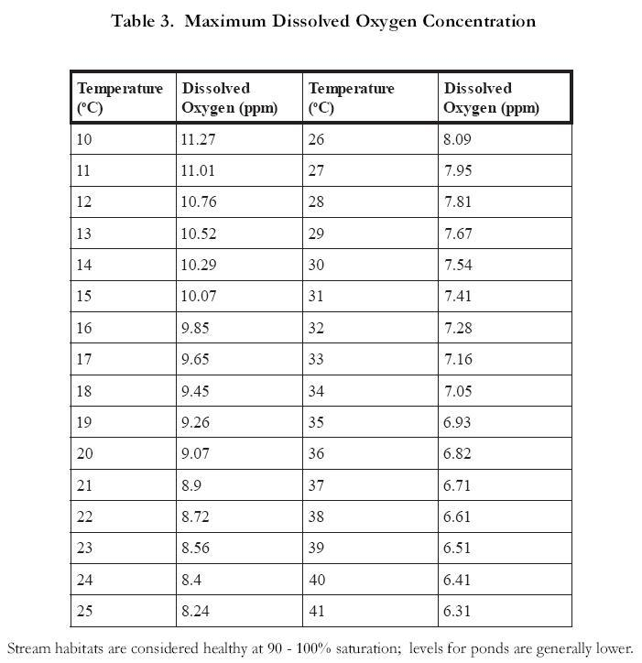
D. Turbidity
Turbidity is a measure of the “cloudiness” of the water. Sediment, algae, bacteria and zooplankton all contribute to what is technically known as the Total Suspended Solids (TSS) that increase the turbidity. As turbidity increases, the degree to which sunlight penetrates the water column declines. This obviously has an impact on photosynthetic rates in algae and submerged vegetation. High turbidity can also raise surface water temperature as suspended particles near the surface absorb more heat from sunlight. Suspended soil particles may also carry nutrients, pesticides and other pollutants and they can bury benthic organisms. Turbid waters tend to be low in dissolved oxygen.

Turbidity can be measured with a turbidimeter in nephelometric turbidity units (NTU). Drinking
water is generally very clear and would have a turbidity measurement less than 10 NTU. Very cloudy water would read about 1000 NTU. Alternatively, relative measures of turbidity can be obtained by using a “spectrophotometer”. This device passes a known quantity of light through a sample in a glass tube called a “cuvette”. A sensor on the opposite side of the cuvette detects the amount of light (% Transmittance) that passes through and displays this amount on a scale. The wavelength of light can be adjusted to measure the amount of various materials dissolved in the sample. The accepted wavelength for the measure of turbidity is 550 nm.

E. Algal Concentration
Algae can have both positive and negative impacts on aquatic ecosystems. Algae produce oxygen through photosynthesis during the day — thus increasing dissolved oxygen concentrations. They also absorb both ammonia and nitrate and use them as nutrients. However, when algal blooms occur, turbidity is increased and algal die offs consume oxygen and release toxic substances such as ammonia, methane and hydrogen sulfide. The concentration and type of algae in a water sample can be used as indirect measures of water quality. High algal concentrations generally indicate abnormally high levels of nutrients — typically nitrates and phosphates.

Algal concentrations will be measured in a manner similar to that which we have used for turbidity. Chlorophyll is the primary pigment in water samples that contain algae and the intensity of the color can be used as a rough measure of algal concentration. Although there are several types of chlorophyll, each with its own spectral properties, we will estimate the abundance of “chlorophyll a” which absorbs best at 660 nm.

F. Nitrate
Nitrogen appears in several forms in water sources, including nitrate (NO₃⁻), nitrite (NO₂⁻) and
ammonia (NH₃). Of these, nitrates are probably the most common inorganic pollutant tested in water. Ammonia is a product of the decomposition of plant and animal protein but tends to be taken up quickly by algae and plants. Nitrites tend to occur at fairly low levels in most water samples because they are readily converted to nitrates by bacteria. Nitrates are a common component of multi-nutrient fertilizers whose nutrient content is indicated by three numbers called the “grade”. The first of these numbers indicates the nitrogen content of the fertilizer. A fertilizer grade of 16-16-16, for example, contains 16% by weight nitrogen, 16% phosphate (P₂O₅) and 16% potassium (K₂O). Both nitrates and ammonia stimulate algal growth and may be responsible for causing cultural eutrophication. If ingested, they are converted to nitrites in the intestines of humans where they combine with hemoglobin in red blood cells, causing the oxygen-carrying capacity to decline. In infants this condition may be fatal. Contamination of groundwater by nitrates that are applied as fertilizer or runoff from feedlots and dairies is a widespread problem in agricultural regions of the country. Improperly treated sewage from sewage treatment plants and septic systems that finds its way into waterways is also an important source. Nitrates can be measured by following the procedure described in the Limnology Test Kit.

The national drinking standard for nitrates in the U.S. is 10 ppm. Waters that have levels as low as 1 ppm, however, can be sufficiently polluted to cause algal blooms.

G. Phosphorus
Phosphorus usually occurs in natural systems as phosphate (PO₄⁻³). This phosphate may be bound to organic compounds (organic phosphate) or inorganic compounds (inorganic phosphate or orthophosphate). Inorganic phosphate is the form most readily available to plants and therefore is generally of greater interest than organic phosphate. Phosphorus tends to be less abundant than nitrates in freshwater ecosystems and is, therefore, often a limiting factor for plant and algal growth. The addition of phosphorus (in the form of phosphates) commonly results in algal blooms (cultural eutrophication). Domestic sewage (particularly those containing significant amounts of laundry detergents) and agricultural runoff are important sources of phosphates. Most sewage treatment plants remove only about 50% of the nitrogen and 33% of the phosphorus from domestic sewage. The remainder is dumped in the effluent into surface water. Phosphorus levels as low as 0.01 ppm can have an impact. Phosphates (inorganic phosphates only) can be measured by following the procedure described in the Limnology Test Kit.

H. Odor
Unpolluted water should be odor-free. Any noticeable odor in the water supplies may be due to
contamination caused by chemicals, raw sewage or action of anaerobic bacteria. A “rotten egg”
smell, for example, usually indicates the presence of hydrogen sulfide (H₂S), a common byproduct of anaerobic breakdown of organic matter.

I. Microscopic Examination
The type of algae and protozoans in a water sample often provide some indication of water quality. Some species are tolerant of conditions found in polluted water while others are far less tolerant. Table 4 lists some species that are used as indicators of water quality. A more complete list and identification aids can be found in the reference cited below.

Table 4. Algal species Used as Indicators of Water Quality in Freshwater
(from Palmer, 1977)
Unpolluted Water | Polluted Water
Cladophora | Euglena
Ulothrix | Chlamydomonas
Phizoclonium | Chlorella
Surirella | Oscillatoria
Pinnularia | Chlorogonium
Phacotus | Anabaena
Meridion | Lepocinclis

Although there are a number of methods available to measure the quantity of algal species in a water sample, we will simply estimate the “percent of individuals” for those that can be readily identified. Wet mounts of water samples will be prepared and examined at 100X and 450X with a compound microscope. Use the available guides to identify algal species and estimate the percent of each species. Record this information on the data sheet.
Constructed Wetlands Lab IV— Addition of Wastewater

INTRODUCTION

An in-class discussion addressed experimental designs proposed by each lab group. The following constraints were presented:

- Wastewater Volume — two 300-gallon tanks of wastewater are available. At least 100 gallons of each should be retained as a control. Therefore, 200 gallons in each tank are available for treatment in 3 constructed wetlands (approximately 60 gallons each).
- Time — All samples must be taken and analyzed in four weeks to allow sufficient time for analysis and write-up.

Given these constraints and after thinking about the merits of various experimental designs, the class decided on the following:

Existing water in wetlands will be drained and measured. If amount drained approximates 50 gallons, 50 gallons of wastewater will be added to each tank in one pulse. If it is significantly less than 50 gallons, 2 pulses of 25 gallons will be added at 1 week interval.

Total amt. added (gal) | 50
When | 1 or 2 pulses dependent upon original volume drained (see note above)
Quantity per pulse (gal) | 50 or 25 (see note above)
Method | dumped on surface around edge
Residence Time | 1 week & approx. 4 weeks
Sampling | through spigot (allow 5 second free flow first) and at surface (if water available)

PROCEDURES

I. Drain existing water from wetland
A. Attach short hose to spigot
B. Open spigot and empty water into a vessel of known volume
C. Remove 50 gallons from tank (or until flow stops, if there are less than 50 gallons in the tank)
D. When flow stops, estimate total volume drained
E. Water may be dumped on gravel

II. Addition of wastewater
A. If volume of existing water in wetland is approximately 50 gallons, obtain 50 gallons of wastewater from your designated tank (“Tank B4” or “Tank B5”)
B. Close spigot
C. Gently and evenly distribute all 50 gallons on surface of wetland taking care not to
disturb soil and plants
D. If volume of existing water is significantly more or less than 50 gallons we will meet as a group and adapt the protocol

III. Wetland Plants — Initial Conditions
In addition to measuring the effects of the constructed wetlands on wastewater, it may be interesting to also look at the effects of the wastewater on the wetlands. We can do this easily by monitoring plant growth during the experiment (Figure 6).
A. Obtain an “average stem height” for each plant we have introduced to the wetlands
B. Measure the height of all new growth in millimeters for each plant species
C. Enter your data on attached data sheet
D. Calculate an average stem height for each species
E. This measurement will be repeated each time a water sample is taken (Figure 7)
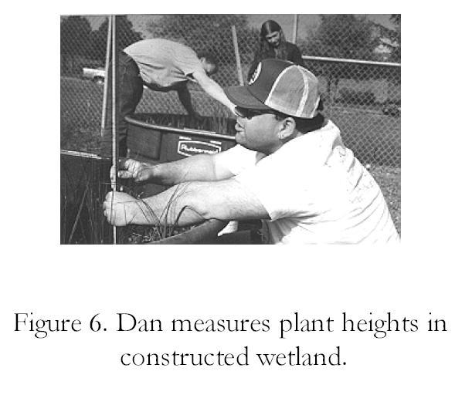
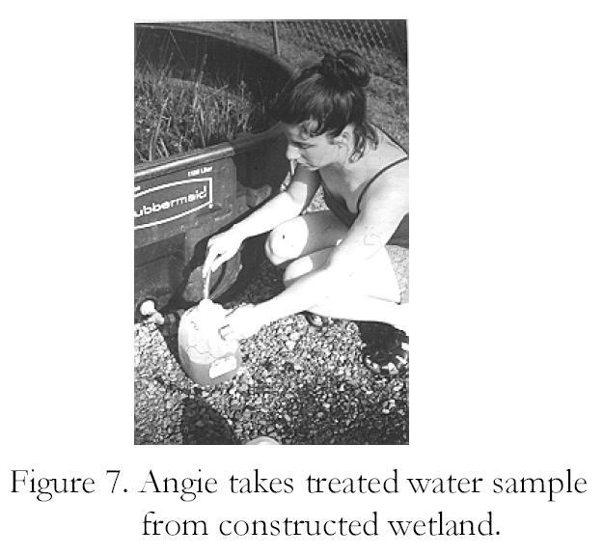

Plant Height Measurements in Constructed Wetlands
(All measurements in millimeters)
Tank No. ______ Date _________ Group Members _______________________
Cattail | Yellow Iris | Smooth Rush | Slough Sedge

Average Values (in mm):
Cattail | Yellow Iris | Smooth Rush | Slough Sedge
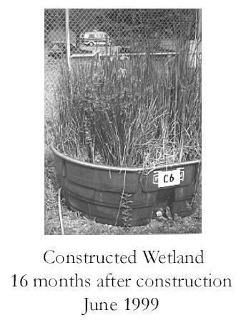
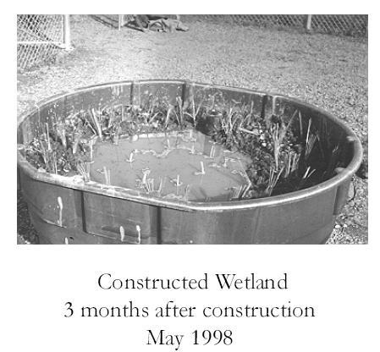

Constructed Wetlands Lab V— Analysis / Interpretation
For the past 10 weeks we have evaluated the effectiveness of constructed wetlands to treat agricultural wastewater. A number of water quality parameters have been measured at one week intervals from pre-treatment (initial conditions) to post-treatment (approximately four weeks). In today’s laboratory we will interpret the results of this term-long study. You will work in small groups and identify major trends in the data and discuss possible reasons for these trends. A more detailed analysis will be presented in your written or oral report for the project.

You will find the following very useful in today’s lab (Bring them with you):
1. All handouts related to the constructed wetlands lab
2. Handout: “How should we interpret water quality measurements?”
3. Summarized data
4. Your Botkin and Keller text

Please examine the attached graphs and tables and use them to respond to the questions below. Put your answers on a separate sheet.

I. Impact of the Wetlands on the Wastewater
A. pH
1. Identify major trends.
2. Explanation for these trends (What do you think caused them?)
3. What is the biological significance of the range of pH’s seen here?
B. Water Temperature
1. What is the significance of these temperature changes?
2. How do these numbers compare to air temperatures on these dates?
3. Why did we measure water temperature?
C. Dissolved Oxygen
1. Identify major trends.
2. Explanation for these trends (What do you think caused them?)
3. What is the biological significance of the dissolved oxygen range seen here?
D. Turbidity
1. What is the relationship between “Turbidity” and “% Transmittance”?
2. Identify major trends.
3. Explanation for these trends (What do you think caused them?)
4. What is the biological significance of the range of turbidity seen here?
E. Algal Concentration
1. What is the relationship between “Algal Concentration” and “% Transmittance”?
2. Identify major trends.
3. Explanation for these trends (What do you think caused them?)
4. What is the biological significance of the range of algal concentration seen here?
F. Nitrogen and Phosphate
1. Initial nitrogen values for the wastewater show very high levels of ammonia nitrogen but very low levels of nitrate nitrogen. Why?
2. What evidence do we have that the wetlands have impacted the level of nitrogen and phosphate in the wastewater?
3. What processes have contributed to these changes? (Hint: Review the phosphate and nitrogen cycles)
G. Microscopic Examination (see Table 1 on next page)
1. Describe changes in the algal community as time progressed. Why did these changes occur?
2. What does the change in algal species tell us about changes in water quality?
3. Which algal species are indicators for “good water quality”? “polluted water”? “very polluted water”?

Table 1. Presence of Green Algae in Wastewater Processed by Constructed Wetlands
 | 4/7/1998 | 5/5/1998 | 5/12/1998 | 5/21/1998
Chlamydomonas
Euglena
Chlorogonium
Lepocinclis
Oscillatoria
Agmenellum
Chlorella
Scenedesmus
Coelastrum
Pandorina
Mougeotia

II. Impact of the Wastewater on the Wetlands
A. Plant Growth
1. Do we have any evidence that suggests a “positive fertilizer effect” (i.e. greater growth at higher fertilizer concentration)? If so, what is the evidence?
2. Do we have any evidence that suggests a “negative fertilizer effect” (i.e. lesser growth at higher fertilizer concentration)? If so, what is the evidence?
3. Do the four wetland plant species differ in their responses? Explain.
B. Plant Mortality
1. How would you describe the level of plant mortality in the constructed wetlands?
2. Is there any evidence that we have exceeded the rate (40 gallons in 4 weeks) at which these wetlands can process wastewater?
III. SUMMARY STATEMENT
In a single paragraph describe how effective the constructed wetlands were in treating agricultural wastewater. Select the most relevant evidence from “I” and “II” above to support your answer.
Constructed Wetlands for Wastewater Treatment
Data Summary

The following data were collected and summarized by students during Spring Term 1998. They are shown here to illustrate the types of data that may result from this activity.

NOTES: “Low” indicates values that were averaged for Tanks A1, A3 and A5 (320 g fertilizer added); “High” indicates values that were averaged for Tanks A2, A4 and A6 (640 g fertilizer added).

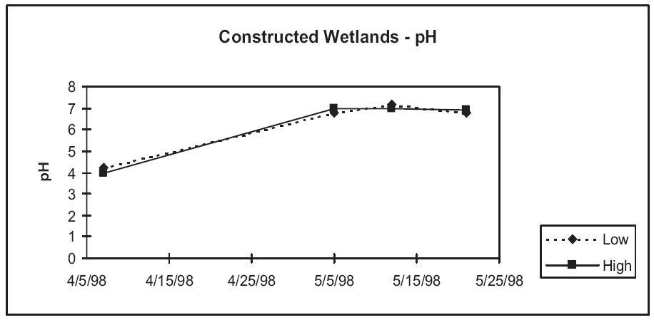

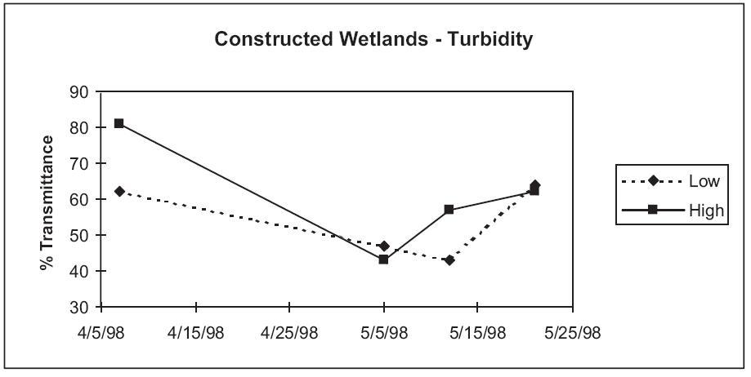
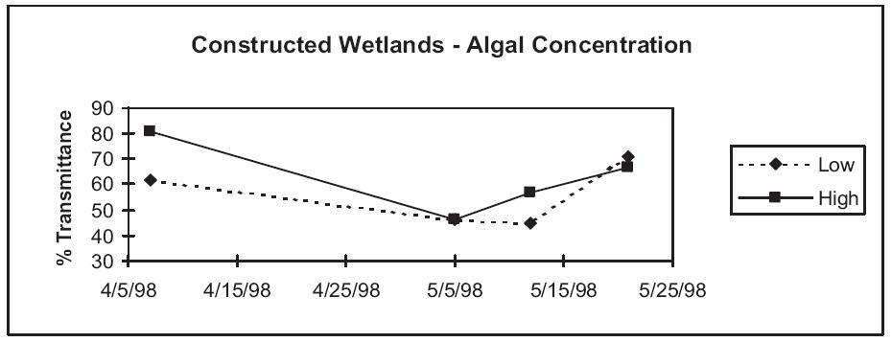

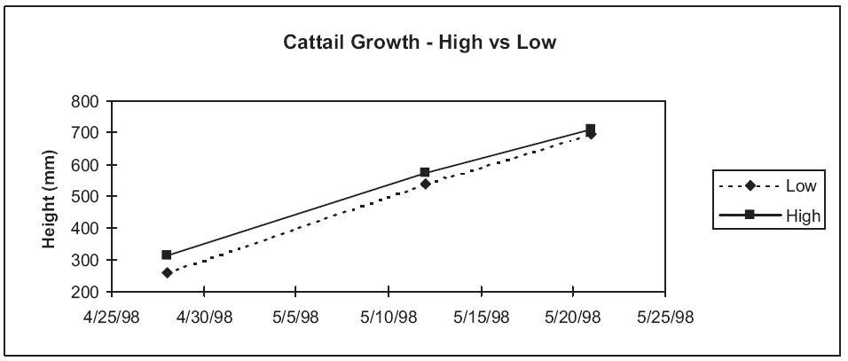

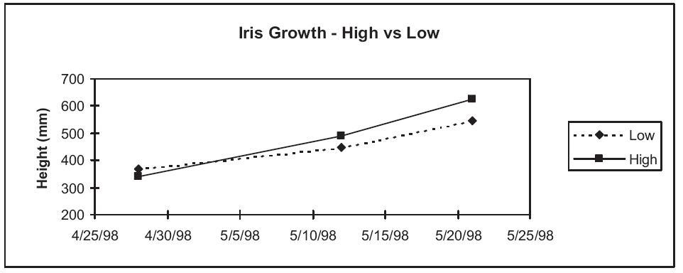
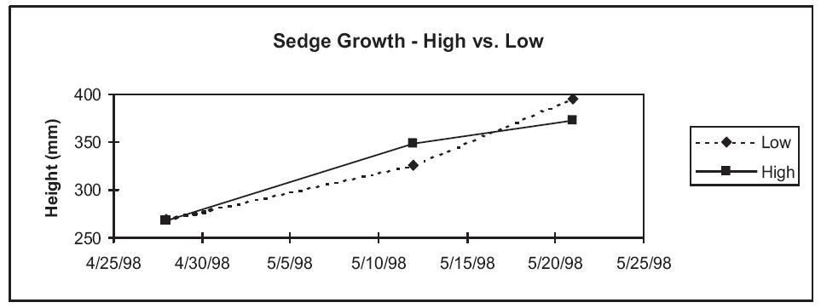

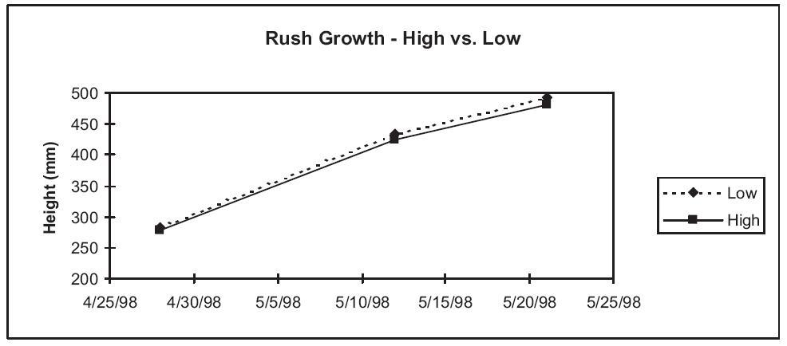
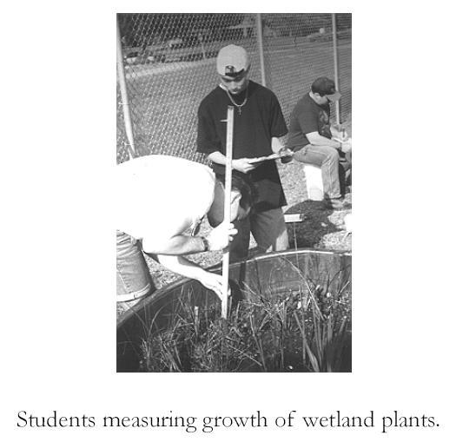
Aquatic Ecology Lab - Primary Production in Constructed Wetlands

INTRODUCTION

A. What is Primary Production?

Primary production is defined as the accumulation of organic matter in an ecosystem that results from photosynthesis. Autotrophic organisms, such as green plants, algae and some bacteria can make their own organic matter (carbohydrates) from a source of energy (sunlight) and inorganic compounds (carbon dioxide and water). You may recall that photosynthesis can be summarized by the following chemical reaction:

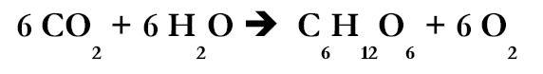

The structure and function of nearly all ecosystems is dependent upon the ability of photosynthetic organisms to convert sunlight into carbohydrates. These carbohydrates then serve as a source of energy for heterotrophic organisms such as insects, small mammals, fungi and some bacteria.

The production of organic material and its use can be described as a three step process:

- A photosynthetic organism produces organic matter through photosynthesis — Gross Primary Production (GP)
- The organism uses some of this matter to fuel its own processes (growth, reproduction, synthesis of other compounds, etc.) — Respiration (R)
- Whatever is not burned as fuel can be stored and accumulated for future use (either by the photosynthetic organism itself or by consumers in the community) — Net Primary Production (NP)

The mathematical relationship between these three can be described as:

NP = GP - R

The situation is analogous to your paycheck. Net Primary Production is your take-home pay
after taxes (Respiration) have been taken out of your gross pay (Gross Primary Production).
For a more detailed discussion of primary production see pp. 145-147 in Botkin and Keller (2000).

B. How can Net Primary Production be Measured?

Net primary production is generally reported as the amount of biomass that accumulates in a given area over a specific time frame. Thus, units such as “g/m2/day” or “tons/hectare/year” are commonly used. There are a number of ways this determination can be made depending on why the measurement is being made, the type of ecosystem, desired accuracy and other factors. Estimates of primary production are commonly made as part of ecosystem studies where biomass pyramids are constructed to represent energy flow through the system. Also, primary production is often estimated in agricultural systems where maximizing yields (and thus profits) is a common goal.

We will use a “clip method” to estimate net primary productivity in constructed wetlands in Chemeketa’s Aquatic Ecology Laboratory. The method is based on weighing the plant material that has accumulated during a growing season. We will clip a sample of the vegetation from a known area and then weigh this material. Since we know the exact date at which these wetlands were planted and we can measure the total area of each wetland, an estimate of net primary production for the system is possible.

C. Background

In today’s laboratory we will be measuring net primary production in six constructed wetlands that were established in February 1998 in Chemeketa’s Aquatic Ecology Laboratory. The design of these wetlands has been described earlier. Once the plants became established, these constructed wetlands were used to test their effectiveness in the treatment of agricultural wastewater. Over the period from April to June 1998, wastewater of two different concentrations was added to the tanks. Tanks A1, A3 and A5 received a total of 40 gallons of wastewater treated with a moderate amount of commercial fertilizer. Tanks A2, A4, and A6 received 40 gallons of wastewater treated with a high amount of the same fertilizer.

We will test the hypothesis that the application of higher concentrations of fertilizer had a positive effect on net primary production in these wetlands. Since tanks A2, A4, and A6 received greater amounts of fertilizer, it might be predicted that net primary production in these tanks would be higher. Let’s see how we can test this hypothesis.

PROCEDURE

- Examine the plants in your wetland and be sure you are able to identify the following:
- Smooth rush
- Slough sedge
- Broad-leaved cattail
- Grasses
Samples will be available for comparison.

- Calculate the surface area of your wetland and record it on your data sheet.
NOTE: Assume that the tank approximates a circle and therefore, its area can be calculated from the formula; A= 3.14 (r²)

- Select a representative area in the rush/sedge zone of your wetland and carefully place the 0.1 m² quadrat on the surface to establish the boundaries of your sample.

- Using scissors, carefully clip all vegetation (dead or alive) within your sample area exactly at ground level.

- Separate the clippings into the following categories:
Smooth rush
Slough sedge
Broad-leaved cattail
Grasses
All other vegetation

- Using digital balances, weigh each category and record to the nearest 0.1 g. These are wet weights for your samples. Record your measurements on the data sheet.

- Label your samples with your name and lab section and place them in the drying oven. Allow samples to dry for one week.

- Re-weigh your samples after one week to determine dry weights.

- Calculate the net primary production (dry weight/m²/day) and total above-ground biomass (g) for each plant category. Enter your estimates on the attached data sheet.

- As estimates of net primary production become available for other tanks from other groups, record this information on your data sheet.

MATERIALS

QUANTITY ITEM
6 Metric tapes
12 Scissors
6 Large plastic basins
18 Sorting trays
3 Digital balances
3 Drying ovens
6 Wire quadrats- 0.1 m2
100 Small tags w/ ties (approx. 1" X 2")

ANALYSIS

Answer each of the following questions in the space provided.

- The experimental period for this study was April to October. How would your estimate of net productivity differ if the experimental period was May through July? November through January?

- Place all class data into either a table or summarize these data in graphical form. Is our original hypothesis supported or refuted by the data? Explain fully.

- Which plant species accounts for the majority of primary production in your wetland?

- How much biomass accumulated in your entire wetland during the experimental period? Show how you determined this.

- We measured net production in today’s experiment; that is, the accumulated biomass over time. In addition to this material, however, these plants produced much more biomass that was not measured (i.e., gross production). Describe some of the possible fates of this “missing biomass”.

- Did you encounter any heterotrophic organisms in your sampling or observations? If so, what were they? Discuss their influence (direct or indirect) on primary productivity.

- Why is “dry weight” rather than “wet weight” used as a standard measure of net productivity?

- Below are some estimates of growing season above ground net primary production for several grassland ecosystems:
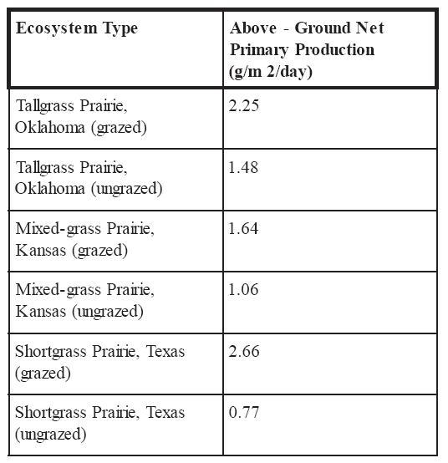
8. continued…
At least for the ecosystems listed here, it appears that grazing has a positive impact on net primary production. Why do you think this is the case?

How do your net primary production estimates compare to those given above? What do you think accounts for differences?

Do you think, in general, that wetlands are more or less productive than prairies? Explain.

- List five environmental factors that may influence the primary production of a wetland ecosystem. Include only “natural” factors, not human-caused influences such as mowing or the application of commercial fertilizer.

a.
b.
c.
d.
e.
- Explain why our net primary production estimates are an under-estimate of total net primary production.

Above-Ground Net Primary Production for Constructed Wetlands in
Chemeketa’s Aquatic Ecology Laboratory
SPECIES: Smooth Rush
Tank # | Sample Wet Weight (g) | Sample Dry Weight (g) | Growth Period (days) | Net Primary Production (g/m²/day) | Area of Tank (m²) | Total Above-ground Biomass (g)
A-1
A-2
A-3
A-4
A-5

SPECIES: Slough Sedge
Tank # | Sample Wet Weight (g) | Sample Dry Weight (g) | Growth Period (days) | Net Primary Production (g/m²/day) | Area of Tank (m²) | Total Above-ground Biomass (g)
A-1
A-2
A-3
A-4
A-5

SPECIES: Grasses
Tank # | Sample Wet Weight (g) | Sample Dry Weight (g) | Growth Period (days) | Net Primary Production (g/m²/day) | Area of Tank (m²) | Total Above-ground Biomass (g)
A-1
A-2
A-3
A-4
A-5
SPECIES: Miscellaneous Wetland Plants
Tank # | Sample Wet Weight (g) | Sample Dry Weight (g) | Growth Period (days) | Net Primary Production (g/m²/day) | Area of Tank (m²) | Total Above-ground Biomass (g)
A-1
A-2
A-3
A-4
A-5

SPECIES: Cattails
Tank # | Sample Wet Weight (g) | Sample Dry Weight (g) | Growth Period (days) | Net Primary Production (g/m²/day) | Area of Tank (m²) | Total Above-ground Biomass (g)
A-1
A-2
A-3
A-4
A-5

SPECIES: All Plant Species Combined
Tank # | Sample Wet Weight (g) | Sample Dry Weight (g) | Growth Period (days) | Net Primary Production (g/m²/day) | Area of Tank (m²) | Total Above-ground Biomass (g)
A-1
A-2
A-3
A-4
A-5

SAMPLE RESULTS

The following data were collected and summarized by students during Fall Term 1998. They are shown here to illustrate the types of data that result from the activity as outlined above. Students were required to use these summarized data to answer the questions on previous pages. Among other questions, they were asked to test the hypothesis that those wetlands that had received a higher concentration of fertilizer would have higher net primary productivity. Since tanks A2, A4, and A6 received greater amounts of fertilizer, it might be predicted that net primary production in these tanks would be higher. Examination of the charts below suggests little evidence in support of this hypothesis.

In addition to analyzing differences in primary productivity among different wetlands, the data can be used to document ecological succession. Above-ground productivity will be estimated for major wetland species each year and compared to values in the chart below.

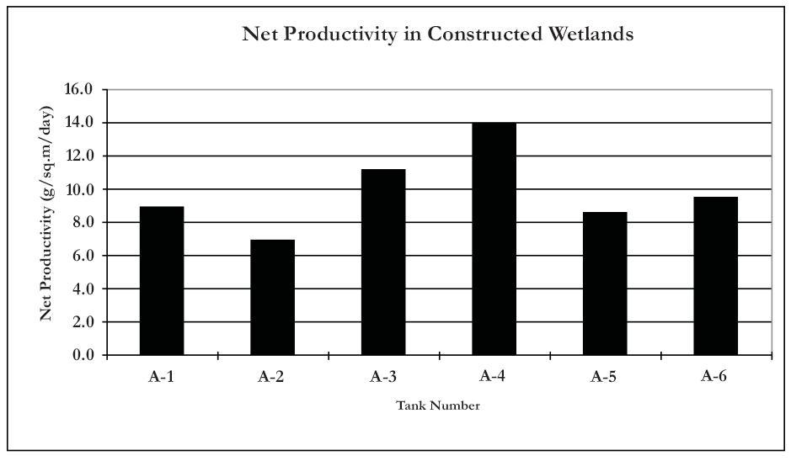
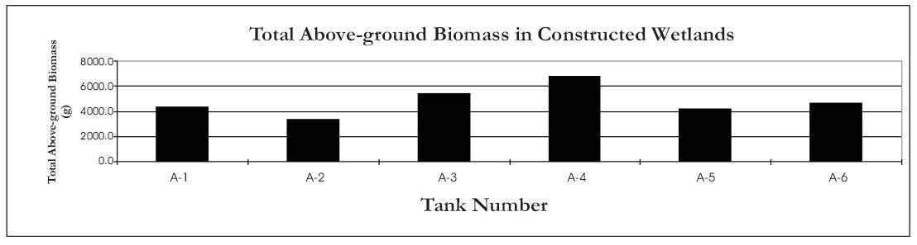

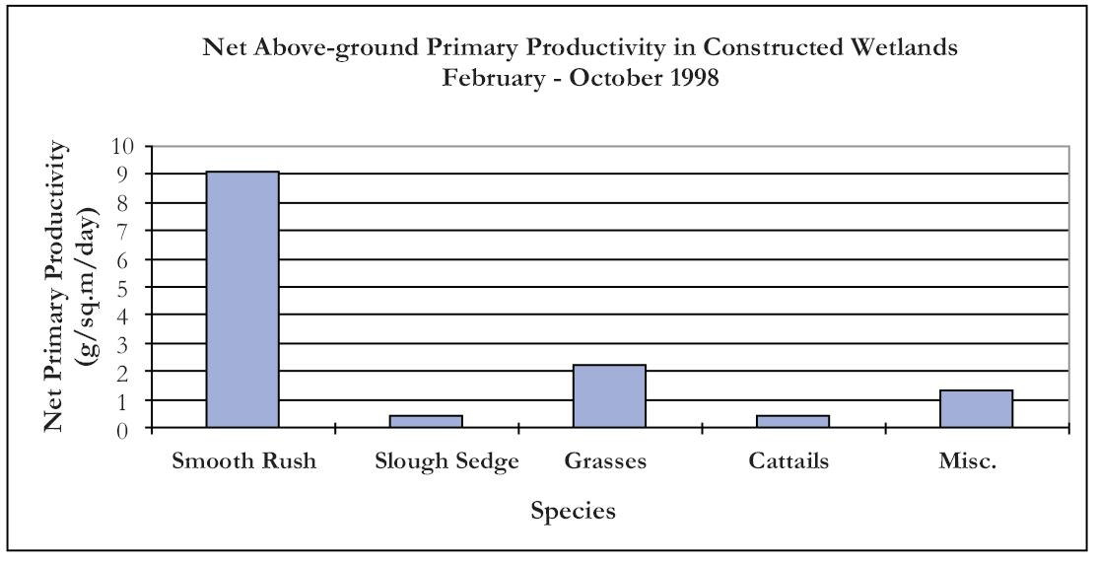

Aquatic Ecology Lab - Ecosystem Analysis Lab
INTRODUCTION

An ecosystem is defined as an ecological (biotic) community and its abiotic environment. Although ecosystems vary greatly in size and attributes, there are certain minimum requirements. There must be an autotrophic (usually photosynthetic) organism to convert sunlight into a more useable form (energy stored in carbohydrates). There must be an energy source (usually sunlight) and a sink (usually stored as carbohydrates in plant and animal tissues). There must be a decomposer to break down complex materials in the system so they can be used by autotrophs. All of the chemical elements required by the autotroph and the decomposer must also be present. Although not essential in a simple ecosystem, most also have one or more levels of consumers that ingest (directly or indirectly) carbohydrates stored in plants.

This laboratory is designed to familiarize you with the structure and function of ecosystems. We will limit our initial study to a small ecosystem with definite borders in the Aquatic Ecology Laboratory—constructed wetlands that were designed by students to study the treatment of agriculture wastewater.

CONSTRUCTED WETLAND DESCRIPTION

Six identical model wetlands were constructed in February 1998 in Chemeketa’s Aquatic Ecology Laboratory by the Environmental Science class. (The design and initial conditions of these wetlands has been described previously). The constructed wetlands have been allowed to mature for approximately 20 months since planting.

PROCEDURE

Enter your tank number here: __________

Answer each of the following questions concerning your model ecosystem as completely as possible in the next section.

I. Ecosystem Composition

A. Abiotic Components - List the abiotic components of your ecosystem in the space below:

B. Biotic Components

1. Identify as many plant species as you are able using available guides. The instructor will also be available to assist in identification.
The following plants have been identified recently in these constructed wetlands:

Yellow iris Iris pseudacorus
Broadleaf cattail Typha latifolia
Smooth rush Juncus effusus
Slough sedge Carex obnupta
Bolander’s rush Juncus bolanderi
European bittersweet Solanum dulcamara
Waterpepper Polygonum hydropiperoides
Ovate spike rush Eleocharis ovata
Large barnyard grass Echinochloa crus-galli
Curly dock Rumex crispus
Common velvet grass Holcus lanatus
Soft-stem bulrush Scirpus tabernaemontani

2. Confirm identification of your plant species with instructor before proceeding.

3. Estimate the number of individual stems of each plant species either by direct count (for those with 50 or fewer individuals) or by sampling (for those with more than 50 individuals).

Record your results in the table below.
Plant Species | No. of Stems

4. Describe the sampling method you have used to estimate those plant species with more than 50 individuals.

5. Are there any species present in the ecosystem now that were absent when the wetland was constructed? Which ones?

6. What are some possible sources of these plants you have listed in #5?

7. Which of the species originally planted in your wetland have increased in number? Which ones have decreased?

8. What do the changes you have described in questions #5, 6 and 7 suggest to you?

9. The term “ecological succession” is used to describe changes in ecosystems that occur over time. Describe how each of the following ecosystem characteristics has changed since planting:

Total biomass

Species diversity

Species composition

10. Based on the changes that have occurred in this ecosystem over the past 20 months, how do you think each of the following will change over the next 20 months? Describe your rationale for each (i.e., why do you think this change will occur?).

Total biomass

Species diversity

Species composition

11. Carefully examine and sample the water and vegetation within your ecosystem for animal species. Collect as many animal species (mostly insects and aquatic invertebrates) as you are able without seriously disturbing the ecosystem. Collection equipment will be available. Use available references and dissecting microscopes to identify these animals.

12. For each animal species you have observed or collected, record your best estimate of numbers of individuals in the table below. Also, indicate whether each is a primary consumer
(herbivore) or secondary consumer (predator).
VEGETATION |  |  | WATER
Species | Estimated Number | Consumer Level | Species | Estimated Number | Consumer Level
II. Ecosystem Processes - Energy Flow and Nutrient Cycling

- Which organisms in the ecosystem are photosynthetic?

- Construct a biomass pyramid that illustrates your estimate of the relative amounts (weights) of producers, primary consumers and secondary consumers in your wetland.

- List all the possible fates of a single green leaf in your ecosystem.

- Describe how plant and animal biomass accumulate in this ecosystem. Include the following terms in your description - carbon dioxide, photosynthesis, carbohydrate, respiration, ingestion.

- Which organisms in the ecosystem are decomposers? What evidence do you see of their existence? Describe their role in nutrient cycling in this ecosystem.

- The ecosystems you have been working with are only models of actual ecosystems. In what ways are these constructed wetlands different from a fully functional wetland ecosystem? In what ways are they the same?

MATERIALS

QUANTITY ITEM
3 Plankton nets (for collection of aquatic invertebrates)
3 Ring stands and rings (to support plankton nets)
12 Dissecting microscopes
12 Fine forceps
12 Eye droppers and bulbs
6 Finger bowls/Large crystallization dishes
24 Small, coaster-type watch glasses
6 1000 ml beakers (for collection of water sample from wetlands)
12 Golden Guides — “Pond Life”; or Rainis and Russell — “Guide to microlife”
6 Insect sweep nets
3 Insect identification guides
3 Wetland plant identification guides
24 Specimen jars with lids (for insects)
12 Clipboards
6 Meter sticks

Aquatic Ecology Lab Literature Cited and
Additional Resources
Aquaculture
These resources specifically address the various aspects of raising aquatic organisms (primarily fish) in artificial environments.

http://ag.ansc.purdue.edu/aquanic/
AquaNIC (Aquaculture Network Information Center) - An excellent source for aquaculture curriculum, publications, media and career opportunities; thousands of links to related sites.

Huet, M. 1986. Textbook of fish culture - Breeding and Cultivation of Fish, 2nd ed. Fishing News Books, Ltd. Farnham, England.

Kosinski, R.J. 1993. Fish Farm - a simulation of commercial aquaculture. The Benjamin/Cummings Publishing Co. Redwood City, CA. 98 pp.

Van Gorder, S.D. and D.J. Strange. 1992. Home Aquaculture: A guide to backyard fish farming. Alternative Aquaculture Association, Inc. Breinigsville, PA 136 pp.

Mesocosms and Microcosms in Ecological Research
Constructed ecosystems at meso- and micro-scales have been used to test a number of hypotheses at population, community and ecosystem levels. These resources are but a small sample of such studies.

Blaustein, A. and D.B. Wake. 1995. The puzzle of declining amphibian populations. Sci. Am. April 1995:52-57.

Carpenter, S.R., S.W. Chisolm, C.J. Krebs, D.W. Schindler and R.F. Wright. 1995. Ecosystem experiments. Science 269:324-327.

Larsen, D., P.F. Denoyelles Jr., F. Stay, and T. Shiroyama. 1986. Comparisons of single species microcosm and experimental pond responses to atrazine exposure. Evironmental Toxicology and Chemistry 5: 179-190.

Lawton, J.H. 1995. Ecological experiments with model systems. Science 269:328-331.

Roush, W. 1995. When rigor meets reality. Science 269:313-315.

Rowe, C.L. and W.A. Dunson. 1994. The value of simulated pond communities in mesocosms for studies of amphibian ecology and ecotoxicology. J. of Herpetology 28(3):346-356.

Wilbur, H. 1987. Regulation of structure in complex systems: experimental temporary pond communities. Ecology 68: 1437-1452.

Wilbur, H.M., P.J. Morin and R.N. Harris. 1983. Salamander predation and the structure of experimental communities: Amphibian responses. Ecology 64:1423-1429.

Wetland Creation and Restoration
Wetland creation, enhancement and restoration projects are routinely conducted to mitigate the loss of natural wetlands due to development. Our knowledge of the effectiveness of these efforts, however, is very limited. These two resources provide some information on the “science of wetland creation and restoration”.

Kuster, J.A. and M.E. Kentula. 1990. Wetland creation and restoration - The status of the science Mitsch, W.J., X. Wu, R.W. Nairn, P.E. Wiehe, N. Wang, R. Deal and C.E. Boucher. 1998.

Creating and restoring wetlands. Bioscience 48 (12): 1019-1030.

Waste Treatment by Constructed Wetlands
Constructed wetlands have been used to treat industrial, agricultural and municipal wastewater. These sources provide a sample of some of these efforts.

http://www.waterrecycling.com/index.htm
Triangle School Water Recycling Project (North Carolina State University) - A detailed description of an ecological wastewater recycling system in Chatham County, North Carolina that uses constructed wetlands.

Mitsch. W.J. 1993. Ecological engineering: a comparative role with the planetary life-support system. Env. Sci. and Tech. 27:438-445.

Brown, K.S. 1995. The green clean. Bioscience 45(9): 579-582.

Carnevale, E. 1995. Cattails treat leachate and save thousands. Environmental Protection Nov. 1995:35-36.

EPA. 1993. Constructed Wetlands for Wastewater treatment and wildlife habitat: 17 Case studies Kadlec and Knight. 1996. Treatment Wetlands. CRC Press, Inc.

Hammer, D.A. 1989. Constructed wetlands for wastewater treatment. Municipal, Industrial and Agricultural. Lewis Publishers, Inc.

http://gus.nsac.ns.ca/~piinfo/resman/wetlands/anno/annobib.html
Wetlands for Waste Treatment - An annotated bibliography of resources on the use of wetlands for waste treatment.

Lesley, D., H. Van Zee and J.A. Moore, eds. 1993. Constructed wetlands wastewater treatment systems: How do they work? Oregon State University Extension Service Misc. Publication 8543.

Moore, J.A. 1993. Using constructed wetlands to improve water quality. Oregon State University Extension Service # EC 1408. 4 pp.

Soil Conservation Service. 1982. Ponds - Planning, Design, Construction . Agriculture Handbook No. 590. 51 pp.

http://www.usouthal.edu/usa/civileng/wetlands.htm
USA Constructed Wetlands Page

http://h2osparc.wq.ncsu.edu/info/wetlands/index.html
A comprehensive site for natural and constructed wetlands (definitions, processes, functions, importance, human impacts, management, mitigation).

http://towtrc.tamu.edu
Texas On-Site Wastewater Treatment Research Council. Constructed wetlands fact sheet can be downloaded from this site. Describes components, design, operation and maintenance of constructed wetlands for wastewater treatment.

http://www.humboldt.edu/~ere_dept/marsh/ownmarsh.html
Humboldt State Environmental Engineering Department. Includes some general guidelines for constructed wetland design (soil, plants, etc.).

http://www.enn.com/search/search.asp
The Environmental News Network posts current and archived articles on environmental issues from a variety of sources. A search for “constructed wetlands” articles will yield a number of pertinent articles (including some on “phytoremediation” - the use of plants to uptake contaminants from soils or water).

General References on Wetlands
Niering, W. 1995. Wetlands. Alfred P. Knopf, Inc. New York, NY.

Mistsch, W.J. 1993. Wetlands. Van Nostrand Reinhold, New York, NY.

Schodari, P.F. Wetlands protection: The role of economics. Environmental Law Institute, Washington, D.C.

EPA. 1995. Wetlands Fact Sheets. EPA Office of Wetlands, Oceans and Watersheds.

EPA. 1993. Natural Wetlands and Urban Stormwater: Potential Impacts and Management. EPA Office of Water.

EPA. 1988. America’s Wetlands: Our vital link between land and water. EPA Office of Wetlands Protection.

Lewis, M. 1998. Plants do the dirty work: Cleaning wastewater, saving the environment. Nation’s Cities Weekly 23 September 1996: V19.n38 pp. 1-5.

http://www.nwi.fws.gov
U.S. Fish and Wildlife Service National Wetlands Inventory
http://www.enn.com/newslenn-stories/020298/chevron.shtm
http://www.waterrecycling.com/soilfilt.htm
http://www.sws.org/wetlandweblinks.html
Another comprehensive wetlands site with lots of links to other sites (agencies, publishers, universities, sites designed for middle school and high schools students).

Wetland Plant and Algae Identification
Activities in model aquatic ecosystems usually require the identification of native species of plants, animals and algae. Also, plant selection for the construction of these systems often requires identification of native plants. These references will be particularly helpful in the Pacific Northwest.

Guard, J. B. 1995. Wetland plants of Oregon and Washington. Lone Pine Publishing, Redmond, WA. 239 pp.

Palmer, C.M. 1977. Algae and water pollution: An illustrated manual on the identification, significance and control of algae in water supplies and polluted water.

EPA-600/9-77-036, U.S. Environmental Protection Agency, Cincinnati, Ohio. 123 pp.

Pojar, J. and A. MacKinnon. 1994. Plants of the Pacific Northwest coast. Lone Pine Publishing, Redmond, WA. 527 pp.

Rainis, K.G. and B.J. Russell. 1996. Guide to microlife. Franklin Watts Publishing, Danbury, CT. 287 pp.

Water Quality Testing
Laboratory activities that use model aquatic ecosystems frequently require the measurement of physical and biological water quality parameters. These resources describe some of the parameters that may be measured along with descriptions of their ecological impacts.

American Public Health Association. Standard Methods for the Examination of Water and Wastewater.

Campbell and Wildberger. 1992. The Monitor’s handbook. LaMotte Company.

Mitchell and Stapp. Field manual for Water Quality Monitoring. GREEN Project.

Murdoch, T. and M. Cheo. 1996. Streamkeepers’ field guide - Watershed inventory and stream monitoring methods. Adopt-A-Stream Foundation, Everett, WA. 296 pp.

http://esa.sdsc.edu/carpenter.htm
This Ecological Society of America report entitled “Non-point Pollution of Surface Waters with
Phosphorus and Nitrogen” is an excellent review of ecological impacts of these contaminants.

http://h2osparc.wq.ncsu.edu/info/index.html
Water Quality and Land Treatment - Excellent site for description, measurement and interpretation of water quality parameters.

Other Aquatic Microcosm Laboratory Activities
A number of laboratory activities that use aquatic microcosms have been developed by other authors for students at all levels of education. The activities below represent a selection of activities that are appropriate for high school and college-level curriculum.

http://www.intercom.net/biz/aquaedu/hatech/
Hydro/Aquatic Technologies (a source for aquaculture-related curriculum).

Carlson, S. 1998. The pleasures of pond scum. Sci. Am. Mar. 1998: 96-98.

Koeniger, J. 1997. Making a splash in the classroom. Carolina Tips 60(1):1-8.

Marcus, B. 1994. Microcosms for lake acidification studies. The American Biology Teacher 56: 433-437.

Murphy, T.M., D. Canington and D.E. Walker. 1992. Herbivory, predation and biological control. The American Biology Teacher, 54:416-419.

Nicol, E. 1990. Hydroponics and aquaculture in the high school classroom. American Biology Teacher 52:182-184.

Porter, J.R. 1989. Herbivory-induced alteration of community structure - a classroom model. American Biology Teacher 51:300-302.

Yensen, N.P. 1988. Ecosystems in glass. Carolina Tips 51(4)13-15.

Measurement of Net Primary Productivity
Botkin, D. and E. Keller. 2000. Environmental Science: Earth as a Living Planet. 3rd ed. John Wiley and Sons, Inc. New York. 649 pp.

Brower, J.E., J.H. Zar and C.N. von Ende. 1990. Field and laboratory methods for general ecology.

3rd ed. Wm. C. Brown Publishers, Dubuque, IA. 237 pp.

Cox, G.W. 1990. Laboratory manual of general ecology. 6th ed. Wm. C. Brown Publishers, Dubuque, IA. 251 pp.

